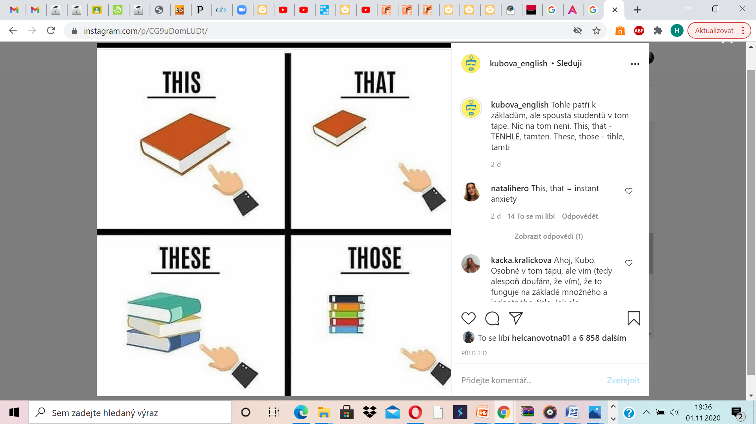

|  |  |  |
| --- | --- | --- |
| *Questions:* |  | |
| *What is it?* | | ***This is ……………………....*** |
| *What is that?* | | ***That is ……………............*** |
| *What are these?* | | ***These are ………………………..*** |
| *What are those?* | | ***Those are ………………………...*** |

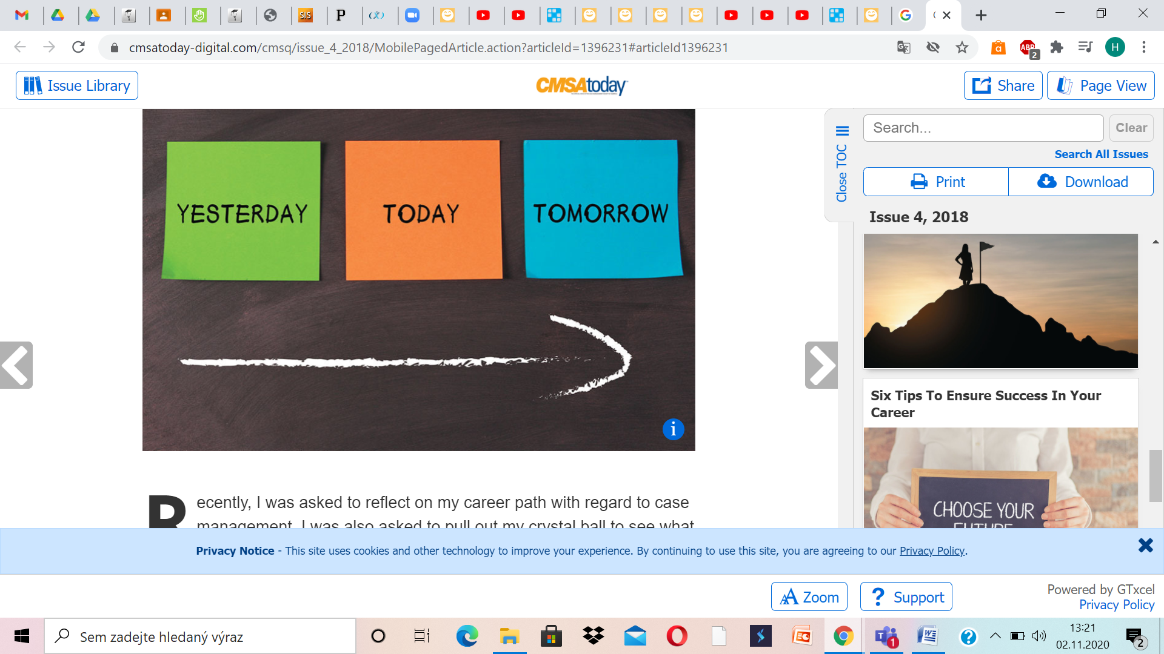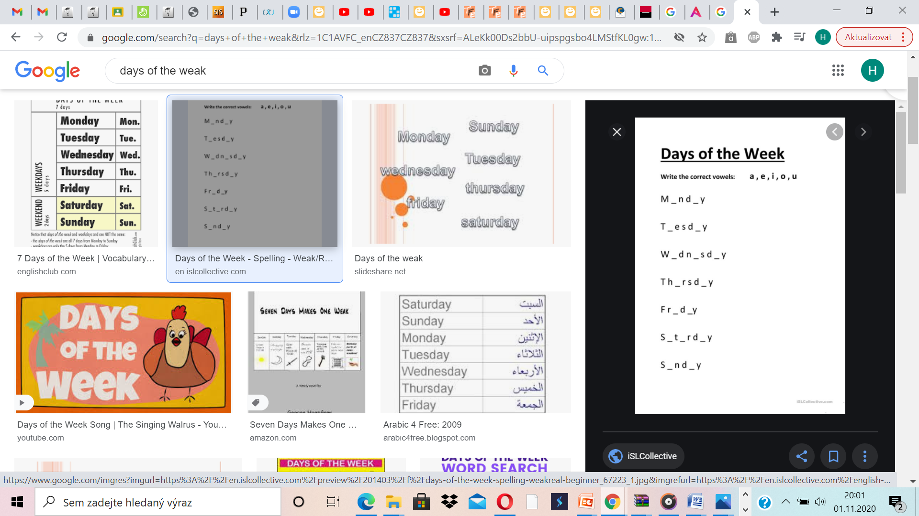

***after- po***

***before- před***

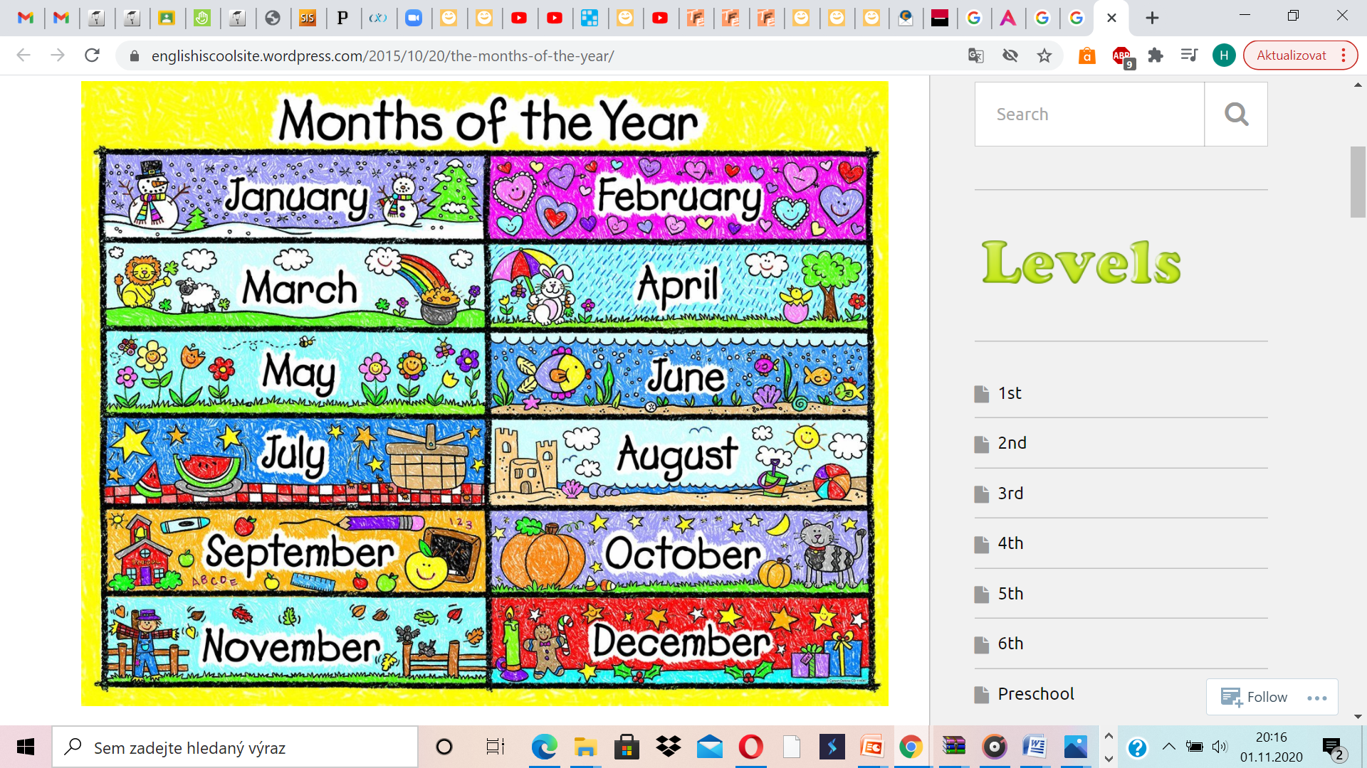

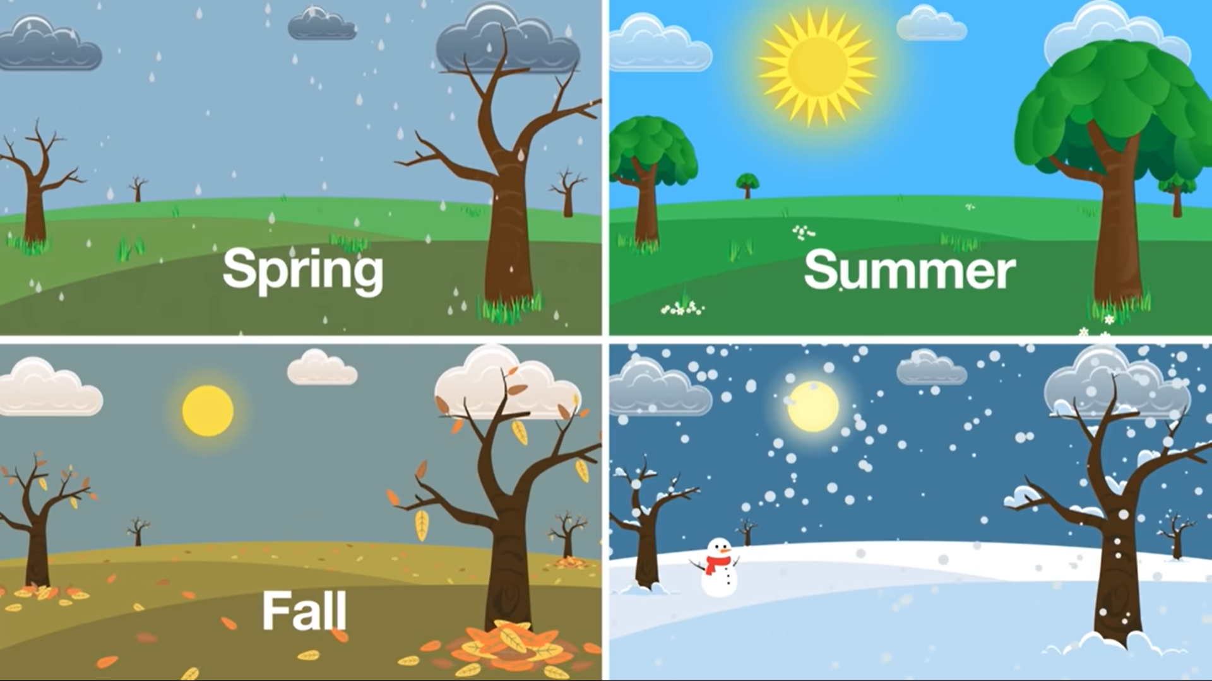

**Winter**

