Creative Writing II
It has been raining a lot in the past few days. The rain made me sleepy and blue, but it also made me wonder how it would probably feel like to stand in it, to get devoured by it, to be touched by it. I figured that rain would be a great opportunity to experience for a creative writing. Eventually, I decided to go outside today afternoon. It was not raining anymore, the sun was soaking through the leaves, but the rain was everywhere in the air, in the soil, in the atmosphere. I went barefoot. I mainly felt, I tried to sense as much as I could, and I touched, smelled, climbed and – many times – almost fell.
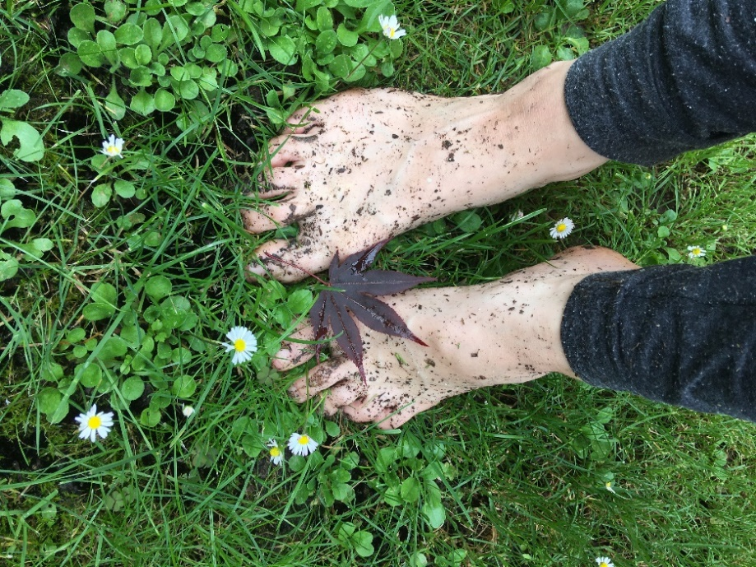
You have to be careful. The feet know what to do, but the slippery ground betrays them. You soil-skate in the forest, search for any rock and tree and root. Is slippery? Is it safe? You try. Step a little, step more. There is this hole in the ground with steep sides, you overcome it. Look behind, the hole is left after a tree. The oak-tree has fallen, its roots are in the brook now, but the tree is alive, sprouting new branches. Such a shuge-respectable-super-earthly creature, but it lies here down next to you, still doing what it wants, not caring about what it should.
The forest explodes green, it screams deep into the cells, you get lost in a jungle of lush, freshness, leaves and leaves. Drip, drip. Step into a brook. Cold, but not too cold, eyes draw your feet into the crystal-clear purity. Inhale. Elderflower bliss. You think, the blossoms on the ground so little, tiny, muddy, have a pasta-shape. Just like little “stars” in a soup, but here they are on the ground. Walking past around the impatiens plants. You get impatient, touch them to make them pop. They know you will get curious, something about their seed capsules does that, which one will burst, and which will not?
What is that? It looks like a giant tortoise buried in the ground. It has a shell and a leg sticking out. No, it is just a piece of wood under a clay dollop, with some woodworm ornaments carved on. It looks so ancient. Can I step on it? My feet sink into the clay.
Looking at a tree bark, noticing a snail, noticing wrinkles and holes, little webs entangled between the openings. Micro-universes in micro-universes, endless spiral of living and livable. What can we notice, what cannot we see? We only see when we pay attention. I have never noticed before – the flowers, the lianas, the little creek. How long have they been there? Is it enchanted, is it only here because I pay attention? Attention is magical. It fulfills, it creates, it enjoys. Mere being becomes interesting when attention fills it.
Step by step, the forest unrolls, and every step brings different views, all different but all the same, green, leaves, branches, hills mud ground. So much is hidden to be found. Feet discover the ground, ground discovers my feet. The mud hugs the skin. Sun beams embrace, the rocks tease, water dripping inviting the snails outside to join the fresh life after rainy storms. Living the vibrancy in my skin of the forest air. Breathing in the rain, walking to meet the pathway of nettles and clay in the childhood familiar but unbeknown neighbourhood.

