Mandatory article

Energy reform could unlock Mexico's shale resource potential

04/16/2014

Rachael Seeley, Editor

http://www.ogj.com/articles/uogr/print/volume-2/issue-2/energy-reform-could-unlock-mexico-s-shale-resource-potential.html
The oil and gas industry is watching with great interest as energy reforms unfold in Mexico. The country has taken the first steps toward opening its energy industry to outside investment that could unlock the potential of its massive unconventional resource. Constitutional reforms, enacted in December, ease investment restrictions and tax obligations for state oil company Pemex and open a path for investment from outside the country for the first time in 75 years.
Mexico holds a sizable unconventional resource base. With an estimated 545 tcf of technically recoverable shale resources, the country ranks sixth in the world in terms of shale gas potential, behind China, Argentina, Algeria, the US, and Canada (Table 1).

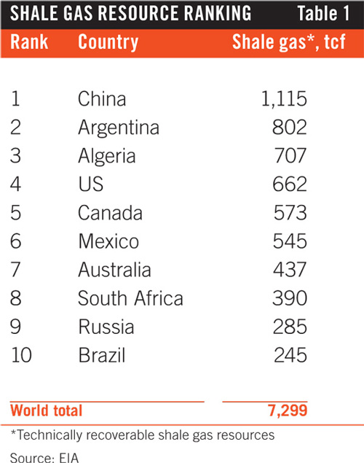

The country ranks eighth in the world in terms of oil and condensate technically recoverable from shale, estimated at 13.1 billion bbl by the US Energy Information Administration (EIA) in January 2014 (Table 2).
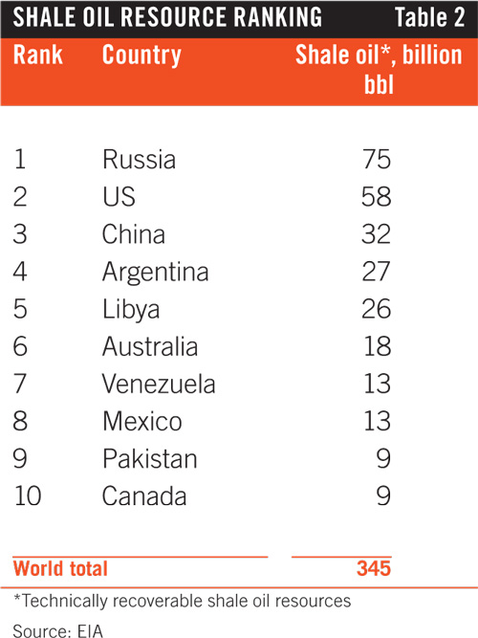

The greatest known shale potential exists in the portion of the Eagle Ford shale that extends into Mexico's Burgos basin from South Texas.
"Oil and gas-prone windows extending south from Texas into northern Mexico have an estimated 343 tcf and 6.3 billion bbl of risked, technically recoverable shale gas and shale resource potential," EIA said.
Pemex—which has for decades held a constitutional monopoly on development of Mexico's oil and gas reserves—is the only company that has tested the Eagle Ford in the Burgos basin. Pemex has drilled four exploratory wells and released initial production data for two of these.
The first well, the Emergente-1, was drilled in late 2010 a few miles south of the Texas-Coahuila border along a continuation of the Eagle Ford trend from South Texas.
The initial horizontal well, drilled in the dry-gas window of the formation, reached a true vertical depth of about 8,200 ft with an 8,366-ft lateral. Pemex completed it using a 17-stage fracture stimulation treatment. It tested at a modest initial production rate of 2.8 MMcfd of gas. EIA estimates the well cost $20-25 million to drill and is uneconomic at current gas prices.
Results were also released for Pemex's Habano-1 in the Eagle Ford's wet gas window. The well had an initial production rate of 2.771 MMcfd of gas and 27 b/d of crude. Initial production rates are not available for the Nomada-1 well drilled in the oil window or the Montanes-1 well drilled in the wet gas window. Pemex plans to drill up to 75 shale exploration wells in the Burgos basin through 2015.
A fifth Eagle Ford shale exploratory well, the Percutor-1, tested the formation in the more geologically complex Sabinas basin to the southwest. That well, drilled in a dry gas area, had an initial production rate of 2.17 MMcfd.

Reforming exploration
One of the biggest hurdles to developing Mexico's unconventional resources was removed in December 2013 when Mexican President Enrique Peña Nieto signed a landmark energy bill that encompassed several key constitutional changes—including the removal of a prohibition against private investment in the oil and gas industry.
The reforms are the most dramatic made in the Mexican oil and gas industry since its nationalization in 1938.
Benjamin Torres-Barron, a partner in the Mexican offices of law firm Baker & McKenzie, called the reforms a true game changer. "No one ever really believed that it was ever going to happen. We've been aiming for this for decades and throughout several federal government administrations."
Now that the constitutional reform has passed, work has begun on a legal framework for oil and gas development and draft contract models for private investment. Many lingering questions will be answered when Congress finalizes the secondary legislation, due for release by Apr. 19.

Contract preparation
Torres-Barron recommends that exploration and production companies interested in investing in Mexican oil and gas begin preparing now for the first state contract tenders, likely in 2015.
Bidding will occur soon after the first tender. Torres-Barron said doing early research will give companies an advantage. "Once the tender is launched you have a very narrow timeframe to incorporate a Mexican entity, to understand the rules, to have them translated for the language barrier, and to analyze the tax structure," Torres-Barron told UOGR at an industry conference, hosted by Baker & McKenzie, in Houston.
He recommends companies begin researching now—analyzing the fields likely to be offered, getting a sense of the competition, and becoming familiar with local authorities. It would also be prudent, he said, to begin building relationships with local contractors. This will help operators take advantage of opportunities when they arise.
"Do your homework," Torres-Barron said. "First you need to know the rules of the game. You will need a group of advisors who will help you."
Before tenders are announced, Torres-Barron recommends assembling a local team of legal and tax advisors familiar with Mexico's regulatory framework and tax structure, as well as advisors from abroad familiar with the contract models likely to be introduced. Companies that can understand the terms of contract tenders before they are announced will have an advantage, he said.
New contract models for exploration and production companies could include a combination of profit-sharing or production-sharing agreements with Pemex or the federal government, license agreements with the federal government, and service agreements with Pemex involving only cash payments.

Pemex's challenge
The reforms also call for reducing the tax burden on Pemex and restructuring the company. Pemex will soon have the ability to enter into partnerships with private parties that could aid in providing the expertise, equipment, and capital needed to explore and develop the country's shale resources, as well as other areas of high resource potential—such as deepwater.
Reform was underpinned by Pemex's declining production numbers. The company is a key part of Mexico's economy, with oil revenues accounting for 8.6% of gross domestic product, and tax revenues covering roughly 30% of the federal government's expenses in 2013, according to analysis by Barclays.
The bulk of Pemex's production comes from legacy oil and gas fields that are in decline, and the company's ability to invest in new production has been hampered by high taxes. Michael Cohen, an analyst with Barclays, said Pemex paid roughly 65% of its revenues in taxes in 2012. "Tax obligations have almost eliminated Pemex's net income, making it very difficult for the company to replace reserves fully over the past 3 years," Cohen said. The company posted a reserves replacement rate of 96% in 2012.
Torres-Barron, of law firm Baker & McKenzie, said Pemex was subject to a variable income tax rate that could reach 70%.
Limited investment by Pemex has hurt production. Crude oil output declined by 1 million b/d over 10 years, Enrique Ochoa Reza, the Mexican energy ministry's undersecretary of hydrocarbons, told a Dec. 19 discussion at the Atlantic Council. The International Energy Agency estimates the country produced 2.5 million b/d in November 2013.
Natural gas production has also slipped. Analysis by Barclays shows that Pemex's gas production averaged 5.6 bcfd in July 2013, down from a peak of 6.5 bcfd in January 2010, resulting in a growing reliance on imported gas. Natural gas imports climbed to meet 30% percent of demand in 2012 from 3% in 1997.
EIA reports that Mexico imported a record 2.1 bcfd of natural gas in 2012, up 21% from 2011. Eighty percent of gas imports came via pipeline from the US (Figs. 1-2).

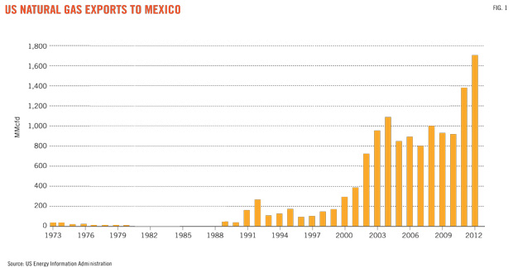
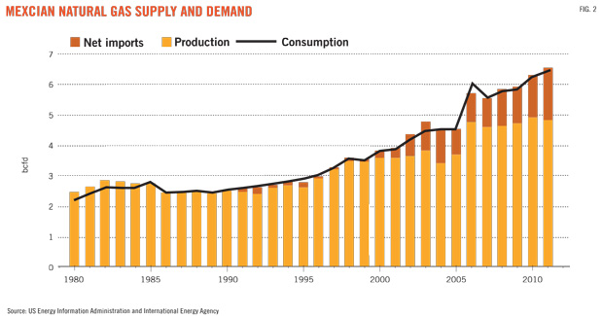

Torres-Barron told UOGR, "Pemex and the federal government realized they could not sustain current production levels to meet the country's demand."
Mexico has taken the first steps toward revolutionizing its oil and gas industry, but unlocking its vast resource potential is bound to take time and requires more legislative pieces to fall into place
Cohen said secondary laws need to be enacted in the first half of 2014, and an implementation process should occur throughout the second half of 2014 extending into 2015.
"The first contracts could materialize by then (2015), and the first flows of investment could be seen in 2016," Cohen said.

Q1: A similarity can be observed between signing NAFTA 20 years ago and a current historic energy reform. Mexico needs to revive its economy, boost the private sector with fresh capital and stabilize its currency. Do you think this move can help the ailing Mexican economy or are there other factors which need to be taken into consideration (drug war etc.)?

Q2: In your opinion, can the foreign investment in Pemex help to eradicate the deep-rooted corruption within its structures?

Q3: Secondary laws are still being negotiated in Mexico´s Congress. (Session ends April 30). Can you think of any hurdles which could prevent passing secondary laws through Congress? Who opposes these reforms?
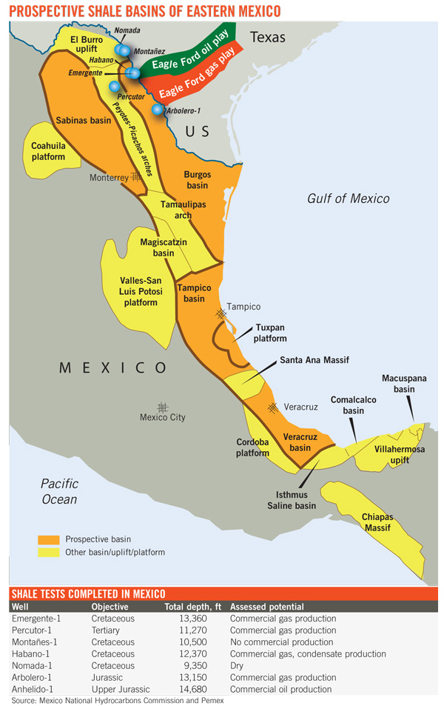

Mortgage Reform Is Worth the Small Extra Cost to Borrowers
By PHILLIP SWAGEL

APRIL 18, 2014, 7:00 AM

http://economix.blogs.nytimes.com/2014/04/18/mortgage-reform-is-worth-the-small-extra-cost-to-borrowers/?module=BlogPost-ReadMore&version=Blog%20Main&action=Click&contentCollection=Business%20Day&pgtype=Blogs&region=Body#more-173656

Phillip Swagel is a professor at the School of Public Policy at the University of Maryland and was assistant secretary for economic policy at the Treasury Department from 2006 to 2009.
In the current housing financing system, shareholders and management of Fannie Mae and Freddie Mac got the considerable profits in good times, and when the housing market collapsed, taxpayers were stuck with the bill — a $190 billion tab in the recent crisis.
A Senate proposal for a new system would have private investors rather than taxpayers take on most of the risks and returns involved with mortgage lending — if a misguided obsession with the small additional cost to borrowers doesn’t sink the reforms.
The proposal put forward recently by Senators Tim Johnson, Democrat from South Dakota, and Michael Crapo, Republican from Idaho, who lead the Senate banking committee, would bring about a housing finance system driven first and foremost by market incentives rather than by government dictates. There are many pieces to the proposal, including support for affordable housing and an innovative approach by which to reward financial firms that serve a broad range of customers and penalize those that do not.
But reducing the government involvement in housing finance and bringing back private capital is at the heart of the bill, which would end the anomalous situation in which the housing finance giants Fannie Mae and Freddie Mac are private companies that earn enormous profits but remain under the control of a government regulator.
Building on an earlier effort by Senators Bob Corker, Republican from Tennessee, and Mark R. Warner, Democrat from Virginia, the Crapo-Johnson legislation reduces taxpayer exposure to housing risk by requiring private investors to risk their own capital in an amount equal to 10 percent of the value of the mortgages receiving a government guarantee. The government would then sell secondary insurance on mortgage-backed securities composed of qualifying home loans (with underwriting protections written into the legislation). As mortgages go bad (which they do even in good times), the private capital would take the first losses and provide a buffer against the need for the government to put out cash on its guarantee.
The 10 percent capital requirement is large enough to protect taxpayers. Fannie Mae and Freddie Mac together in the crisis suffered losses of about 4 percent of the value of their assets, meaning it would take an economic upheaval considerably worse than that of the last seven years to burn through the private capital protecting taxpayers. In exchange for the increased role of the private sector, the existence of the secondary government backstop would ensure that mortgages remained available to Americans across financial market ups and downs.
Adding this protection for taxpayers has a cost, since private investors require compensation to take on housing risk. This translates into higher mortgage interest rates for borrowers.
Before the financial crisis, advocates for reforms were sometimes attacked as “antihousing,” on the grounds that the higher interest rates from reduced government support would make it more difficult for Americans to become homeowners. This complaint is misguided, since the impact on interest rates from the Crapo-Johnson is the consequence of fixing the flaw in the old system that left taxpayers at risk: the higher cost for borrowers corresponds to the protection for taxpayers that was missing.
Moreover, Senators Crapo and Johnson address concerns over the impact of higher interest rates on low- and moderate-income families by including billions of dollars to subsidize affordable housing, both rental and owner-occupied.
Mortgage bankers argue alongside housing advocates for a private capital requirement of only 5 percent rather than 10. There is an irony in the apparent alliance, since groups that support affordable housing subsidies typically look skeptically at the role of large banks in the economy. Many left-leaning groups supported a past legislative proposal to impose a 15 percent capital requirement on megabanks, with the aim of protecting taxpayers against bailing out institutions that are too big to fail. Presumably their view is that the higher capital requirement would have only a modest negative impact on bank lending — the opposite of the argument that 10 percent capital would have a large impact on housing-related activity.
It would be hard to know the overall result for home buyers until the new system was in place, but the incremental impact on interest rates of having 10 percent private capital to protect taxpayers rather than 5 percent is likely to be modest. The first 5 percent of private capital slated to take losses would be costly, because investors know their money is on the line in the event of another housing debacle. But this 5 percent private capital would be present under all legislative proposals.
The cost of the next 5 percent of private capital to take losses ahead of taxpayers is at issue. It takes only a moment’s reflection to recognize that the cost is likely to be modest once a new system with more capital is put into place over time. The reasoning is that the sixth to tenth percentage points of private capital would be at risk only after the first 5 percent was wiped out. Or as I put it in testimony in October before the Senate Banking Committee, if 5 percent private capital is enough to protect taxpayers, then the next 5 percent private capital is safe and cannot be expensive. If the additional private capital is expensive, then it must be that 5 percent is not enough to protect taxpayers — it cannot be both ways.
The best estimates to date suggest that mortgage interest rates under the Crapo-Johnson proposal would rise less than half a percentage point compared to the current system. By way of comparison, interest rates are likely to increase by multiple percentage points in the next two or three years as the Federal Reserve moves away from the zero interest rates in place since late 2008. Just as Janet L. Yellen, the Fed chief, will be doing her job to return interest rates back to normal, so, too, will Congress by protecting taxpayers against another housing bailout.
One reasonable hesitation for undertaking any housing finance reform is that it would rearrange a sector of the economy central to the economic and social aspirations of American families. We have all seen the confusion created by the Affordable Care Act in forcing too many people to endure undesired changes in their insurance policies and choice of physicians, and setting the stage for galloping insurance premium increases in the future.
But the Crapo-Johnson bill is the opposite of Obamacare. It brings the private sector back into a housing finance system now dominated by the government. Market incentives rather than government officials would determine the availability of mortgage financing, allowing private investors to extend mortgage loans to potential home buyers who today are prevented from buying a home by the pendulum swing to overly strict post-crisis lending standards. Indeed, bringing in considerable private capital will not just protect taxpayers, but also provide an incentive for prudence in lending on the part of investors whose money is at risk.
Without housing finance reform, the government will continue to dominate mortgage markets. The alternative to the Crapo-Johnson bill is not a fully private system but instead setting in concrete the current situation and thus effectively nationalizing the housing finance system. A fully private mortgage market might seem attractive on paper, but it ignores the political and financial reality that any future Congress and President will act to stabilize mortgage markets if Americans cannot obtain home loans.

The government guarantee in housing is thus latent, even in a system that is ostensibly private. Pretending otherwise would inadvertently recreate a salient defect of the past: the implicit backstop under which shareholders and the management of Fannie and Freddie kept the upside in good times and taxpayers were stuck with the bill when the housing market collapsed — a $190 billion tab in the recent crisis. Rather than creating a system that is private only until th Reform of housing finance remains among the chief unaddressed legacies of the financial crisis. The Crapo-Johnson bill is truly a bipartisan compromise, satisfying neither side in whole but constituting a vast improvement over the current housing finance system in which taxpayers are at risk even while too many families cannot obtain mortgages.e inevitable next crisis, it is thus preferable to make clear the government’s limited role and to ensure that an immense amount of private capital takes losses before another taxpayer bailout. Formalizing a taxpayer backstop on housing is anathema on the right, but it is the first and necessary step to shrinking the government’s role.
Democrats might hesitate at reducing the government role but applaud the innovative approach in the legislation under which mortgage companies have a financial incentive to serve all borrowers capable of sustaining a mortgage (and not just high-income families). This would be in addition to money for affordable housing activities through mechanisms created in the Housing and Economic Recovery Act of 2008 but that did not receive funds as a result of the financial difficulties at Fannie and Freddie.
A sticking point from the left is that many housing advocates expect Melvin L. Watt, the director of the Federal Housing Finance Agency, to put the money into affordable housing activities out of the now-considerable profits of Fannie and Freddie. Mr. Watt has the legal authority to do this now — some would say that the 2008 law requires him to do so. If the money for affordable housing flows ahead of broader reform, however, an important incentive for left-leaning stakeholders to support Crapo-Johnson would be removed. It is ironic that action by Mr. Watt could actually undermine a measure supported by President Obama.

The American Middle Class Is No Longer the World’s Richest
By David Leonhardt andKevin Quealy
APRIL 22, 2014
http://www.nytimes.com/2014/04/23/upshot/the-american-middle-class-is-no-longer-the-worlds-richest.html?_r=0
The American middle class, long the most affluent in the world, has lost that distinction.
While the wealthiest Americans are outpacing many of their global peers, a New York Times analysis shows that across the lower- and middle-income tiers, citizens of other advanced countries have received considerably larger raises over the last three decades.
After-tax middle-class incomes in Canada — substantially behind in 2000 — now appear to be higher than in the United States. The poor in much of Europe earn more than poor Americans.
The numbers, based on surveys conducted over the past 35 years, offer some of the most detailed publicly available comparisons for different income groups in different countries over time. They suggest that most American families are paying a steep price for high and rising income inequality.
Although economic growth in the United States continues to be as strong as in many other countries, or stronger, a small percentage of American households is fully benefiting from it. Median income in Canada pulled into a tie with median United States income in 2010 and has most likely surpassed it since then. Median incomes in Western European countries still trail those in the United States, but the gap in several — including Britain, the Netherlands and Sweden — is much smaller than it was a decade ago.
In European countries hit hardest by recent financial crises, such as Greece and Portugal, incomes have of course fallen sharply in recent years.
The income data were compiled by LIS, a group that maintains the Luxembourg Income Study Database. The numbers were analyzed by researchers at LIS and by The Upshot, a New York Times website covering policy and politics, and reviewed by outside academic economists.
The struggles of the poor in the United States are even starker than those of the middle class. A family at the 20th percentile of the income distribution in this country makes significantly less money than a similar family in Canada, Sweden, Norway, Finland or the Netherlands. Thirty-five years ago, the reverse was true.
LIS counts after-tax cash income from salaries, interest and stock dividends, among other sources, as well as direct government benefits such as tax credits.
The findings are striking because the most commonly cited economic statistics — such as per capita gross domestic product — continue to show that the United States has maintained its lead as the world’s richest large country. But those numbers are averages, which do not capture the distribution of income. With a big share of recent income gains in this country flowing to a relatively small slice of high-earning households, most Americans are not keeping pace with their counterparts around the world.
“The idea that the median American has so much more income than the middle class in all other parts of the world is not true these days,” saidLawrence Katz, a Harvard economist who is not associated with LIS. “In 1960, we were massively richer than anyone else. In 1980, we were richer. In the 1990s, we were still richer.”
That is no longer the case, Professor Katz added.
Median per capita income was $18,700 in the United States in 2010 (which translates to about $75,000 for a family of four after taxes), up 20 percent since 1980 but virtually unchanged since 2000, after adjusting for inflation. The same measure, by comparison, rose about 20 percent in Britain between 2000 and 2010 and 14 percent in the Netherlands. Median income also rose 20 percent in Canada between 2000 and 2010, to the equivalent of $18,700.
The most recent year in the LIS analysis is 2010. But other income surveys, conducted by government agencies, suggest that since 2010 pay in Canada has risen faster than pay in the United States and is now most likely higher. Pay in several European countries has also risen faster since 2010 than it has in the United States.
Three broad factors appear to be driving much of the weak income performance in the United States. First, educational attainment in the United States has risen far more slowly than in much of the industrialized world over the last three decades, making it harder for the American economy to maintain its share of highly skilled, well-paying jobs.
Americans between the ages of 55 and 65 have literacy, numeracy and technology skills that are above average relative to 55- to 65-year-olds in rest of the industrialized world, according to a recent study by the Organization for Economic Cooperation and Development, an international group. Younger Americans, though, are not keeping pace: Those between 16 and 24 rank near the bottom among rich countries, well behind their counterparts in Canada, Australia, Japan and Scandinavia and close to those in Italy and Spain.
A second factor is that companies in the United States economy distribute a smaller share of their bounty to the middle class and poor than similar companies elsewhere. Top executives make substantially more money in the United States than in other wealthy countries. The minimum wage is lower. Labor unions are weaker.
And because the total bounty produced by the American economy has not been growing substantially faster here in recent decades than in Canada or Western Europe, most American workers are left receiving meager raises.
Finally, governments in Canada and Western Europe take more aggressive steps to raise the take-home pay of low- and middle-income households by redistributing income.
Janet Gornick, the director of LIS, noted that inequality in so-called market incomes — which does not count taxes or government benefits — “is high but not off the charts in the United States.” Yet the American rich pay lower taxes than the rich in many other places, and the United States does not redistribute as much income to the poor as other countries do. As a result, inequality in disposable income is sharply higher in the United States than elsewhere.
Whatever the causes, the stagnation of income has left many Americans dissatisfied with the state of the country. Only about 30 percent of people believe the country is headed in the right direction, polls show.
“Things are pretty flat,” said Kathy Washburn, 59, of Mount Vernon, Iowa, who earns $33,000 at an Ace Hardware store, where she has worked for 23 years. “You have mostly lower level and high and not a lot in between. People need to start in between to work their way up.”
Middle-class families in other countries are obviously not without worries — some common around the world and some specific to their countries. In many parts of Europe, as in the United States, parents of young children wonder how they will pay for college, and many believe their parents enjoyed more rapidly rising living standards than they do. In Canada, people complain about the costs of modern life, from college to monthly phone and Internet bills. Unemployment is a concern almost everywhere.

But both opinion surveys and interviews suggest that the public mood in Canada and Northern Europe is less sour than in the United States today.
“The crisis had no effect on our lives,” Jonas Frojelin, 37, a Swedish firefighter, said, referring to the global financial crisis that began in 2007. He lives with his wife, Malin, a nurse, in a seaside town a half-hour drive from Gothenburg, Sweden’s second-largest city.
They each have five weeks of vacation and comprehensive health benefits. They benefited from almost three years of paid leave, between them, after their children, now 3 and 6 years old, were born. Today, the children attend a subsidized child-care center that costs about 3 percent of the Frojelins’ income.
Even with a large welfare state in Sweden, per capita G.D.P. there has grown more quickly than in the United States over almost any extended recent period — a decade, 20 years, 30 years. Sharp increases in the number of college graduates in Sweden, allowing for the growth of high-skill jobs, has played an important role.

Elsewhere in Europe, economic growth has been slower in the last few years than in the United States, as the Continent has struggled to escape the financial crisis. But incomes for most families in Sweden and several other Northern European countries have still outpaced those in the United States, where much of the fruits of recent economic growth have flowed into corporate profits or top incomes.
This pattern suggests that future data gathered by LIS are likely to show similar trends to those through 2010.
There does not appear to be any other publicly available data that allows for the comparisons that the LIS data makes possible. But two other sources lead to broadly similar conclusions.
A Gallup survey conducted between 2006 and 2012 showed the United States and Canada with nearly identical per capita median income (and Scandinavia with higher income). And tax records collected by Thomas Piketty and other economists suggest that the United States no longer has the highest average income among the bottom 90 percent of earners.
One large European country where income has stagnated over the past 15 years is Germany, according to the LIS data. Policy makers in Germany have taken a series of steps to hold down the cost of exports, including restraining wage growth.
Even in Germany, though, the poor have fared better than in the United States, where per capita income has declined between 2000 and 2010 at the 40th percentile, as well as at the 30th, 20th, 10th and 5th.
More broadly, the poor in the United States have trailed their counterparts in at least a few other countries since the early 1980s. With slow income growth since then, the American poor now clearly trail the poor in several other rich countries. At the 20th percentile — where someone is making less than four-fifths of the population — income in both the Netherlands and Canada was 15 percent higher than income in the United States in 2010.
By contrast, Americans at the 95th percentile of the distribution — with $58,600 in after-tax per capita income, not including capital gains — still make 20 percent more than their counterparts in Canada, 26 percent more than those in Britain and 50 percent more than those in the Netherlands. For these well-off families, the United States still has easily the world’s most prosperous major economy.

