Version 07/04/2022
- Work with the following sequence:
MNWELLLWLLVLCALLLLLVQLLRFLRADGDLTLLWAEWQGRRPEWELTDMVVWVTGASS
GIGEELAYQLSKLGVSLVLSARRVHELERVKRRCLENGNLKEKDILVLPLDLTDTGSHEA
ATKAVLQEFGRIDILVNNGGMSQRSLCMDTSLDVYRKLIELNYLGTVSLTKCVLPHMIER
KQGKIVTVNSILGIISVPLSIGYCASKHALRGFFNGLRTELATYPGIIVSNICPGPVQSN
IVENSLAGEVTKTIGNNGDQSHKMTTSRCVRLMLISMANDLKEVWISEQPFLLVTYLWQY
MPTWAWWITNKMGKKRIENFKSGVDADSSYFKIFKTKHD

- Identify the sequence.
Human DHRS7
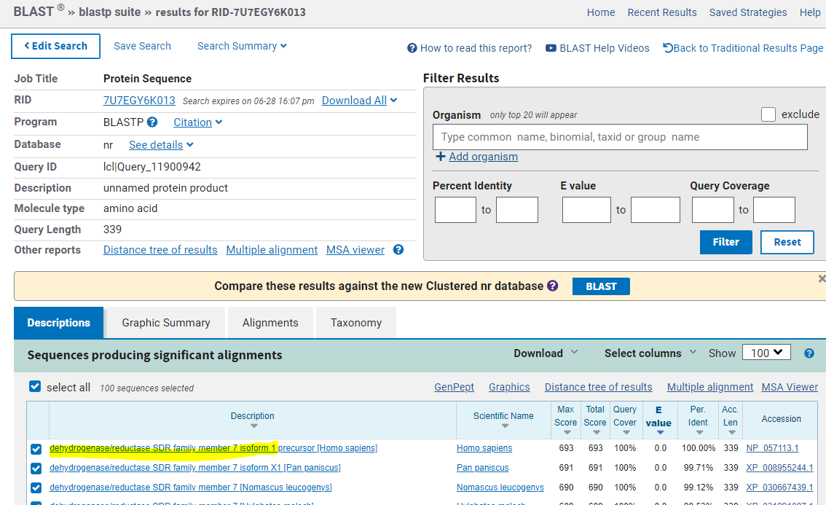

- Does this protein have any transmembrane regions?
Yes, one
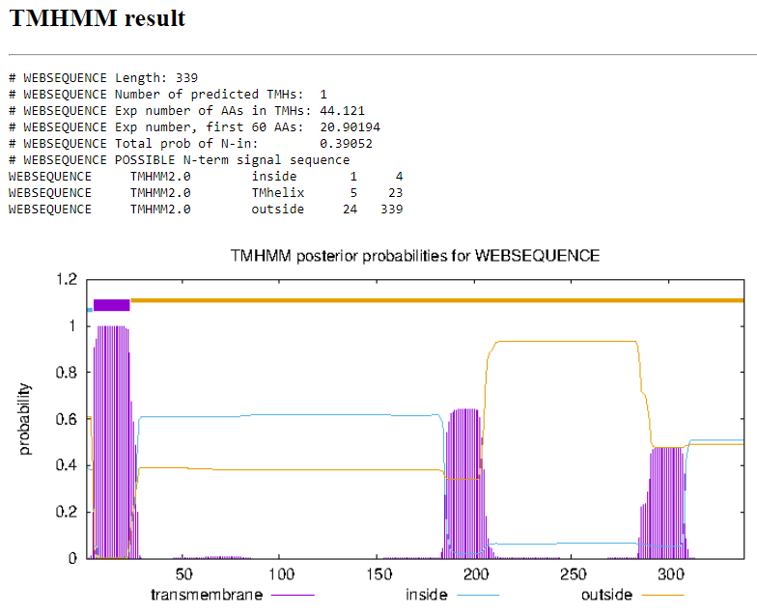
- How many isoforms this protein has? Align them.
In NCBI Four
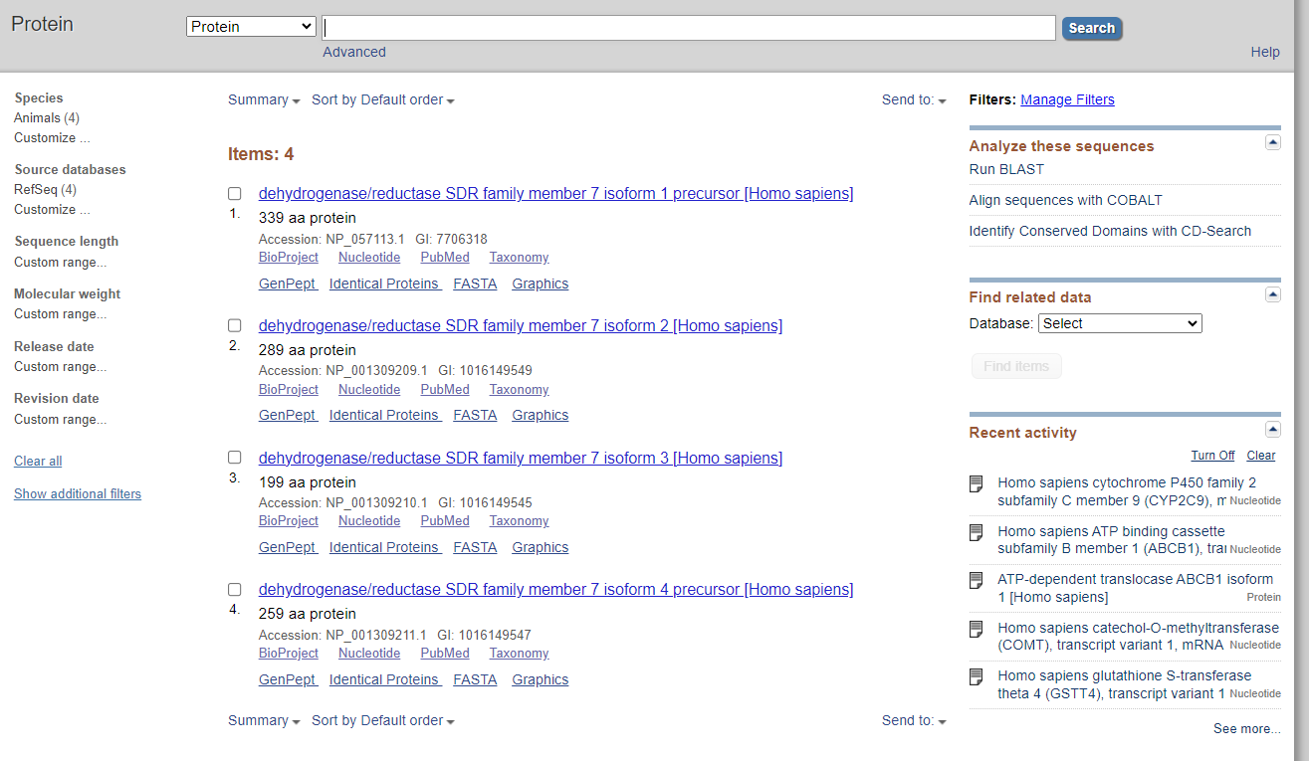
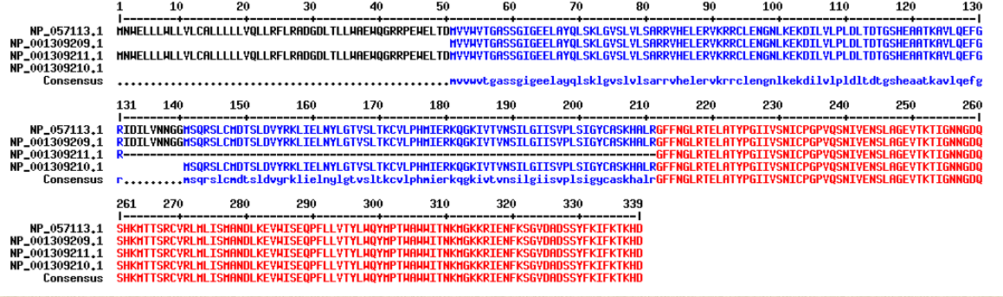
Two in Uniprot
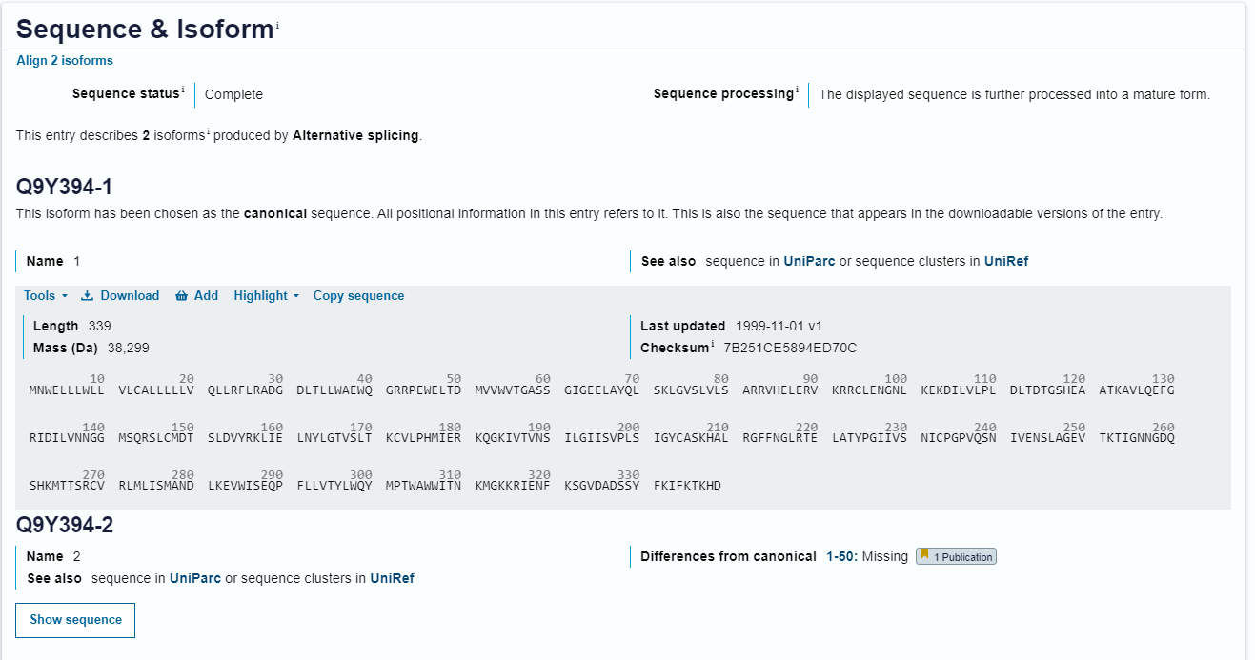
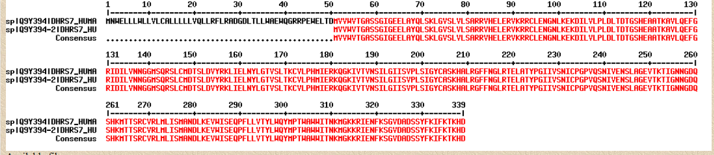
- How many cysteines does the sequence have?
Seven
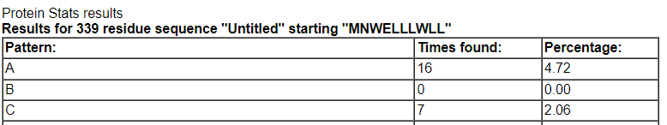
- Design primers to amplify the CDS of the respective gene.
CDS:
>NM_016029.4:90-1109 Homo sapiens dehydrogenase/reductase 7 (DHRS7), transcript variant 1, mRNA
ATGAACTGGGAGCTGCTGCTGTGGCTGCTGGTGCTGTGCGCGCTGCTCCTGCTCTTGGTGCAGCTGCTGC
GCTTCCTGAGGGCTGACGGCGACCTGACGCTACTATGGGCCGAGTGGCAGGGACGACGCCCAGAATGGGA
GCTGACTGATATGGTGGTGTGGGTGACTGGAGCCTCGAGTGGAATTGGTGAGGAGCTGGCTTACCAGTTG
TCTAAACTAGGAGTTTCTCTTGTGCTGTCAGCCAGAAGAGTGCATGAGCTGGAAAGGGTGAAAAGAAGAT
GCCTAGAGAATGGCAATTTAAAAGAAAAAGATATACTTGTTTTGCCCCTTGACCTGACCGACACTGGTTC
CCATGAAGCGGCTACCAAAGCTGTTCTCCAGGAGTTTGGTAGAATCGACATTCTGGTCAACAATGGTGGA
ATGTCCCAGCGTTCTCTGTGCATGGATACCAGCTTGGATGTCTACAGAAAGCTAATAGAGCTTAACTACT
TAGGGACGGTGTCCTTGACAAAATGTGTTCTGCCTCACATGATCGAGAGGAAGCAAGGAAAGATTGTTAC
TGTGAATAGCATCCTGGGTATCATATCTGTACCTCTTTCCATTGGATACTGTGCTAGCAAGCATGCTCTC
CGGGGTTTTTTTAATGGCCTTCGAACAGAACTTGCCACATACCCAGGTATAATAGTTTCTAACATTTGCC
CAGGACCTGTGCAATCAAATATTGTGGAGAATTCCCTAGCTGGAGAAGTCACAAAGACTATAGGCAATAA
TGGAGACCAGTCCCACAAGATGACAACCAGTCGTTGTGTGCGGCTGATGTTAATCAGCATGGCCAATGAT
TTGAAAGAAGTTTGGATCTCAGAACAACCTTTCTTGTTAGTAACATATTTGTGGCAATACATGCCAACCT
GGGCCTGGTGGATAACCAACAAGATGGGGAAGAAAAGGATTGAGAACTTTAAGAGTGGTGTGGATGCAGA
CTCTTCTTATTTTAAAATCTTTAAGACAAAACATGACTGA

F: ATG AAC TGG GAG CTG CTG CT
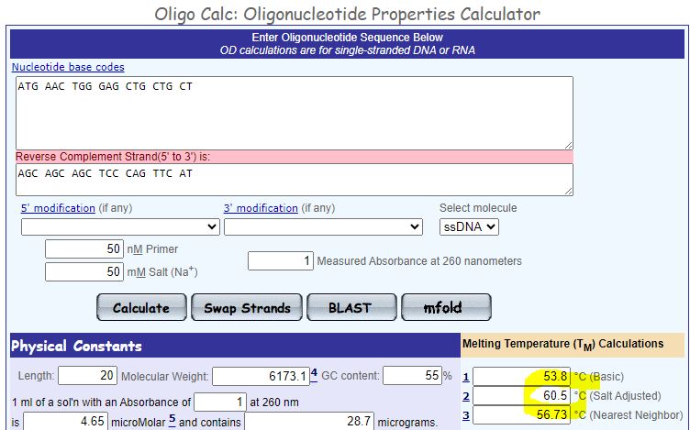

R: TCA GTC ATG TTT TGT CTT AAA GAT TTT A
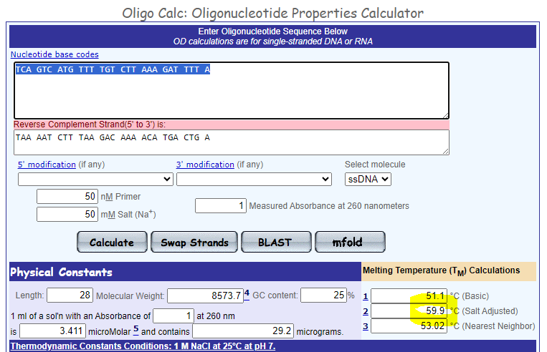
- Download from database the sequence NM_001282692.1
- What does this mRNA encode?
Homo sapiens flavin containing dimethylaniline monoxygenase 1 (FMO1)
- How long is the second exon?
189nt
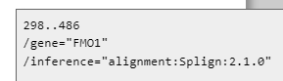
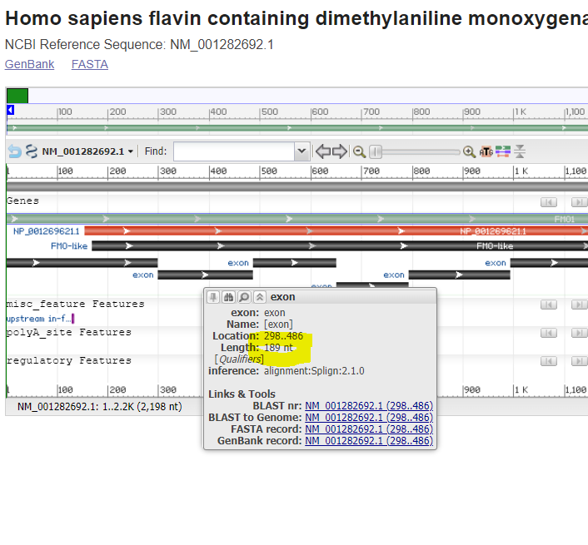
- Will the CDS of this sequence be cleaved by the following enzymes: BamHI, EcoRI or ScaI?
Yes,no,yes

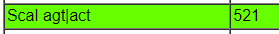

- What fragments are formed after cleavage by all these enzymes at once?
Three fragments: 857+520+234bp
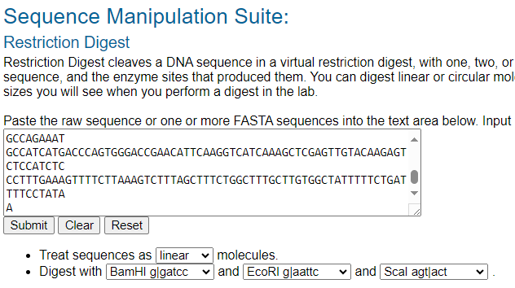
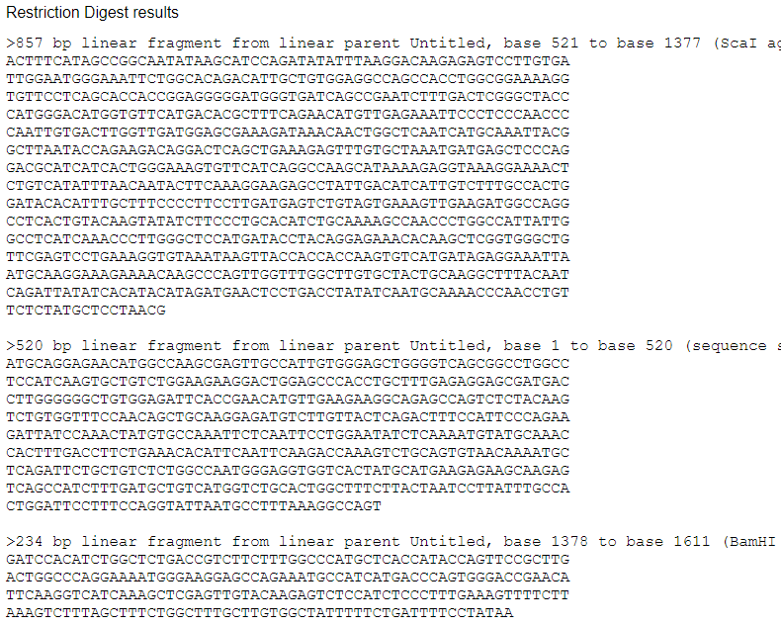
- Compare how similar is the corresponding protein to the respective mouse homologue?
91.2% similarity
