Version A1
- Work with following sequence:
GCCTTCATCGAGTTTAAGAATTTCAAAAAGGAAAAGGAAACCCCCTTTAACCAAGTCCCC
ATACTCGAAATGGACAACATCATATTTGCCCAAAGTCAAGCCATAGTAAGGTACCTCTCC
AAGAAATACAAAATAAGTGGGAACAGCGAGCTGAACGAATTTTACGCCGACATGATTTTT
TGTGGAGTACAAGACATACATTATAAATTTAACAATACAAATTTATTTAAGCAGAATGAG
ACCACCTTTCTTAATGAGGAGTTGCCGAAGTGGTCAGGTTACTTTGAGAATATTTTGAAA
CCCGACTGGAAAGCGGGCAGTGAGCGCAACGCAATTAATGTGAGTTAGCTCACTCATTAG
GCACCCCAGGCTTTACACTTTATGCTTCCGGCTCGTATGTTGTGTGGAATTGTGAGCGGA
TAACAATTTCACACAGGAAA

- Find out if there is any vector contamination.
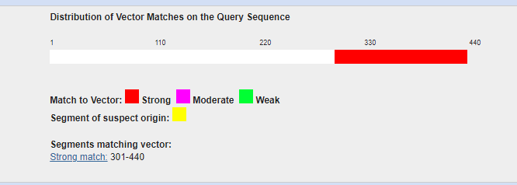
- If yes, get the “purified” sequence and write it down in FASTA format
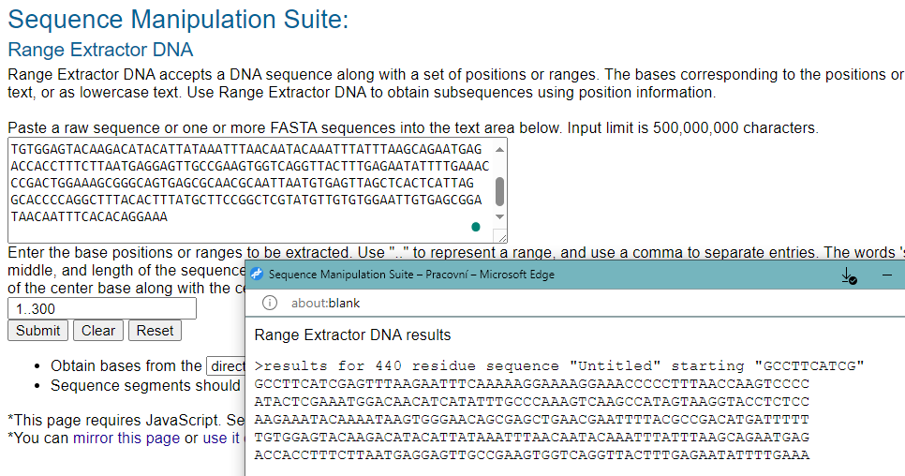
>purified sequence
GCCTTCATCGAGTTTAAGAATTTCAAAAAGGAAAAGGAAACCCCCTTTAACCAAGTCCCC
ATACTCGAAATGGACAACATCATATTTGCCCAAAGTCAAGCCATAGTAAGGTACCTCTCC
AAGAAATACAAAATAAGTGGGAACAGCGAGCTGAACGAATTTTACGCCGACATGATTTTT
TGTGGAGTACAAGACATACATTATAAATTTAACAATACAAATTTATTTAAGCAGAATGAG
ACCACCTTTCTTAATGAGGAGTTGCCGAAGTGGTCAGGTTACTTTGAGAATATTTTGAAA
- Would be the purified sequence cut by restriction endonucleases KpnI, HpaII or RsaI?
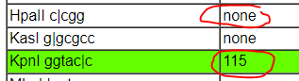
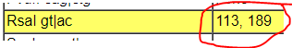
- How long is the longest peptide after translation? In which open reading frame (ORF) is it encoded?
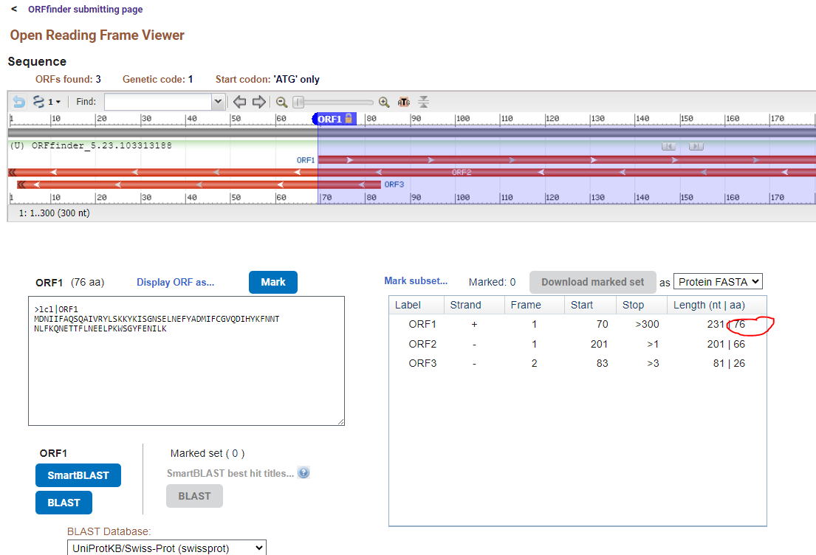
Or if you select “any sense codon” (which is better if we don´t know if the sequence is full length.
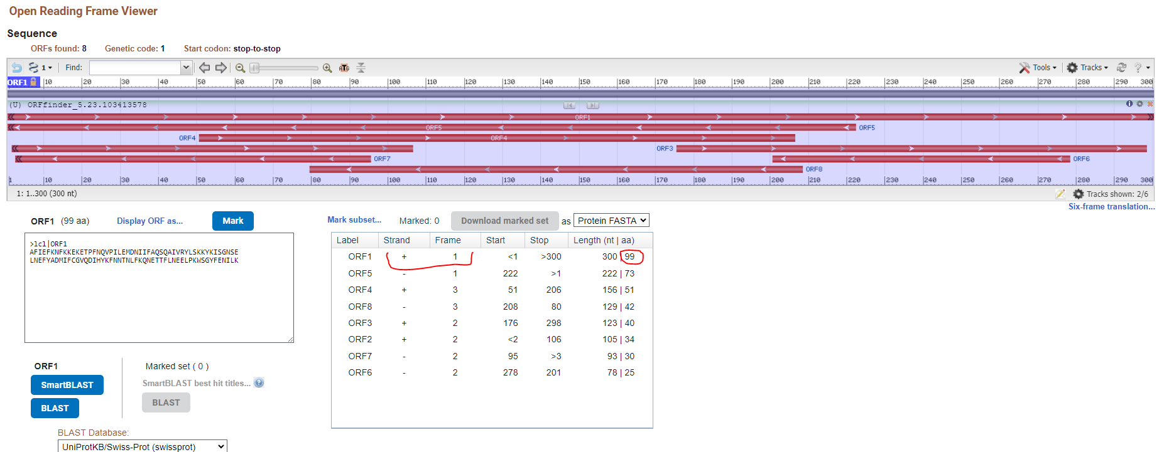

- From which organism does this sequence likely come from?
=identification of unknown sequence-BLASTn
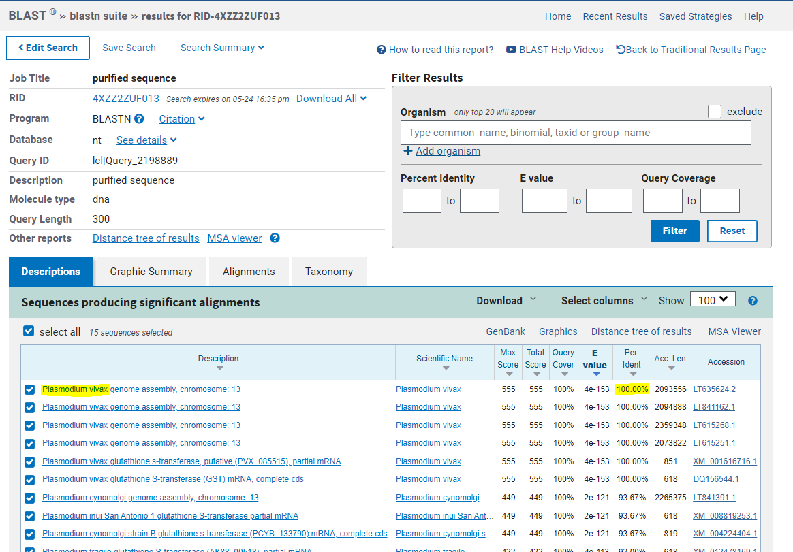

- Download the sequence of the accession number: NM_000771.4

- How long is the coding sequence and how long will the translated protein be?
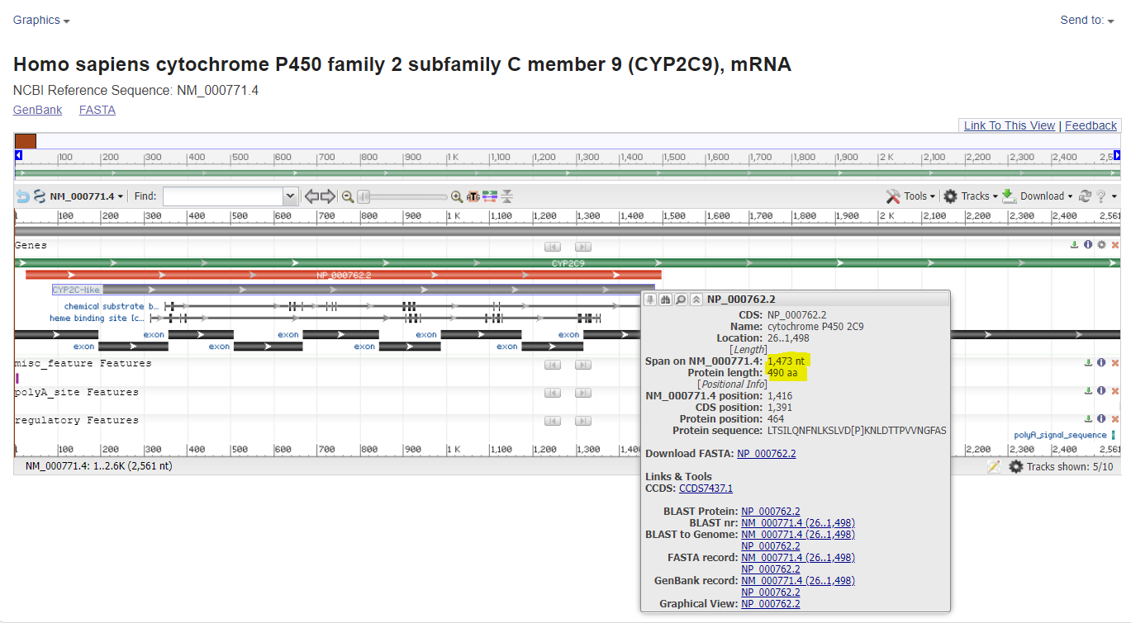
- Design primers for the detection of this gene for amplification of the product no longer than 500nt.
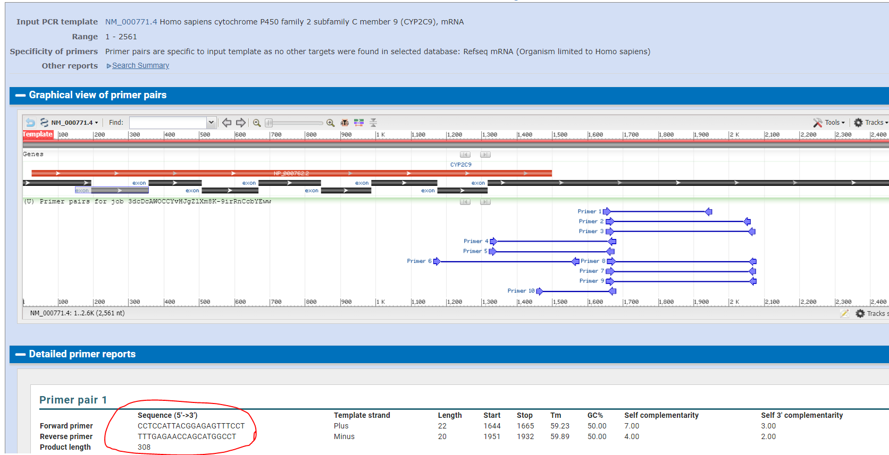
- How many prolines does corresponding protein have?
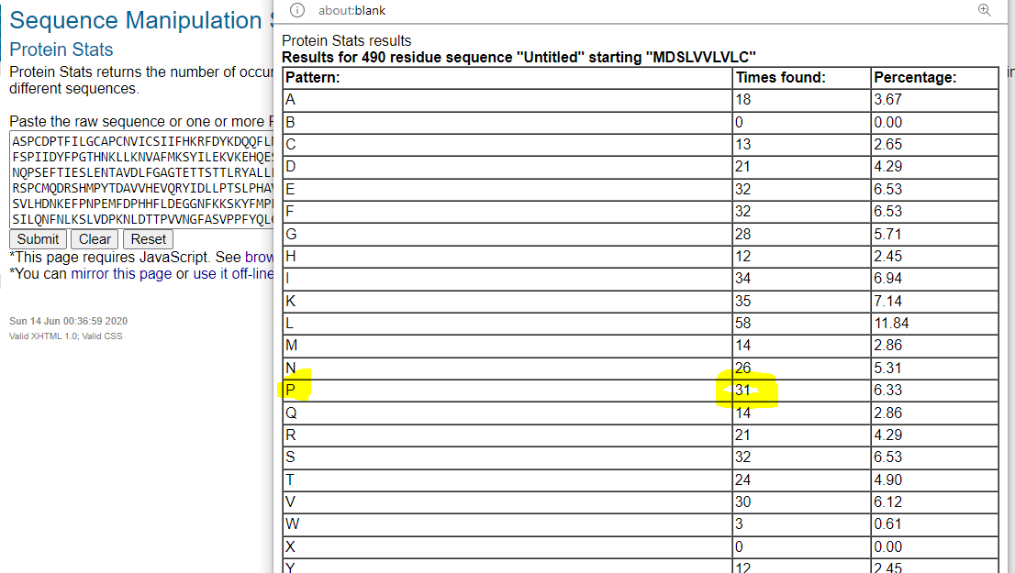
- How many times would be the sequence cut by pepsin (pH1.3)?
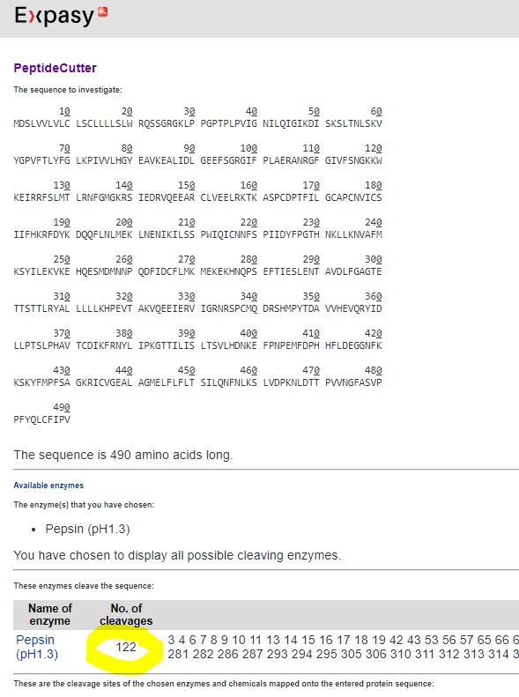
- Compare the corresponding protein with protein with accession number: P10632. What is the level of identity?
