VMFT- DSC 13/03/2026

Students: arian
Instrument: Maia DSC 200 F3

Sample: Resomer RG

Crucible + sample mass: ??? mg
Crucible mass: ??? mg
Sample mass: ??? mg

Temperature protocol:
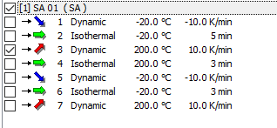

DSC scan:
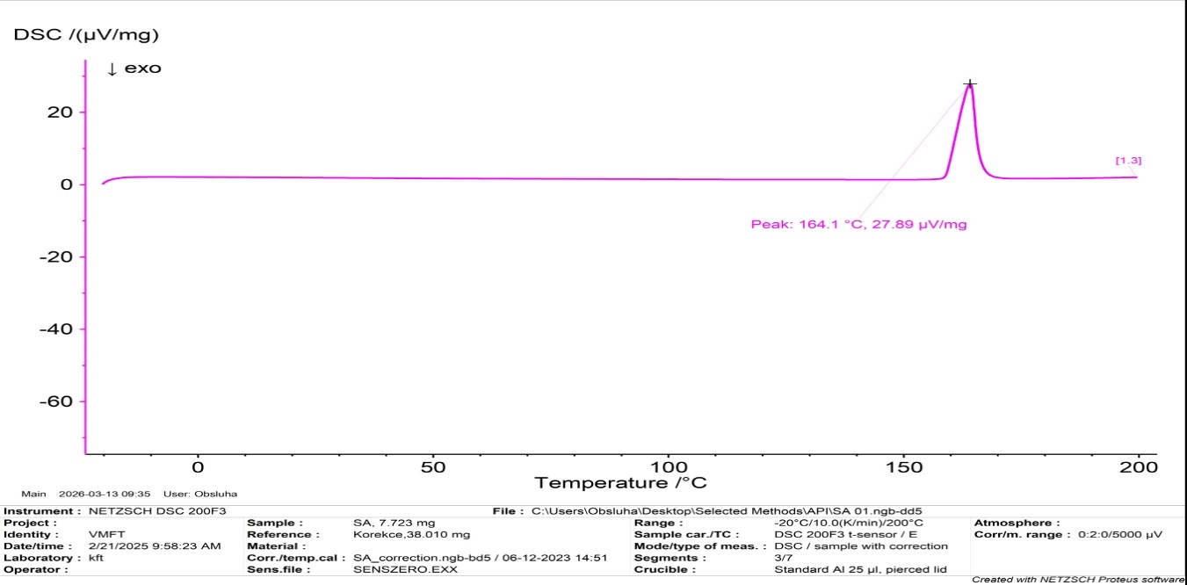
Procedure of measurement and evaluation:

Firstly we measure the sample mass then we insert it to the DSC and we measure the melting point T_{m} based on first heating peak point.

Conclusion: The melting point is 164.1°C.

