Handout 5 Torts

Introduction to Torts
In the realm of civil law, torts form a crucial area concerned with remedies for wrongful acts that cause injury, harm, or damage to individuals or their property. Derived from the Latin term “tortum”, meaning wrong, tort law encompasses a wide array of wrongful conduct and provides a framework for holding wrongdoers accountable for their actions.
Torts are broadly categorized into three main types: intentional torts, negligent torts, and strict liability torts. Intentional torts occur when a person intentionally commits an act that results in harm or injury to another individual or their property. Examples include assault, battery, false imprisonment, trespass to land, trespass to goods, and defamation (which encompasses both libel and slander). Negligent torts arise from the failure of a person to exercise reasonable care, resulting in harm to another party. Negligence requires the establishment of duty, breach of duty, causation, and damage. Examples include car accidents caused by careless driving, medical malpractice, and slip-and-fall cases. Unlike intentional and negligent torts, strict liability torts do not require proof of fault or intent. Liability is imposed regardless of the defendant's conduct, based solely on the fact that certain activities are inherently dangerous or involve a substantial risk of harm. Common examples include liability for defective products and certain hazardous activities.
In tort law, liability refers to the legal responsibility of a tortfeasor, or wrongdoer, for the harm or injury caused to the aggrieved party. Liability may be established based on fault, strict liability, or vicarious liability. Under fault-based liability, the plaintiff must demonstrate that the defendant's negligent conduct directly caused the harm or injury suffered. The court may award damages to compensate the injured party for their losses, including both compensatory and, in some cases, punitive damages (punitive damages, i.e. exemplary damages, are monetary awards in civil lawsuits meant to punish defendants for severe misconduct and deter future wrongdoing. They are distinct from compensatory damages, aiming to punish intentional or reckless behaviour rather than compensate for losses). Strict liability imposes legal responsibility on defendants without the need to prove fault or negligence. Vicarious liability holds one party accountable for the tortious acts of another, typically based on a special relationship between the parties. Employers, for example, may be held vicariously liable for the actions of their employees committed within the scope of their employment.
Defendants in tort cases may assert various defences to mitigate or negate their liability, including voluntary assumption of risk, where plaintiffs knowingly expose themselves to danger, potentially forfeiting their right to damages; necessity, which justifies a defendant's actions in preventing greater harm; contributory negligence, asserting the plaintiff's own fault in causing their injury, possibly reducing or eliminating the defendant's liability; and comparative negligence, where damages may be allocated based on each party's level of fault, in jurisdictions that recognize this principle.
Tort law plays a critical role in providing remedies for individuals who suffer harm or injury due to the wrongful conduct of others. By establishing principles of liability, causation, and damages, tort law seeks to compensate aggrieved parties and deter future wrongdoing.

Team work: what was the case about?
Try to think about a possible tort case related to the image.
Team 1 | 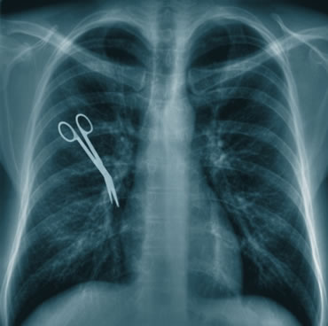 | - Who were the plaintiff and defendant?  - What damage was inflicted on the aggrieved party?  - What type of tort was committed?  - Was there any negligent conduct?  - What was the defendant’s defence?  - How did the court decide? Or was there any out-of-court settlement?  - What was the amount of damages (if any)?
Team 2 |  | - Who were the plaintiff and defendant?  - What damage was inflicted on the aggrieved party?  - What type of tort was committed?  - Was there any negligent conduct?  - What was the defendant’s defence?  - How did the court decide? Or was there any out-of-court settlement?  - What was the amount of damages (if any)?
Team 3 | 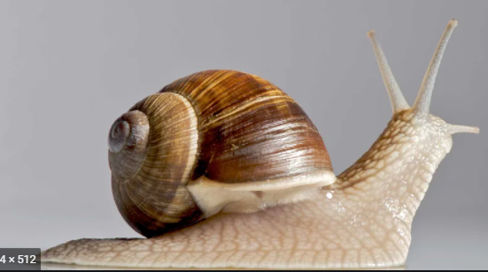 | - Who were the plaintiff and defendant?  - What damage was inflicted on the aggrieved party?  - What type of tort was committed?  - Was there any negligent conduct?  - What was the defendant’s defence?  - How did the court decide? Or was there any out-of-court settlement?  - What was the amount of damages (if any)?
Team 4 |  | - Who were the plaintiff and defendant?  - What damage was inflicted on the aggrieved party?  - What type of tort was committed?  - Was there any negligent conduct?  - What was the defendant’s defence?  - How did the court decide? Or was there any out-of-court settlement?  - What was the amount of damages (if any)?

A poem

We thought that we would never see
A suit to compensate a tree.
A suit whose claim in tort is prest
Upon a mangled tree's behest;
A tree whose battered trunk was prest
Against a Chevy's crumpled crest;
A tree that faces each new day
With bark and limb in disarray;
A tree that may forever bear
A lasting need for tender care.
Flora lovers though we three,
We must uphold the court's decree.

Video: Silk 3 – a summary
Identify factual mistakes in this summary:
Clive, the barrister, contacted Billy, the clerk, to relay the outcome of the drugs mule case. He informed Billy that his own client received a more lenient sentence compared to Martha's pregnant client. Clive also mentioned that he anticipated receiving a favorable reference from the judge for his silk application. Following the call, Billy discussed the prospects of women attaining the title of Queen's Counsel, expressing the opinion that at that time women had significantly better chances than men in this regard.
During the aggravated burglary trial, Martha's tardiness irked the judge. In response, Martha said that barristers were expected to deliver stellar performances, and their substantial earnings reflected their skill. The judge complimented Martha on her previous day's performance and granted her fifteen minutes to speak with Gary Rush, the defendant. In the interview, Martha inquired if Gary was in the room where the elderly man was beaten. Gary vehemently denied any presence, and his response appeared convincing. However, he expressed displeasure upon learning that Martha had insufficient time to prepare for the trial.
Subsequently, Mr. Dodds, the victim, provided testimony, detailing the assault and theft of valuables. It became evident from his account that Mr. Dodds suffered from memory loss, unable to recall crucial details about the crime or describe the intruder's appearance.
During a break, Nick, the pupil, noted that the defendant had an extensive criminal history. Martha acknowledged that repeat offenders were more likely to be convicted than those with clean records.
In the trial's second phase, Martha sought to establish that Mr. Dodds, due to his advanced age, was unfit to identify the perpetrator during the identification procedure. She argued that his failing eyesight and hearing compromised his reliability as a witness. Mr. Dodds omitted mentioning that the assailant had been humming while attacking him, which further undermined his credibility. It also emerged that Mr. Dodds opposed the perpetrator being placed in a mental institution, preferring a severe punishment without leniency. Martha's trial strategy effectively portrayed Mr. Dodds as a vengeful individual.
During the lunch break, Mercedes, the drugs mule, awaited Martha in vain. Martha, engrossed in trial preparations, declined Nick's attempt to engage in conversation, and she emphasised the importance of emotional detachment for barristers. Nick visited a nearby shop selling barrister wigs and gowns. After trying on a gown and wig, he learned that the wig cost £1,759, VAT included. Nick inquired about second-hand options, and the shopkeeper disappeared to fetch a cheaper wig. Nick ran out of the shop, and stole the gown and wig.

Revision of terminology
For each scenario, identify 1-2 key words.
- A chemical company stores hazardous waste, which leaks into a nearby river despite all precautions. The company is sued.
- A delivery driver working for a courier company causes an accident while making deliveries. Who should the aggrieved party sue?
- A man slips on an unmarked wet floor in a supermarket and falls. He suffers minor bruises but seems otherwise fine. Three days later, he has a severe back spasm and is diagnosed with a herniated disc. He sues the supermarket, claiming that the fall caused his injury.
- (a) In Maryland, if a pedestrian distracted by their phone is hit by a speeding car, their partial fault could prevent them from receiving any compensation. (b) In California, if the court finds that the pedestrian was 40% at fault for not paying attention and the speeding driver was 60% at fault, the pedestrian’s total compensation would be reduced by 40%.
- A doctor fails to diagnose an illness. In another case, a doctor operates while intoxicated and removes the wrong organ.
- A construction worker removes safety barriers from a dangerous site, knowing that someone might fall. A passerby falls and is injured. How is this different from negligence?
- A spectator at a baseball game gets hit by a ball and sues the team.
- During a storm, a hiker breaks into a cabin to take shelter. The owner sues for trespass.
- A driver is following all traffic rules when a tree suddenly falls onto the road, causing them to swerve and hit another car.
- (a) A journalist writes a false and damaging article about a local business, accusing it of fraud without any evidence. The newspaper editor approves and publishes the article without fact-checking. As a result, the business suffers financial losses and reputational harm. (b) A social media influencer falsely claims that a restaurant has a history of health violations, causing a drop in customers. On the same day, an online news website independently publishes an article, also falsely alleging that the restaurant was recently fined for food safety violations.
- In a civil case, who must prove their claim: the plaintiff or the defendant?
- A swimming pool owner does not put up a fence, despite a law requiring it. A child falls in and drowns.
- While walking past a café, Tom raises his fist and steps toward Lisa in a threatening manner. She freezes, fearing he is about to hit her.
- During an argument, Sarah slaps John across the face.
- A local newspaper falsely reports that Emma, a teacher, was caught stealing from the school, damaging her reputation among parents and colleagues.
- A shopkeeper locks a customer inside the store for suspicion of theft, even though the customer did nothing wrong.
- A driver runs a red light and hits another car, injuring the driver, because he failed to pay attention at the intersection.
- A homeowner plays extremely loud music late at night every day, making it impossible for the neighbour to sleep.
- A factory emits thick smoke into the town centre, making it difficult for residents and pedestrians to breathe or go about their day.
- At the gym, Julia tells several other members that her colleague lied on their resume to get promoted, even though it’s completely false.

