Selected Methods of Pharmaceutical Technology

Rheometry Protocol - Thixotropy test

Date: 14. 3. 2025

Students: Adam Jiráň, Natálie Kulíková, Hana Bayerová, Hana Koletnik, Seoyoon Choi

Samples: Terbinafin creme 10 mg/g, Lamisil cream as a standard

Device: Kinexus Pro+ Malvern Instruments

Geometry: PU 20

Test: Toolkit_V002 Three Step Shear Rate – Thixotropy test

Temperature: 25 °C

Shear rates: 0.01 – 100.0 – 0.01 s-1

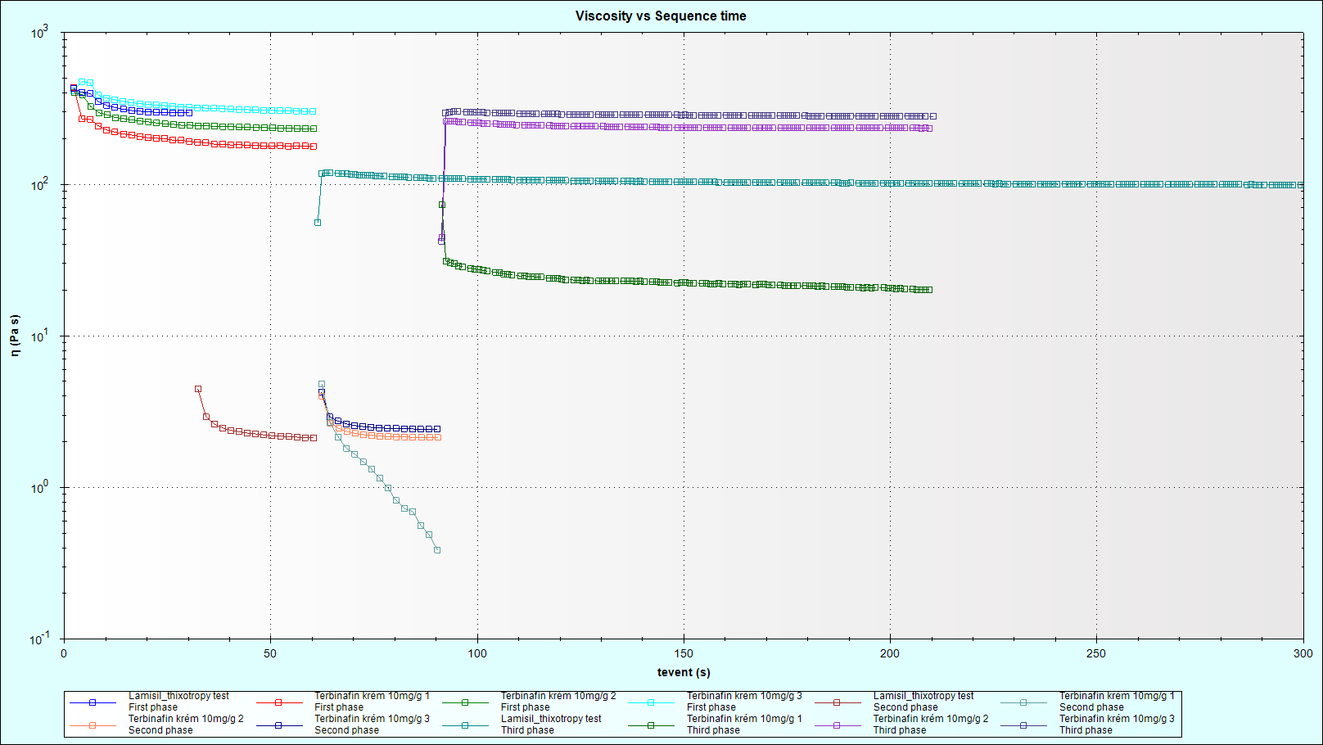

|  |  |  |  |  |  |  |  |  |  |  |  |  |  |  |  |  |  |  |  |  |  |  |  |  |  |  |  |  |  |  |  |  |  |  |
| --- | --- | --- | --- | --- | --- | --- | --- | --- | --- | --- | --- | --- | --- | --- | --- | --- | --- | --- | --- | --- | --- | --- | --- | --- | --- | --- | --- | --- | --- | --- | --- | --- | --- | --- |
|  |  |  | |  |  |  |  | | --- | --- | --- | --- | |  | 1. step [Pa . s] | 2. step [Pa . s] | rebuilt [%] | | standard | 296.8 | 98.33 | 33.13 | | sample 1 | 179 | 20.24 | 11.31 | | sample 2 | 261 | 234.59 | 89.89 | | sample 3 | 337.5 | 281.47 | 83.4 | |  |  |  |  |  |  |  |  |  |  |  |
|  |  |  |  |  |  |  |  |  |  |  |  |  |  |  |

**Conclusion:**

The rebuilt of the generic preparation is 61.53 ± 43.62 %. The variability of three measurements of a newly loaded sample is high.

The thixotropic properties of the generic product do not meet the properties of the standard.