Selected Methods of Pharmaceutical Technology

Rheometry Protocol – Spreadability of the creams

Date: 14. 3. 2025

Names of students: Choi Seoyoon, Koletnik Hana, Bayerová Hana, Jiráň Adam, Kulíková Natálie

Sample: Terbinafin krém 10 mg/g, Lamisil cream as a standard

Device: Kinexus Pro+ Malvern Instruments

Geometry: PU20

Test sequence: Toolkit_V005 Shear Rate Ramp - Alternative Flow Curve

Temperature: 25 °C

Shear rate range: 0.1000 – 100.0 s-1

Evaluation: Power law model

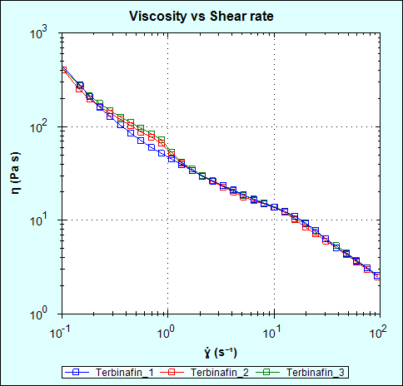 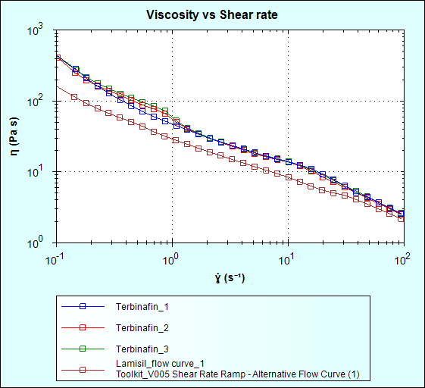

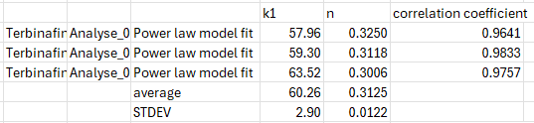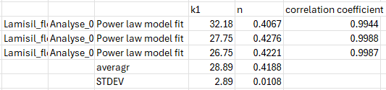

**Conclusion**

Based on the values ​​of the consistency index K and the index of non-Newtonian behavior, it can be concluded that the spreadability of Terbinafine 10 mg/g cream is better than the spreadability of the Lamisil standard.