**VMFT- DSC 28/02/2025**

Students: Choi Seoyoon, Koletnik Hana, Bayerová Hana, Adam Jiráň, Natálie Kulíková

Instrument: DSC 200 F3 Maia Netzsch

**Sample: Cacao oleum**

Crucible + sample mass: 50.552 mg

Crucible mass: 38.596 mg

Sample mass: 11.956 mg

Temperature protocol: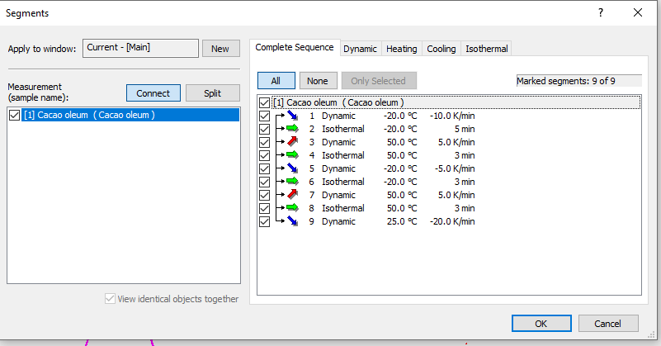

DSC scan:

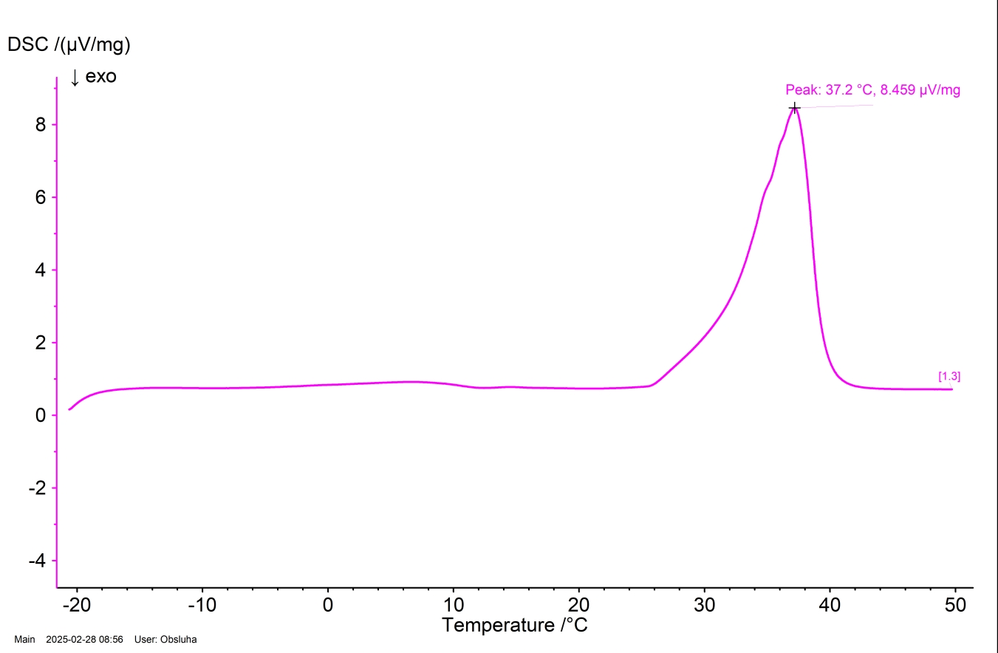

Conclusion: The melting point is 37.2 °C, a little bit higher then body temparature. ☹

Students: Choi Seoyoon, Koletnik Hana, Bayerová Hana, Adam Jiráň, Natálie Kulíková

Instrument: DSC 200 F3 Maia Netzsch

**Sample: Ibuprofenum**

Crucible + sample mass: 45.862 mg

Crucible mass: 38.761 mg

Sample mass: 7.101mg

Temperature protocol:

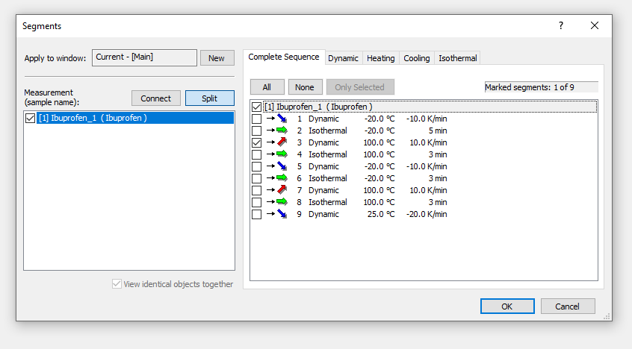

DSC scan:

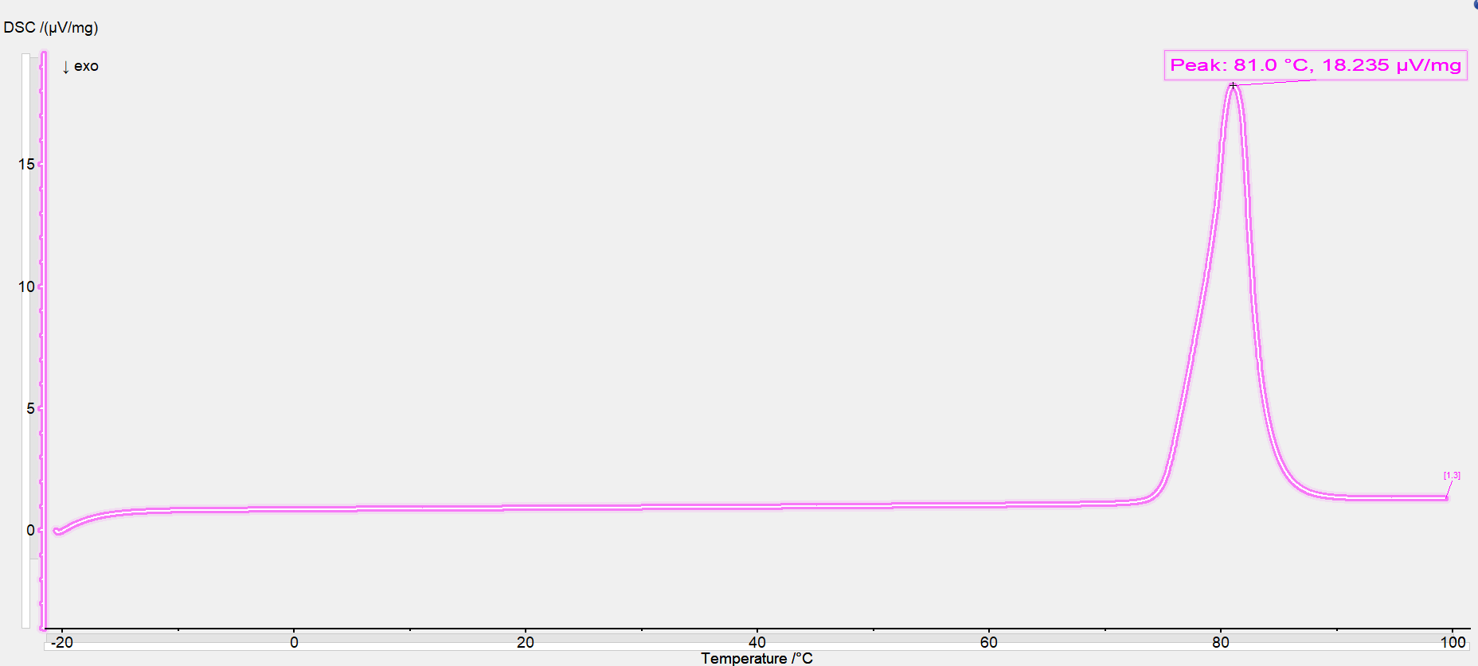

Conclution: Melting poin (literature) 75-78 °C, measured 81°C. 😊