Circulation

**Laboratory exercise and seminar in medical physiology**

Student protocol

The minimal pressure necessary for perfusion in a given tissue is called……………………………..

Draw a graph of this relationship

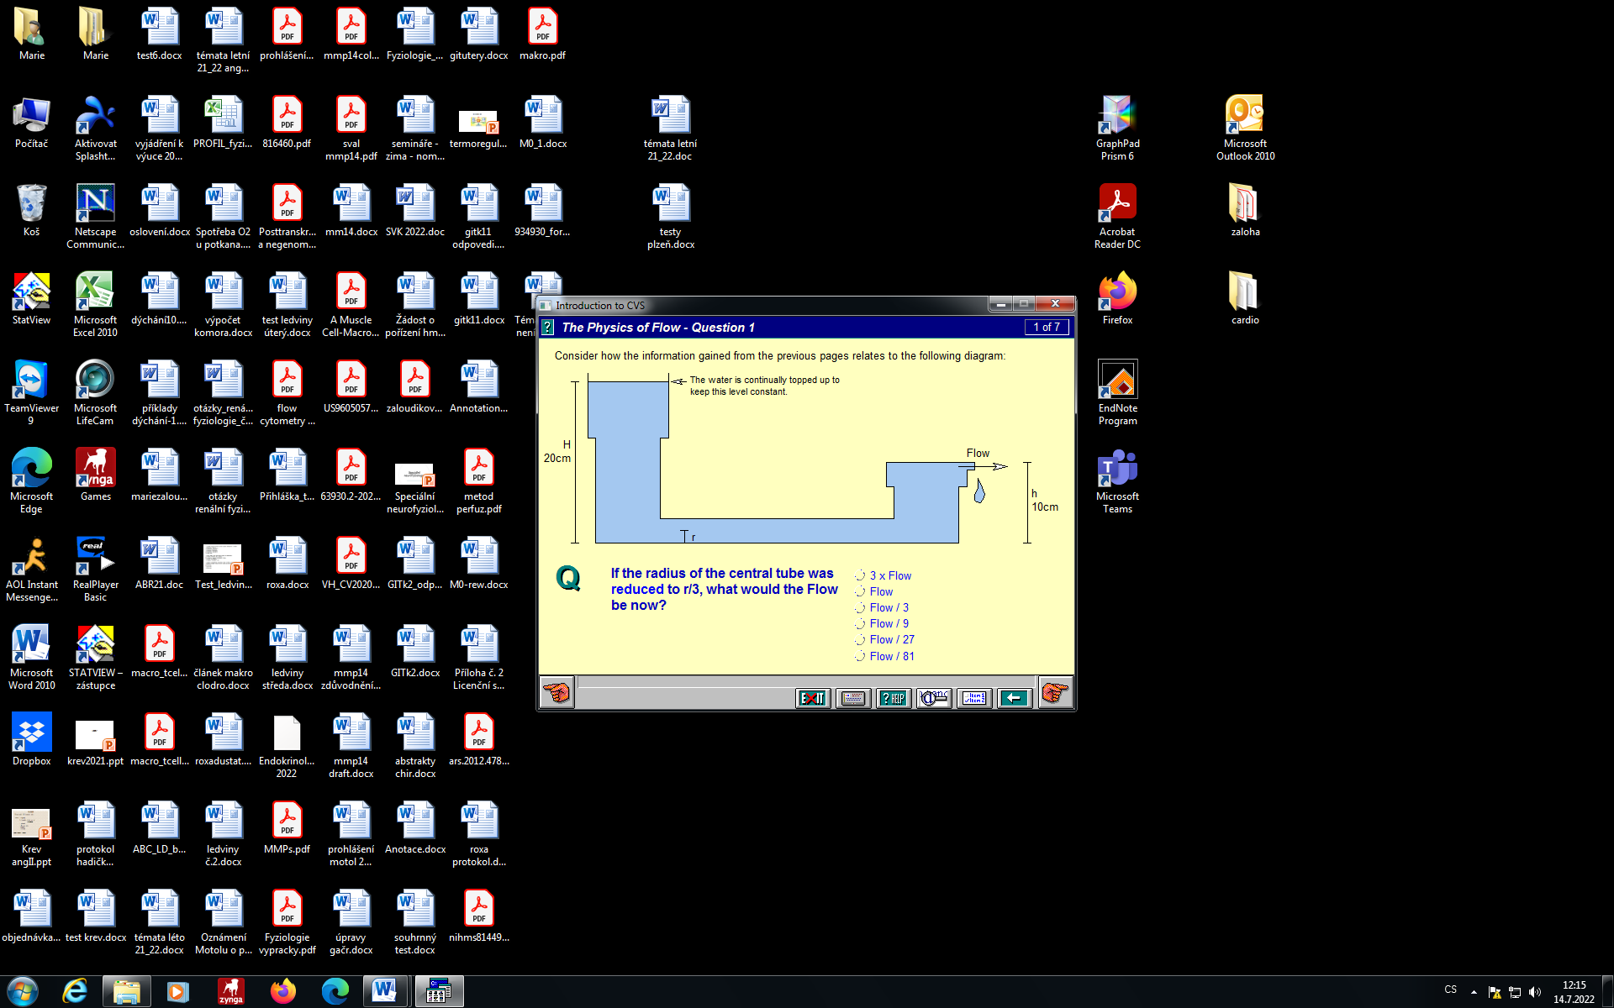

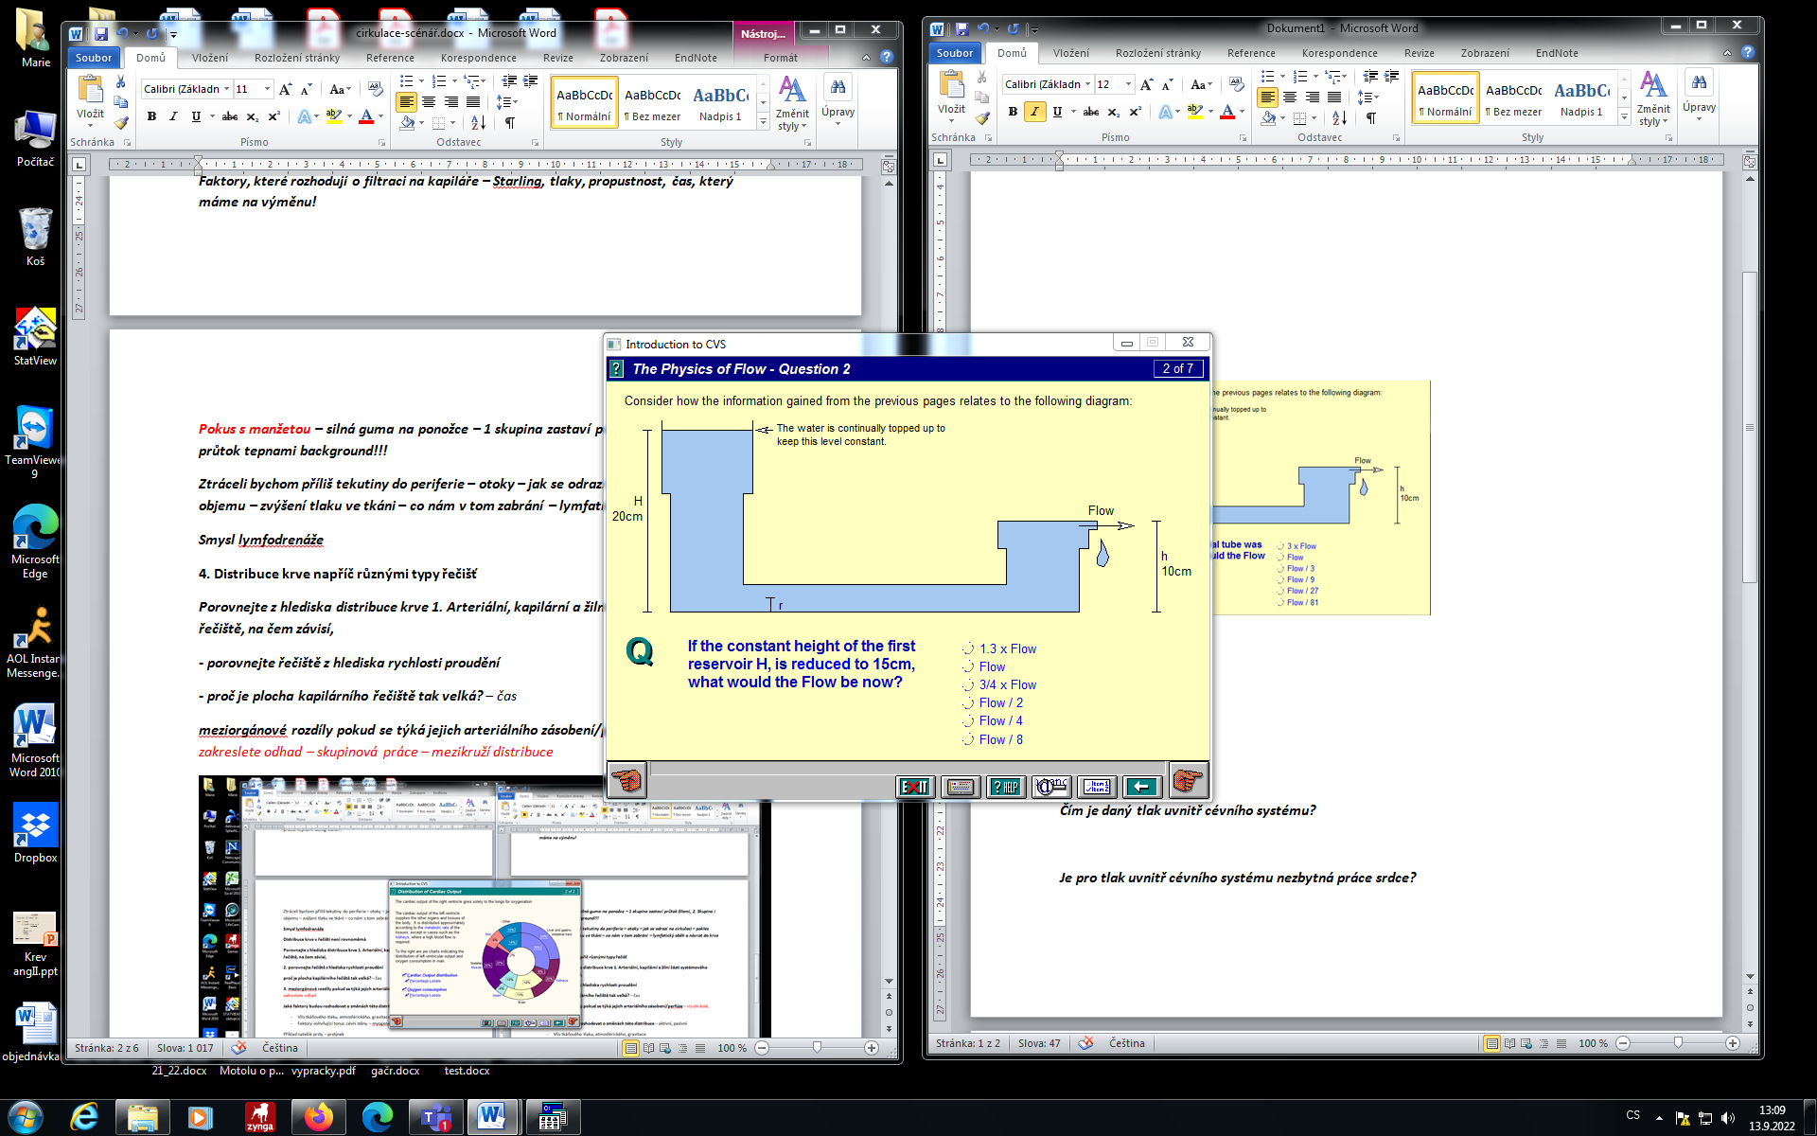

How did the stop of flow in the veins/arteries manifested in the tissue?

Plot an estimate of the distribution of blood volume between:

A. through different parts of the riverbed (systemic arteries, systemic veins, capillaries, heart, lungs) B. arterial supply/perfusion of various organ systems (heart, brain, skin, kidneys, muscles, liver and GIT, others)

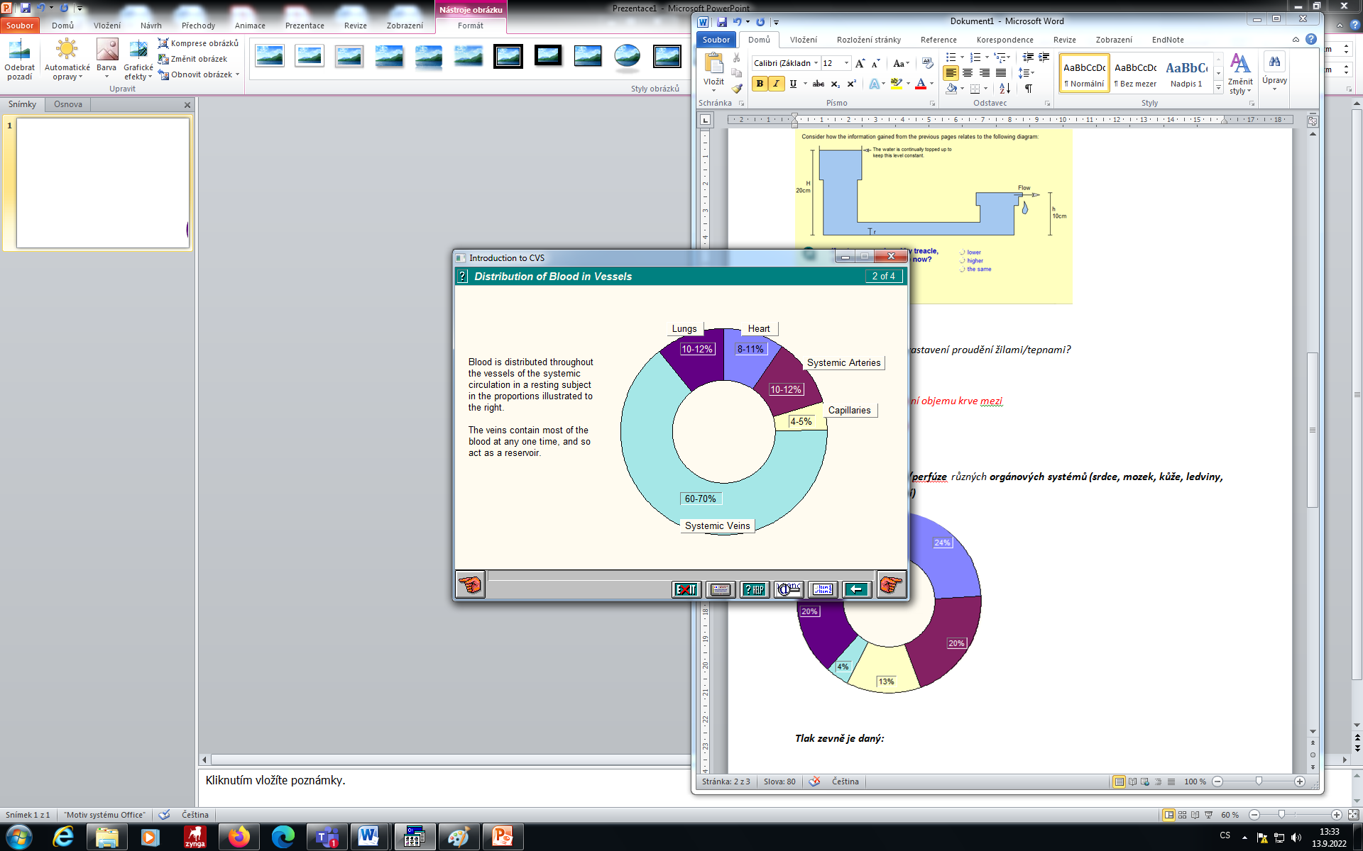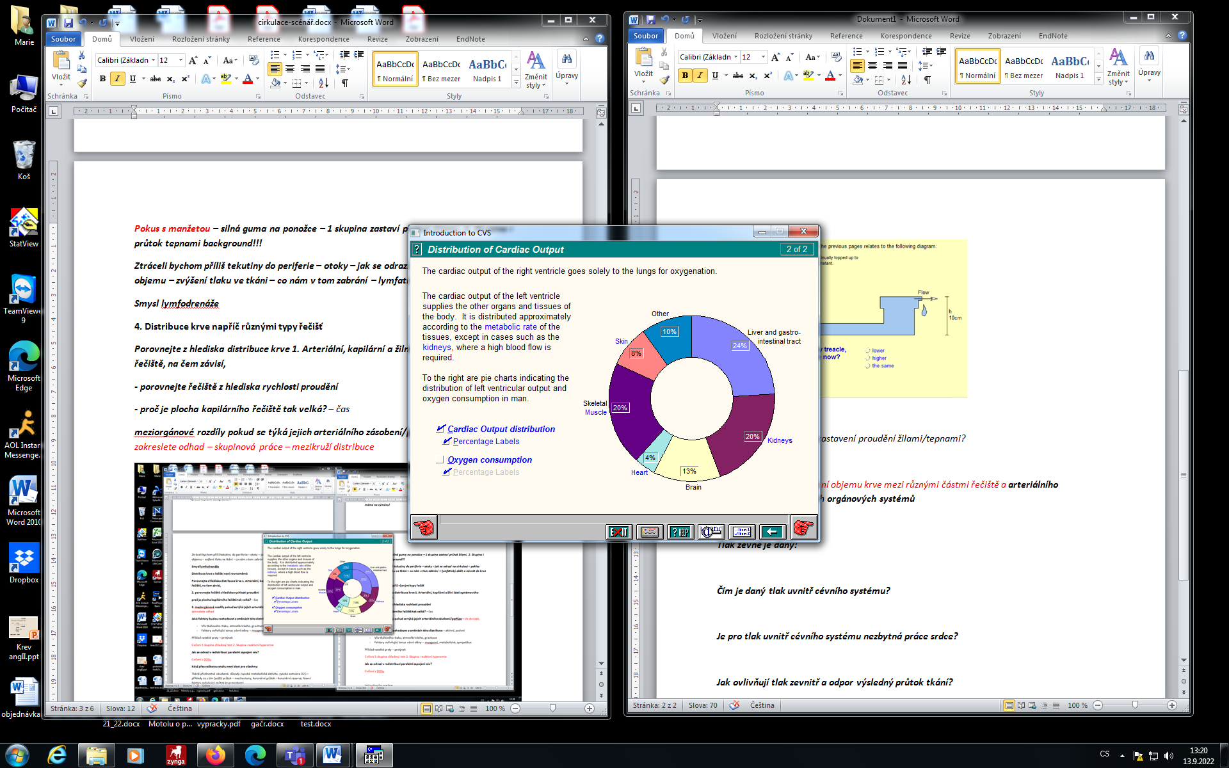

A.

B.

Observation of reactive hyperemia - describe what changes in skin color occurred and explain the principle.

The left ventricle pumps blood into the systemic circulation at a pressure of 90 mm Hg. The total resistance of the systemic circulation is 0.02 mmHg. The right ventricle pumps blood under a pressure of 15 mmHg. Calculate the resistance of the pulmonary bed so that the circulation in the beds connected in this way (in series) works correctly.

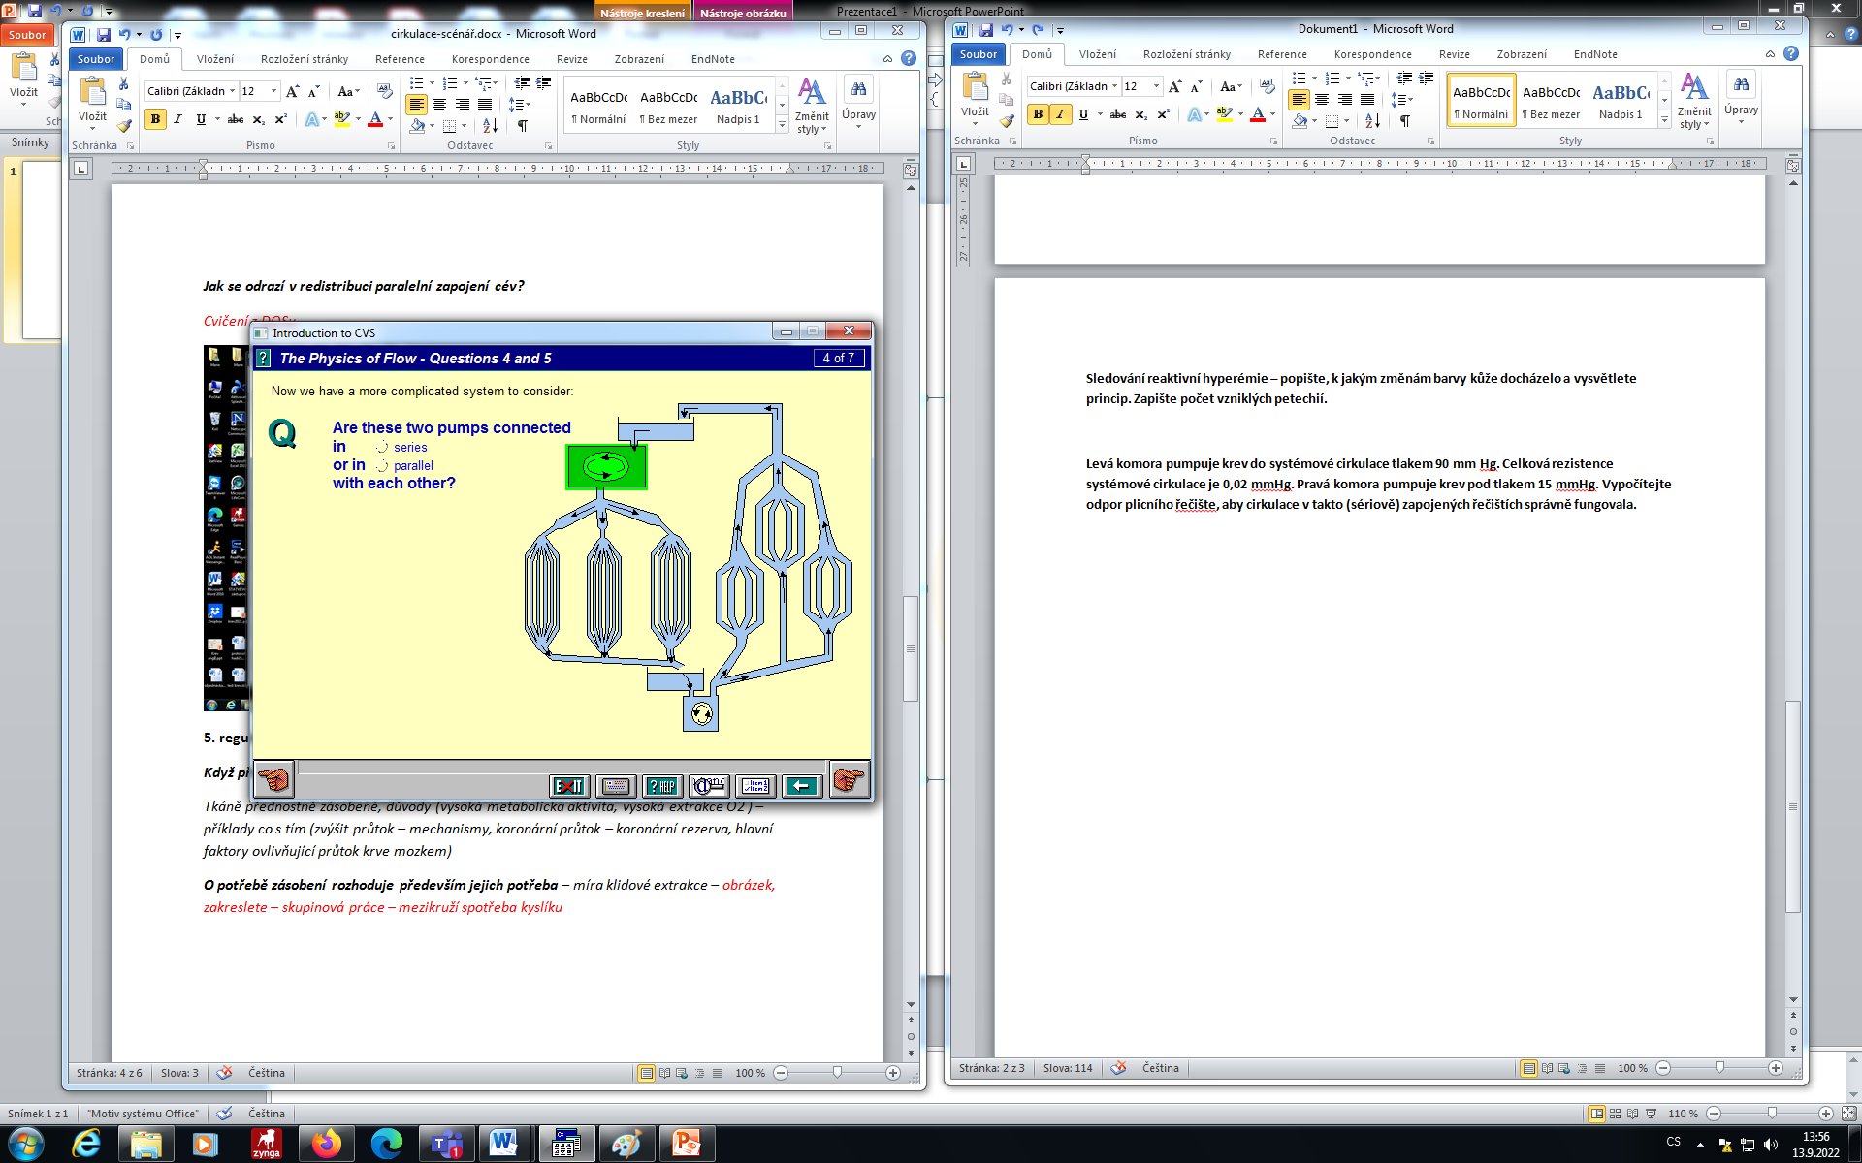

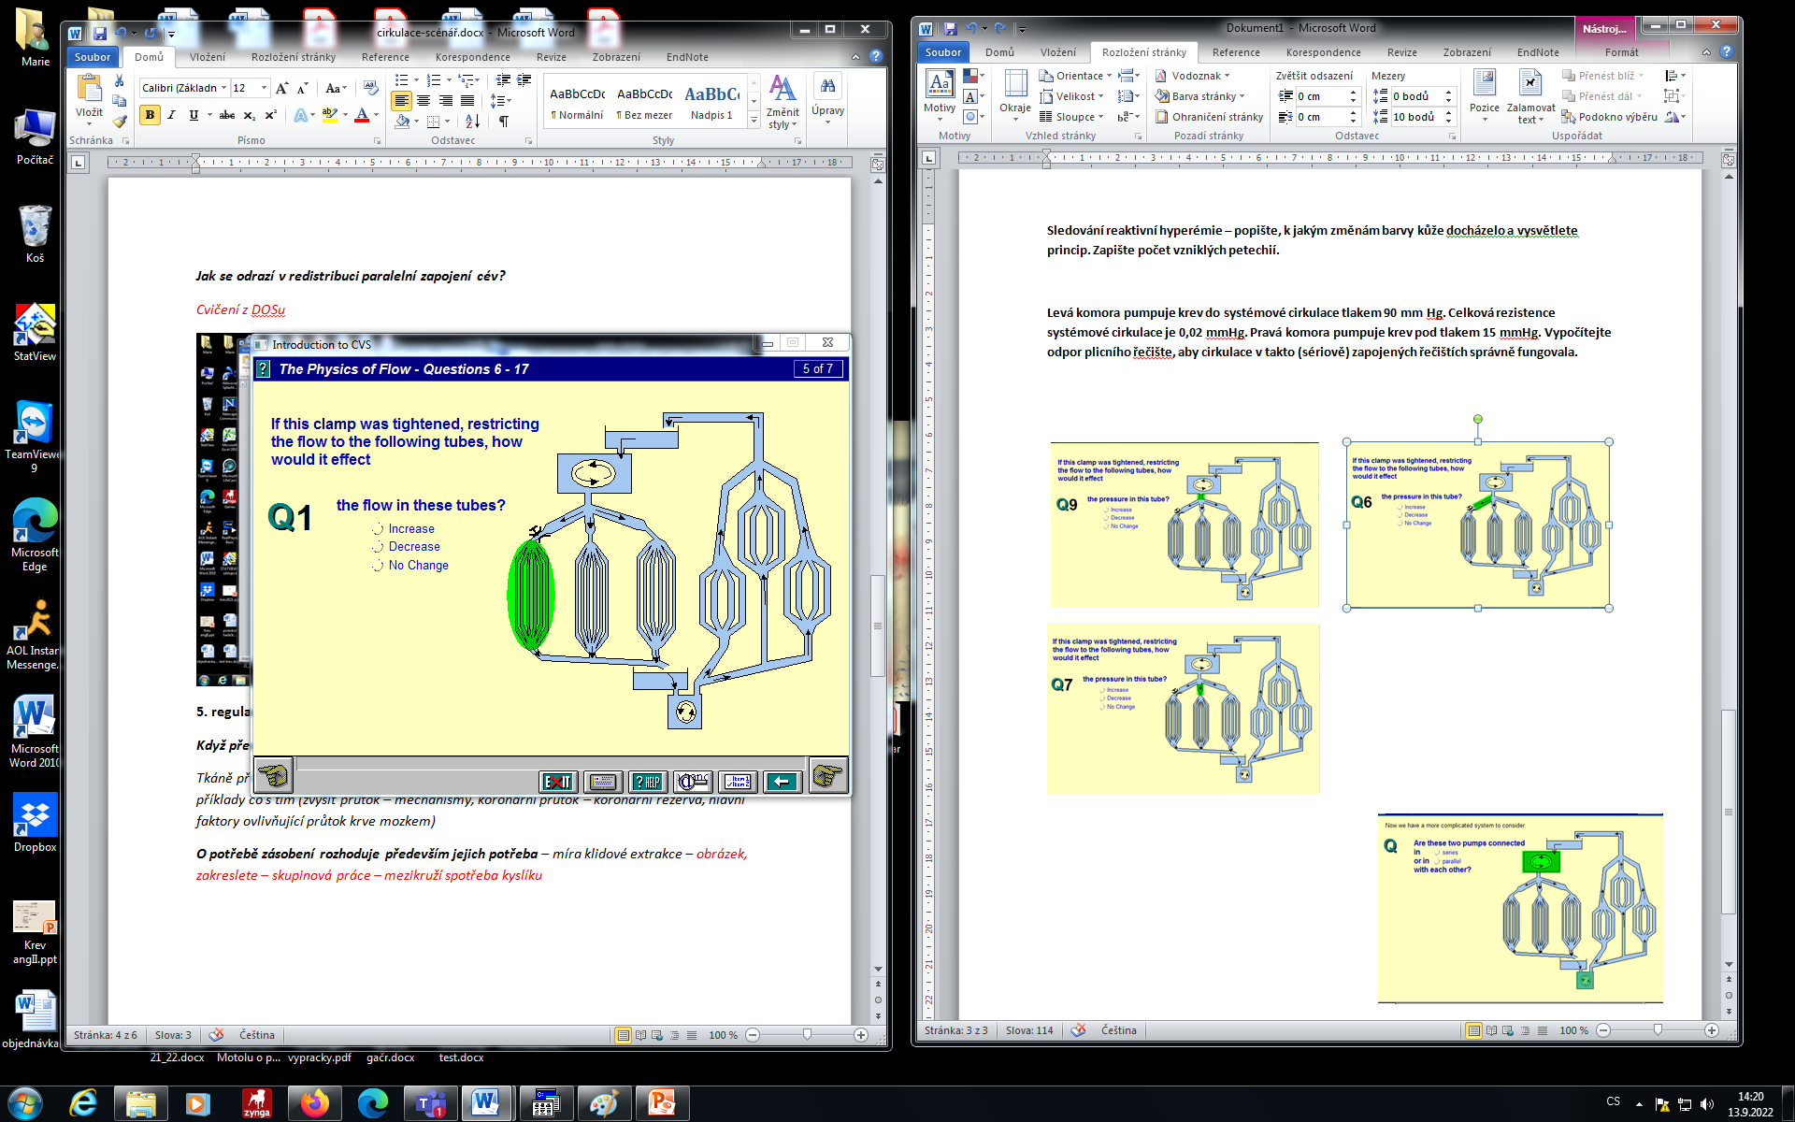

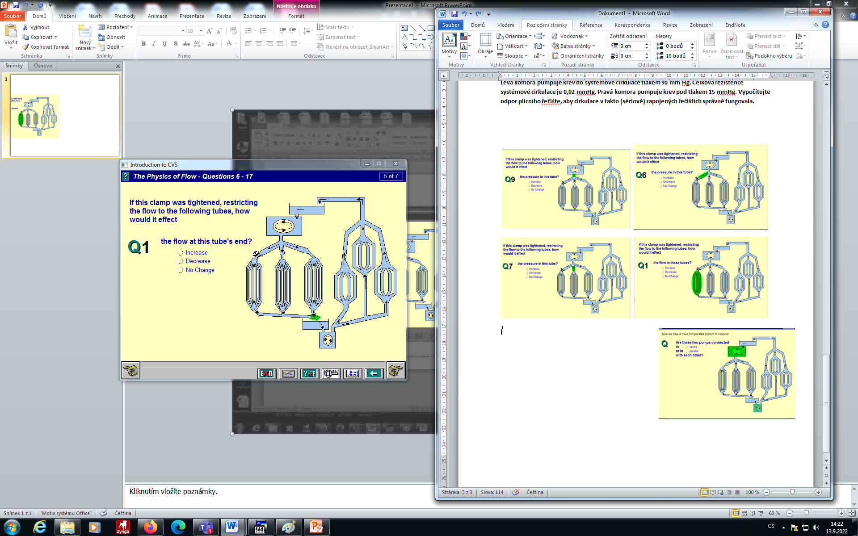

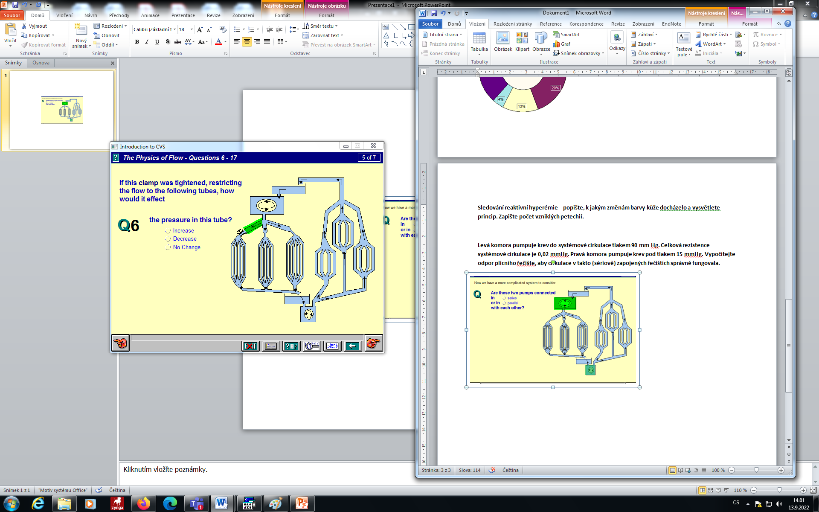

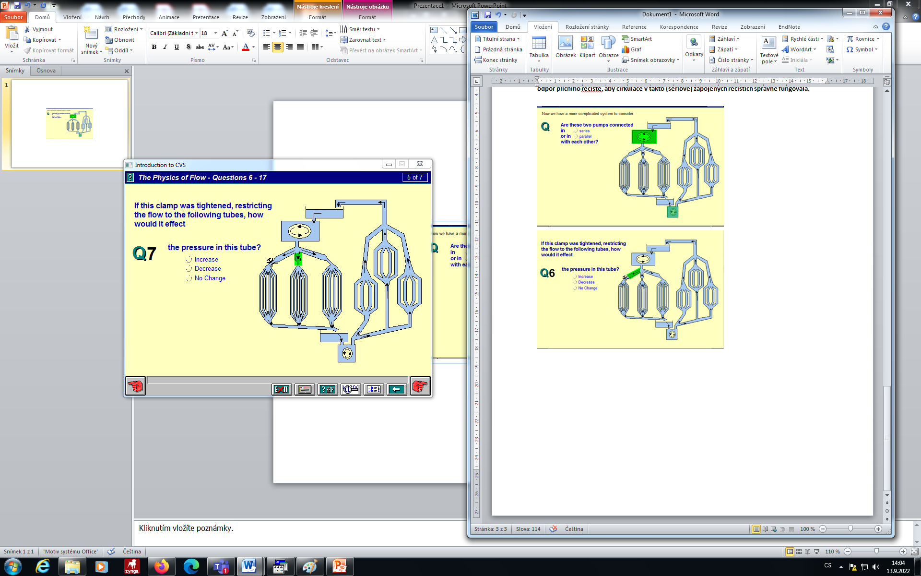

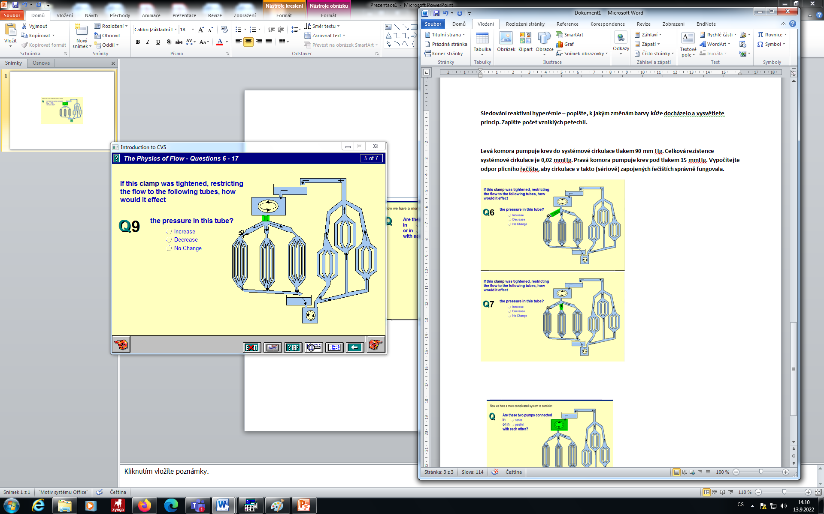

**Fill the table:**

| **Parameter** | **Exercise** | |
| --- | --- | --- |
| **dynamic** | **static** |
| Heart rate |  |  |
| Peripheral resistance |  |  |
| Systolic pressure |  |  |
| Diastolic pressure |  |  |
| Cardiac output |  |  |
| Cardiac output per minute |  |  |