Action potential
different tissues

Laboratory exercise and seminar in medical physiology

Home preparation, study materials and learning objectives

Learning objectives - what you will be able to do

- List the conductive tissues of the human body.
- Explain the concepts of depolarization, hyperpolarization, threshold potential, all or nothing law, refractory period.
- Draw a different running of the action potential in individual conducting tissues.
- Explain the action potential principle.
- Correctly describe the mechanism of signal propagation along a nerve and muscle fiber over a longer distance.

Studying materials

- Lecture Electrical properties of the cell
(the recording of the lecture from 2020 can be found here: https://www.youtube.com/watch?v=9u6vXPclphw)

- O. Kittnar Textbook - Medical Physiology 2nd Edition
- Pages 98 – 114
- Textbook L. Constanzo – Physiology, 6th or 7th edition
  - Pages 19 – 24
- Herget textbook - Lecture notes
  - Pages 98 – 114 https://fyziologie.lf2.cuni.cz/sites/fyziologie/files/page/files/2021/Herget_skripta_dychani_obeh_svaly_neuro.pdf

- Additional resources:
  - Guyton AC, Hall JE: Textbook of Medical Physiology. Elsevier, 2020. (Chapter 5: Membrane Potentials and Action Potentials)
  - Ninja Nerd Lectures: Resting membrane, Graded, Action Potentials
- (minute 31 to 50) (https://www.youtube.com/watch?v=Jk_9IhHVOTk)

Preparing a presentation

- One student will prepare a presentation on the topic Propagation of the action potential along the nerve fiber (max. 10 minutes).

Instructions for practice - NMJ - neuromuscular junction training program

The program installation can be easily downloaded here:

http://spider.science.strath.ac.uk/sipbs/page.php?page=software_sims

In this practical exercise, only the part of the program related directly to electrical stimulation of the muscle will be used. First, we will familiarize ourselves with the overall arrangement of the experiment.

A part of the diaphragm with the corresponding phrenic nerve was dissected from an anesthetized rat and placed in a flat dish through which Krebs solution saturated with a mixture of 95% O2 and 5% CO2 at a temperature of 32°C slowly flows.

Certain drugs can be added to the flowing Krebs solution and its ionic composition can also be changed. The dish is placed on the stage of the dissection microscope and a glass microelectrode with a tip smaller than 0.1 mm is inserted into the area of the neuromuscular plate. The muscle fiber can be activated either transsynaptically during nerve irritation, which we will not pay attention to for now, or directly by injecting a depolarizing current of adjustable intensity and duration (see below).
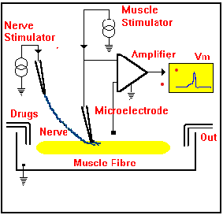

After familiarizing ourselves with the layout of the experiment, we will return to the basic display screen.
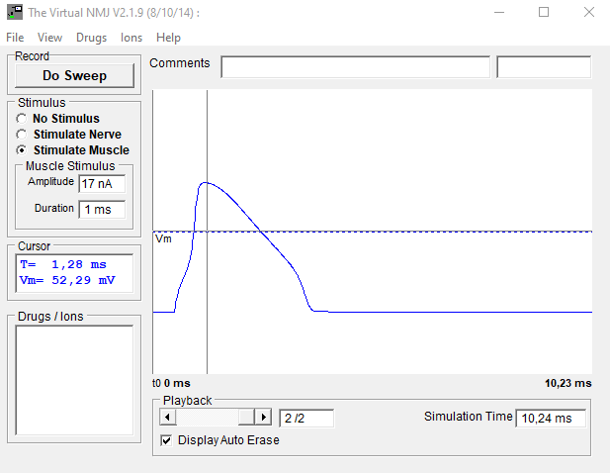
On the "screen of the oscilloscope" the membrane potential of the muscle fiber is displayed, sensed by a microelectrode introduced intracellularly to the area in close proximity to the neuromuscular plate. The time base of the oscillogram is about 10 ms and is triggered 0.5 ms before the moment of stimulation.

Muscle stimulation: let's mark the stimulation of the muscle (Stimulate Muscle)
we set the size of the stimulus (Amplitude) and its duration (Duration).
start the stimulation with the button (Do Sweep)

Subtraction of membrane potential (MP) values: when moving the cursor, we subtract the MP value at the appropriate time point.

Display the results of previous experiments: the Playback slider

Displaying all results at the same time: cancel the Display Auto Erase function and move to the last experiment with the Playback button

Ion concentration change: Ions (in the top bar)
Reset to normal – setting the default physiological situation.
(Don't forget to return the concentration of ions in the washing solution to normal after the experiment!!!)

Administration of pharmaceuticals: Drugs (in the upper bar)

Evaluation of action potential changes:

1. Resting membrane potential.
2. Amplitude.
3. Rate of depolarization and rate of repolarization.
Homework - print and bring to the seminar

Calculation of the equilibrium membrane potential

Using the Nernst equation, calculate the equilibrium potential for K+ under physiological conditions ([K+_{i}] = 140 mmol/L, [K+_{e}] = 5 mmol/L). Perform the same calculation for hyperkalemia ([K+_{e}] = 8 mmol/l) and hypokalemia ([K+_{e}] = 3 mmol/l). For an easier calculation, you can use a modified form of the Nernst equation: E = -62/z. logo Ci/Ce.

Nerve cell action potential graph

On the upper graph, describe the vertical axis including units and mark the following data: resting membrane potential, stimulus threshold, subthreshold stimulation, depolarization, repolarization, hyperpolarization.

In the bottom graph, complete the membrane permeability for Na+ and K+ ions during the AP.
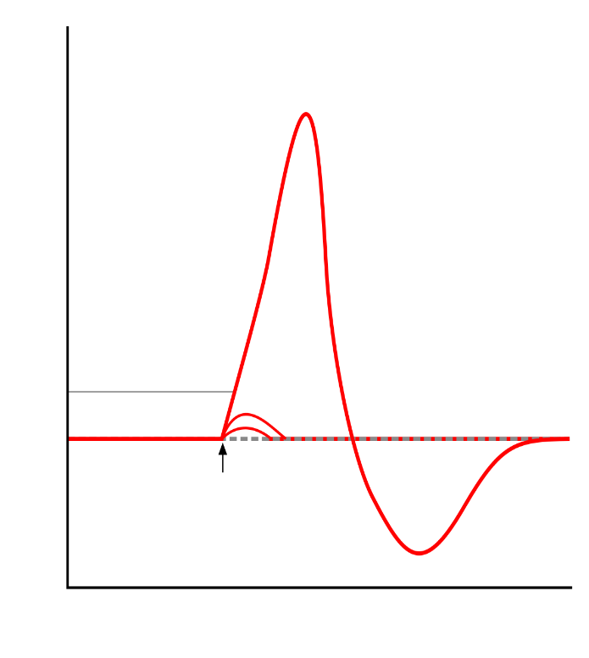
Time 4 ms

Time 4 ms

Permeability

