We Are Still All Censors— and that Includes Perry Nodelman
I wrote the essay about censorship that accompanies this one well over a quarter of a century ago, and I have not looked at it for almost as long; so when I was asked about the possibility of publishing a Portuguese translation of it, I knew I had to reread it. It’s probably a sign of my outrageously inflated ego that my first response on doing so was to congratulate myself on how clever I once was—and, of course, still am, for I found myself happily agreeing with the wisdom of what I said so long ago. Yes, I told myself, I still believe that “there is nothing that anybody should not be allowed to say or to write—nothing, no matter how offensive, how narrow-minded, how boneheaded, or how dangerous I might personally find it. Not anything sexist or racist. Not neo-Nazis misrepresentations of history. Not pornography. Nothing.” And yes, I still believe that children need access to a whole range of books and information and ideas that many adults try desperately to keep them ignorant of, and I am still convinced that “more evil is done by people ignorant of what thoughtful moral beings might consider to be evil than by those with knowledge of that: that it is ignorance and not knowledge that destroys paradise.”
But then I had a second thought. In the years since writing that essay, I have become aware of the work of a number of scholars and writers of children’s literature who come from what are considered to be minority backgrounds in Canada, the United States, Australia, and elsewhere, and I have felt great sympathy for their concerns about books that repeat racial or cultural stereotypes about, for instance, Indigenous North Americans or about Americans and Canadians whose ancestry is African. I have been pleased to see an upsurge of interest in considerations of how often minority characters appear in children’s books–albeit dismayed by the statistics put together by the Cooperative Children’s Book Center in Madison Wisconsin showing that in 2017, when Black, Latinx and Native Americans formed 37% of the American population and over 50% of the students enrolled from kindergarten to grade twelve in American public schools (“Table 203.60”), only 7% of the children’s books published in the USA in that year were by writers from those groups (“Publishing Statistics”)
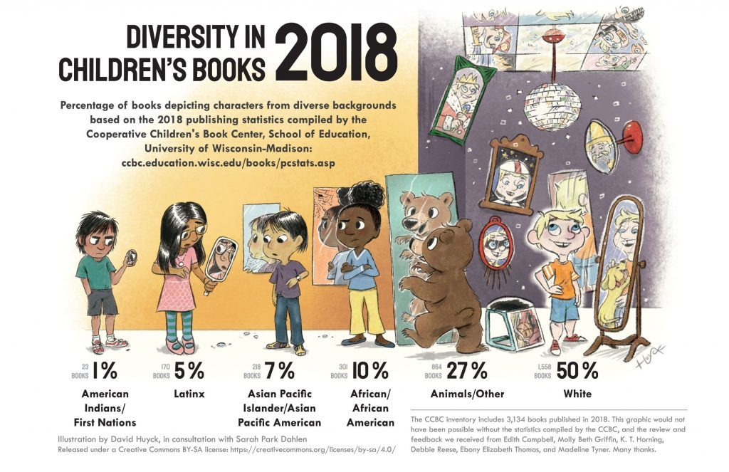
On the other hand, it’s heartening to see that the percentage of children’s books published in the US containing multicultural characters, after hovering around 10% for two decades, tripled between 2012 and 2017. Meanwhile, there have been extensive online discussions about publishers of books for young people using images of light-skinned people on the covers of books about darker-skinned characters and about movie producers casting lighter-skinned characters in film versions of books about darker-skinned ones (Schutte); about the continuing low number of people from minority backgrounds working as editors and publishers in mainstream US children’s publishing; and about the benefits and negative implications of efforts by people in the publishing business to provide non-minority authors with helpful advice about their depictions of minority characters by assigning “sensitivity readers”—people with personal knowledge of minority lifestyles–to comment on their work in progress (Alter).
In 2016, a firestorm of controversy broke out about the depiction of slaves in both Emily Jenkins’s text and Sophie Blackall’s illustrations for their picture book A Fine Dessert.
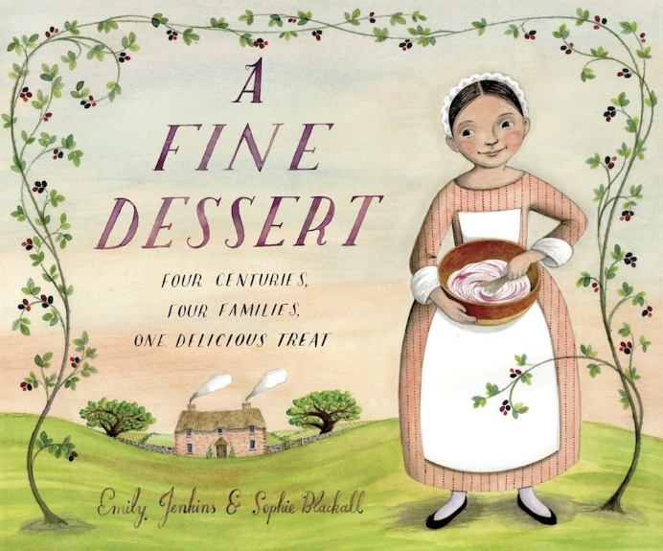
One blog commentator said,
Based on the illustrations, there are too many implications that should make us as adults squirm about what we might be telling children about slavery:
- That slave families were intact and allowed to stay together.
- Based on the smiling faces of the young girl . . . that being enslaved is fun and or pleasurable.
- That to disobey as a slave was a fun (or to use the reviewer’s word “relaxed”) moment of whimsy rather than a dangerous act that could provoke severe and painful physical punishment.
Jenkins acknowledged the problematic nature of what she depicted and apologized for it. Blackall did not, saying that the book “does not fully depict the horrors of slavery, but I don’t think such a depiction would be appropriate for this particular age group” (“Depicting Slavery in A Fine Dessert”). Why then depict it at all, one might ask, to which Blackall responds, “I wonder whether the only way to avoid offense would have been to leave slavery out altogether, but sharing this book in school visits has been an extraordinary experience and the positive responses from teachers and librarians and parents have been overwhelming.” That strikes me as being a peculiar avoidance of personal responsibility: I did it, Blackall implies, but a lot of people like it and its misrepresentation of slavery, so I clearly did nothing wrong.
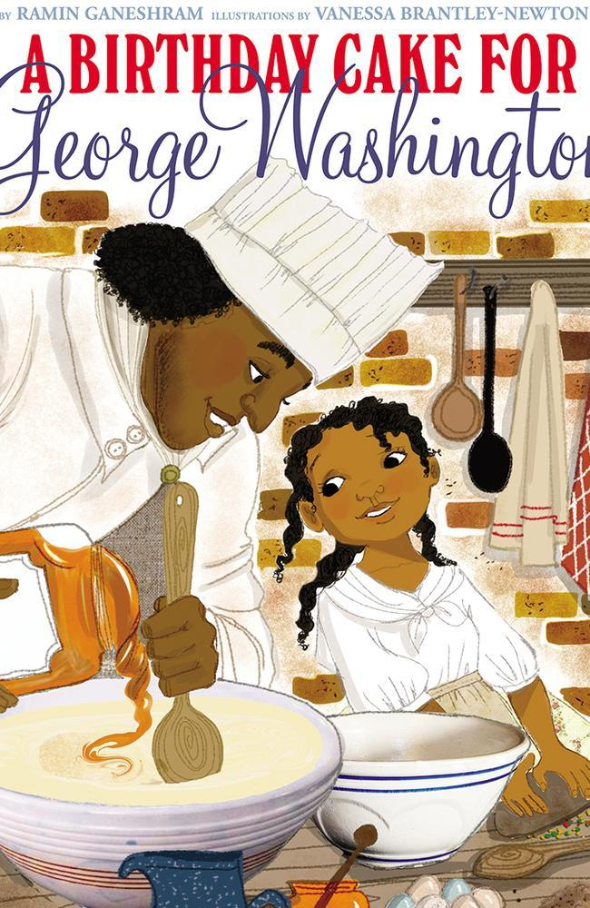
Shortly after the Fine Dessert controversy, another one developed about another picture book, Ramin Ganeshram’s A Birthday Cake for George Washington illustrated by Vanessa Brantley-Newton, for similarly downplaying the ugliness of slavery. The time its publisher, Scholastic, took the extraordinary step of withdrawing the book from circulation, because “without more historical background on the evils of slavery than this book for younger children can provide, the book may give a false impression of the reality of the lives of slaves.”
More recently, in response to online controversy over the ways in which aspects of the fantasy world of her YA novel Blood Heir seemed to depict and condone the history of slavery in America, its author, the Chinese American immigrant Amélie Wen Zhao, asked her publishers to delay publication, saying, “The narrative and history of slavery in the United States is not something I can, would, or intended to write, but I recognize that I am not writing in merely my own cultural context. I am so sorry for the pain this has caused.” And as I write in March, 2019, Kosoko Jackson has asked his publisher to withdraw his YA historical novel, A Place for Wolves, after readers of advance copies complained about the novel’s problematic representation of the Kosovo War, genocide, and Muslim characters.

The people who objected to the slaves in A Fine Desert and withdrew A Birthday Cake for George Washington, Blood Heir, and A Place for Wolves from circulation were all accused, quite correctly, of censorship—they did, more or less, ban books. But as I have followed these developments and controversies, I have tended to find myself very much in agreement with those who objected to the white faces placed on the covers of novels in order to disguise the presence of black characters and therefore presumably, limit their readership—for all too common wisdom suggests that, while minority readers, in the absence of other choices, will willingly read about white characters, white readers are uninterested in characters with darker skins. While dark skin always affects a character’s lifestyle and opportunities, too many white people assume that white skin has no effect on such things at all.
I have also agreed with objections to the lies about and misrepresentations of Black and Muslim life in the past and the present inside books for young people. I was surprised that Scholastic took the extraordinary step of withdrawing a book they had already released and that the publishers of Zhao and Jackson’s novels chose not to proceed with their publication until some rewriting occurred —but, I have to admit, I am not unhappy that they had done so. There’s nothing inherently wrong with a children’s picture book depicting the world as a utopian place eternally filled with sunshine and smiles—but then, why include depictions of smiling slaves in the utopia? For that matter, why depict a place that did actually have slaves in it as utopian? Should child readers be encouraged to feel good about slavery? And why proceed with publishing insensitive and inaccurate stereotypes if you have been made aware of them and have the option of getting rid of them? The many online objections to these authors’ submission to their critics as a denial of their freedom of speech seemed to forget that working through the drafts of a story is a continual process of second thoughts and self-censoring. Then, if authors are lucky enough to find a publisher who considers the work suitably publishable within the constraints of current assumptions about why and what books can and cannot be published, they will be offered advice or even required to make changes by their editors, who are themselves constrained by their knowledge of what makes books sellable. All the way through the process of getting a book into print, authors have to choose how to act in response to all these forces—and the choices are often self-censoring ones. The only difference between the standard practice that constrains authors’ choices at every stage of writing and publishing and Zhao and Jackson’s request for delays in publication is that their awareness of what might be problematic came too late and too publicly—which seems to me like a good argument for the use of sensitivity readers.
My growing awareness of unconsciously racist content in children’s books and my willingness to acknowledge my upset about it has been nurtured by my knowledge of the work of scholars like Ebony Thomas, whose The Dark Fantastic perceptively explores the implications of portrayals of darker-skinned characters like Rue in Suzanne Collins’s The Hunger Game and Angelina Johnson in J.K. Rowling’s Harry Potter and audience reactions to them.
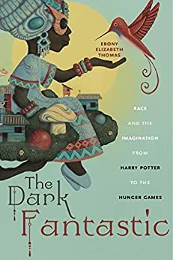
I’ve been pleased to see the development of a body of scholarship now worthy of its identification as a field on its own: Diversity Studies, as represented by the work of the Korean-American scholar Sarah Park Dahlen, co-editor with Jamie Naidoo of the children’s and young adult multicultural literature textbook Diversity in Youth Literature: Opening Doors Through Reading and one of the founders of the new journal Research on Diversity in Youth Literature.
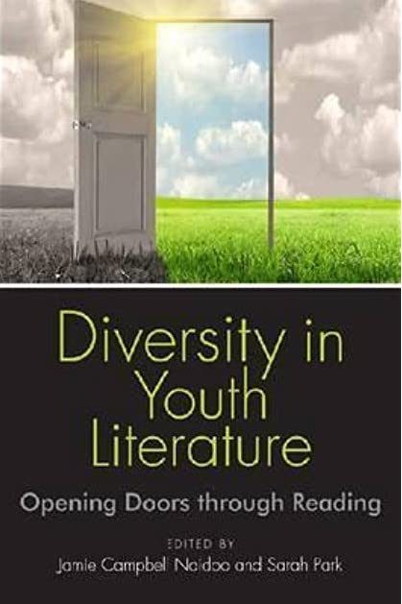
I’ve been particularly persuaded by the determination of people like Debbie Reese, tribally enrolled at Nambe Pueblo in New Mexico and author of the influential blog American Indians in Children’s Literature, to identify where and how books old and new repeat old clichés and stereotypes about characters who share her Indigenous background.
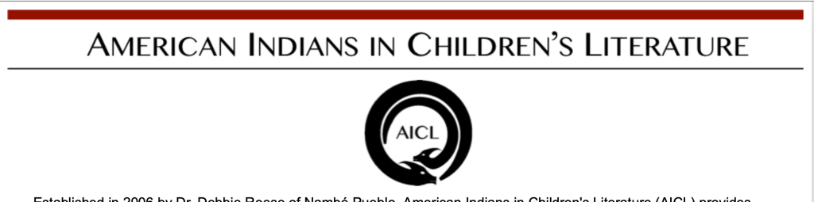
For instance, as Reese points out in response to descriptions of Indigenous Americans in children’s fiction, “Not all Native people have dark hair, dark skin, dark eyes, and prominent cheekbones, but that is the default physical description a lot of authors use” (“Not Recommended: THE METROPOLITANS by Carol Goodman”). As evidence, Reese refers not just to a number of Indigenous characters with sharp cheekbones, but also to a scene in the Harry Potter novels in which Harry looks at a picture of Dumbledore’s mother, who “had jet-black hair pulled into a high bun. . . . Harry thought of photos of Native Americans he’d seen as he studied her dark eyes, high cheekbones, and straight nose.” Reese also all too often finds examples of children’s authors casually using a long list of racist stereotypes—phrases like “war whoop,” “off the reservation,” “like a bunch of wild Indians,” “low man on the totem pole,” “bury the hatchet” “circle the wagons,” “happy hunting grounds,” “Indian giver,” or “on the warpath”–to describe the behavior of non-Indigenous characters, with no apparent awareness of or concern about their history and their racist implications.
Reese’s conscious awareness of the implications of phrases like these emerges, of course, from her own membership in the group they so dismissively stereotype. Where I find her work most compelling is in her concern for Indigenous child readers who might come across these casual unconscious insults. As she argues in her essay “Indigenizing Children’s Literature,” “Native children’s self esteem is far too often assaulted in their classrooms—unintentionally— when teachers or librarians uncritically share books with images of Indians as primitive savages or with other historical or cultural misinformation. Educational strategies that support Indigenous nation building preclude the uncritical use of children’s books with images that are likely to directly or indirectly harm a child’s efforts to establish an identity as a Native person.” (621).
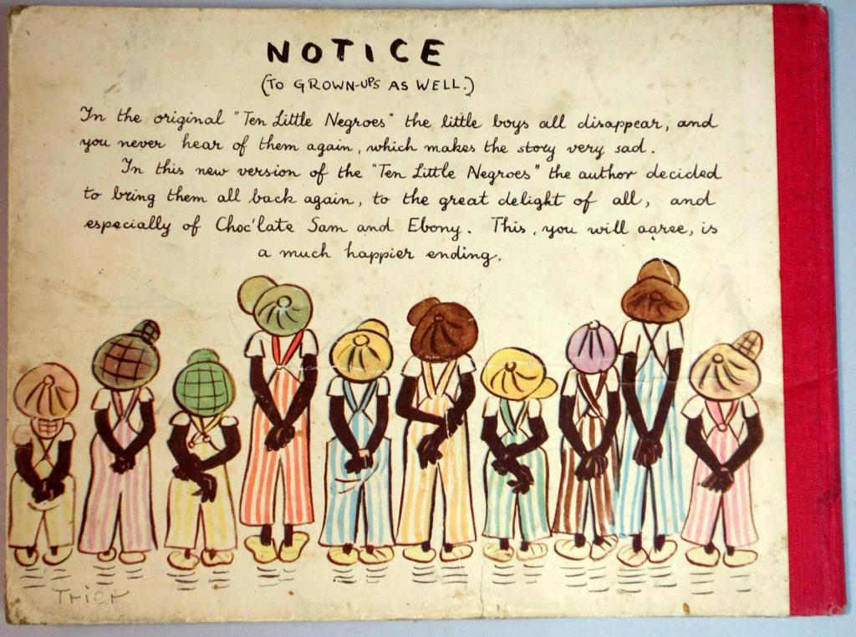
In my old essay on censorship, I dismiss the potential effect of racism of Walter Trier’s 10 Little Negroes, the book my white student remembered loving in her childhood but now keeps on the top shelf of a dark closet, safely away from her own children. While I acknowledged the obnoxious racism of the story of Choc’late Sam and his wife Ebony, who are “as proud as any coons” of their ever-increasing family of “N***** boys,”—note my decision just now not to spell out the entire N-word as I once did–I pointed out that my student’s horror about the book as an adult clearly established that her reading of it as a child had not made her racist. What it had not occurred to me to think about as I said that was the kind of child who shared the skin color of Choc’late Sam—the kind of young reader whose self-esteem Debbie Reese so rightly worries about–reading this book. Is it possible, I find myself wondering now , that the ease with which I once proclaimed that there is “nothing that anybody should not be allowed to say or to write,” including “anything sexist or racist,” might not come from my relative lack of personal experience, as an old white man, of coming upon stereotypes like these about people like me in children’s books? My own self-esteem not having been assaulted in this undeniably distressing way, is it fair for me to recommend such an unbending defiance of all censorship always to others less fortunate?
There has been much discussion in recent years about what has come to be known as white privilege: the freedom to be unaware of how one’s skin colour has allowed one to slide through life without having to deal with all the ways in which people of colour are subject to limitations that emerge from a widespread but often unconscious form of prejudice—what Peggy Mcintosh in her 1988 essay, “White Privilege and Male Privilege” identifies as “an invisible weightless knapsack of special provisions, assurances, tools, maps, guides, codebooks, passports, visas, clothes, compass, emergency gear, and blank checks” (2) that, unlike others, white people have access to. As Mcintosh’s title suggests, furthermore, as an old white man in a society that remains astonishingly patriarchal, I also possess an equivalent male privilege—and as a relatively well-off white man, obviously, I also enjoy at least some of the power of class privilege. It has been exceedingly easy for me not to be aware of how fortunate I am, and how easy it has been for me to make such blanket statements about not accepting the censorship of children’s book in any form.
In recent years, I have learned to become at least a little aware of these things. In response to one of Debbie Reese’s post on her blog, I wrote the following:
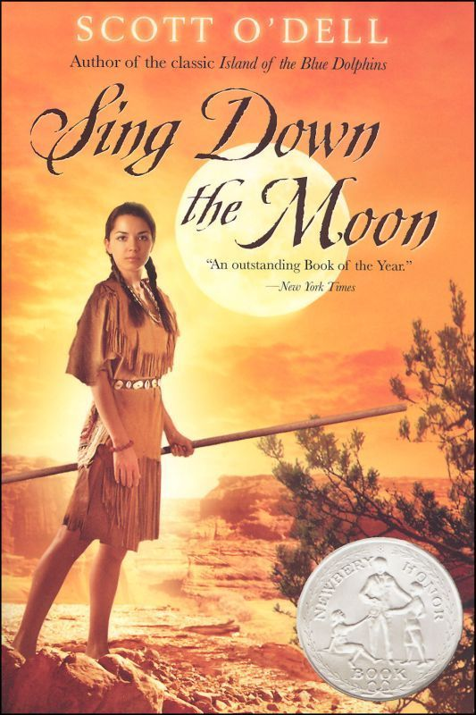
I recently became painfully aware of my own unconscious expression of white privilege as I looked through old articles I was considering uploading to Academia.edu, and came upon one on Scott O’Dell’s Sing Down the Moon which was published in Horn Book in 1984. It’s full of praise for a novel about the “Long Walk” of 1863, in which American soldiers forced the entire Navajo nation to relocate after destroying their villages and crops. Among other things, I say in this essay that I admire O’Dell’s choice of not providing his young Navaho narrator with a name for much of the book–a choice which I saw in 1984 as universalizing her and making her a sympathetic and believable character, and which I now see as a commentary on the deprivation of her personhood that in fact confirms and reinforces that deprivation. I also celebrate O’Dell’s depiction of the Navajo stoicism and refusal to express anger at what is happening to them–another confirmation of a hoary stereotype.
Worst of all, it become apparent to me as I read through this old essay that I simply took it as an absolute truth that no one who was Navajo or even remotely like a Navajo would ever be part of the audience of the book: “Sing Down the Moon is about people unlike ourselves,” I conclude, clearly and unconsciously assuming that all the readers of this book would all be white like me. I am wrestling now with whether or not I should upload this essay as evidence of how ignorant I was and how much I’ve learned about these matters in the last three decades–much of it from you, Debby. Uploading it would have to potential to be very embarrassing; not doing so would misrepresent who I once was. I’m tending to choose to upload it.
At any rate, I find these issues of unconscious racism–my own and that of other white people, especially other white men–deeply troubling. I don’t want to have to remain silent about the racism that I find so troublesome, but I’m also aware of the troubling aspects of my choosing to speak about what so troubles me. My own solution to this dilemma is to forefront in anything I write about these topics my awareness of the potentially poisonous aspects of my speaking about them—to acknowledge my white male privilege and to attempt to become aware of how it might be distorting how I see things and read texts before and during and after my readings of those texts. I want to acknowledge and accept the possibility that I might yet once more be seriously embarrassing myself, in the faith that even if I do, my doing so will help to further a cause I profoundly believe in by confirming the blindness of my privilege. And I would hope that any discussion of these matters by other white men like me would be equally aware of and forthright about the minefield they enter in writing about race, equally open to exploring the possibility of their blindnesses, and equally unwilling to assume a kind of authority that unconsciously replicates the very kinds of unconscious repression they want to argue against.
I did, finally, choose to upload that piece about Sing Down the Moon; it can now be found on Zenodo.
(“Dear Philip Nel,” American Indians in Children’s Literature)
But: having become painfully aware of my white male middle class privilege, I now find myself faced with what appears to be a massive contradiction in my thinking:
- On the one, hand, I am against censorship; and I believe children ought to have access to as much knowledge of the world as possible.
- On the other hand: I am not only aware of the unconscious assumption of privilege that might be influencing any and all of my convictions, but I also share the concern of writers like Thomas, Park Dahlen and Reese about how consciously and unconsciously racist depictions of characters and usages of language in children’s books might have powerful negative effects on young readers and might well be criticized and avoided.
Or in other words: while I am firmly against censorship, I also sometimes seem to be in support of it.
What, then, should I do about that? Is there some way of resolving the contradiction? As I consider that possibility, I remind myself that, as well being firmly against censorship back in 1992, and even though I was decidedly unaware of my while male middle class privilege, I considered myself to be firmly against racism, sexism, and all the other forms of intolerance I was aware of. But, I ask myself now in the light of my new awareness of the privilege I once took for granted, was I? Really? Are there things my lack of awareness of that privilege was causing me to take for granted? Was I unconsciously approving racist content without recognizing its racism? Perhaps my defence of the positions I asserted so confidently back then needs a closer look.
As I take that closer look, one thing becomes almost immediately apparent. In order to make my argument against the censorship of children’s books, I pointed out that children’s literature was an act of censorship even in the act of existing—that it had first emerged from a desire by adults to keep children safe from too much knowledge of the world, and that it has survived across the centuries exactly by promising that sort of safety. That is why so many people feel justified in being angrily censorious when books labeled as being for children do or say things these people think children ought not to hear. Nevertheless, I was taking my awareness of the limited access to knowledge characteristic of children’s literature for granted when I declared myself willing to allow children access to all of it. I could safely argue for that access because I knew that most children, in 1992 or now, are not likely to have all that much contact with children’s books celebrating, say, Nazism or cannibalism or depriving women of their right to vote. I could speak proudly of my willingness to allow my own children to read any and all of the wide assortment of picture books that, as a teacher of children’s literature who collected bad examples as well as good ones, I had on my shelves, in the safe knowledge that, those books all having being published and identified as children’s books, none of them was going to try to persuade their readers that Jews like my children’s father needed to be exterminated, or that properly prepared, human beings make a delicious main course for a fancy dinner (or perhaps a fine dessert), or that all women belong at home doing the dishes and washing diapers.
Most people in children’s publishing, children’s librarianship, or early-grade teaching tend to be women, and the few men tend to have what was traditionally assumed to be a feminine interest in nurturing—a focus on matters of the heart rather than those of the head and/or the fists that tends most often to be accompanied by a supposedly soft-hearted left-leaning view of how the world ought to work. As a result, books in praise of fascism or women staying barefoot in the kitchen rarely get published for the children’s market or find their way into library collections. Furthermore, sadly, there are people interested in children for sexual purposes, so there might well be a market for books to be shared with children declaring the wholesomeness of the predatory behaviour of pedophiles and encouraging young readers to think positively about them and eagerly await them. But happily, most mainstream publishers of children’s literature are unlikely to publish such books. A little more subtly, because almost all the producers, distributors and purchasers of children’s books are adults, there are few books available from mainstream or even less mainstream children’s publishers that encourage young children to defy their parents or their teachers or otherwise disrespect adults. While children’s stories often allow children to imagine freedom from the restrictions adults place on them, they almost always end up with a child character’s realization that a restrictive home is better than the dangers of freedom from adult supervision, and with a celebration of parental authority and the wisdom of conventional parental values. I realize, now that I’ve forced myself to think about it, that I took all that for granted when I spoke out so bravely about universal access to all books for all children always. I really only meant the kind of safely childlike books I imagined they would usually have access to.
The privilege I was unaware of also led me to provide examples of censorship that I found laughable in order to make people see how ridiculous censorship was.
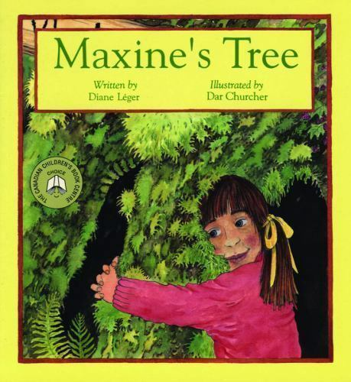”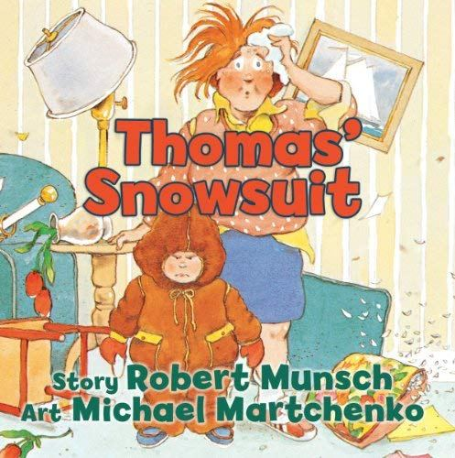
As a result, though, I slid over the possibility of there being books that even back then I might have found to be problematic. If I had been made aware of examples of unconscious racial prejudice like those provided by Debbie Reese, would I have concluded that people like Reese who question the wisdom of sharing such books with young readers are no different than the loggers who did not want children to read about how evil logging was? Or would I have been perceptive enough to see the difference between banning books that celebrate values different from your own and those that celebrate specifically racist and otherwise inhumane values? I remain convinced that lumber-industry proponents have no right to prevent the publication of children’s books against the kind of clear-cut logging that might eventually deprive the human race of all its oxygen; but I’m less convinced that publishers ought to keep on publishing work with damaging racial stereotypes.
But even if publishers did stop publishing such books, there is no guarantee that children would not have access to them. As I argued back in 1992, “we live in a world filled, not just with books we don’t approve of, but also with TV advertising, drug pushers, phone solicitors, politicians, evangelists, and the children of parents with values different from our own. Keeping children from access to ideas and values we don’t like is next to impossible.” If I were writing that passage now, I’d certainly have to add the Internet to the list. Nowadays, Nazism and anti-feminine diatribes are available in each and every home with online access with the simple tap on a screen, not to mention hard-core violence and harder-core pornography. There is even a page on Yahoo Answers that addresses the issue, “Cannibalism? pro? cons?” A surprising number of people in the discussion claim to have no problem with eating other people:
It is logical for a starving population to kill and eat each other before people actually die, so that the dying do not uselessly take up food, which would result in the death of the whole community (i.e. some die now, or all die later). Furthermore, such cannibalism can also serve to eliminate diseases by eating the infected, and it can serve a eugenic purpose by eating the most geneticly-poor individuals. Each such starving community should have the freedom to choose whether or not they will use such initiative cannibalism, such that the ones that use it will live, and the ones that do not will die.
I find myself wondering how the person who wrote that ode to the joys of cannibalism would feel about a children’s picture book, perhaps one specifically aimed at child readers in starving communities, in praise of eating people.
If readily available celebrations of cannibalism and white supremacy were not enough, children internationally are now even more subjected to a barrage of advertising that encourage them to lust after specific lines of toys, whether first-hand or through other children whose parents have already given in to the pressure of their children and bought them those toys. When my own children were young the desirable toys were Barbies and Cabbage Patch dolls.
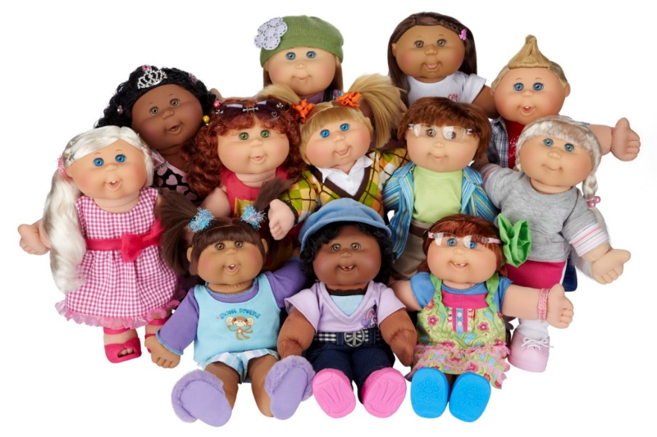
My six-year-old granddaughter recently emerged from an obsession with Paw Patrol cartoons, toys, stickers, colouring books, and dress-up costumes,
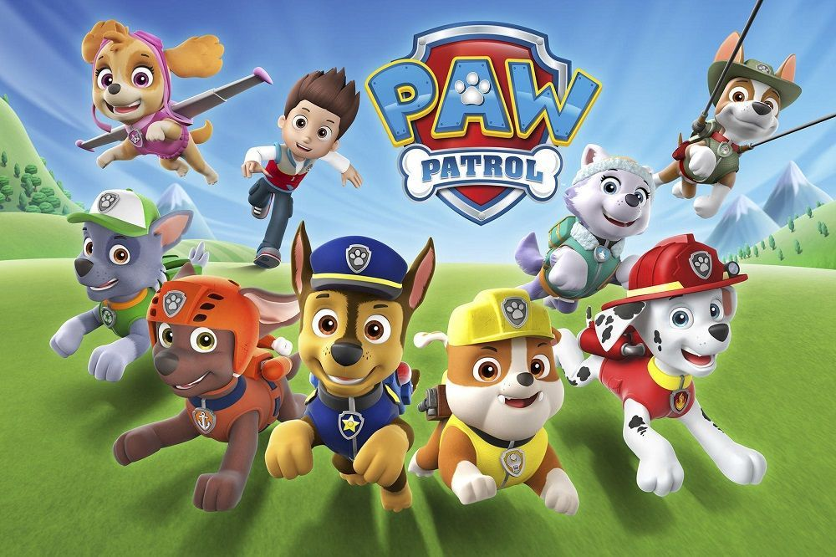
and she currently spends hours watching YouTube videos in which eccentric adults enthuse over LOL dolls, showing how, when each of these creepily huge-eyed dolls is immersed in water, it will either cry or spit or pee into the water. The same water. “Yuck!” I yell at her, but she insists on watching anyway (”LOL Surprise Baby Dolls”).
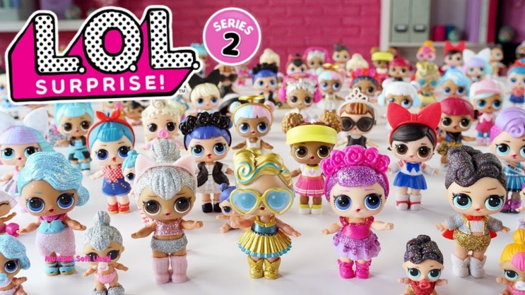
Her LOL doll collection consists of just two right now, but she has her heart set on as many, many more as one of her friends already has and mercilessly and endlessly brags about.
Back in 1992, I offered a way of handling children’s encounters with things like LOLs: “It would be more logical to protect them, not by trying to suppress the potentially dangerous materials, but by helping them to learn the important skill of being less trusting.” In other words: teach them critical thinking. I talked about how when our young children watched TV with my wife and me, “they had to hear both their parents wax sarcastic about the silliness of some of the TV shows we made a point of watching with them—and learn either to defend their taste or share the sarcasm. They soon learned both.” I represented the state of mind we were encouraging in them as a sort of innocence protected by knowledge of evil—an armed innocence:
True innocence is not ignorant. To remain innocent, that is, to try not to do evil, requires knowledge of what evil is. Knowledge then protects innocence: it is only those armed with knowledge of evil, and with the habit of considering the ethical and practical implications of the behaviour of themselves and others, who have the means to be good. And, I am convinced, that especially includes children
I still believe that, and I’m now watching YouTube with my granddaughter and not just saying “Yuck” but also making many sarcastic comments about the weird lady pushing LOL dolls. But I have to note what I took for granted back then:
- In those pre-Internet days, I assumed that it wasn’t all that difficult for adults to shield children from access to things like pornography and that parents could be aware of all the insidious information about things like LOL dolls that might be available to their young ones. With younger and younger children having their own cellphones, that is less and less true. The likelihood of any children anywhere being unaware of undesirable aspects of reality is increasingly unlikely.
- While I recommended (and still do recommend) adult involvement and discussion with children about these fraught matters, and while I acknowledged that not all children were lucky enough to have parents willing or able to offer the involvement, I tended to assume the kind of mainstream middleclass lifestyle my own children experienced as a norm, and to elide the existence of children in the midst of war, poverty, parental abuse, immigration detention centers, and so on—children who didn’t need TV or the internet to learn about violence, corruption, and horror. I did not point out the irrelevance of my recommendations for parents about sharing books with children for children without books, or, for that matter, without parents. I did not point out, as I might now, that sharing the majority of children’s books with such children—book designed for normatively well-off middle-class audiences and most typically depicting well-off middle-class lifestyles as the way things usually are—might create more pain for less fortunate children than they offer pleasure. They might even, as writers like Debbie Reese suggest, offer readers who do not share the middle-class privilege they depict a painful awareness of their own exclusion from the intended audience as being other than and inferior to it.
- In 1992 I thought I knew what evil was and how to recognize it. While I am still convinced about the wickedness of pornography, cannibalism, Barbies, and LOL dolls, I now have to acknowledge other evils I once was not as aware of as I ought to have been. I suspect my various forms of privilege still blind me to much more I should be more wary of, and more able to make the children in my life more wary of—more armed to resist. I’m also now willing to confront the possibility raised by Reese and others that some forms of evil are too painful and potentially damaging for young audiences—or for that matter, old ones—to read about. Sometimes, I now want to say, attempts to arm innocence can actually destroy it.
So, then: where does all that leave me? Mostly, it leaves me confused and conflicted. I still believe, even more fervently than I did in 1992, that it is impossible to protect children from knowledge of the dangers of the world we share with them, that trying to limit their access to information about those dangers is the worst way to protect them from it—that what keeps us all, children and adults, safest is knowing more, not less, about what threatens us. On the other hand, however: with a new consciousness of how often evil might be present and of my own inability to always be aware of it, I conclude that I need to be humbler about my ability to protect children from evil by offering them an awareness of it. I cannot protect them from what I am not yet aware of what they might need protecting from.
Or perhaps, I tell myself, maybe I can. Might adult efforts to teach children the kind of critical thinking that can protect their innocence include the possibility of the children developing a consciousness of theirprivilege—what they might be taking for granted? Can young children learn to see past the safety of the values and assumptions about themselves and others that the adults in their lives have, consciously or not, encouraged them to take for granted? And would many parents and teachers be happy about it if they did learn it?
Or again, and alternately: I have come to realize that awareness of evil might not necessarily always be a good thing. Awareness of what can hurt you can be hurtful. It can damage children’s self-esteem or perhaps, makes them feel a powerlessness in the face of forces beyond their own or their caregiver’s control that might work to limit their chance of success and happiness in childhood and beyond. Sometimes, then, the potential harm to young readers might justify their lack of access to certain forms of knowledge—outside of children’s literature in terms of things like child pornography, inside of it in terms of the kinds of damaging stereotypes and assumptions I have learned to acknowledge were always there without my always knowing it. While I cannot deny that I prefer the idea of leaving the stereotypes in, in order to be able to point them out and explore their implications, I also cannot deny that I am not Black enough or Indigenous enough or Asian enough–or female enough or obese enough or disabled enough or gay enough–to have been the target of such stereotypes and personally felt their ongoing painfulness. One can know the pain of being belittled and understand its implications perfectly well without constantly having to repeat one’s painful experience of it.
So: here, then, is where my thinking has brought me: Censorship is wrong, except sometimes when it is right. And access to as much information and knowledge as possible is a good thing, except sometimes when it is a bad one.
Finally, I have to acknowledge that most of us involved with children’s books—including me—have always been willing to accept censorious choices. We just like to label them as something other than censorship.
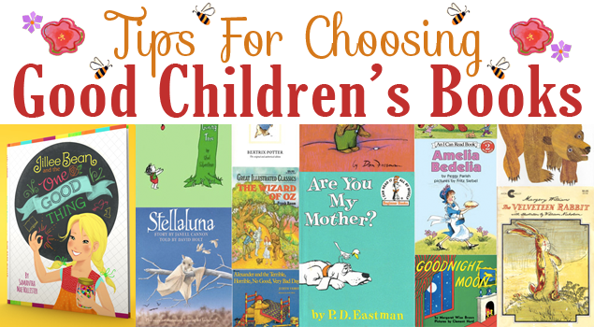
We call them book selection and see them as the act of choosing the right books for libraries or individual children, an act which also always, though we might not be willing to acknowledge it, deprives child readers of access to what we think are the wrong books. Even in choosing not to buy or share certain books because we cannot buy or share everything, we are still depriving young readers of access to the ones we have opted to leave out. If practising censorship—oops, I mean book selection—is inevitable, then we ought to do it humbly and with and ongoing sense of how easily it might turn into something more recognizably censorious. We might best do it while trying to have an awareness of our own various forms of privilege and their possible effect on our selection decisions—how it might be persuading us to leave out too much, or perhaps, I have to acknowledge, to leave out too little. We might best select with humility about the extent and limitations of our own wisdom and our own values, with an effort to be aware of what we haven’t considered to be negative and with a willingness to allow as much as we possibly can and leave out as little as we can persuade ourselves to leave out. We might best remember that the necessity of selecting books does not free us from our obligation as adults to help children develop knowledge of how to interact with and think productively about the world in all its aspects—including the ones we would rather they did not know about.
And perhaps above all, we might best approach our considerations of these matters and how to deal with them with a profound sense of our own fallibility. We might try to be less certain—less certain, certainly, than I was myself in 1992.

Works Cited
Alter, Alexandra. “In an Era of Online Outrage, Do Sensitivity Readers Result in Better Books, or Censorship?” New York Times, December 24, 2017. https://www.nytimes.com/2017/12/24/books/in-an-era-of-online-outrage-do-sensitivity-readers-result-in-better-books-or-censorship.html
Blackall. Sophie “Depicting Slavery in A Fine Dessert.” Sophie Blackall blog. http://sophieblackall.blogspot.com/2015/10/depicting-slavery-in-fine-dessert.html
Calling Caldecott. Horn Book. September 23, 2015. https://www.hbook.com/2015/09/blogs/calling-caldecott/a-fine-dessert/
“Cannibalism? pro? cons?” Yahoo Answers. https://answers.yahoo.com/question/index?qid=20070427215335AA2Sd6r
“The Diversity Gap in Children’s Book Publishing, 2018.” The Open Book Blog, May 10, 2018. Https://Blog.Leeandlow.Com/2018/05/10/The-Diversity-Gap-In-Childrens-Book-Publishing-2018/
Ganeshram, Ramin. A Birthday Cake for George Washington. Illustrated Vanessa Brantley-Newton. New York : Scholastic Press, 2016.
Jackson, Kosoko. A Place for Wolves. Naperville, Illinois : Sourcebooks Fire, 2019.
Jenkins, Emily. A Fine Dessert, illus. Sophie Blackall. New York: Schwartz & Wade Books, 2015.
“LOL Surprise Baby Dolls in Blind Bag–Do They Cry, or Color Change in Water?” YouTube. https://www.youtube.com/watch?v=rI2HtAU2KOs
Menkart, Deborah. “Under Pressure, Scholastic Recalls Racist Children’s Book. Huffington Post, Dec 6, 2017. https://www.huffingtonpost.com/the-zinn-education-project/under-pressure-scholastic_b_9010900.html
Mcintosh, Peggy . “White Privilege and Male Privilege. A Personal Account of Coming to See Correspondences through Work in Women’s Studies.” Seed. https://www.nationalseedproject.org/images/documents/White_Privilege_and_Male_Privilege_Personal_Account-Peggy_McIntosh.pdf
Nodelman, Perry. “A Second Look: Sing Down the Moon.” Horn Book Magazine 60.1 (Feb 1984): 94-98 https://zenodo.org/record/556564#.XJPwMy3MzOQ
– – -. “We Are All Censors.” Canadian Children Literature 68 (1992): 121-133. https://zenodo.org/record/557034#.XJTshi3MzOQ
Park Dahlen, Sarah, and Jamie Naidoo. Diversity in Youth Literature: Opening Doors Through Reading. ALA Editions, 2012.
“Publishing Statistics on Children’s Books about People of Color and First/Native Nations and by People of Color and First/Native Nations Authors and Illustrators.” CCBC https://ccbc.education.wisc.edu/literature-resources/ccbc-diversity-statistics/
Reese, Debbie. American Indians in Children’s Literature. https://americanindiansinchildrensliterature.blogspot.com
– – – . “Indigenizing Children’s Literature.” Journal of Language and Literacy Education [Online], 4,2 (2008): 59-72. http://jolle.coe.uga.edu/wp-content/uploads/2013/03/indigenizing.pdf
Research on Diversity in Youth Literature. http://sophia.stkate.edu/rdyl/
“Table 203.60: Enrollment and percentage distribution of enrollment in public elementary and secondary schools, by race/ethnicity and level of education: Fall 1999 through fall 2027.” Digest of Education Statistics. IES/NCES: National Center for Education Statistics. https://nces.ed.gov/programs/digest/d17/tables/dt17_203.60.asp?
Thomas Ebony, The Dark Fantastic: Race and the Imagination from Harry Potter to The Hunger Games. New York: New York University Press, 2019.
Trier, Walter. 10 Little Negroes. London: Sylvan Press, 1944
Zhao, Amélie Wen. Blood Heir. New York: Delacorte Press, [2019.

