A public school in England and Wales is a fee-charging endowed school originally for older boys that was "public" in the sense of being open to pupils irrespective of locality, denomination or paternal trade or profession. ... Public schools have had a strong association with the ruling classes.
- public school (Britain, esp. England) = a private school for young people between the ages of 13 to 18, whose parents pay for their education. The students often live at the school while they are studying.
- English state-funded schools, commonly known as state schools, provide education to pupils between the ages of 3 and 18 without charge. Approximately 93% of English schoolchildren attend 20,000 or so such schools. Since the year 2008 about 75% have attained "academy status", which essentially gives them a higher budget per pupil from the Department for Education.
There are a number of categories of English state-funded schools including academy schools, community schools, faith schools, foundation schools, free schools (including 'studio schools' and University technical colleges), and a small number of state boarding schools and City Technology Colleges. About one third of English state-funded schools are faith schools; i.e. affiliated with religious groups, most often from the Church of England (approximately 2/3 of faith schools), or the Roman Catholic Church (around 3/10). There are also schools affiliated to other Christian churches; in 2011, there were 42 Jewish, 12 Muslim, 3 Sikh and 1 Hindu faith schools. All of these are funded through national and local taxation. A number of state-funded secondary schools are specialist schools, receiving extra funding to develop one or more subjects in which the school specialises, such as Cirencester Deer Park School, which currently has 5 specialisms. State schools may request payment from parents for extracurricular activities such as swimming lessons and field trips, provided these charges are voluntary.
- public school (US, Australia, Scotland and other countries) = a free local school paid by the government
- state school (known as a "public school" in some countries), a no-fee school, funded and operated by the government
- private schools (religious and non-sectarian) are available, but students must pay tuition to attend them.
- high school (secondary school) (in US) for young people between the ages of 14 and 18 (in Britain) between the ages of 11 and 18

- college (in both Br. and North Am. English) is a place where you can go to study after you leave secondary school In Britain you can go to a college to study or to receive a training in a particular skill. In the US you can study for your first degree at a college.
- university offers more advanced degrees in addition to first degrees.
- public university, in some countries, e.g. the United States, any university operated by the government as opposed to a privately owned organization. All children in the United States have access to free public schools.

GUIDE TO THE EDUCATION SYSTEM IN THE UNITED STATES BY ANTONELLA CORSI-BUNKER

AMERICAN EDUCATION SYSTEM: AN OVERVIEW
General Information

The American education system is unlike that in many other countries. Though the U.S. Federal government contributes almost 10% to the national education budget, education is primarily the responsibility of state and local government. For example, in Minnesota, almost 80 percent of public education funds come from state sources. About 17 percent comes from local sources, while less than 5 percent comes from the Federal government.

Every State has its own department of education and laws regulating finance, the hiring of school personnel, student attendance, and curriculum. States also determine the number of years of compulsory education: in most states, education is compulsory from five or six to sixteen; but in some states teens have to stay on in school until age 18. So, every state has great control over what is taught in its schools and over the requirements that a student must meet, and it is also responsible for the funding of schooling. In most States, the public education system is further divided into local school districts, which are managed by a school board, representing the local community.

School districts can be small, covering just a small town or rural county, or enormous, covering a whole large city; according to their local policy, they are responsible for coordinating education policies, planning for changing educational needs in the community, and often even establishing programs and curricula. They will also delegate a varying amount of freedom or independence to each individual school within their sector (with some exceptions, such as general rules concerning health and safety). Public schools have also relied heavily on local property taxes to meet the vast majority of school expenses.

American schools have thus tended to reflect the educational values and financial capabilities of the communities in which they are located. Therefore, there is huge variation among schools regarding courses, subjects, and other activities – it always depends on where the school is located. Still, there are some common points, as e.g. the division of the education system into three levels: elementary/primary education, secondary education, and postsecondary/higher education (college or university).

Formal schooling lasts 12 years, until around age 18.

Compulsory schooling, though, ends by age 16 in most states; the remaining states require students to attend school until they are 17 or 18. All children in the United States have access to free public schools. Private schools (religious and non-sectarian) are available, but students must pay tuition to attend them.

Many states and communities provide schools or special classes for children with special educational needs, including those with emotional and behavioural problems, moderate and severe learning difficulties, communication problems, partial hearing or physical disabilities. There are also private schools catering for gifted and talented children, and most public schools have gifted and talented programs. In the following description of the U.S. education structure, we will focus on early childhood, primary and secondary education systems.

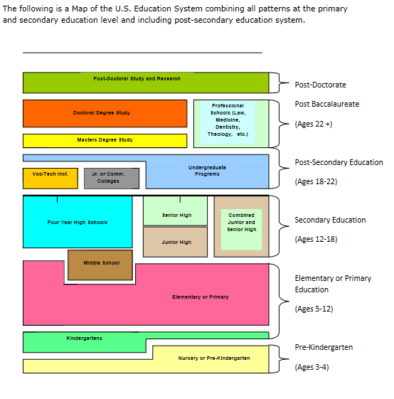
Separation of State and Religion
The US constitution requires the separation of state and religion and forbids religious observance in public schools, but in some schools children are still expected to participate in the ritual morning pledge of allegiance to the American flag in many schools (although the words ‘under God’ are optional).

Parental Involvement
An aspect of the US education system is the high degree of parental involvement. ‘Parent power’ isn’t only accepted, but is welcomed and encouraged through local Parent Teacher Associations (PTAs) attached to every school. PTAs meet regularly and concern themselves with many aspects of a school’s affairs including the curriculum, facilities, school hours and after-school activities and programs. Parents are encouraged to attend meetings and show an interest in the school and their children’s education (it’s also a good way for newcomers to make friends). Schools organize parent days, ‘back to school’ nights and parent-teacher conferences, where parents can meet teachers and examine their child’s school timetable.

Individual Responsibility
Individual responsibility has an important place in the American value system. This value is taught to children from a young age. For example, beginning from kindergarten, each year students are given a handbook that outlines the details of the school’s policies and procedures, and the consequences for violating them. The handbook includes policies on Hazing, Personal Possessions, and Harassment, and is designed to help parents and students understand the district’s guidelines for acceptable behavior in all of these areas. BOTH parents and students are expected to read it and sign a form attesting they are aware of their rights and responsibilities. Many teachers also ask students to sign a handout detailing policies and procedures to follow in their classes.

