Peter Gray - www.psychologytoday.com/blog/freedom-learn
www.svobodauceni.cz
Neill, A. S.: Summerhill. A Radical Approach to Child Rearing. 1960
Goodman,Paul: Compulsory Miseducation. 1964
Holt, John: How Children Fail. 1964
Rogers, Carl: Freedom to Learn. 1969
Illich, Ivan: Deschooling Society. 1971
Kozol, Jonathan: Free Schools. 1972
Holt, John: Freedom and Beyond, 1972

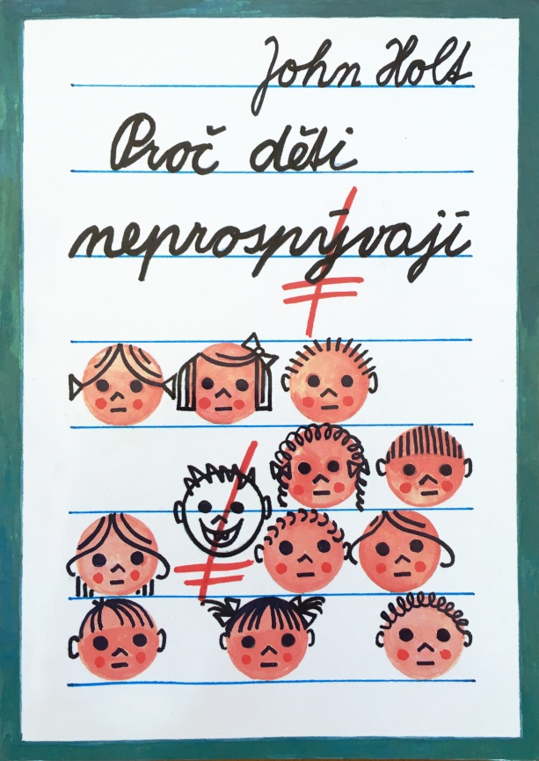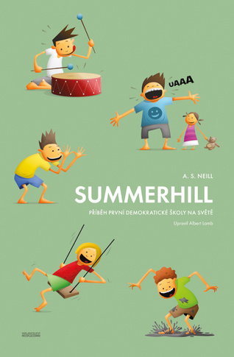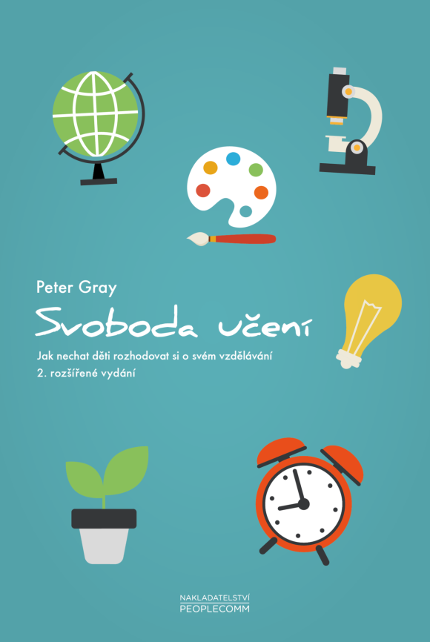
Jana Nováčková - Názory Aktuálně.cz (aktualne.cz)

