Economical pillar task

- Study terms and write notes
Market law, supply and demand law, Global World, marketing move, price, value, valuation, Gross Domestic Product, circular economy, planetary boundaries

- See and write notes on Ecological Footprint history
Who invented? Why?

- See on the list of countries by ecological footprint. Choose your state and write the number and your openion about its position.

- Compare Ecological Footprint with GDP. What connections do you see?

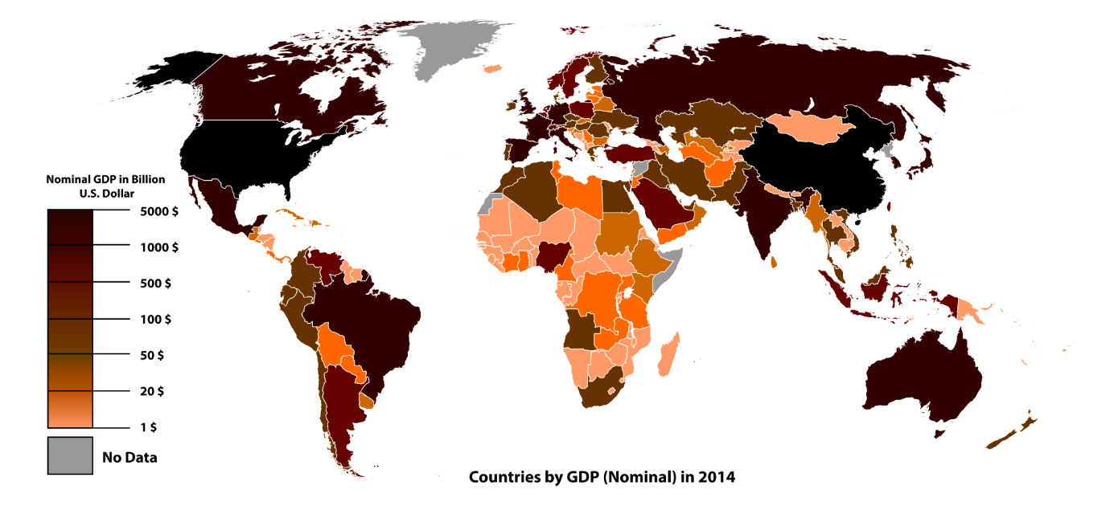

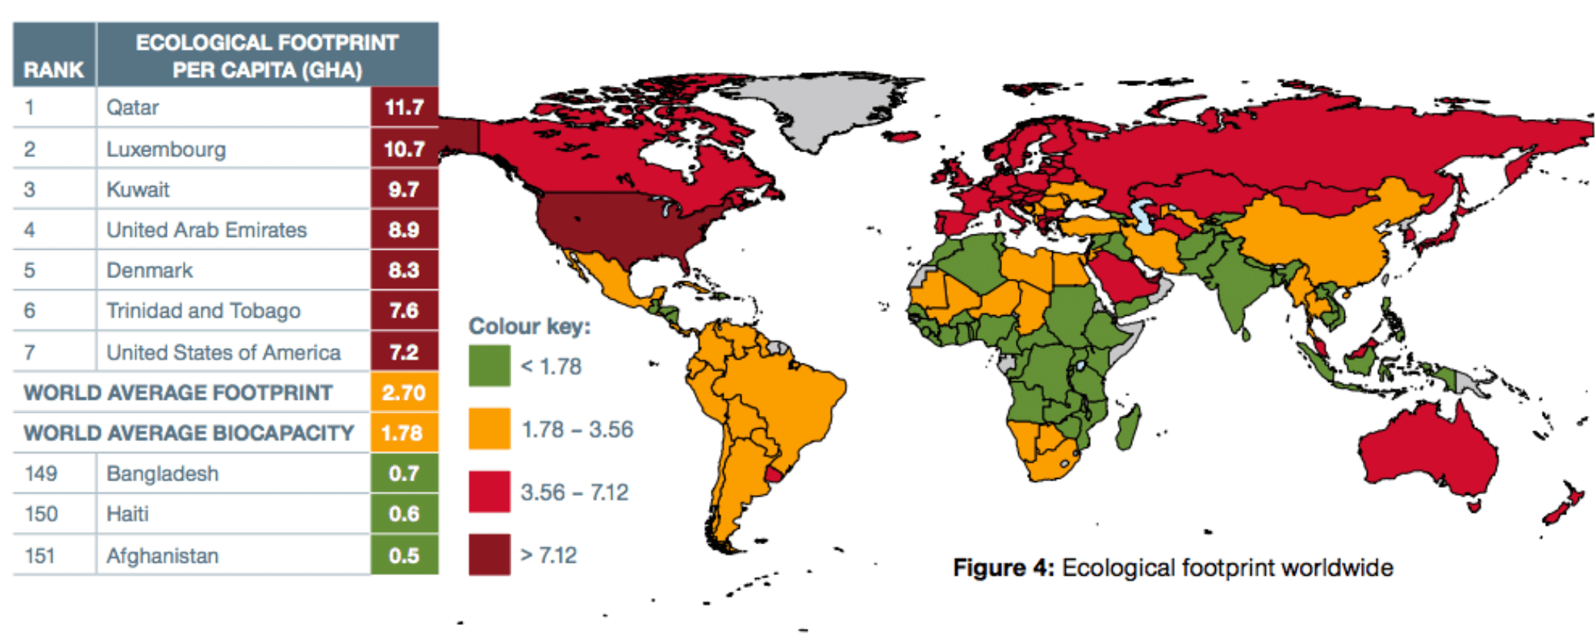

- Count ecological footprint, write the number and your notes
For example on the calculator https://www.footprintcalculator.org/
- Study the case of "Rose of Africa". Write me short essey about the topic. Do you change behavior when you have information? Why yes, why not etc.

