Handout 7 Property law, inheritance

Internet search

- Tangible property
- An interest in land
- To dispose of property
- Compulsory purchase order
- To convey property

Vocabulary – questions
- Under English law, some types of right in rem must be registered. Explain “right in rem”.
- If you own a car together with your brother, what is this called?
- Property owned by the spouses is called ___________________________ .
- In several English-speaking countries, you can own property with someone else either in joint tenancy or in tenancy in common. In these expressions, the word “tenancy” is synonymous with “ownership”. TRUE/FALSE
- Which of these terms (joint tenancy or tenancy in common) involves the right of survivorship? Explain what the “right of survivorship” is.
- Explain the legal meaning of personal property. Provide a synonym.
- Explain the difference between realty and personalty.
- Provide a synonym for immovable property.
- Anything that can be physically touched is known as __________________.
- What are chattels?
- Provide some examples of intangible property.
- Corporeal property is the same thing as ___________________ .
- Can you possess a car without owning it? Explain your answer.
- If you were deprived of possession, you were __________________ (1 verb).
- Provide a noun derived from the verb “to acquire”.
- What is an easement?
- An easement is a type of incorporeal property. TRUE/FALSE
- Can you see any difference between the words heritage and inheritance?
- The person who inherited some property is called a/an __________ .
- The document in which people decide who should inherit their property is called ____________________ .
- If you devise or bequeath your property to someone, what does it mean?
- “He devised his land to his daughter”. “He bequeathed his car to his daughter”. Formulate the difference between “to devise” and “to bequeath”.
- What is a holographic will?
- If a decedent made two wills, the subsequent will would prevail. Who is a decedent?
- A decedent's estate refers to the assets and liabilities of a deceased person prior to the division of the estate. Estate is synonymous here with ____________ .
- The forced heir has the right to a portion of the estate, depending on how many other children there are. Provide an example to illustrate forced heirship.
- In the context of inheritance law, what is the difference between an executor and an administrator?
- Explain the difference between testamentary succession and intestate succession.
- Intestacy is the same thing as _________________ .
- John died testate and Mary died intestate. Explain.
- What is the purpose of probate?
- The property passes to multiple heirs by operation of law. Explain this sentence.
- A person who has written a last will is known as a ______________ .
- What is a compulsory share (= statutory share) of the inheritance?

Bernie Krooks – Last will (0-7:30)

Spot the factual mistakes in the text and correct them.
- If you die testate, the person you appoint in your will (the administrator) is responsible for marshalling all your assets and selling some of them to pay off your debts. The rest will be distributed to the persons you have listed in your will. In New York State, just as in any other jurisdiction, you are required to leave a part of your property to your minor children. This is called forced heirship. If you are of unsound mind, you can leave your property to anyone. In other words, you have the right to dispose of your property as you please. Your spouse is a forced heir – she is entitled to 1/3 of your estate. Other than the spouse and your children, you don’t have to leave your property to anyone else.
- New York State has prepared a neat copy of a last will (which stipulates who gets your property) for every single citizen who dies intestate. Intestacy means that you have died without a will. The applicable statute sets out the hierarchy of persons who will inherit in case you die without a will. If you die intestate, the person who will take care of your estate is called an executor.
- Sometimes people don’t want their estate to be distributed among their children equally, because some of the children make more money than the others, and as some lawyers say, “what’s equal isn’t fair, and what’s fair isn’t equal.”
- Wills are “ambulatory” which means that they can be typed or hand-written, and both types are equally effective.
- These days there are disputes in many families, often concerning deep-rooted issues. So if you wish to take your last revenge, your last will is a perfect way how to do that. Preferably you should explain your reasons for excluding someone from your last will because then the child who is getting short-changed is less likely to contest the last will. Other lawyers do not recommend this practice because it can add fuel to the fire and worsen the family relationships.
- After your death, the will gets admitted to the probate. The word “probate” comes from Latin and it means “to prove”. The primary objective of the probate proceedings is to verify whether your signature on the last will is genuine.

Questions

- Do you know anyone in your family who has drafted their last will?
- Do you intend to prepare your own last will?
- What are the necessary elements of a last will?
- Do last wills have to be drafted by lawyers?
- What is a “living will”?

The case of George

In 1948, a Canadian farmer named George was working on his land one day when he became trapped under his tractor. George knew that his situation was dire, and, to ensure his wife would be taken care of in case he died that day, he took out his pocket knife and scratched a will onto his tractor fender. The etching read, “In case I die in this mess I leave all to the wife. George Harris.” George was ultimately trapped under the tractor for about 10 hours by the time others in the community realized he needed help. Although George made it to a local hospital, he succumbed to his injuries the following day.

- Summarise the case in your own words.
- What could be a relevant legal issue that could lead to some disputes?
- Who could initiate the dispute and why?
- How would a judge decide?

Lousiana Civil Code, Articles 477, 518

Supply appropriate synonyms
Ownership is the (1) entitlement? ………………….. that confers on a person direct, immediate, and (2) monopoly? ………………… authority over a thing. The owner of a thing may (3) utilize? ……………….., enjoy, and (4) handle? …….……………. of it within the limits and under the conditions established by law.
The ownership of (5) personalty? …………………………… is voluntarily (6) transferred? …….……………… by a contract between the owner and the transferee that purports to transfer the ownership of the movable. (7) If no other arrangements apply? ………………………………………………, the transfer of ownership takes place as between the parties by the effect of the agreement and against third persons when the possession of the movable is delivered to the (8) acquirer? …………….
When possession has not been delivered, a subsequent transferee to whom possession is delivered (9) obtains? …………………… ownership (10) as long as? ………………………… he is (11) bona fide? …………………………... (12) The entity to whom you owe money? ……………………………… of the transferor may seize the movable while it is still in his possession.

Video: Silk 5

- Put the pictures in a chronological order.
- For each picture, briefly describe what happened in the video.
a.
b.
c.
d. | 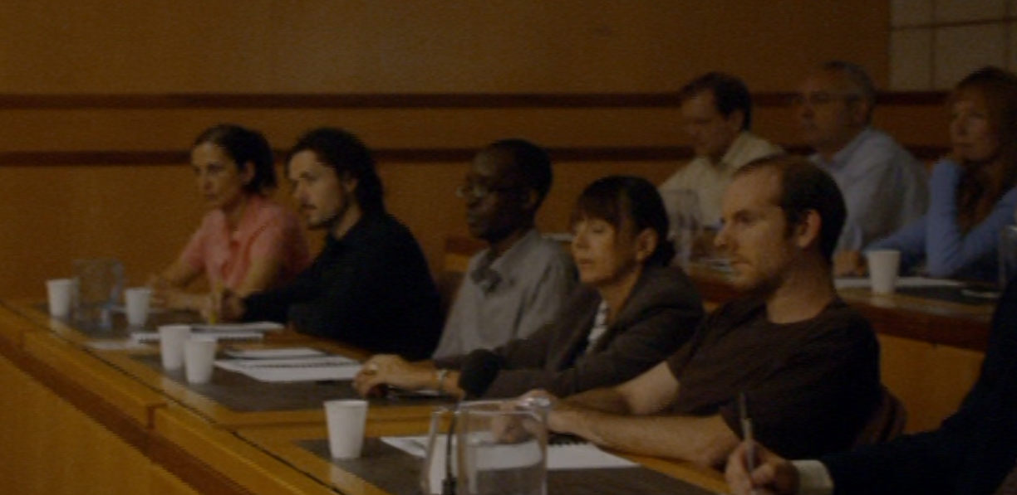
e.
f.
g.
h.

