CLASS 1 ORIGINS AND UNIQUE NATURE OF HUMAN LANGUAGE
What enables TALKING?
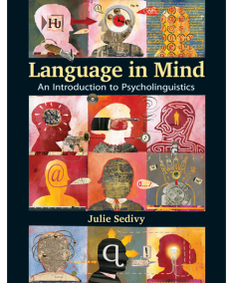
Descartes’ (1596-1650) Meditations ar. 1637, on the on the significance of language, and homo sapiens vs. the beasts: For it is a very remarkable thing that there are no men, not even the insane, so dull and stupid that they cannot put words together in a manner to convey their thoughts. On the contrary, there is no other animal however perfect and fortunately situated it may be, that can do the same. And this is not because they lack the organs, for we see that magpies and parrots can pronounce words as well as we can, and nevertheless cannot speak as we do, that is, in showing that they think what they are saying. On the other hand, even those men born deaf and dumb, lacking the organs which others make use of in speaking, and at least as badly off as the animals in this respect, usually invent for themselves some signs by which they make themselves understood. And this proves not merely animals have less reason than men but that they have none at all, for we see that very little is needed to talk (Descartes, 1637/1960, p. 42).
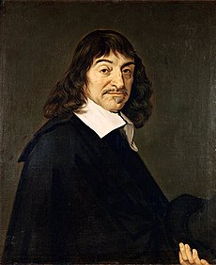
QUESTIONS:
LANGUAGE ADVANCEMENT/ becoming advanced due to human language
1. What’s implied by human language being conventional?
2. Is language a genetic blueprint or learned on the basis of general cognitive skills?
3. Did we invent language (cf. Dan Everett’s bows and arrows analogy)?
- Why us? Why do HUMANS have language?
- Is human language different down to its core or just a sophisticated modification of a system that predated it?
- HOW DOES LANGUAGE WORK?
- WHAT MAKES HUMAN LANGUAGE HUMAN?
- What are some of the explicit connections between brain and language usage?
- 9. Is language an outcome of human evolution?
- 10. How is communication different from "language"?
- HOW and WHY did LANGUAGE ORIGINATE?
- WHY does LANGUAGE exist in so many languages?
- In what ways is the language confusion linked to building the tower of Babel a blessing?
- And in what ways is language diversity related to the nature of human brain and human language?
- How does language distinguish our mind from animal mind?
- What is the basic goal of animal vs. human communication?

CLASS 2: Human language cf. animal communication systems
Hockett’s design features of human languages
Minding the gap between behavior and knowledge
Social underpinnings of language
Language structure and programming
The recursive power of syntax
Communication systems of bees, vervet monkeys, chimps, baboons, etc. p. 13
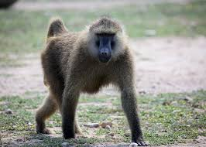
- What’s missing about “language” in vervets’ warning calls?
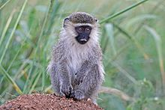
Jane Goodall ‘s TED on studying chimps in Tanzania: https://www.ted.com/talks/jane_goodall_what_separates_us_from_chimpanzees?referrer=playlist-ancient_clues
18. Why teach chimps “language”?
19. How and where do chimps USE “language”?
20. In what way is the learning environment important? cf. Were hands made for piano playing?
21. What is it about human language that’s so different from what animals do when they communicate? Do we have a “communicative urge”? What’s the substance of human communication?
22. What’s the point of pointing, as when babies point? Do chimps point or respond to helpful pointing?
23. What’s so important about “joint attention”?
24. What’s implied by the suggestion of independent evolution of vocal skills in diverse animals?

What’s unexpected about the soundmaking apparatus and sound learning of humans and birds, and humans and chimps? How far can chimps go in mimicking vocalizations? What is songbirds’ range of vocalizations and mimicking capacity?
- How would you describe human vocalizations vs. those of chimps that are affective, innate and inflexible?
- Why and how do babies babble?
- In relation to speech, what’s the one feature of human language make-up that Hockett didn’t get right?
SEDIVY 2.1, exs 1-3 https://learninglink.oup.com/access/sedivy-2e-student-resources#tag_chapter-03
Describe the kind of evidence you would want to see in order to be able to determine whether particular features (of Hockett’s list of human language characteristics) are present:

Example 1: Your dog is able to obey simple commands such as sit, heel, stay, down and roll over.

Example 2: Your cat is able to persuade you to feed her by circling her empty dish and meowing loudly.

Example 3: According to researchers Stephanie King and Vincent Janik (2013), dolphins are able to invent or learn new “signature” whistles that are used to identify individual dolphins. When the researchers played recordings of signature whistles, dolphins responded to their own signature whistles by calling back with the same sounds, but did not respond to whistles that were not their own.

Example 4: Animal researcher Con Slobodchikoff has argued that prairie dogs have the most complex communication system that has so far been observed in animals. The following video describes his findings. Based on the information in this video, discuss which of Hockett’s features seem to apply to prairie dog communication. http://www.youtube.com/watch?v=c_hUIEBwlEo
LANGUAGE STRUCTURE
1. Are we programmed for LANGUAGE STRUCTURE / preexisting structural biases (Noam Chomsky)?
2. What does STRUCTURE imply?
3. In what way does invention of words move communication to a new level? Why can’t sounds do?
4. How do we practice the “duality of patterning“?
5. What is meant by adding the syntax level to communication? Wouldn’t words do?
6. In what way is recursive syntax powerful (“stringing” and “nesting”)?
7. What made N. Chomsky search for “universal grammar”?
8. Would you say that,
a. language is made up similarly in all of us, constrained by the same-for-all human brain and predisposed genetically in certain ways, or,
b. the „sameness“ is due to universal genetic programming and hard-wired biases responsible for the acquisition of identical language structures?
9. Can we list universal features evident in languages? Can we list similarities?
10. What is the innate cognitive predisposition to learn language all about?
11. Do we, then, need cultural transmission? What does it contribute to language learning?
12. What’s understood by babies’ “robust learning” of language? What’s their resource?
13. Sedivy suggests that common patterns evident in languages may be due to humans’ effort to solve the same sort of “communicative problems” (D. Everett’s bows and arrows analogy)? What do you understand by communicative problems?

Web Activity 2.2 Finding structure in language

Example 1 Where can and appear in English?
The conjunction and is used to join words or phrases in English, but it can not appear just anywhere. Can you describe the places where it can be used as a connector? How do you think English-learning children would figure out the correct patterns?
Example 2 Can prepositional phrases appear at the beginning of a sentence in English?
Consider the examples below. Why are prepositional phrases allowed at the beginning of a sentence some of the time, but not always? Can you articulate a generalization?
Siobhan has her singing lessons on Tuesday. Cf. On Tuesdays, S. has her singing lessons.
vs. Siobhan heard a lecture on Proust. Cf. *On Proust, Siobhan heard a lecture.

Example 3 Verbs in Semitic languages
It’s common for verbs to change their shape and convey information about whether the action took place in the past or present, or about who is initiating the action. (For example, in English: I play, he plays, we played.) But the verbs of Semitic languages spoken in the Middle East change their shape in quite unusual ways. Consider the examples from Egyptian Arabic below: Can you get a handle on the pattern that drives the changes in verbs? To say “he copied”, you would say na’al (symbol ’ denotes a glottal stop. How would you pronounce “I copy,” “copier,” or “copied”?
Katab | “he wrote” | Daras | “he studied”
Baktib | “I write” | Badris | “I study”
Iktib | “Write!” | Idris | “Study!”
Kaatib | “writer” | Daaris | “studier”
maktuub | “written” | madruus | “studied”

