[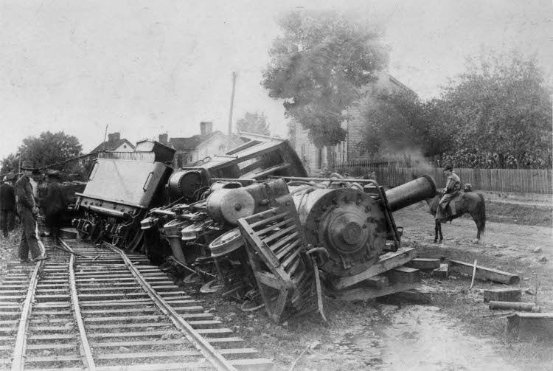](https://www.google.cz/url?sa=i&rct=j&q=&esrc=s&source=images&cd=&cad=rja&uact=8&ved=0ahUKEwi4rebM1d3SAhWIuRoKHWIEAB0QjRwIBw&url=https://www.drive2.ru/b/436136/&psig=AFQjCNEaY9mN8WUKWR27LlOis4uxDb6dyw&ust=1489844493613078)

[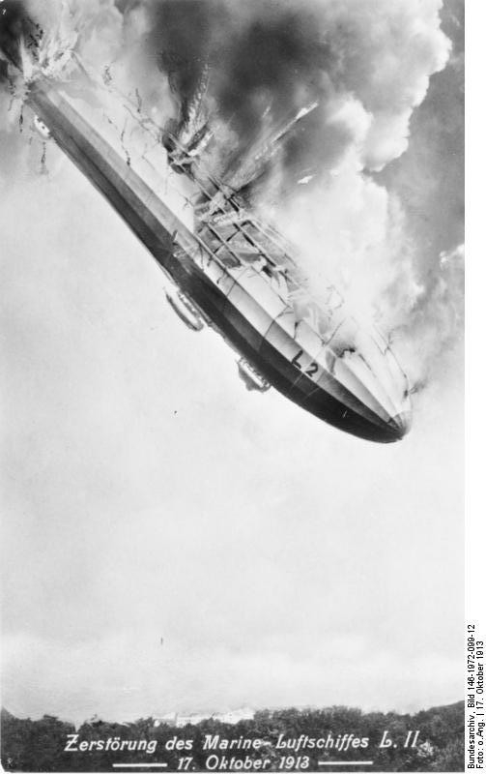](http://www.google.cz/url?sa=i&rct=j&q=&esrc=s&source=images&cd=&cad=rja&uact=8&ved=0ahUKEwjT4Orw1d3SAhXB5xoKHXsOCxwQjRwIBw&url=http://www.phototopic.ru/novisti-v-fotografiyah/top-10-samyh-uzhasnyh-katastrof-dirizhabley.html&bvm=bv.149760088,d.d2s&psig=AFQjCNGWNS2tf2LdlGV_JXtzC3K8xj2njg&ust=1489844612792857)

[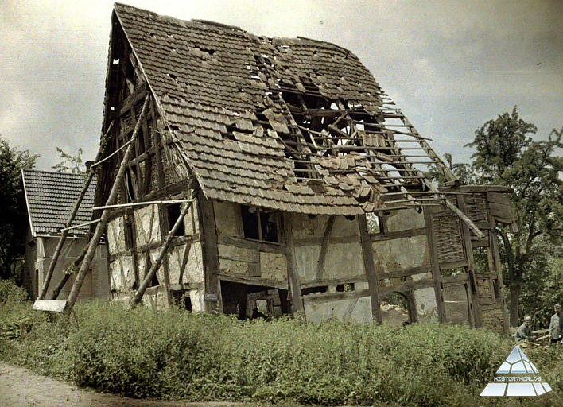](http://www.google.cz/url?sa=i&rct=j&q=&esrc=s&source=images&cd=&cad=rja&uact=8&ved=0ahUKEwiAgKfN1t3SAhWClxoKHeQRAx0QjRwIBw&url=http://www.historyworlds.ru/gallery/vojjny-narodov/pervaja-mirovaja-vojjna/cvetnye-fotografii/8161-foto-14.html&bvm=bv.149760088,d.d2s&psig=AFQjCNH3Xxm5mhnahNRVvQTTuu2y-BNwJw&ust=1489844810279435)

[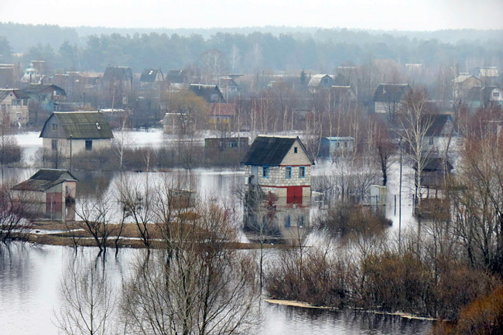](http://www.google.cz/url?sa=i&rct=j&q=&esrc=s&source=images&cd=&cad=rja&uact=8&ved=0ahUKEwjrs4GS193SAhXH0hoKHe27AhsQjRwIBw&url=http://www.mogilev.by/mnews/76997-dachniki-iz-mozyrskogo-rayona-srochno-evakuiruyut-svoe-imuschestvo-lovyat-rybu-pryamo-na-ulice-i-prosyat-otsypat-im-dorogu.html&bvm=bv.149760088,d.d2s&psig=AFQjCNFXUSzNe4B9qb8cuS_MTnZs02X2Zg&ust=1489844744509607)

[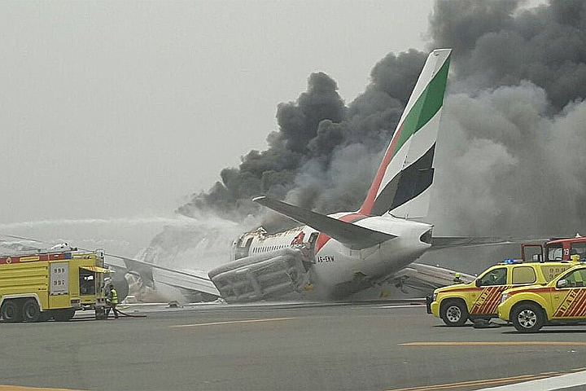](http://www.google.cz/url?sa=i&rct=j&q=&esrc=s&source=images&cd=&cad=rja&uact=8&ved=0ahUKEwid5cX_193SAhUG1BoKHQpfAiUQjRwIBw&url=http://www.kp.ru/online/news/2469814/&bvm=bv.149760088,d.d2s&psig=AFQjCNFXUSzNe4B9qb8cuS_MTnZs02X2Zg&ust=1489844744509607)

[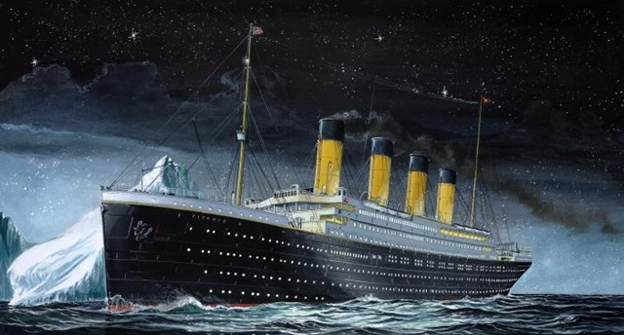](http://www.google.cz/url?sa=i&rct=j&q=&esrc=s&source=images&cd=&cad=rja&uact=8&ved=0ahUKEwi_xpno2N3SAhVBBBoKHaqHAh0QjRwIBw&url=http://lifeglobe.net/blogs/details?id%3D792&bvm=bv.149760088,d.d2s&psig=AFQjCNFNfMm8Krpz_ZERaHaYNJdG_VQrSA&ust=1489845375216897)

[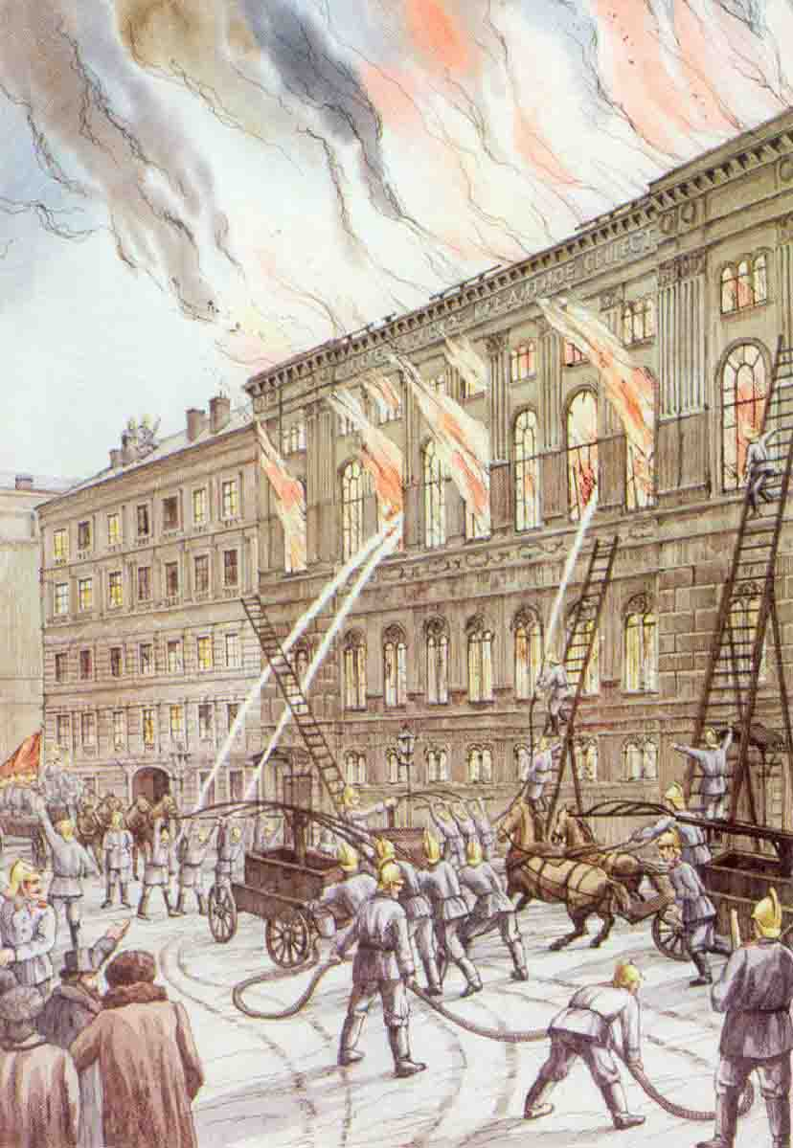](http://www.google.cz/url?sa=i&rct=j&q=&esrc=s&source=images&cd=&cad=rja&uact=8&ved=0ahUKEwi186rW3N3SAhVDDxoKHehKBRsQjRwIBw&url=http://54.mchs.gov.ru/folder/1463366&bvm=bv.149760088,d.d2s&psig=AFQjCNHVwGtVpgF5ncZyQk5lam9ERh9Arw&ust=1489846398852380)

[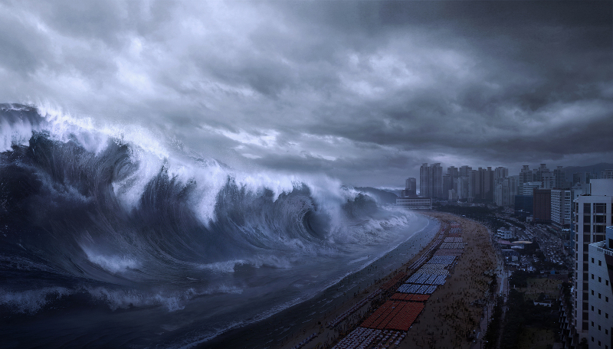](http://www.google.cz/url?sa=i&rct=j&q=&esrc=s&source=images&cd=&cad=rja&uact=8&ved=0ahUKEwi91qzY2d3SAhXJfhoKHUdCDRUQjRwIBw&url=http://www.meteovesti.ru/news.n2?item%3D63503079784&bvm=bv.149760088,d.d2s&psig=AFQjCNFJvtZYBBJsLY47_GOH6mo9Y8y7jA&ust=1489845617014342)

[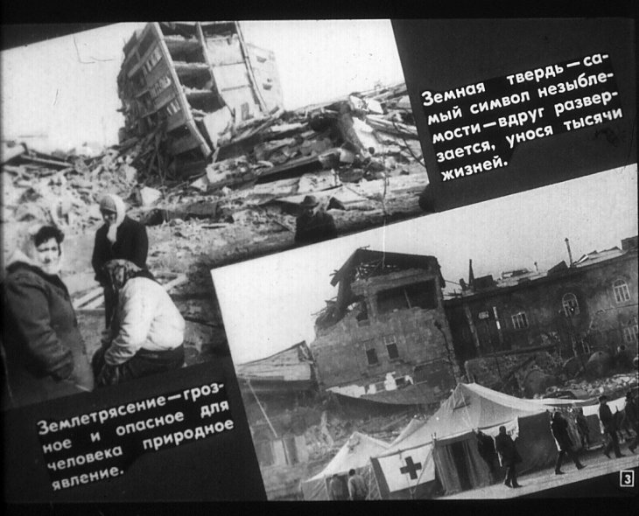](http://www.google.cz/url?sa=i&rct=j&q=&esrc=s&source=images&cd=&cad=rja&uact=8&ved=0ahUKEwig0MDp2d3SAhWCbBoKHeNiBxsQjRwIBw&url=http://diafilmy.su/1789-ostorozhno-zemletryasenie.html&bvm=bv.149760088,d.d2s&psig=AFQjCNHY_OqrWI2jzKj32UtRmUCBpNfrrg&ust=1489845679214731)

[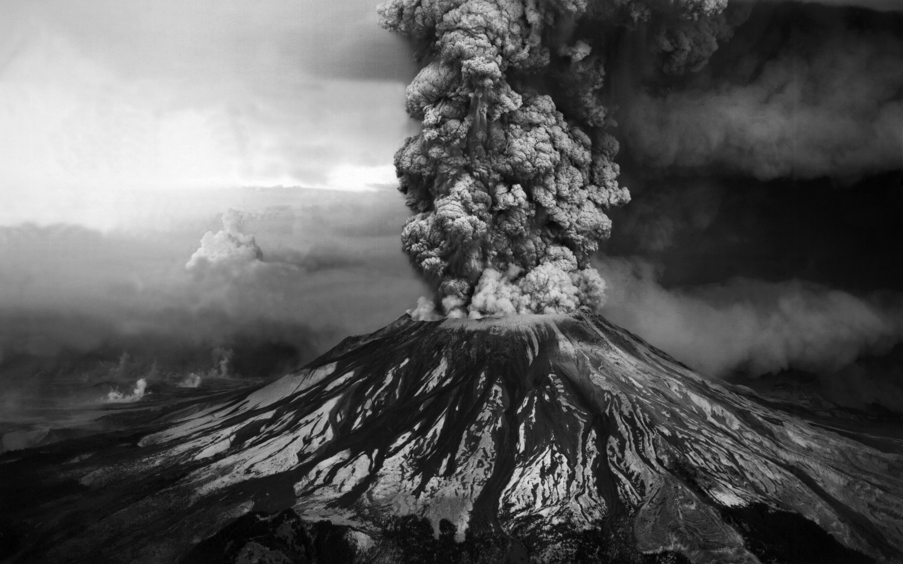](http://www.google.cz/url?sa=i&rct=j&q=&esrc=s&source=images&cd=&cad=rja&uact=8&ved=0ahUKEwi3kL7x2t3SAhXF2BoKHUbbBR8QjRwIBw&url=http://www.gandex.ru/oboishow/32130/9/&bvm=bv.149760088,d.d2s&psig=AFQjCNFXhhcmN2a_QdJXA2Q_Xqxr4D-CPQ&ust=1489845928603943)