[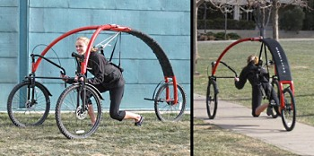](http://www.google.cz/url?sa=i&rct=j&q=&esrc=s&source=images&cd=&cad=rja&uact=8&ved=0ahUKEwi3odz51cvSAhXHbBoKHRT-DTQQjRwIBw&url=http://xage.ru/trehkolesnyij-glajder-dlya-lyubitelej-strannyih-vidov-transporta/&psig=AFQjCNEUMjgrc8_dvNm6ha2Foe202kcnsA&ust=1489226138865571)

[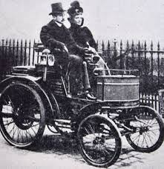](https://www.google.cz/imgres?imgurl=http://vintage-retro.ru/images/avto/retro-avto_09.jpg&imgrefurl=http://vintage-retro.ru/retro-avto.html&docid=1jl5qyPLZdLoiM&tbnid=S-IN8zfJvLzMZM:&vet=1&w=1036&h=1072&bih=933&biw=1920&q=%D1%87%D0%B5%D1%80%D0%BD%D0%BE%D0%B1%D0%B5%D0%BB%D1%8B%D0%B5%20%D0%BA%D0%B0%D1%80%D1%82%D0%B8%D0%BD%D0%BA%D0%B8%20%D1%81%D1%80%D0%B5%D0%B4%D1%81%D1%82%D0%B2%20%D1%82%D1%80%D0%B0%D0%BD%D1%81%D0%BF%D0%BE%D1%80%D1%82%D0%B0&ved=0ahUKEwiL9YGe1cvSAhWEfhoKHflnADQQMwhBKBowGg&iact=mrc&uact=8)

[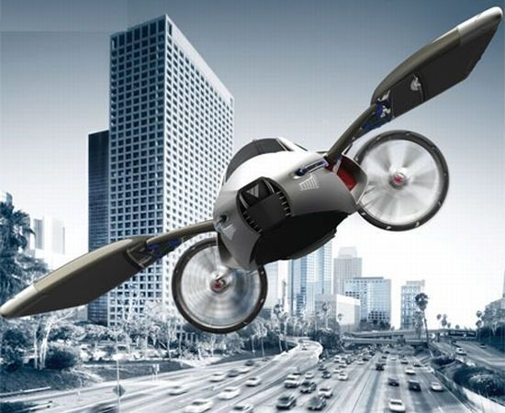](http://www.google.cz/url?sa=i&rct=j&q=&esrc=s&source=images&cd=&cad=rja&uact=8&ved=0ahUKEwiet6-W1svSAhUFChoKHQJ4CTQQjRwIBw&url=http://neskuchno-news.com/hi-tech/chudo-tekhnika-futuristicheskie-transportnye-sredstva-o-kotorykh-malo-kto-znaet-105512.html&psig=AFQjCNEUMjgrc8_dvNm6ha2Foe202kcnsA&ust=1489226138865571)

[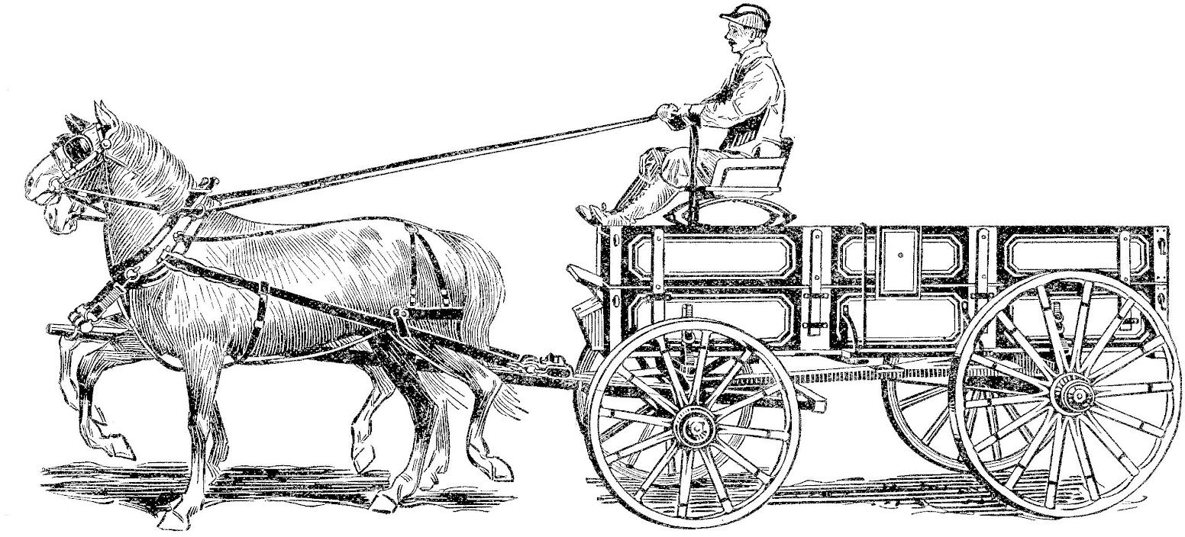](http://www.google.cz/url?sa=i&rct=j&q=&esrc=s&source=images&cd=&cad=rja&uact=8&ved=0ahUKEwiKla3Z1cvSAhXHvRoKHVCvDDMQjRwIBw&url=http://vintage-retro.ru/retro-avto.html&psig=AFQjCNE-OUsEJZDWyz0dbuaDptzxV8tPLA&ust=1489225981298261)

[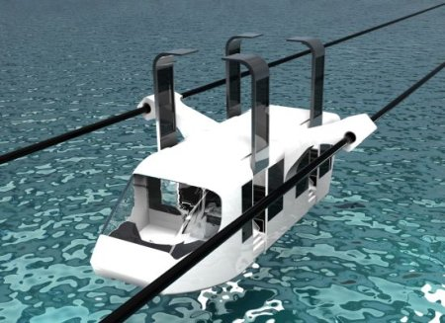](http://www.google.cz/url?sa=i&rct=j&q=&esrc=s&source=images&cd=&cad=rja&uact=8&ved=0ahUKEwjRsd6q1svSAhWJnBoKHUJIDTQQjRwIBw&url=http://www.dailytechinfo.org/auto/1248-gorodskoj-obshhestvennyj-transport-budushhego-sistema-na-magnitnoj-podveske-maglev.html&psig=AFQjCNEUMjgrc8_dvNm6ha2Foe202kcnsA&ust=1489226138865571)

[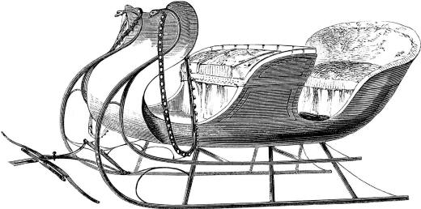](http://vintage-retro.ru/images/avto/retro-avto_07.jpg)

[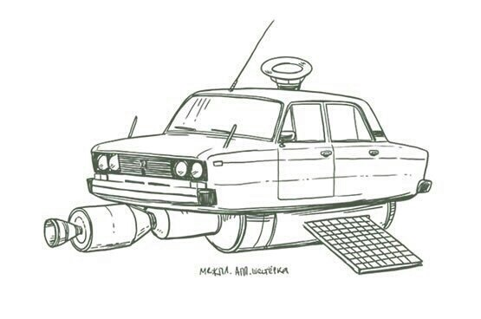](https://www.google.cz/url?sa=i&rct=j&q=&esrc=s&source=images&cd=&cad=rja&uact=8&ved=0ahUKEwj41_eujczSAhUHChoKHSY1BDQQjRwIBw&url=https://www.drive2.com/b/2230697/&bvm=bv.149093890,d.d2s&psig=AFQjCNGJl5UAIjZp3yxbAtoF0cwLKz5S1A&ust=1489240936699308)

[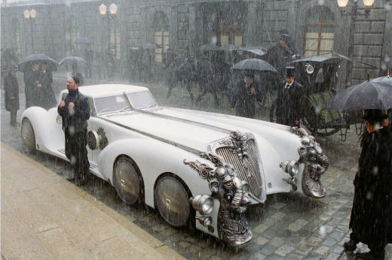](http://vintage-retro.ru/images/avto/retro-avto_08.jpg)

[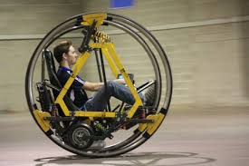](https://www.google.cz/imgres?imgurl=http://energycraft.org/images/stories/a0108.jpg&imgrefurl=http://energycraft.org/realizaciya/studenty-predstavili-transport-buduego.html&docid=YfxfWG4-M1hiwM&tbnid=gU4WS_CQpGLC9M:&vet=1&w=450&h=300&bih=933&biw=1920&q=%D1%87%D0%B5%D1%80%D0%BD%D0%BE%D0%B1%D0%B5%D0%BB%D1%8B%D0%B5%20%D0%BA%D0%B0%D1%80%D1%82%D0%B8%D0%BD%D0%BA%D0%B8%20%D1%81%D1%80%D0%B5%D0%B4%D1%81%D1%82%D0%B2%20%D1%82%D1%80%D0%B0%D0%BD%D1%81%D0%BF%D0%BE%D1%80%D1%82%D0%B0&ved=0ahUKEwjn3or5jMzSAhXJ0RoKHV7OCzQQMwhkKEAwQA&iact=mrc&uact=8)

[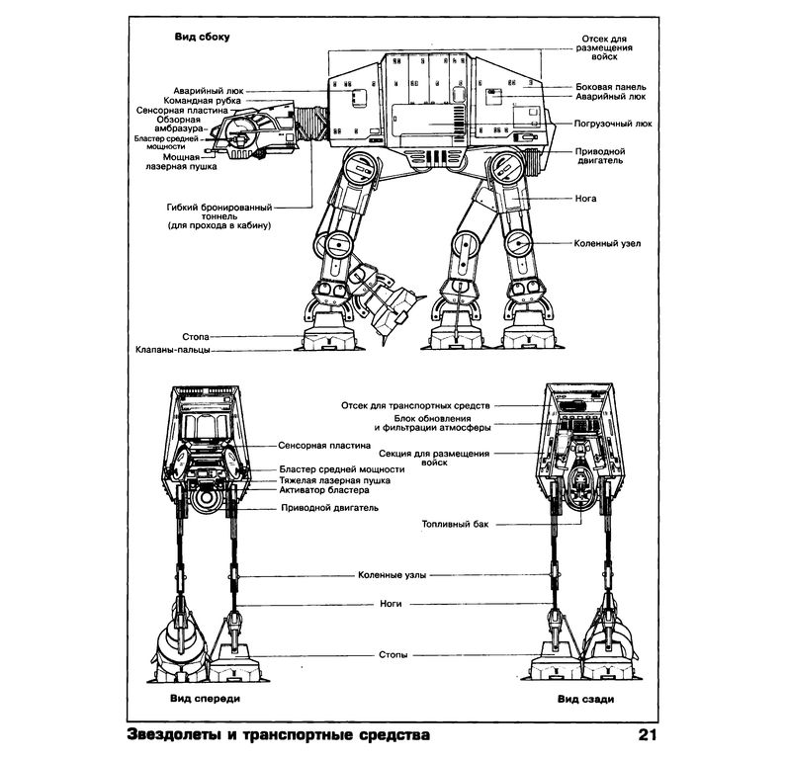](https://www.google.cz/url?sa=i&rct=j&q=&esrc=s&source=images&cd=&cad=rja&uact=8&ved=0ahUKEwiEkq_wjczSAhXD0hoKHXDoAjQQjRwIBw&url=https://bk-world.ru/products/kniga-zvezdnye-voyny-zvezdolety-i-transportnye-sredstva&psig=AFQjCNFhGrNcvwoXHK0b0TTylaxfyyI2cA&ust=1489241179562534)