[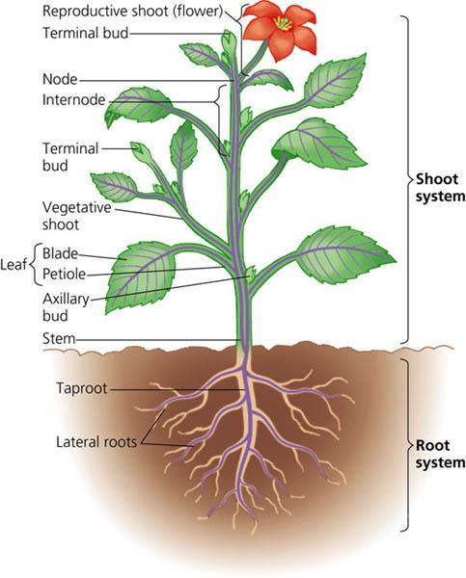](http://www.google.cz/url?sa=i&rct=j&q=&esrc=s&source=images&cd=&cad=rja&docid=kyU8IBl9zKh70M&tbnid=7z-1RJSu2DMX5M:&ved=0CAUQjRw&url=http://homeworks-edsci.blogspot.com/2013/04/k-to-12-science-grade-6-science.html&ei=wwTNUrqBL67M0AXX6oCACg&bvm=bv.58187178,d.ZGU&psig=AFQjCNEn6e72g7a-Mq1K1QhMZx6cbzMJFQ&ust=1389253958178587)