[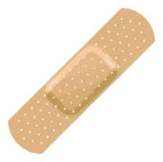](http://www.google.cz/url?sa=i&rct=j&q=&esrc=s&source=images&cd=&cad=rja&uact=8&ved=0CAcQjRw&url=http://www.claremontportside.com/print-edition/2012-2013/december-2012/the-band-aid-of-affirmative-action/&ei=iVURVf6mDYTTygOggIKwCw&bvm=bv.89184060,d.bGQ&psig=AFQjCNFAdKCzmM60dQaGN89NXh9D5XeZAg&ust=1427285773583278) [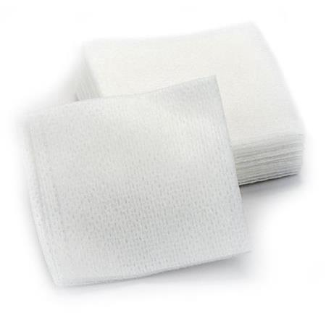](http://www.google.cz/url?sa=i&rct=j&q=&esrc=s&source=images&cd=&cad=rja&uact=8&ved=0CAcQjRw&url=http://www.massagewarehouse.com/shop-by-department/esthetic-supplies/cotton-supplies/&ei=B1YRVafvCMGsPJScgKgG&bvm=bv.89184060,d.bGQ&psig=AFQjCNGnxaQPtbWtqZlPpSkno9TyW9nQ_Q&ust=1427285874172713) [](http://www.google.cz/url?sa=i&rct=j&q=&esrc=s&source=images&cd=&cad=rja&uact=8&ved=0CAcQjRw&url=http://www.thefirstaidkits.com/products/55684.html&ei=r1YRVam7C8etPJ-8gZAJ&bvm=bv.89184060,d.bGQ&psig=AFQjCNHTSZaeuexedpJepZrixkBe1iHRsg&ust=1427285954465562)

Band aid / sticking plaster Gauze pads Gauze bandage

[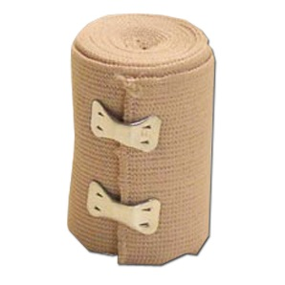](https://www.google.cz/url?sa=i&rct=j&q=&esrc=s&source=images&cd=&cad=rja&uact=8&ved=0CAcQjRw&url=https://store.federalresources.com/medical/wound-care/flesh-colored-elastic-bandage-6-x-4.5-yds.html&ei=MlcRVajAPMf2O-uNgZAB&bvm=bv.89184060,d.bGQ&psig=AFQjCNFMmOKDPDkKfauv-n6egPJM-U_XnA&ust=1427286112449902) [](http://www.google.cz/imgres?imgurl=http://i01.i.aliimg.com/photo/v6/536601201/Solvent_based_adhesive_tape_foam_Single_side.jpg&imgrefurl=http://pixshark.com/adhesive-tape.htm&h=530&w=800&tbnid=IHxjZ8upFiWflM:&zoom=1&docid=55KRPLpHGYzUZM&ei=V1cRVemqDcSfyAPt54DABw&tbm=isch&ved=0CFAQMygqMCo) [](http://www.google.cz/url?sa=i&rct=j&q=&esrc=s&source=images&cd=&cad=rja&uact=8&ved=0CAcQjRw&url=http://tappedout.net/mtg-decks/dem-fabulous-scissors/&ei=BlgRVZKdBIWrPJedgGA&psig=AFQjCNEK7ieL1oPKMj7wsIkcjp-MF6353g&ust=1427286396841217)

Elastic bandage Adhesive tape Scissors

[](http://www.google.cz/url?sa=i&rct=j&q=&esrc=s&source=images&cd=&cad=rja&uact=8&ved=0CAcQjRw&url=http://www.groomers-online.com/product.php/2194/ear-tweezers&ei=O1gRVfI_jN89i_iBiAg&psig=AFQjCNHH0MiDNUafUaZn8j6_NWTeAVZBWQ&ust=1427286441177961) [](http://www.google.cz/imgres?imgurl=http://englishfromfriends.com/blog/wp-content/uploads/2012/08/cottonswab.jpg&imgrefurl=http://englishfromfriends.com/blog/2012/08/07/cotton-swab/&h=350&w=350&tbnid=0iD9ScDKEML-YM:&zoom=1&docid=pWs3v4hAWsFBVM&ei=bFgRVZqdGeTqyQO2tYLYDA&tbm=isch&ved=0CCoQMygMMAw) [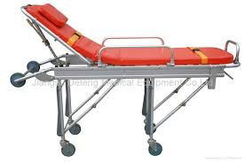](http://www.google.cz/imgres?imgurl=http://img.diytrade.com/cdimg/1191906/13102871/0/1276138805/Ambulance_stretcher_first-aid_stretcher_medical_stretcher.jpg&imgrefurl=http://www.diytrade.com/china/pd/6931000/Ambulance_stretcher_first_aid_stretcher_medical_stretcher.html&h=548&w=827&tbnid=phrI5rsHJUnxsM:&zoom=1&docid=pw0jnOCy2B69PM&ei=AFkRVbDJDYL5ygPC4oCwCQ&tbm=isch&ved=0CFUQMygsMCw)

Tweezers Cotton swab / Q-tip Stretcher

[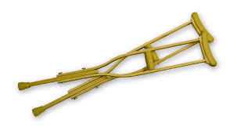](http://www.google.cz/imgres?imgurl=http://www.ojmedical.com/img/prods/large/ldicr123medium_2_wooden_crutches.jpg&imgrefurl=http://eldertpeacock.blogspot.com/2014/05/crutches.html&h=1200&w=2181&tbnid=bE9Yv0zOUCEpHM:&zoom=1&docid=UJ2hMTAGxZsFMM&ei=TFkRVb7BKqXOygOLm4DwBg&tbm=isch&ved=0CEAQMygaMBo) [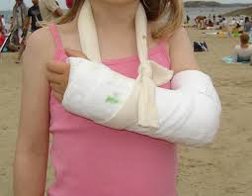](http://www.google.cz/imgres?imgurl=http://www.survivaldoctor.info/wp-content/uploads/2014/09/cast.jpg&imgrefurl=http://imgkid.com/plaster-cast-arm.shtml&h=1005&w=1291&tbnid=cnU1FX1lqPyT-M:&zoom=1&docid=7VlLqW9Sn9ZXdM&ei=sVkRVfKqE-H8ygO584HYDw&tbm=isch&ved=0CHkQMyhTMFM)

Crutches Plaster (cast) / cast

[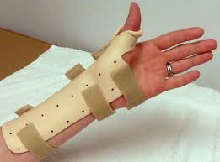](http://www.google.cz/imgres?imgurl=http://www.adirondacktherapy.com/img/custom_splinting/splint3.jpg&imgrefurl=http://www.adirondacktherapy.com/custom_splinting.php&h=370&w=500&tbnid=dl0cgDMGiSbR_M:&zoom=1&docid=HibxEj9MvCxtVM&ei=FFoRVfvnBsH6ygP-vIDoCA&tbm=isch&ved=0CCgQMygKMAo) [](http://www.google.cz/imgres?imgurl=http://cleananytime.com/wp-content/uploads/2014/10/neck-braces5.jpg&imgrefurl=http://cleananytime.com/brace/modern-products-neck-braces.html&h=235&w=235&tbnid=xQEZYE6F-0VooM:&zoom=1&docid=2CkEKdCZ3KbRPM&ei=YFoRVdOTKITgyQOsooGgCw&tbm=isch&ved=0CCwQMygOMA4) [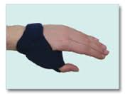](http://www.google.cz/imgres?imgurl=http://orkrisz.hu/hu/images/products/functional_saddle_joint_orthesis_basic.png&imgrefurl=http://www.orkrisz.hu/hu/terapias-sinek/kezto-sinek/45-funkcionalis-rovid-nyeregizuleti-ortezis&h=165&w=220&tbnid=5h0wo925NrE8tM:&zoom=1&docid=z5XAA24PqSDJuM&ei=QFsRVbTaGaHPygOUkoGgDQ&tbm=isch&ved=0CEcQMyg_MD84yAE)

Splint / immobilizer Neck brace Orthosis

[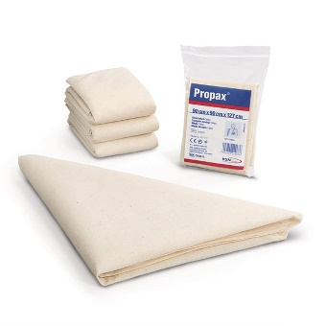](https://www.google.cz/url?sa=i&url=https%3A%2F%2Fwww.firstaidandsafetyonline.com%2Ftriangular-bandage-non-sterile-with-pins%2F&psig=AOvVaw0cuA4JgA07ukSedAk5EHyT&ust=1581063470116000&source=images&cd=vfe&ved=0CAIQjRxqFwoTCOiL9sW-vOcCFQAAAAAdAAAAABAE) [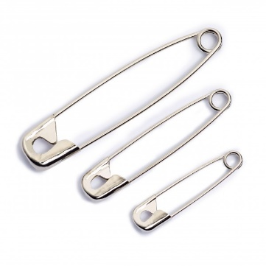](https://www.google.cz/url?sa=i&url=https%3A%2F%2Fwww.prym.com%2Fen%2Fsafety-pins-27%2F38%2F50mm-assorted-silver-coloured-24-items-085124&psig=AOvVaw36jxIbgHbhBtrhhMvdEbOI&ust=1581063587897000&source=images&cd=vfe&ved=0CAIQjRxqFwoTCNj0i_6-vOcCFQAAAAAdAAAAABAE) [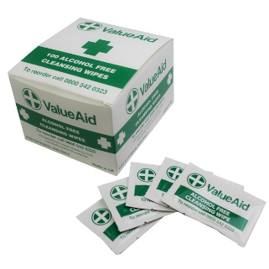](https://www.google.cz/url?sa=i&url=https%3A%2F%2Fwww.firstaid4less.co.uk%2FWipes%2FAlcohol-Free-Wipes%2FAlcohol-Free-Cleansing-Wipes&psig=AOvVaw3dBQ-zw_SqDQqTqbzCGuEp&ust=1581063657765000&source=images&cd=vfe&ved=0CAIQjRxqFwoTCNjBtp-_vOcCFQAAAAAdAAAAABAL)

Triangular bandage Safety pins Antiseptic cleansing wipes

[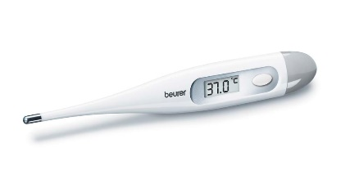](https://www.google.cz/url?sa=i&url=https%3A%2F%2Fwww.noelleeming.co.nz%2Fshop%2Fpersonal-care%2Fhealth%2Fhealth-monitoring%2Fbeurer-ft09-digital-express-thermometer%2Fprod149527.html&psig=AOvVaw2wAPKBdlTchddDEVVT-6d7&ust=1581063783995000&source=images&cd=vfe&ved=0CAIQjRxqFwoTCNit2du_vOcCFQAAAAAdAAAAABAL) [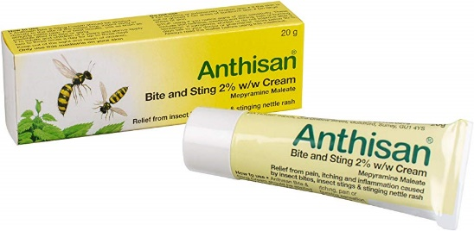](https://www.google.cz/url?sa=i&url=https%3A%2F%2Fwww.amazon.co.uk%2FAnthisan-Bite-Sting-Cream-20%2Fdp%2FB00U375M94&psig=AOvVaw1PkAjyAtG5ivZeXyAbypxx&ust=1581063938990000&source=images&cd=vfe&ved=0CAIQjRxqFwoTCMiEv6XAvOcCFQAAAAAdAAAAABAE) [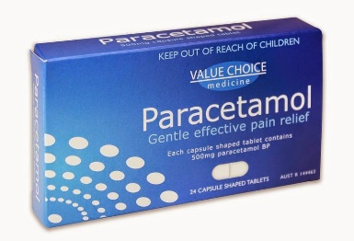](https://www.google.cz/url?sa=i&url=http%3A%2F%2Fdrug-dosage.blogspot.com%2F2016%2F02%2Fdrug-dosage-paracetamol-acetaminophen.html&psig=AOvVaw0SRM0A7LMTc0WSrbs194Oo&ust=1581064097029000&source=images&cd=vfe&ved=0CAIQjRxqFwoTCJCi8PDAvOcCFQAAAAAdAAAAABAK)

Thermometer Insect bite and sting cream Pain killers and antipyretics

[](https://www.google.cz/url?sa=i&url=https%3A%2F%2Fwww.schoolhealth.com%2Fmedi-first-antiseptic-spray&psig=AOvVaw3Z4zRF4TGSNVPkqm-E9eDW&ust=1581064809543000&source=images&cd=vfe&ved=0CAIQjRxqFwoTCLj02MTDvOcCFQAAAAAdAAAAABAP) [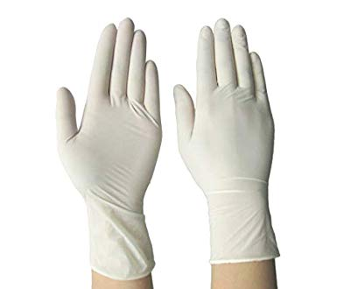](https://www.google.cz/url?sa=i&url=https%3A%2F%2Fwww.amazon.in%2FSurgicare-Disposable-Surgical-Rubber-Gloves%2Fdp%2FB07GNKG3NY&psig=AOvVaw0tSpulGAvj1SRXZRdZe3pN&ust=1581064946595000&source=images&cd=vfe&ved=0CAIQjRxqFwoTCLDuhIbEvOcCFQAAAAAdAAAAABAI) [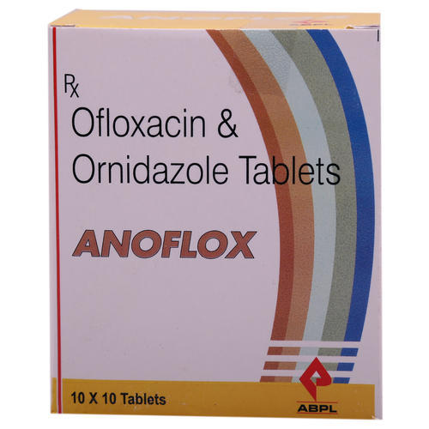](https://www.google.cz/url?sa=i&url=https%3A%2F%2Fwww.indiamart.com%2Fanon-group%2Fanti-diarrheal-drugs.html&psig=AOvVaw1PuUrWtJRZvgyXKpNBduZg&ust=1581065058111000&source=images&cd=vfe&ved=0CAIQjRxqFwoTCKiQnrvEvOcCFQAAAAAdAAAAABAR)

Antiseptic spray Disposable sterile gloves Antidiarrheal drugs

[](https://www.google.cz/url?sa=i&url=https%3A%2F%2Fliveritehealthcare.com%2Fproduct%2Fbenylin-tickly-cough-syrup%2F&psig=AOvVaw1dm_q98KtfIUHVqH82hzsb&ust=1581065225291000&source=images&cd=vfe&ved=0CAIQjRxqFwoTCMjj7YrFvOcCFQAAAAAdAAAAABAE) [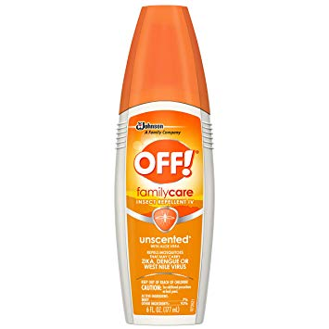](https://www.google.cz/url?sa=i&url=https%3A%2F%2Fwww.amazon.in%2FFamilycare-Insect-Repellent-Unscented-Fluid%2Fdp%2FB0000DIWN9&psig=AOvVaw0baL92EYLTUaJrE9i-d1rs&ust=1581065384396000&source=images&cd=vfe&ved=0CAIQjRxqFwoTCPCk3NbFvOcCFQAAAAAdAAAAABAW) [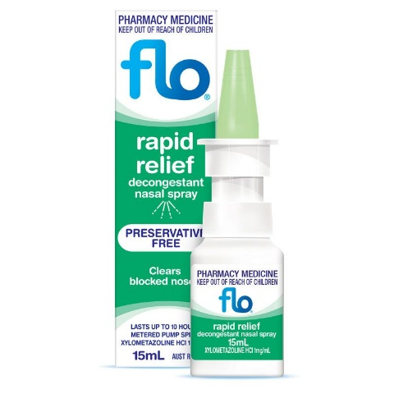](https://www.google.cz/url?sa=i&url=https%3A%2F%2Fwww.pharmacyonline.com.au%2Fflo-rapid-relief-nasal-spray-15ml&psig=AOvVaw0o6QHelmN6Y7edthCKu3W6&ust=1581065502455000&source=images&cd=vfe&ved=0CAIQjRxqFwoTCLiCiI_GvOcCFQAAAAAdAAAAABBc)

Cough medicine Insect repellent Nasal decongestant spray

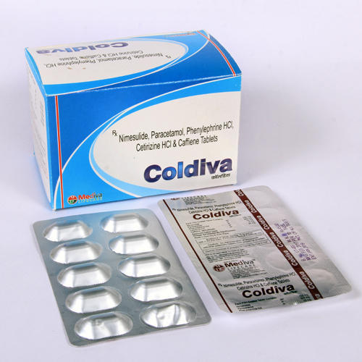 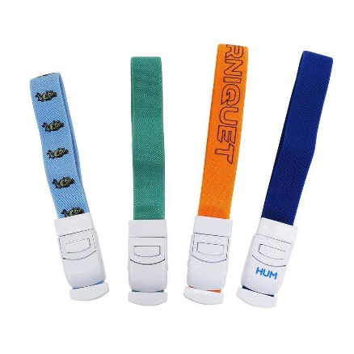 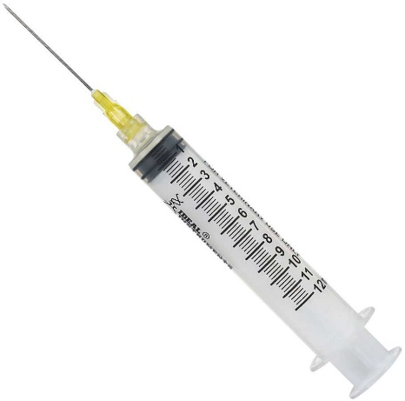

Antiemetic drugs Elastic band tourniquet Syringe and needle

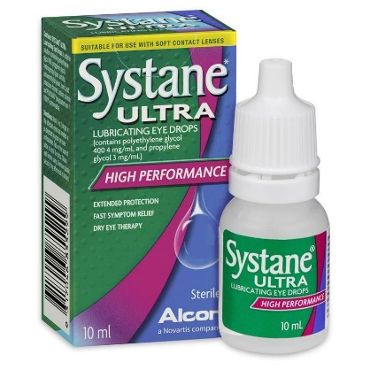

Eye drops