[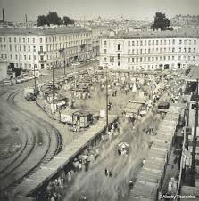](https://www.google.cz/imgres?imgurl=http://s1.fotokto.ru/topics/full/2/27642.jpg&imgrefurl=http://fotokto.ru/blogs/aleksei-titarenko-cherno-belie-dni-na-foto-4874.html&docid=BzDLpdmgiHqcTM&tbnid=1cQUQzG69BIFLM:&vet=1&w=593&h=600&bih=933&biw=1920&q=%D1%87%D0%B5%D1%80%D0%BD%D0%BE%D0%B1%D0%B5%D0%BB%D1%8B%D0%B5%20%D0%BA%D0%B0%D1%80%D1%82%D0%B8%D0%BD%D0%BA%D0%B8%20%D0%B3%D0%BE%D1%80%D0%BE%D0%B4&ved=0ahUKEwiVlvudibrSAhWRDRoKHTNrCr04rAIQMwgYKBYwFg&iact=mrc&uact=8)

[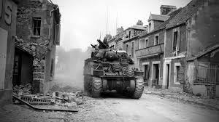](https://www.google.cz/imgres?imgurl=http://stratraza.ru/photo/38/tank_gorod_chernobeloe_1920x1080.jpg&imgrefurl=http://stratraza.ru/foto/tank_gorod_chernobeloe&docid=57joHGwTDUlv_M&tbnid=bAO0LrAFkW34RM:&vet=1&w=1920&h=1080&itg=1&bih=933&biw=1920&q=%D1%87%D0%B5%D1%80%D0%BD%D0%BE%D0%B1%D0%B5%D0%BB%D1%8B%D0%B5%20%D0%BA%D0%B0%D1%80%D1%82%D0%B8%D0%BD%D0%BA%D0%B8%20%D0%B3%D0%BE%D1%80%D0%BE%D0%B4&ved=0ahUKEwiZv_aUxbrSAhXMAxoKHWgeC7042AQQMwhdKFswWw&iact=mrc&uact=8)

[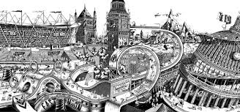](https://www.google.cz/imgres?imgurl=http://kartinca.ru/wp-content/uploads/2013/10/%D0%A7%D1%91%D1%80%D0%BD%D0%BE-%D0%B1%D0%B5%D0%BB%D1%8B%D0%B5-%D0%B8%D0%BB%D0%BB%D1%8E%D1%81%D1%82%D1%80%D0%B0%D1%86%D0%B8%D0%B8-%D0%A3%D0%B3%D0%BE-%D0%93%D0%B0%D1%82%D1%82%D0%BE%D0%BD%D0%B8-Ugo-Gattoni-2.jpg&imgrefurl=http://kartinca.ru/mexanizmy-mira-gattoni/&docid=DQNq4lgV5JbaYM&tbnid=VvNfDgVD5E3p8M:&vet=1&w=1300&h=609&bih=933&biw=1920&q=%D1%87%D0%B5%D1%80%D0%BD%D0%BE%D0%B1%D0%B5%D0%BB%D1%8B%D0%B5%20%D0%BA%D0%B0%D1%80%D1%82%D0%B8%D0%BD%D0%BA%D0%B8%20%D0%B3%D0%BE%D1%80%D0%BE%D0%B4&ved=0ahUKEwiQ2I6aibrSAhVBMhoKHVOnCVM4yAEQMwhXKFUwVQ&iact=mrc&uact=8)

[](https://www.google.cz/imgres?imgurl=http://allwelikes.com/wp-content/uploads/2011/06/marcin_stawiarz-hong_kong-4.jpg&imgrefurl=http://allwelikes.ru/2011/06/16/marcin-stawiarz-photography/&docid=07aDXMDcJvq3zM&tbnid=wE-oWAizcMARZM:&vet=1&w=850&h=426&bih=933&biw=1920&q=%D1%87%D0%B5%D1%80%D0%BD%D0%BE%D0%B1%D0%B5%D0%BB%D1%8B%D0%B5%20%D0%BA%D0%B0%D1%80%D1%82%D0%B8%D0%BD%D0%BA%D0%B8%20%D0%B3%D0%BE%D1%80%D0%BE%D0%B4&ved=0ahUKEwiVlvudibrSAhWRDRoKHTNrCr04rAIQMwgVKBMwEw&iact=mrc&uact=8)

[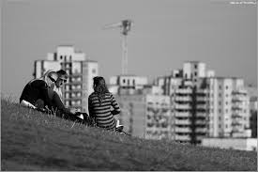](https://www.google.cz/imgres?imgurl=http://www.shunk.ru/pics/2158.jpg&imgrefurl=http://www.shunk.ru/photo/2158&docid=I034JkydTdrbLM&tbnid=_AqEHIyb2Xos9M:&vet=1&w=854&h=571&bih=933&biw=1920&q=%D1%87%D0%B5%D1%80%D0%BD%D0%BE%D0%B1%D0%B5%D0%BB%D1%8B%D0%B5%20%D0%BA%D0%B0%D1%80%D1%82%D0%B8%D0%BD%D0%BA%D0%B8%20%D0%B3%D0%BE%D1%80%D0%BE%D0%B4&ved=0ahUKEwiVlvudibrSAhWRDRoKHTNrCr04rAIQMwgaKBgwGA&iact=mrc&uact=8)

[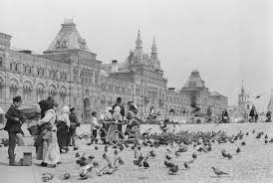](https://www.google.cz/imgres?imgurl=https://prikolnye-kartinki.ru/img/picture/Sep/16/53d8a825fbbebeda7680033285c13d06/3.jpg&imgrefurl=https://prikolnye-kartinki.ru/shirokoformatnye/46450-SHirokoformatnee-foto-gorodov-cherno-belee.html&docid=LBi6KN7ATt0HLM&tbnid=4CwrRnrgEueibM:&vet=1&w=1919&h=1288&bih=933&biw=1920&q=%D1%87%D0%B5%D1%80%D0%BD%D0%BE%D0%B1%D0%B5%D0%BB%D1%8B%D0%B5%20%D0%BA%D0%B0%D1%80%D1%82%D0%B8%D0%BD%D0%BA%D0%B8%20%D0%B3%D0%BE%D1%80%D0%BE%D0%B4&ved=0ahUKEwiVlvudibrSAhWRDRoKHTNrCr04rAIQMwghKB8wHw&iact=mrc&uact=8)

[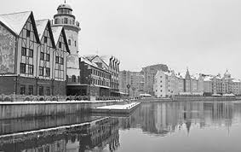](https://www.google.cz/imgres?imgurl=https://photolium.ru/uploads/posts/2015-01/1422275723_pr2.jpg&imgrefurl=https://photolium.ru/cities/&docid=XuCYFq_QOP1Q2M&tbnid=v6dMR59oujDXuM:&vet=1&w=393&h=248&bih=933&biw=1920&q=%D1%87%D0%B5%D1%80%D0%BD%D0%BE%D0%B1%D0%B5%D0%BB%D1%8B%D0%B5%20%D0%BA%D0%B0%D1%80%D1%82%D0%B8%D0%BD%D0%BA%D0%B8%20%D0%B3%D0%BE%D1%80%D0%BE%D0%B4&ved=0ahUKEwiZv_aUxbrSAhXMAxoKHWgeC7042AQQMwhhKF8wXw&iact=mrc&uact=8)

[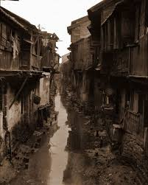](https://www.google.cz/imgres?imgurl=http://mc2websites.com/uploads/posts/2011-05/1304426016_starye-fotografii-kitaya-3.jpg&imgrefurl=http://mc2websites.com/interesnoe/print:page,1,34495-cherno-belye-fotografii-starogo-kitaya.html&docid=esUO-s6QbuHVTM&tbnid=Z_G1Yi3pxhY4bM:&vet=1&w=561&h=700&bih=933&biw=1920&q=%D1%87%D0%B5%D1%80%D0%BD%D0%BE%D0%B1%D0%B5%D0%BB%D1%8B%D0%B5%20%D0%BA%D0%B0%D1%80%D1%82%D0%B8%D0%BD%D0%BA%D0%B8%20%D0%B3%D0%BE%D1%80%D0%BE%D0%B4&ved=0ahUKEwiZv_aUxbrSAhXMAxoKHWgeC7042AQQMwhHKEUwRQ&iact=mrc&uact=8)

[](https://www.google.cz/imgres?imgurl=http://www.kulturologia.ru/files/u12645/Mitch-Dobrowner-4.jpg&imgrefurl=http://www.kulturologia.ru/blogs/011112/17329/&docid=nSr9v2qyUrdZkM&tbnid=E1-q6JA9vAmUgM:&vet=1&w=700&h=453&bih=933&biw=1920&q=%D1%87%D0%B5%D1%80%D0%BD%D0%BE%D0%B1%D0%B5%D0%BB%D1%8B%D0%B5%20%D0%BA%D0%B0%D1%80%D1%82%D0%B8%D0%BD%D0%BA%D0%B8%20%D0%B3%D0%BE%D1%80%D0%BE%D0%B4&ved=0ahUKEwiZv_aUxbrSAhXMAxoKHWgeC7042AQQMwgvKC0wLQ&iact=mrc&uact=8)

[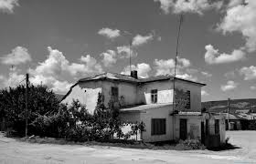](https://www.google.cz/imgres?imgurl=http://andalira.ru/images/photos/medium/64e721504430c927abab4c8a8e6d7ba2.jpg&imgrefurl=http://andalira.ru/clubs/photoalbum1169/page-2&docid=6r-_BN0YF7GeEM&tbnid=VNJLZwBzKqk0bM:&vet=1&w=1024&h=660&bih=933&biw=1920&q=%D1%87%D0%B5%D1%80%D0%BD%D0%BE%D0%B1%D0%B5%D0%BB%D1%8B%D0%B5%20%D0%BA%D0%B0%D1%80%D1%82%D0%B8%D0%BD%D0%BA%D0%B8%20%D0%B3%D0%BE%D1%80%D0%BE%D0%B4&ved=0ahUKEwiZv_aUxbrSAhXMAxoKHWgeC7042AQQMwgQKA4wDg&iact=mrc&uact=8)