[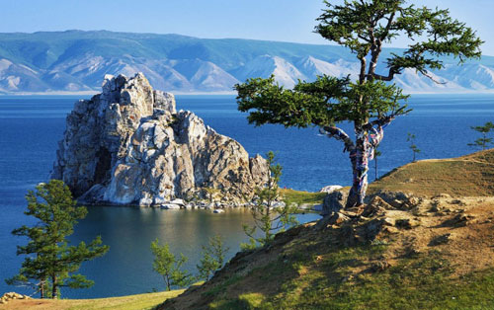](http://www.google.cz/url?sa=i&rct=j&q=&esrc=s&source=images&cd=&cad=rja&uact=8&ved=0ahUKEwjD45jX2cLWAhUI7RQKHfflC94QjRwIBw&url=http://www.webmechta.com/poznay-mir/2679-dostoprimechatelnosti-i-krasoty-rossii&psig=AFQjCNGKD5q0wR7SNhCy78d78qYZ8oC3PA&ust=1506510103662857)

[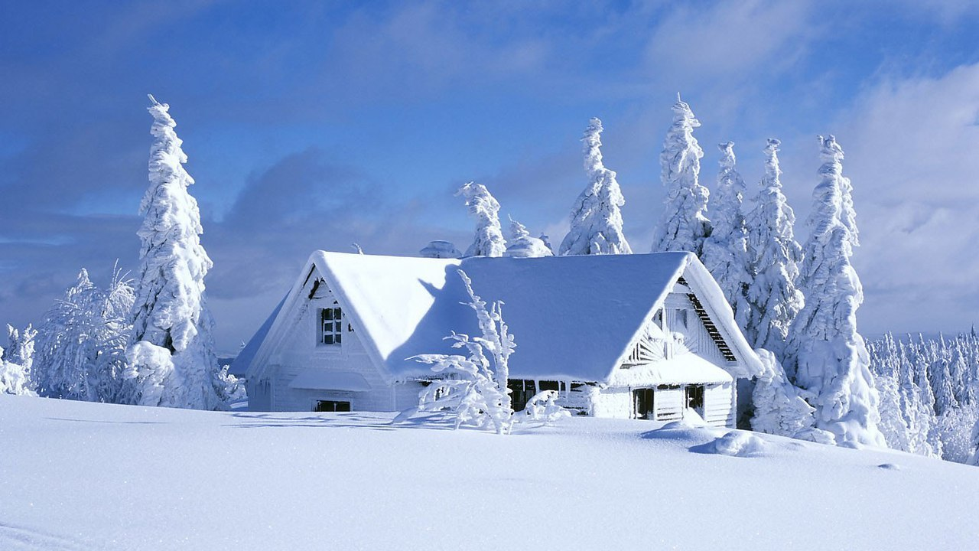](https://www.google.cz/url?sa=i&rct=j&q=&esrc=s&source=images&cd=&cad=rja&uact=8&ved=0ahUKEwja3-fx2cLWAhVFuhQKHVjNACUQjRwIBw&url=https://m.pikabu.ru/story/krasotyi_rossii_4637165&psig=AFQjCNFyOl30mmrfLdtocvtFbtdvNr7MeA&ust=1506510175834560)

[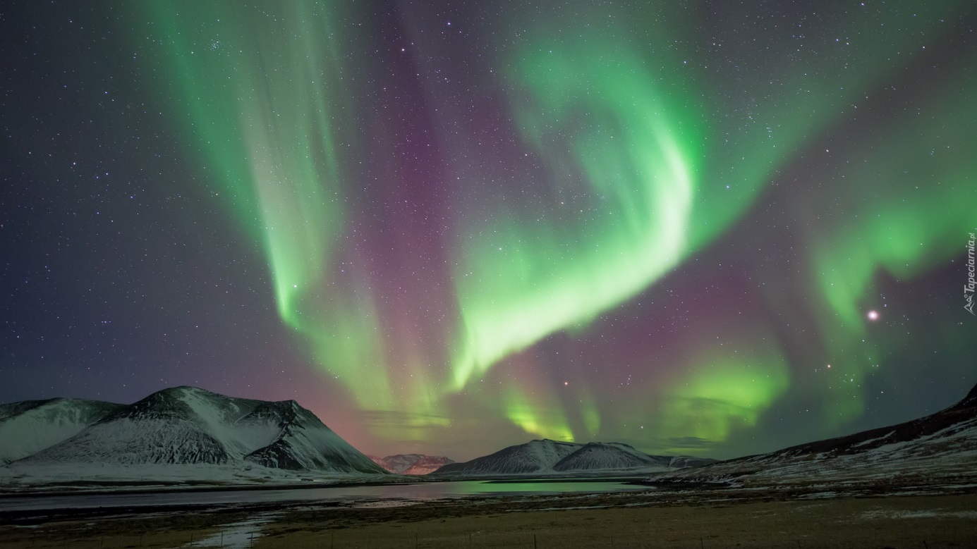](http://www.google.cz/url?sa=i&rct=j&q=&esrc=s&source=images&cd=&cad=rja&uact=8&ved=0ahUKEwi5sLX62cLWAhUBvRQKHRS4CrYQjRwIBw&url=http://www.tapeciarnia.pl/177685_gory_zorza_polarna&psig=AFQjCNFyOl30mmrfLdtocvtFbtdvNr7MeA&ust=1506510175834560)

[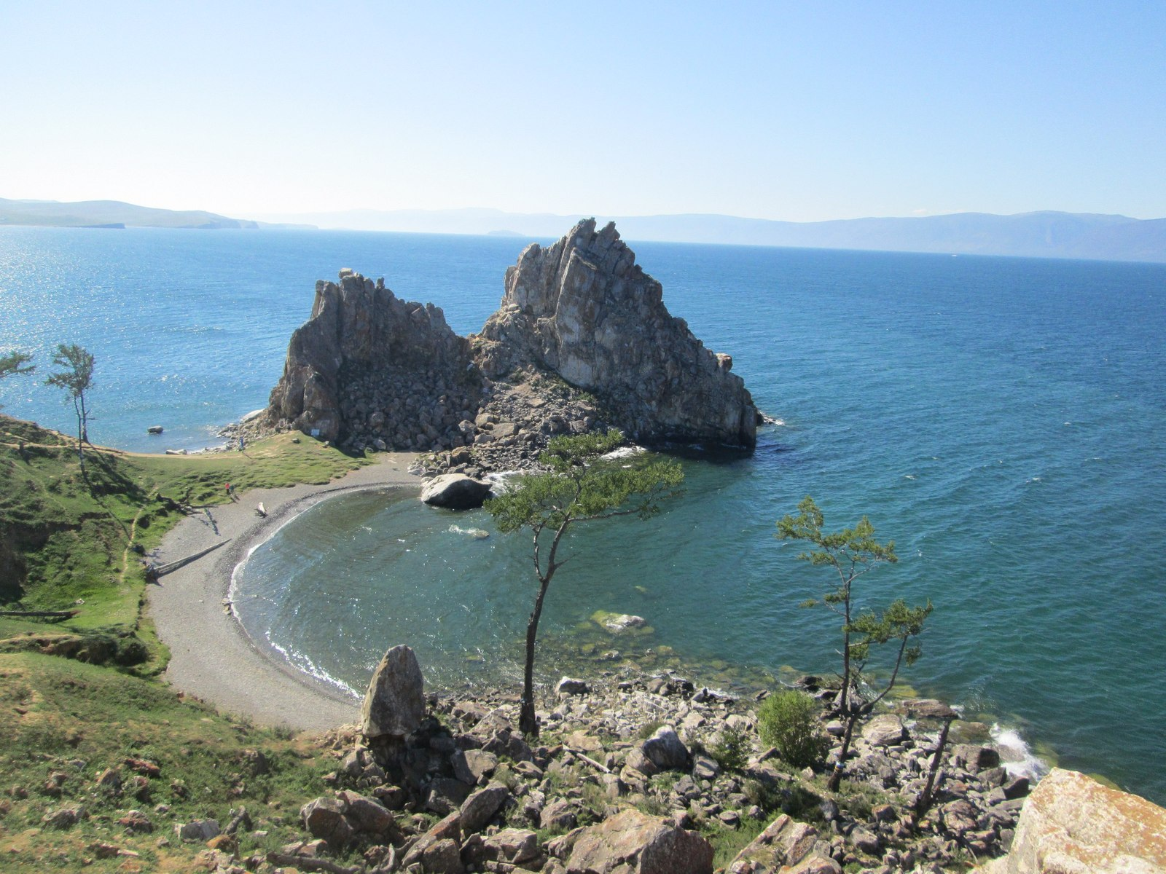](http://pikabu.ru/story/baykal_olkhon_avgust_2016_chast_i_4773841)

[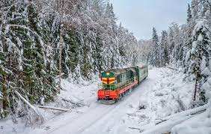](https://www.google.cz/imgres?imgurl=https://s00.yaplakal.com/pics/pics_original/6/4/9/7126946.jpg&imgrefurl=https://www.yaplakal.com/forum2/topic1309265.html&docid=qR63gJ6DtOU1-M&tbnid=yyOgz42Ks7dU0M:&vet=10ahUKEwicv5nw2cLWAhXmYpoKHbx4BZkQMwhwKEEwQQ..i&w=1023&h=649&bih=933&biw=1920&q=%D0%BA%D1%80%D0%B0%D1%81%D0%BE%D1%82%D1%8B%20%D1%80%D0%BE%D1%81%D1%81%D0%B8%D0%B8&ved=0ahUKEwicv5nw2cLWAhXmYpoKHbx4BZkQMwhwKEEwQQ&iact=mrc&uact=8)

[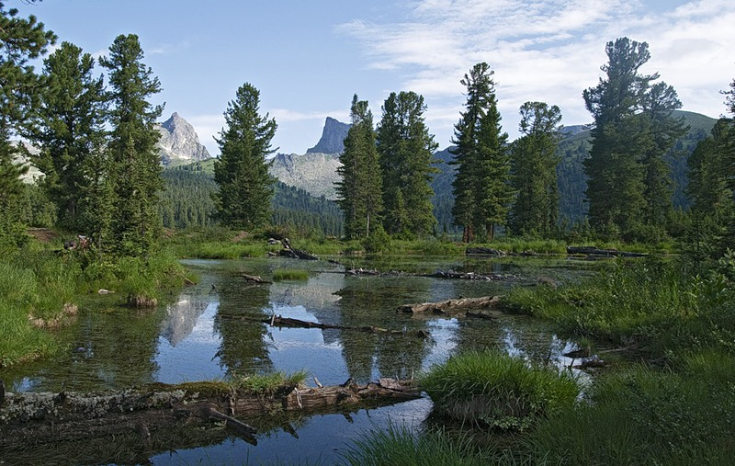](https://www.google.cz/url?sa=i&rct=j&q=&esrc=s&source=images&cd=&cad=rja&uact=8&ved=0ahUKEwis0JHO2sLWAhXLwBQKHSewDOYQjRwIBw&url=https://www.pinterest.com/pin/282389839105828399/&psig=AFQjCNEq5cILDU8CM7n2iOnKtCkwZUHGWQ&ust=1506510352089657)

[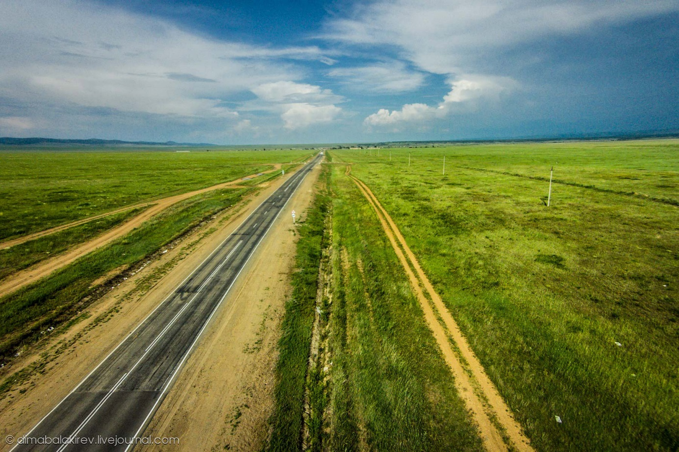](http://www.google.cz/url?sa=i&rct=j&q=&esrc=s&source=images&cd=&cad=rja&uact=8&ved=0ahUKEwjJiMr62sLWAhWCVRQKHXx9A34QjRwIBw&url=http://dimabalakirev.livejournal.com/151736.html&psig=AFQjCNEq5cILDU8CM7n2iOnKtCkwZUHGWQ&ust=1506510352089657)

\

[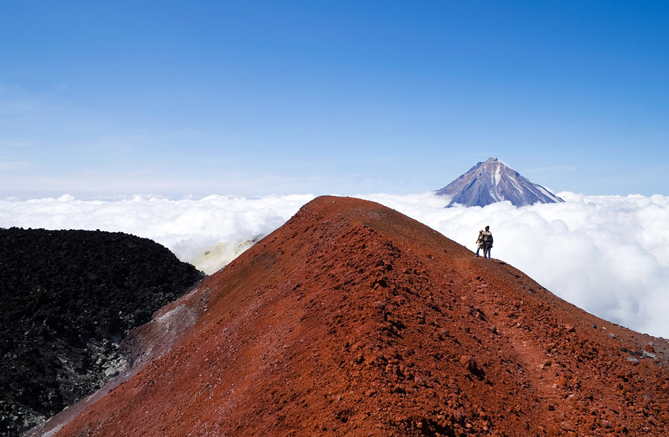](http://www.google.cz/url?sa=i&rct=j&q=&esrc=s&source=images&cd=&cad=rja&uact=8&ved=0ahUKEwj3sdKL28LWAhUFWRQKHZNkBucQjRwIBw&url=http://vasilisa-vasya.livejournal.com/99903.html&psig=AFQjCNEq5cILDU8CM7n2iOnKtCkwZUHGWQ&ust=1506510352089657)

[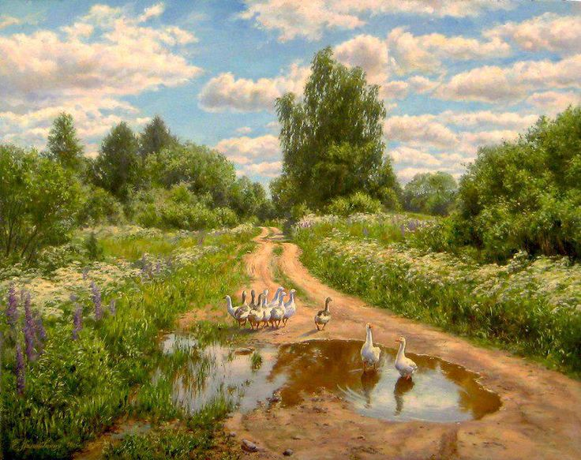](https://www.google.cz/url?sa=i&rct=j&q=&esrc=s&source=images&cd=&cad=rja&uact=8&ved=0ahUKEwis0u-V28LWAhUIOxQKHVkCDyAQjRwIBw&url=https://www.pinterest.com/klykovka63/%D0%B5%D0%BA%D0%B0%D1%82%D0%B5%D1%80%D0%B8%D0%BD%D0%B0-%D0%BA%D0%B0%D0%BB%D0%B8%D0%BD%D0%BE%D0%B2%D1%81%D0%BA%D0%B0%D1%8F/&psig=AFQjCNEq5cILDU8CM7n2iOnKtCkwZUHGWQ&ust=1506510352089657)

[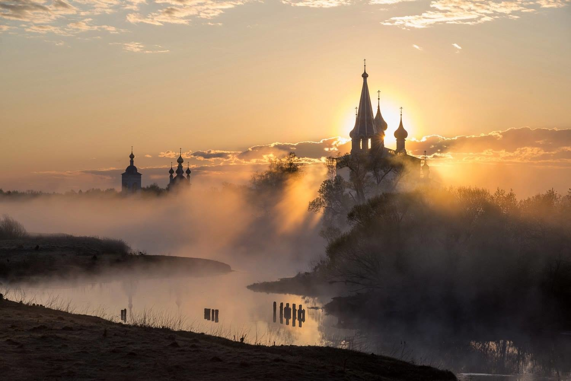](http://www.google.cz/url?sa=i&rct=j&q=&esrc=s&source=images&cd=&cad=rja&uact=8&ved=0ahUKEwjy762d28LWAhUGcRQKHQLyAf8QjRwIBw&url=http://mirpozitiva.ru/photo/1590-ehto-vsyo-rossiya-krasivye-mesta-nashej-rodiny.html&psig=AFQjCNEq5cILDU8CM7n2iOnKtCkwZUHGWQ&ust=1506510352089657)