[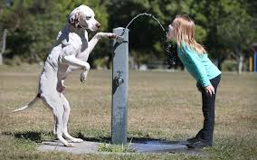](http://www.google.cz/url?sa=i&rct=j&q=&esrc=s&source=images&cd=&cad=rja&uact=8&ved=0ahUKEwiDj7zdtJLTAhXBbxQKHafuCD4QjRwIBw&url=http://russian.china.org.cn/exclusive/txt/2013-01/15/content_27689227_8.htm&psig=AFQjCNE-dKXZRcUd3zG1T3ZPDxOuCscPMA&ust=1491656769533858)

[](https://www.google.cz/url?sa=i&rct=j&q=&esrc=s&source=images&cd=&cad=rja&uact=8&ved=0ahUKEwj3q8OQtZLTAhXH6RQKHYFPDQMQjRwIBw&url=https://www.youtube.com/watch?v%3DiLETeN7_AaE&bvm=bv.152174688,d.ZGg&psig=AFQjCNE_5Gv7hdWSmCfOjsjMwg6I0edClw&ust=1491656869506280)

[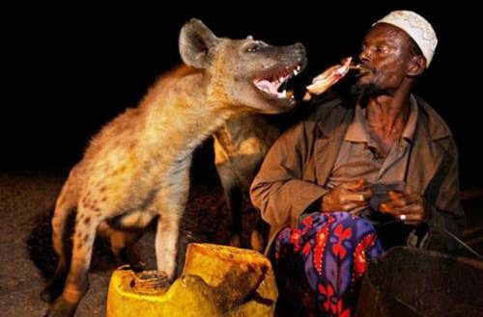](http://www.google.cz/url?sa=i&rct=j&q=&esrc=s&source=images&cd=&cad=rja&uact=8&ved=0ahUKEwiLh7mwtpLTAhULOxQKHXHQCJsQjRwIBw&url=http://pitomzy.com/2014/01/druzhba-zhivotnyh-s-lyudmi.html&bvm=bv.152174688,d.ZGg&psig=AFQjCNGSqZEAyAlbCKw_ptFDhr3f_F8xSw&ust=1491656999804206)[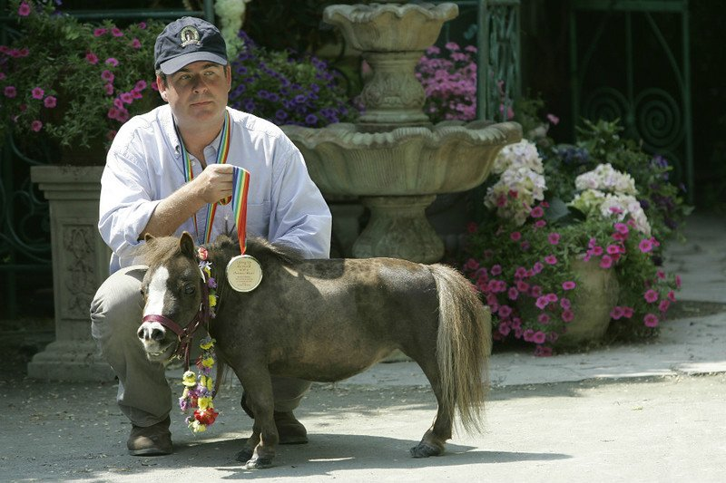](http://www.google.cz/url?sa=i&rct=j&q=&esrc=s&source=images&cd=&cad=rja&uact=8&ved=0ahUKEwi42sOjtZLTAhWJthQKHSduDOkQjRwIBw&url=http://billionnews.ru/records/3365-samye-malenkie-zhivotnye-v-svoem-vide-10-foto.html&psig=AFQjCNE_oBijg1kGS4atShfcjGQqOcEICA&ust=1491656922926135)[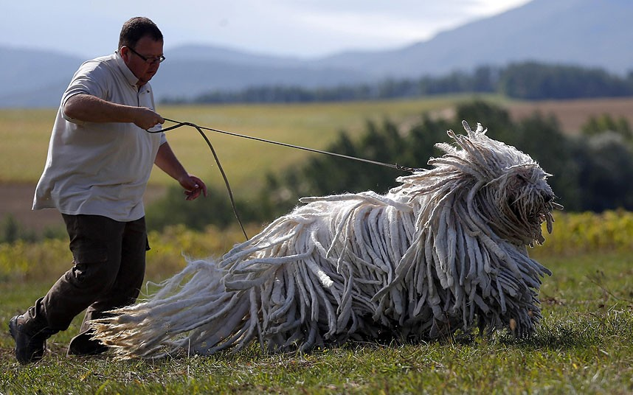](http://www.google.cz/url?sa=i&rct=j&q=&esrc=s&source=images&cd=&cad=rja&uact=8&ved=0ahUKEwiJ48TCtJLTAhVBuBQKHSTxA6kQjRwIBw&url=http://vova-91.livejournal.com/3382790.html&psig=AFQjCNFwDWIXBWSWPXxu76EFYcGX2ORG8Q&ust=1491656708479397)

[](http://www.google.cz/url?sa=i&rct=j&q=&esrc=s&source=images&cd=&cad=rja&uact=8&ved=0ahUKEwjJq97ft5LTAhUEORQKHeWcD1wQjRwIBw&url=http://dobriiden.ru/content/lyudi-i-dikie-zhivotnye-osobye-otnosheniya-25-foto/&bvm=bv.152174688,d.ZGg&psig=AFQjCNGSqZEAyAlbCKw_ptFDhr3f_F8xSw&ust=1491656999804206)[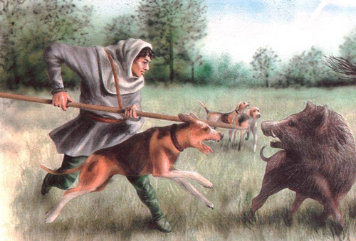](http://www.google.cz/url?sa=i&rct=j&q=&esrc=s&source=images&cd=&cad=rja&uact=8&ved=0ahUKEwjlpJ_At5LTAhVLthQKHW88C-sQjRwIBw&url=http://www.nehudlit.ru/articles/descr1182842.html&bvm=bv.152174688,d.ZGg&psig=AFQjCNGSqZEAyAlbCKw_ptFDhr3f_F8xSw&ust=1491656999804206)

[](http://www.google.cz/url?sa=i&rct=j&q=&esrc=s&source=images&cd=&cad=rja&uact=8&ved=0ahUKEwjO8qWctpLTAhVB7BQKHVp1BA0QjRwIBw&url=http://russian.china.org.cn/exclusive/txt/2011-08/19/content_23243665.htm&bvm=bv.152174688,d.ZGg&psig=AFQjCNHVwwc8ExtZfqgmdre2MJzGusMGSw&ust=1491657191720378)[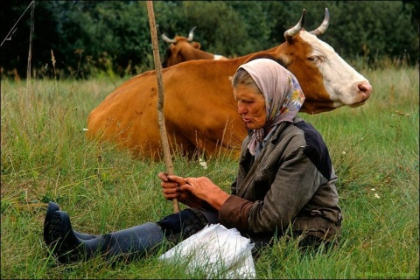](http://www.google.cz/url?sa=i&rct=j&q=&esrc=s&source=images&cd=&cad=rja&uact=8&ved=0ahUKEwjkiu7FtZLTAhWDyRQKHb1vDJsQjRwIBw&url=http://jenskiymir.mirtesen.ru/blog/43491020844/Trogatelnyie-otnosheniya-lyudey-i-zhivotnyih?page%3D2&bvm=bv.152174688,d.ZGg&psig=AFQjCNGSqZEAyAlbCKw_ptFDhr3f_F8xSw&ust=1491656999804206)

[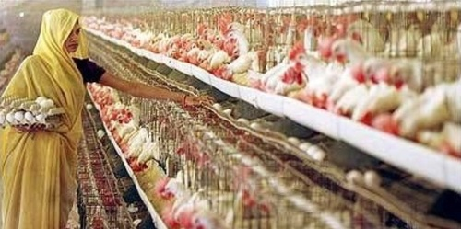](http://www.google.cz/url?sa=i&rct=j&q=&esrc=s&source=images&cd=&cad=rja&uact=8&ved=0ahUKEwiv_e_LuJLTAhWDbhQKHQ4lD4QQjRwIBw&url=http://pangeaflow.tumblr.com/post/94625415193/meat-the-truth-ii-%D0%BF%D1%80%D0%BE%D0%BC%D1%8B%D1%88%D0%BB%D0%B5%D0%BD%D0%BD%D0%BE%D0%B5-%D0%B6%D0%B8%D0%B2%D0%BE%D1%82%D0%BD%D0%BE%D0%B2%D0%BE%D0%B4%D1%81%D1%82%D0%B2%D0%BE&bvm=bv.152174688,d.ZGg&psig=AFQjCNHD3W2xbsMQ_GZn41FnMLeSEKg6lA&ust=1491657827510767)[](http://www.google.cz/url?sa=i&rct=j&q=&esrc=s&source=images&cd=&cad=rja&uact=8&ved=0ahUKEwjmz8aPuJLTAhWF0RQKHdrPBPIQjRwIBw&url=http://www.ukrinform.ru/rubric-lastnews/1509876-festival_sobachego_myasa_proydet_na_yuge_kitaya_foto_1531185.html&bvm=bv.152174688,d.ZGg&psig=AFQjCNFw68Gf-QD-yARLMWVqBSxYeRfirg&ust=1491657684294396)

[](http://www.google.cz/url?sa=i&rct=j&q=&esrc=s&source=images&cd=&cad=rja&uact=8&ved=0ahUKEwjZ0I6rtJLTAhXGxxQKHX4PBwgQjRwIBw&url=http://www.arrabiadance.com/zver.php?id%3D35197&psig=AFQjCNGpqFfbUWE4bAlCAlx3dLS84b_g7Q&ust=1491656574193607)