[](https://www.google.cz/imgres?imgurl=http://alimero.ru/uploads/images/00/59/44/2013/02/18/41fa78.jpg&imgrefurl=http://alimero.ru/blog/biograph/top-15-velikih-zhenshchin-20-stoletiya.9054.html&docid=wKuHytX9c6bgOM&tbnid=SSsMLHXXWLppaM:&vet=10ahUKEwiKsb2HgNnTAhUEXBoKHWsqAxUQMwhEKBYwFg..i&w=415&h=598&bih=933&biw=1920&q=%D0%BA%D0%B0%D1%80%D1%82%D0%B8%D0%BD%D0%BA%D0%B8%20%D1%81%D0%B0%D0%BC%D1%8B%D0%B5%20%D0%B8%D0%B7%D0%B2%D0%B5%D1%81%D1%82%D0%BD%D1%8B%D0%B5%20%D0%BB%D1%8E%D0%B4%D0%B8%2020%20%D0%B2%D0%B5%D0%BA%D0%B0&ved=0ahUKEwiKsb2HgNnTAhUEXBoKHWsqAxUQMwhEKBYwFg&iact=mrc&uact=8)

[](https://www.google.cz/imgres?imgurl=http://24smi.org/public/media/news/2015/03/06/1425655821_2.jpg&imgrefurl=https://24smi.org/news/23501-samye-izvestnye-lyudi_specf50.html&docid=LC7GZS_SGdDdSM&tbnid=dC8YhvWKnIQEpM:&vet=10ahUKEwiKsb2HgNnTAhUEXBoKHWsqAxUQMwhGKBgwGA..i&w=448&h=251&bih=933&biw=1920&q=%D0%BA%D0%B0%D1%80%D1%82%D0%B8%D0%BD%D0%BA%D0%B8%20%D1%81%D0%B0%D0%BC%D1%8B%D0%B5%20%D0%B8%D0%B7%D0%B2%D0%B5%D1%81%D1%82%D0%BD%D1%8B%D0%B5%20%D0%BB%D1%8E%D0%B4%D0%B8%2020%20%D0%B2%D0%B5%D0%BA%D0%B0&ved=0ahUKEwiKsb2HgNnTAhUEXBoKHWsqAxUQMwhGKBgwGA&iact=mrc&uact=8)

[](https://www.google.cz/imgres?imgurl=http://www.uznayvse.ru/images/stories/uzn_1406712141.jpg&imgrefurl=http://www.uznayvse.ru/interesting-facts/samyie-izvestnyie-lyudi-v-mire.html&docid=AwFBl5zxUt6NuM&tbnid=PqZM-wEcTYU_xM:&vet=10ahUKEwiB29nTgNnTAhWG1BoKHZDODkE4yAEQMwhMKEowSg..i&w=560&h=420&bih=933&biw=1920&q=%D0%BA%D0%B0%D1%80%D1%82%D0%B8%D0%BD%D0%BA%D0%B8%20%D1%81%D0%B0%D0%BC%D1%8B%D0%B5%20%D0%B8%D0%B7%D0%B2%D0%B5%D1%81%D1%82%D0%BD%D1%8B%D0%B5%20%D0%BB%D1%8E%D0%B4%D0%B8%2020%20%D0%B2%D0%B5%D0%BA%D0%B0&ved=0ahUKEwiB29nTgNnTAhWG1BoKHZDODkE4yAEQMwhMKEowSg&iact=mrc&uact=8)

[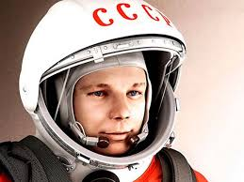](https://www.google.cz/imgres?imgurl=http://www.molomo.ru/img/1/3/6.jpg&imgrefurl=http://www.molomo.ru/inquiry/famous_astronauts.html&docid=_SdlON6OjHHL4M&tbnid=boo7FFlWeKB1aM:&vet=10ahUKEwiB29nTgNnTAhWG1BoKHZDODkE4yAEQMwhjKGEwYQ..i&w=600&h=450&bih=933&biw=1920&q=%D0%BA%D0%B0%D1%80%D1%82%D0%B8%D0%BD%D0%BA%D0%B8%20%D1%81%D0%B0%D0%BC%D1%8B%D0%B5%20%D0%B8%D0%B7%D0%B2%D0%B5%D1%81%D1%82%D0%BD%D1%8B%D0%B5%20%D0%BB%D1%8E%D0%B4%D0%B8%2020%20%D0%B2%D0%B5%D0%BA%D0%B0&ved=0ahUKEwiB29nTgNnTAhWG1BoKHZDODkE4yAEQMwhjKGEwYQ&iact=mrc&uact=8)

[](http://www.google.cz/url?sa=i&rct=j&q=&esrc=s&source=images&cd=&cad=rja&uact=8&ved=0ahUKEwiSstX3gdnTAhVFOhoKHYd6Cd4QjRwIBw&url=http://www.ravnye.ru/publ/samye_izvestnye_ljudi_mira_s_ogranichennymi_vozmozhnostjami_ili_bezgranichnymi/1-1-0-14&psig=AFQjCNHhjmTRPmCRpTT376ywpAk2iBUYoA&ust=1494082322534002)

[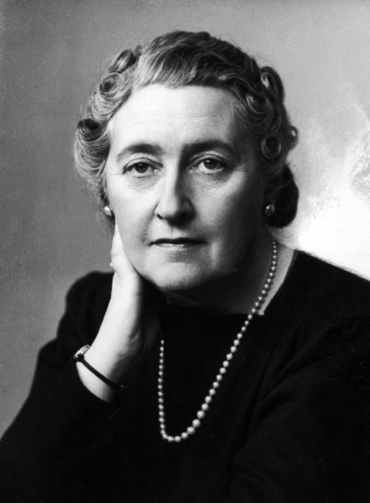](http://www.google.cz/url?sa=i&rct=j&q=&esrc=s&source=images&cd=&cad=rja&uact=8&ved=0ahUKEwirxYCggtnTAhWC1xoKHc68AgcQjRwIBw&url=http://fb.ru/article/64605/samyie-izvestnyie-pisateli-veka&psig=AFQjCNHhjmTRPmCRpTT376ywpAk2iBUYoA&ust=1494082322534002)

[](https://www.google.cz/imgres?imgurl=http://www.molomo.ru/img/1/8/965.jpg&imgrefurl=http://www.molomo.ru/inquiry/famous_politicians.html&docid=j1pMyHTZ8vVEvM&tbnid=28Po5pHpe1fYmM:&vet=10ahUKEwiB29nTgNnTAhWG1BoKHZDODkE4yAEQMwhXKFUwVQ..i&w=600&h=450&bih=933&biw=1920&q=%D0%BA%D0%B0%D1%80%D1%82%D0%B8%D0%BD%D0%BA%D0%B8%20%D1%81%D0%B0%D0%BC%D1%8B%D0%B5%20%D0%B8%D0%B7%D0%B2%D0%B5%D1%81%D1%82%D0%BD%D1%8B%D0%B5%20%D0%BB%D1%8E%D0%B4%D0%B8%2020%20%D0%B2%D0%B5%D0%BA%D0%B0&ved=0ahUKEwiB29nTgNnTAhWG1BoKHZDODkE4yAEQMwhXKFUwVQ&iact=mrc&uact=8)

[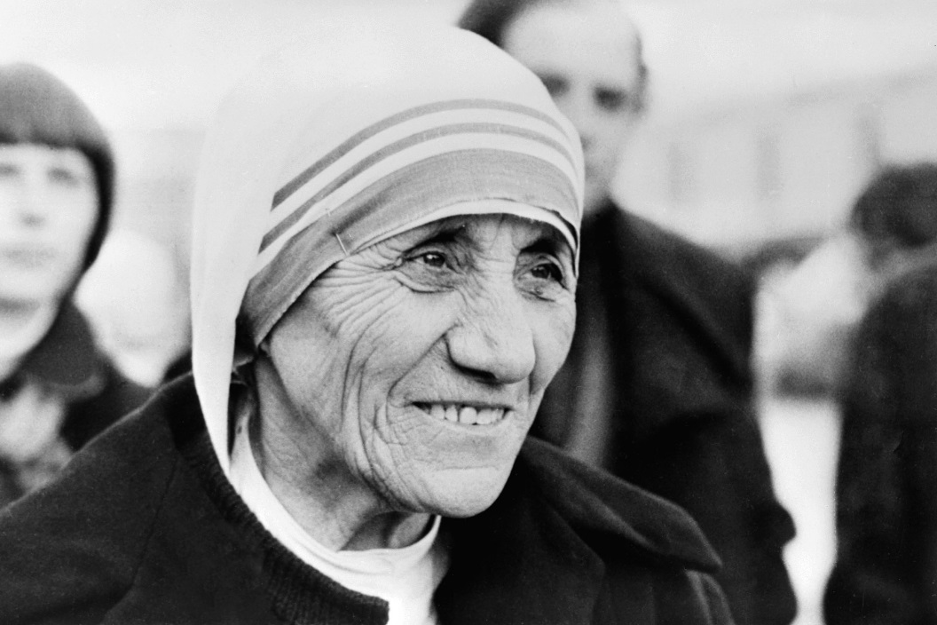](https://www.google.cz/url?sa=i&rct=j&q=&esrc=s&source=images&cd=&cad=rja&uact=8&ved=0ahUKEwjy4ejXgtnTAhUFLhoKHW2cBzkQjRwIBw&url=https://www.adme.ru/zhizn-dobro/20-zapovedej-materi-terezy-753960/&psig=AFQjCNFKXm0CURMaS_rpqAS2n69nTwFlUw&ust=1494082903770945)

[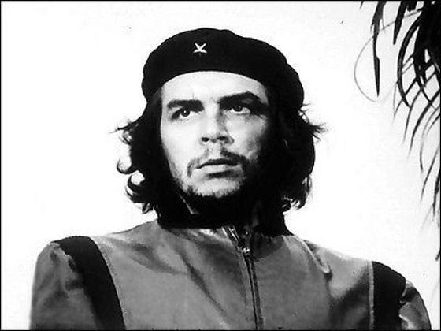](http://www.google.cz/url?sa=i&rct=j&q=&esrc=s&source=images&cd=&cad=rja&uact=8&ved=0ahUKEwj8yJe6hNnTAhWMDxoKHQ0_BPsQjRwIBw&url=http://www.uznayvse.ru/interesting-facts/samyie-izvestnyie-foto-v-istorii.html&psig=AFQjCNHhjmTRPmCRpTT376ywpAk2iBUYoA&ust=1494082322534002)

[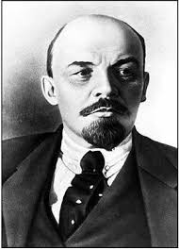](https://www.google.cz/imgres?imgurl=http://fb.ru/misc/i/gallery/14155/594107.jpg&imgrefurl=http://fb.ru/article/163979/samyie-znamenityie-lyudi-rossii-za-vsyu-istoriyu&docid=aRRAmrZLrUQzgM&tbnid=2yBE-8hZ_-GpYM:&vet=10ahUKEwjqkfnBgNnTAhVE0xoKHTEfCacQMwhcKC4wLg..i&w=292&h=408&bih=933&biw=1920&q=%D0%BA%D0%B0%D1%80%D1%82%D0%B8%D0%BD%D0%BA%D0%B8%20%D1%81%D0%B0%D0%BC%D1%8B%D0%B5%20%D0%B8%D0%B7%D0%B2%D0%B5%D1%81%D1%82%D0%BD%D1%8B%D0%B5%20%D0%BB%D1%8E%D0%B4%D0%B8%2020%20%D0%B2%D0%B5%D0%BA%D0%B0&ved=0ahUKEwjqkfnBgNnTAhVE0xoKHTEfCacQMwhcKC4wLg&iact=mrc&uact=8)