[](https://www.google.cz/imgres?imgurl=http://yaturistka.ru/wp-content/uploads/2017/04/announce_big_9-23.png&imgrefurl=http://yaturistka.ru/whole-world/10-sposobov-kak-puteshestvovat-avtosto/&docid=Igli-jgGRz0-yM&tbnid=xiotfnHeVb_ONM:&vet=10ahUKEwjk-ZPduanXAhXFtBoKHagXAmk4rAIQMwgJKAcwBw..i&w=783&h=583&bih=933&biw=1920&q=%D1%81%D0%BF%D0%BE%D1%81%D0%BE%D0%B1%D1%8B%20%D0%BF%D1%83%D1%82%D0%B5%D1%88%D0%B5%D1%81%D1%82%D0%B2%D0%BE%D0%B2%D0%B0%D1%82%D1%8C%20%D0%BA%D0%B0%D1%80%D1%82%D0%B8%D0%BD%D0%BA%D0%B8&ved=0ahUKEwjk-ZPduanXAhXFtBoKHagXAmk4rAIQMwgJKAcwBw&iact=mrc&uact=8)[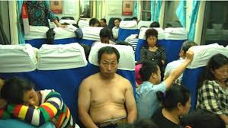](https://www.google.cz/imgres?imgurl=https://ykitai.files.wordpress.com/2016/01/yingzuo2.jpg?w%3D600%26h%3D338&imgrefurl=https://ykitai.com/2016/01/18/super-budget/&docid=U06vjLTKyF-BVM&tbnid=mk-zDlBT76-XvM:&vet=10ahUKEwj-o7mwt6nXAhWOhRoKHS0BCGc4ZBAzCCIoIDAg..i&w=600&h=338&bih=933&biw=1920&q=%D1%81%D0%BF%D0%BE%D1%81%D0%BE%D0%B1%D1%8B%20%D0%BF%D1%83%D1%82%D0%B5%D1%88%D0%B5%D1%81%D1%82%D0%B2%D0%BE%D0%B2%D0%B0%D1%82%D1%8C%20%D0%BA%D0%B0%D1%80%D1%82%D0%B8%D0%BD%D0%BA%D0%B8&ved=0ahUKEwj-o7mwt6nXAhWOhRoKHS0BCGc4ZBAzCCIoIDAg&iact=mrc&uact=8)

[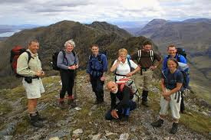](https://www.google.cz/imgres?imgurl=http://sunsurfers.ru/wp-content/uploads/2017/05/Trip-Leader-for-HF-Holidays.jpg&imgrefurl=http://sunsurfers.ru/10-sposobov-puteshestvovat-po-miru-besplatno/&docid=OQacsc8R7KGHBM&tbnid=b4XL2NvanY3jCM:&vet=10ahUKEwiB_uKvt6nXAhWJ0hoKHfvTCHMQMwh5KEkwSQ..i&w=600&h=400&bih=933&biw=1920&q=%D1%81%D0%BF%D0%BE%D1%81%D0%BE%D0%B1%D1%8B%20%D0%BF%D1%83%D1%82%D0%B5%D1%88%D0%B5%D1%81%D1%82%D0%B2%D0%BE%D0%B2%D0%B0%D1%82%D1%8C%20%D0%BA%D0%B0%D1%80%D1%82%D0%B8%D0%BD%D0%BA%D0%B8&ved=0ahUKEwiB_uKvt6nXAhWJ0hoKHfvTCHMQMwh5KEkwSQ&iact=mrc&uact=8)[](https://www.google.cz/imgres?imgurl=http://www.storymil.com/wp-content/uploads/2016/07/z10670129Qkot-podroz-z-kotem-900x620.jpg&imgrefurl=https://www.storymil.com/sposoby-puteshestvovat-tolko-s-ruchnoj-kladyu/&docid=zoxj7eJr4mmsYM&tbnid=K9FNicY6JBCFcM:&vet=10ahUKEwj-o7mwt6nXAhWOhRoKHS0BCGc4ZBAzCB8oHTAd..i&w=900&h=620&bih=933&biw=1920&q=%D1%81%D0%BF%D0%BE%D1%81%D0%BE%D0%B1%D1%8B%20%D0%BF%D1%83%D1%82%D0%B5%D1%88%D0%B5%D1%81%D1%82%D0%B2%D0%BE%D0%B2%D0%B0%D1%82%D1%8C%20%D0%BA%D0%B0%D1%80%D1%82%D0%B8%D0%BD%D0%BA%D0%B8&ved=0ahUKEwj-o7mwt6nXAhWOhRoKHS0BCGc4ZBAzCB8oHTAd&iact=mrc&uact=8)

[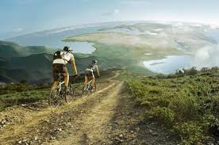](https://www.google.cz/imgres?imgurl=http://www.vitamarg.com/images/img4/5-sposobov-puteshestvovat-besplatno.jpg&imgrefurl=http://www.vitamarg.com/tourizm/5334-5-sposobov-puteshestvovat-besplatno&docid=M2U5LHsLTlg-GM&tbnid=eoYMr6nTFD3KxM:&vet=10ahUKEwj-o7mwt6nXAhWOhRoKHS0BCGc4ZBAzCAkoBzAH..i&w=500&h=331&bih=933&biw=1920&q=%D1%81%D0%BF%D0%BE%D1%81%D0%BE%D0%B1%D1%8B%20%D0%BF%D1%83%D1%82%D0%B5%D1%88%D0%B5%D1%81%D1%82%D0%B2%D0%BE%D0%B2%D0%B0%D1%82%D1%8C%20%D0%BA%D0%B0%D1%80%D1%82%D0%B8%D0%BD%D0%BA%D0%B8&ved=0ahUKEwj-o7mwt6nXAhWOhRoKHS0BCGc4ZBAzCAkoBzAH&iact=mrc&uact=8)[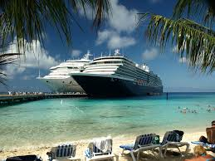](https://www.google.cz/imgres?imgurl=http://img1.restbee.ru/polieznyie-znaniia/krugosvetnoe-puteshestvie/cruise.jpg?time%3D1366967855&imgrefurl=http://www.restbee.ru/guides/polieznyie-znaniia/krughosvietnoie-putieshiestviie-voploshchaia-dietskuiu-miechtu.html&docid=qwgEKUdn-04SCM&tbnid=vrNYFr-oNxJvHM:&vet=10ahUKEwj-o7mwt6nXAhWOhRoKHS0BCGc4ZBAzCB0oGzAb..i&w=1024&h=768&bih=933&biw=1920&q=%D1%81%D0%BF%D0%BE%D1%81%D0%BE%D0%B1%D1%8B%20%D0%BF%D1%83%D1%82%D0%B5%D1%88%D0%B5%D1%81%D1%82%D0%B2%D0%BE%D0%B2%D0%B0%D1%82%D1%8C%20%D0%BA%D0%B0%D1%80%D1%82%D0%B8%D0%BD%D0%BA%D0%B8&ved=0ahUKEwj-o7mwt6nXAhWOhRoKHS0BCGc4ZBAzCB0oGzAb&iact=mrc&uact=8)

[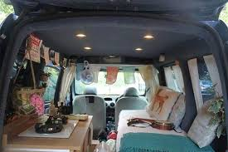](https://www.google.cz/imgres?imgurl=https://4tololo.ru/files/styles/large/public/images/20171002164107.jpg?itok%3DmSQDs200&imgrefurl=https://4tololo.ru/content/14097&docid=e-L1CfdiLJhUEM&tbnid=7Pov88zkt5S5eM:&vet=10ahUKEwiB_uKvt6nXAhWJ0hoKHfvTCHMQMwiNAShdMF0..i&w=650&h=434&bih=933&biw=1920&q=%D1%81%D0%BF%D0%BE%D1%81%D0%BE%D0%B1%D1%8B%20%D0%BF%D1%83%D1%82%D0%B5%D1%88%D0%B5%D1%81%D1%82%D0%B2%D0%BE%D0%B2%D0%B0%D1%82%D1%8C%20%D0%BA%D0%B0%D1%80%D1%82%D0%B8%D0%BD%D0%BA%D0%B8&ved=0ahUKEwiB_uKvt6nXAhWJ0hoKHfvTCHMQMwiNAShdMF0&iact=mrc&uact=8)[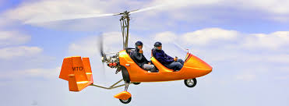](https://www.google.cz/imgres?imgurl=http://cs6.pikabu.ru/post_img/big/2017/05/25/10/1495731586182157523.jpg&imgrefurl=http://pikabu.ru/story/mne_byi_v_nebo_ili_novyiy_sposob_puteshestvovat_v_dalnyak_5077358&docid=JNL8tZ85xkKAHM&tbnid=Lkb0prgBuCrbyM:&vet=10ahUKEwj-o7mwt6nXAhWOhRoKHS0BCGc4ZBAzCAgoBjAG..i&w=820&h=300&bih=933&biw=1920&q=%D1%81%D0%BF%D0%BE%D1%81%D0%BE%D0%B1%D1%8B%20%D0%BF%D1%83%D1%82%D0%B5%D1%88%D0%B5%D1%81%D1%82%D0%B2%D0%BE%D0%B2%D0%B0%D1%82%D1%8C%20%D0%BA%D0%B0%D1%80%D1%82%D0%B8%D0%BD%D0%BA%D0%B8&ved=0ahUKEwj-o7mwt6nXAhWOhRoKHS0BCGc4ZBAzCAgoBjAG&iact=mrc&uact=8)

[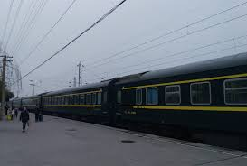](https://www.google.cz/imgres?imgurl=https://karma-journey.ru/wp-content/uploads/2017/09/transport-kitay-5-1482x1000.jpg&imgrefurl=https://karma-journey.ru/china/transport-v-kitae&docid=omvoXK569h4TUM&tbnid=jUbKcuK0MWuV6M:&vet=10ahUKEwj-o7mwt6nXAhWOhRoKHS0BCGc4ZBAzCDooODA4..i&w=1482&h=1000&bih=933&biw=1920&q=%D1%81%D0%BF%D0%BE%D1%81%D0%BE%D0%B1%D1%8B%20%D0%BF%D1%83%D1%82%D0%B5%D1%88%D0%B5%D1%81%D1%82%D0%B2%D0%BE%D0%B2%D0%B0%D1%82%D1%8C%20%D0%BA%D0%B0%D1%80%D1%82%D0%B8%D0%BD%D0%BA%D0%B8&ved=0ahUKEwj-o7mwt6nXAhWOhRoKHS0BCGc4ZBAzCDooODA4&iact=mrc&uact=8)[](https://www.google.cz/imgres?imgurl=http://kolyan.net/uploads/posts/2009-10/thumbs/1256538036_fantasy_art_scenery_wallpaper_cliff_cramp_01.jpg&imgrefurl=http://nlo-mir.ru/paramamir/24350-puteshestvija-v-inye-miry.html&docid=8oDRdYl2otcJVM&tbnid=MOdke1vDE0gdFM:&vet=10ahUKEwj-o7mwt6nXAhWOhRoKHS0BCGc4ZBAzCEkoRzBH..i&w=700&h=437&bih=933&biw=1920&q=%D1%81%D0%BF%D0%BE%D1%81%D0%BE%D0%B1%D1%8B%20%D0%BF%D1%83%D1%82%D0%B5%D1%88%D0%B5%D1%81%D1%82%D0%B2%D0%BE%D0%B2%D0%B0%D1%82%D1%8C%20%D0%BA%D0%B0%D1%80%D1%82%D0%B8%D0%BD%D0%BA%D0%B8&ved=0ahUKEwj-o7mwt6nXAhWOhRoKHS0BCGc4ZBAzCEkoRzBH&iact=mrc&uact=8)

[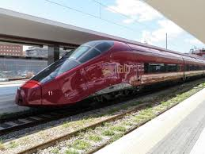](https://www.google.cz/imgres?imgurl=https://avatars.mds.yandex.net/get-pdb/49816/bb50cb0c-122b-42d1-8b15-c95b6f481a6e/s800&imgrefurl=https://yandex.ru/collections/card/57ceab95663518eaf9e2fcd5/&docid=-U2bKv1bdNrq5M&tbnid=grpke7m9dNAqrM:&vet=10ahUKEwj-o7mwt6nXAhWOhRoKHS0BCGc4ZBAzCEIoQDBA..i&w=800&h=600&bih=933&biw=1920&q=%D1%81%D0%BF%D0%BE%D1%81%D0%BE%D0%B1%D1%8B%20%D0%BF%D1%83%D1%82%D0%B5%D1%88%D0%B5%D1%81%D1%82%D0%B2%D0%BE%D0%B2%D0%B0%D1%82%D1%8C%20%D0%BA%D0%B0%D1%80%D1%82%D0%B8%D0%BD%D0%BA%D0%B8&ved=0ahUKEwj-o7mwt6nXAhWOhRoKHS0BCGc4ZBAzCEIoQDBA&iact=mrc&uact=8)[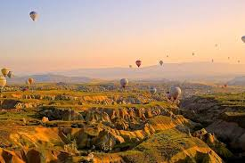](https://www.google.cz/imgres?imgurl=https://media.thequestion.ru/image/with_proportions/744x0/2168572036b2a4da2a68b9badbc152b3e05ecf3d?url%3Dhttps%3A%2F%2Fthequestion.s3.eu-central-1.amazonaws.com%2F209%2F313530-6e4b6c9e.jpeg&imgrefurl=https://thequestion.ru/questions/188259/kak-ne-prinadlezhat-odnomu-mestu-kak-puteshestvovat-po-raznym-stranam-i-zhit-tam-mesyac-dva-a-inogda-bolshe&docid=6OXjC5GCQRXaeM&tbnid=OPWvN1jh6qMkgM:&vet=10ahUKEwj-o7mwt6nXAhWOhRoKHS0BCGc4ZBAzCEUoQzBD..i&w=744&h=495&bih=933&biw=1920&q=%D1%81%D0%BF%D0%BE%D1%81%D0%BE%D0%B1%D1%8B%20%D0%BF%D1%83%D1%82%D0%B5%D1%88%D0%B5%D1%81%D1%82%D0%B2%D0%BE%D0%B2%D0%B0%D1%82%D1%8C%20%D0%BA%D0%B0%D1%80%D1%82%D0%B8%D0%BD%D0%BA%D0%B8&ved=0ahUKEwj-o7mwt6nXAhWOhRoKHS0BCGc4ZBAzCEUoQzBD&iact=mrc&uact=8)

[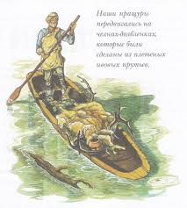](https://www.google.cz/imgres?imgurl=http://malish.info/sites/default/files/field/image/s32.jpg&imgrefurl=http://malish.info/drevneyshiy-sposob-puteshestvovat.html&docid=Cl5wORaEZ14KvM&tbnid=UbJUpv2TMjbLsM:&vet=10ahUKEwj-o7mwt6nXAhWOhRoKHS0BCGc4ZBAzCFMoUTBR..i&w=911&h=1016&bih=933&biw=1920&q=%D1%81%D0%BF%D0%BE%D1%81%D0%BE%D0%B1%D1%8B%20%D0%BF%D1%83%D1%82%D0%B5%D1%88%D0%B5%D1%81%D1%82%D0%B2%D0%BE%D0%B2%D0%B0%D1%82%D1%8C%20%D0%BA%D0%B0%D1%80%D1%82%D0%B8%D0%BD%D0%BA%D0%B8&ved=0ahUKEwj-o7mwt6nXAhWOhRoKHS0BCGc4ZBAzCFMoUTBR&iact=mrc&uact=8)[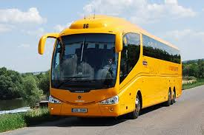](https://www.google.cz/imgres?imgurl=https://s14.stc.all.kpcdn.net/share/i/12/10160509/inx960x640.jpg&imgrefurl=https://www.kp.by/daily/26720.7/3745486/&docid=ffJOwVijZQUPlM&tbnid=3vQ4f8-8Vu9-2M:&vet=10ahUKEwijrqXmuKnXAhUHQBoKHRaZDW04yAEQMwgeKBwwHA..i&w=960&h=640&bih=933&biw=1920&q=%D1%81%D0%BF%D0%BE%D1%81%D0%BE%D0%B1%D1%8B%20%D0%BF%D1%83%D1%82%D0%B5%D1%88%D0%B5%D1%81%D1%82%D0%B2%D0%BE%D0%B2%D0%B0%D1%82%D1%8C%20%D0%BA%D0%B0%D1%80%D1%82%D0%B8%D0%BD%D0%BA%D0%B8&ved=0ahUKEwijrqXmuKnXAhUHQBoKHRaZDW04yAEQMwgeKBwwHA&iact=mrc&uact=8)

[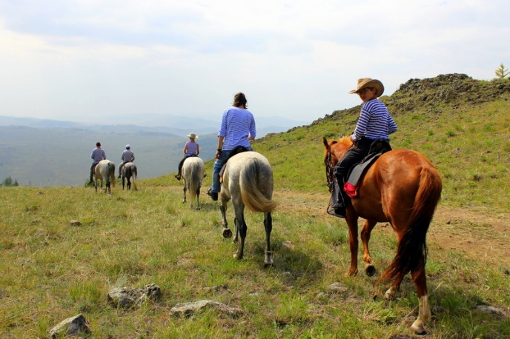](http://www.google.cz/url?sa=i&rct=j&q=&esrc=s&source=images&cd=&cad=rja&uact=8&ved=0ahUKEwjxkIeUuqnXAhWGtxQKHf7EBQEQjRwIBw&url=http://horsebaikaltour.com/content/baykalskiy_konno_turisticheskiy_centr&psig=AOvVaw2Zo5V49IunhHLzW9YkyNLg&ust=1510040712868252)[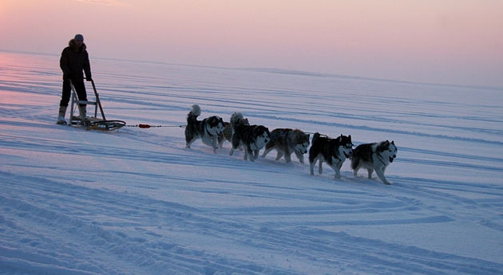](http://www.google.cz/url?sa=i&rct=j&q=&esrc=s&source=images&cd=&cad=rja&uact=8&ved=0ahUKEwj50K3YuqnXAhXEbxQKHWJcDQ0QjRwIBw&url=http://tonkostyturizma.ru/puteshestvie-na-severnyj-polyus.html&psig=AOvVaw0NpEjHstKh_FuHGLmhHsTL&ust=1510040749155150)