[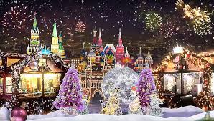](https://www.google.cz/imgres?imgurl=http://tripsmile.ru/images/uploads/2015/12/meroprijatija-moskva-2016-650cp.jpg&imgrefurl=http://tripsmile.ru/kalendar/386-programma-meroprijatij-na-novogodnie-prazdniki-2016-v-moskve&docid=aG2a7nM-6QlptM&tbnid=gVE3misqlogKaM:&vet=10ahUKEwj5iNKmxIvYAhXiYpoKHTQxCWM4yAEQMwgXKBUwFQ..i&w=859&h=487&bih=933&biw=1920&q=%D0%BF%D1%80%D0%B0%D0%B7%D0%B4%D0%BD%D0%B8%D0%BA%D0%B8&ved=0ahUKEwj5iNKmxIvYAhXiYpoKHTQxCWM4yAEQMwgXKBUwFQ&iact=mrc&uact=8)[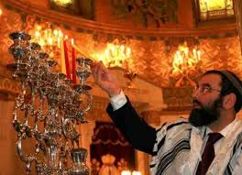](https://www.google.cz/imgres?imgurl=http://www.pro-israel.ru/wp-content/uploads/images/hanuka-e1350849587747.jpg&imgrefurl=http://www.pro-israel.ru/kalendar-israelya.html&docid=zFcKs4B3Gj5drM&tbnid=DVloxSq_5QOrIM:&vet=10ahUKEwi_2uSIxIvYAhXkQJoKHVL-Bh84ZBAzCDMoMDAw..i&w=600&h=434&bih=933&biw=1920&q=%D0%BF%D1%80%D0%B0%D0%B7%D0%B4%D0%BD%D0%B8%D0%BA%D0%B8&ved=0ahUKEwi_2uSIxIvYAhXkQJoKHVL-Bh84ZBAzCDMoMDAw&iact=mrc&uact=8)[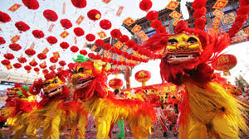](https://www.google.cz/imgres?imgurl=http://myzen.com.ua/images/gallery/events/kitaiskii_noviy_god.jpg&imgrefurl=http://myzen.com.ua/ru/art/prazdniki&docid=MpQX-taJ9QEH5M&tbnid=Rgwf2_t-ge4iRM:&vet=10ahUKEwjO3azww4vYAhXjDpoKHVHxAc8QMwh0KBswGw..i&w=1280&h=720&bih=933&biw=1920&q=%D0%BF%D1%80%D0%B0%D0%B7%D0%B4%D0%BD%D0%B8%D0%BA%D0%B8&ved=0ahUKEwjO3azww4vYAhXjDpoKHVHxAc8QMwh0KBswGw&iact=mrc&uact=8)[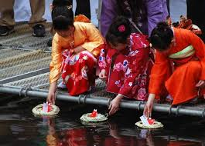](https://www.google.cz/imgres?imgurl=https://arttravelblog.ru/wp-content/uploads/2017/03/%D0%BF%D1%80%D0%B0%D0%B7%D0%B4%D0%BD%D0%B8%D0%BA-%D0%B4%D0%B5%D0%B2%D0%BE%D1%87%D0%B5%D0%BA-%D1%8F%D0%BF%D0%BE%D0%BD%D0%B8%D1%8F-3.jpg&imgrefurl=https://arttravelblog.ru/interesnoe/xinamacuri-tradicionnyj-prazdnik-devochek-v-yaponii.html&docid=Rk1rQiKxUq9cEM&tbnid=3swv1pcDRKgjsM:&vet=10ahUKEwj5iNKmxIvYAhXiYpoKHTQxCWM4yAEQMwhRKE4wTg..i&w=600&h=430&bih=933&biw=1920&q=%D0%BF%D1%80%D0%B0%D0%B7%D0%B4%D0%BD%D0%B8%D0%BA%D0%B8&ved=0ahUKEwj5iNKmxIvYAhXiYpoKHTQxCWM4yAEQMwhRKE4wTg&iact=mrc&uact=8)[](https://www.google.cz/imgres?imgurl=https://vikiland.ru/images/gallery/event-management/prazdnik11.jpg&imgrefurl=https://vikiland.ru/event-management/&docid=svDzLW9oU5d8IM&tbnid=eGs4Iv5KQXH-cM:&vet=10ahUKEwjO3azww4vYAhXjDpoKHVHxAc8QMwhvKBYwFg..i&w=1024&h=683&bih=933&biw=1920&q=%D0%BF%D1%80%D0%B0%D0%B7%D0%B4%D0%BD%D0%B8%D0%BA%D0%B8&ved=0ahUKEwjO3azww4vYAhXjDpoKHVHxAc8QMwhvKBYwFg&iact=mrc&uact=8)[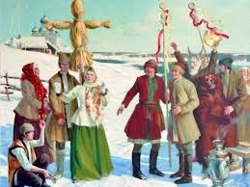](https://www.google.cz/imgres?imgurl=http://cont.ws/uploads/pic/2015/11/komoeditsa-slavyanskiy-prazdnik.jpg&imgrefurl=https://cont.ws/post/150375&docid=o2q_9gMUecVnTM&tbnid=JnlbBSRNuKngmM:&vet=10ahUKEwi_2uSIxIvYAhXkQJoKHVL-Bh84ZBAzCF0oWjBa..i&w=800&h=600&bih=933&biw=1920&q=%D0%BF%D1%80%D0%B0%D0%B7%D0%B4%D0%BD%D0%B8%D0%BA%D0%B8&ved=0ahUKEwi_2uSIxIvYAhXkQJoKHVL-Bh84ZBAzCF0oWjBa&iact=mrc&uact=8)[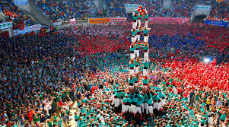](https://www.google.cz/imgres?imgurl=http://www.leanga.ru/upload/iblock/b61/b612d93618792bdbf2debf4b4684c2a9.jpg&imgrefurl=http://www.leanga.ru/articles/neobychnye-prazdniki-i-festivali-v-ispanii/&docid=E0wOp_xJvoheKM&tbnid=xgcK1oGPHzpTZM:&vet=10ahUKEwj5iNKmxIvYAhXiYpoKHTQxCWM4yAEQMwhNKEowSg..i&w=900&h=500&bih=933&biw=1920&q=%D0%BF%D1%80%D0%B0%D0%B7%D0%B4%D0%BD%D0%B8%D0%BA%D0%B8&ved=0ahUKEwj5iNKmxIvYAhXiYpoKHTQxCWM4yAEQMwhNKEowSg&iact=mrc&uact=8)[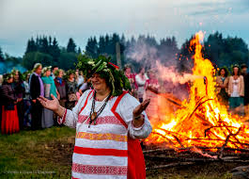](https://www.google.cz/imgres?imgurl=http://www.true-photo-archive.com/images/399/01.JPG&imgrefurl=http://www.interesmir.ru/slavyanskie-prazdniki-letnego-solntsestoyaniya/&docid=srrTNXcS1f_CYM&tbnid=kUItLvAdbZcg5M:&vet=10ahUKEwjMgK7IxIvYAhWEYJoKHQrHDzg4rAIQMwgFKAMwAw..i&w=1200&h=860&bih=933&biw=1920&q=%D0%BF%D1%80%D0%B0%D0%B7%D0%B4%D0%BD%D0%B8%D0%BA%D0%B8&ved=0ahUKEwjMgK7IxIvYAhWEYJoKHQrHDzg4rAIQMwgFKAMwAw&iact=mrc&uact=8)

[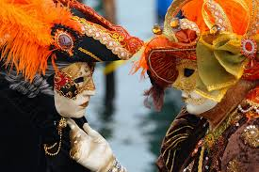](https://www.google.cz/imgres?imgurl=http://www.hoteldiscount.ru/uploads/4/29/b0e652e477af2043a9811d8709715.jpg&imgrefurl=http://www.hoteldiscount.ru/guide/italy/?guide_id%3D294&docid=8bU-JFtX3iNL5M&tbnid=vLhja33uT2_sUM:&vet=10ahUKEwij7JiWxovYAhWhC5oKHUz0DRs49AMQMwhOKEswSw..i&w=1024&h=683&bih=933&biw=1920&q=%D0%BF%D1%80%D0%B0%D0%B7%D0%B4%D0%BD%D0%B8%D0%BA%D0%B8&ved=0ahUKEwij7JiWxovYAhWhC5oKHUz0DRs49AMQMwhOKEswSw&iact=mrc&uact=8)[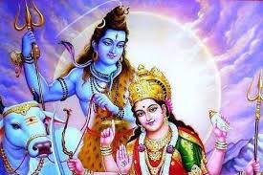](https://www.google.cz/imgres?imgurl=http://satyam-shivam-sundaram.org/images/festivals/navratri-ancient-festival_s.jpg&imgrefurl=http://satyam-shivam-sundaram.org/festivals&docid=FdfLfRDJ_l8xPM&tbnid=WXVqNISlqmYcgM:&vet=10ahUKEwj5iNKmxIvYAhXiYpoKHTQxCWM4yAEQMwgIKAYwBg..i&w=480&h=320&bih=933&biw=1920&q=%D0%BF%D1%80%D0%B0%D0%B7%D0%B4%D0%BD%D0%B8%D0%BA%D0%B8&ved=0ahUKEwj5iNKmxIvYAhXiYpoKHTQxCWM4yAEQMwgIKAYwBg&iact=mrc&uact=8)[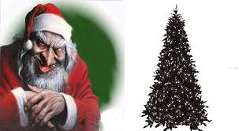](https://www.google.cz/imgres?imgurl=http://www.islamdag.ru/sites/img/stati/2009/4kv/ded_moroz_b.jpg&imgrefurl=http://dylym.ru/mozhno-li-prazdnovat-nemusulmanskie-prazdniki-naprimer-novyj-god/&docid=lR6_OlKQE6tqHM&tbnid=L438pdiblGqe2M:&vet=10ahUKEwij7JiWxovYAhWhC5oKHUz0DRs49AMQMwgaKBcwFw..i&w=1200&h=658&bih=933&biw=1920&q=%D0%BF%D1%80%D0%B0%D0%B7%D0%B4%D0%BD%D0%B8%D0%BA%D0%B8&ved=0ahUKEwij7JiWxovYAhWhC5oKHUz0DRs49AMQMwgaKBcwFw&iact=mrc&uact=8)[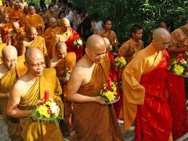](https://www.google.cz/imgres?imgurl=http://www.hollydays.ru/img/holidays/buddhism.jpg&imgrefurl=http://www.hollydays.ru/celebrations/buddhism/2018/&docid=RLyAT3i9quIXrM&tbnid=kJNlg4mbxja7vM:&vet=10ahUKEwitk86kxovYAhWBJ5oKHT0VADE42AQQMwgqKCcwJw..i&w=300&h=225&bih=933&biw=1920&q=%D0%BF%D1%80%D0%B0%D0%B7%D0%B4%D0%BD%D0%B8%D0%BA%D0%B8&ved=0ahUKEwitk86kxovYAhWBJ5oKHT0VADE42AQQMwgqKCcwJw&iact=mrc&uact=8)[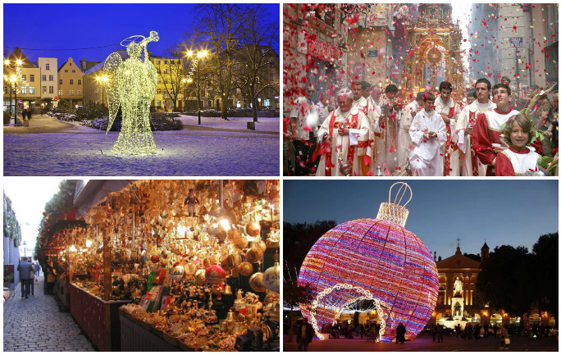](http://www.google.cz/url?sa=i&rct=j&q=&esrc=s&source=images&cd=&cad=rja&uact=8&ved=0ahUKEwinqZiexYvYAhXRyKQKHSidDzEQjRwIBw&url=http://poland1.top/zhizn-v-polshe/prazdniki-i-pamyatnye-daty-v-polshe.html&psig=AOvVaw2OckBdTVeRpe73RSgefL6l&ust=1513410578178236)