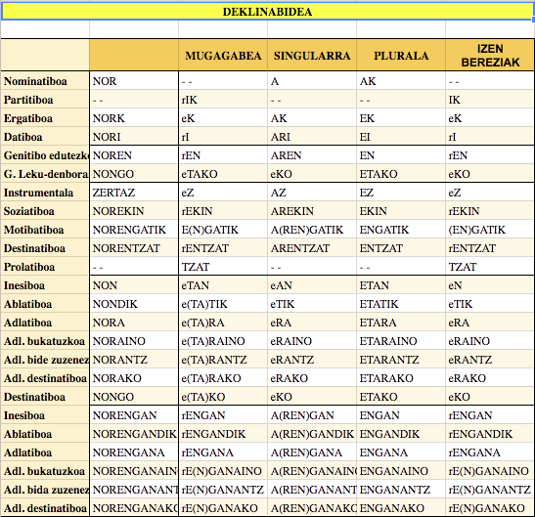-

THIS IS THE TABLE OF THE DECLINATION OF THE BASQUE LANGUAGE. IT HAS 24 CASES, SUFFIXES. IN BASQUE, THESE CASES OR SUFFIXES ARE ADDED TO THE WORDS ACCORDING TO THE FUNCTION THEY PERFORM WITHIN THE SYNTAGM

**Mark alaia da** (SOV) /*Mark is happy. Caso NOR ø- Passive subject*

***Markek autoa du***(SOV)  */ Mark has a car / Caso NORK -Active subject*

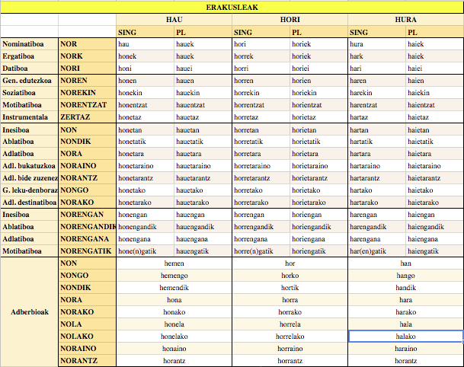

THIS IS THE TABLE OF THE DECLINATION OF THE DEMONSTRATIVE ADJECTIVES OR PRONOUNS (THIS, THAT, THAT, THIS, THAT, THAT) THEY ARE ALSO CALLED DEMONSTRATIVE DETERMINANTS. IN BASQUE THEY ARE CALLED “ERAKUSLEAK”. THE SUFFIX OR CASE OF THE DECLINATION IS ALSO ADDED, ACCORDING TO THE FUNCTION THEY PERFORM IN THE SYNTAGM

|  |  |
| --- | --- |
| **Etxe hau-** This house | **Hau –** This |
| **Etxe hori –** That house | **Hori –** *That* |
| **Etxe hura –** That house (further away) | **Hura –** *That (further away)* |
| **Etxe hauek –** These houses | **Hauek -** These |
| **Etxe horiek –** Those houses | **Horiek -** *Those* |
| **Etxe haiek –** Those houses (further away) | **Haiek –** *Those (further away)* |