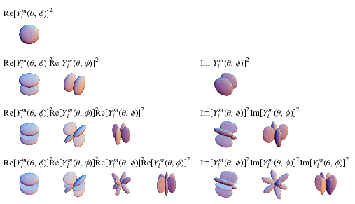

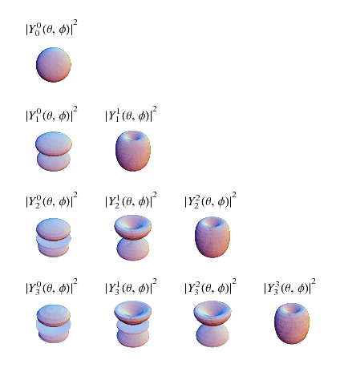

|  |  |  |  |
| --- | --- | --- | --- |
| Y_0^0(theta,phi) | = | 1/21/(sqrt(pi)) |  |
| Y_1^(-1)(theta,phi) | = | 1/2sqrt(3/(2pi))sinthetae^(-iphi) |  |
| Y_1^0(theta,phi) | = | 1/2sqrt(3/pi)costheta |  |
| Y_1^1(theta,phi) | = | -1/2sqrt(3/(2pi))sinthetae^(iphi) |  |
| Y_2^(-2)(theta,phi) | = | 1/4sqrt((15)/(2pi))sin^2thetae^(-2iphi) |  |
| Y_2^(-1)(theta,phi) | = | 1/2sqrt((15)/(2pi))sinthetacosthetae^(-iphi) |  |
| Y_2^0(theta,phi) | = | 1/4sqrt(5/pi)(3cos^2theta-1) |  |
| Y_2^1(theta,phi) | = | -1/2sqrt((15)/(2pi))sinthetacosthetae^(iphi) |  |
| Y_2^2(theta,phi) | = | 1/4sqrt((15)/(2pi))sin^2thetae^(2iphi) |  |
| Y_3^(-3)(theta,phi) | = | 1/8sqrt((35)/pi)sin^3thetae^(-3iphi) |  |
| Y_3^(-2)(theta,phi) | = | 1/4sqrt((105)/(2pi))sin^2thetacosthetae^(-2iphi) |  |
| Y_3^(-1)(theta,phi) | = | 1/8sqrt((21)/pi)sintheta(5cos^2theta-1)e^(-iphi) |  |
| Y_3^0(theta,phi) | = | 1/4sqrt(7/pi)(5cos^3theta-3costheta) |  |
| Y_3^1(theta,phi) | = | -1/8sqrt((21)/pi)sintheta(5cos^2theta-1)e^(iphi) |  |
| Y_3^2(theta,phi) | = | 1/4sqrt((105)/(2pi))sin^2thetacosthetae^(2iphi) |  |
| Y_3^3(theta,phi) | = | -1/8sqrt((35)/pi)sin^3thetae^(3iphi). |  |