[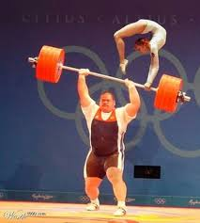](https://www.google.cz/imgres?imgurl=https://xage.ru/media/uploads/2010/3/fotokurezyi-gibridnyie-vidyi-sporta/fotokurezyi-gibridnyie-vidyi-sporta_1.jpg&imgrefurl=https://xage.ru/fotokurezyi-gibridnyie-vidyi-sporta/&docid=gPnHGnwQ1bTvRM&tbnid=5LNL_CdfjRQEBM:&vet=12ahUKEwi7uMyM3rnZAhWEEywKHQWUBxY4ZBAzKFYwVnoECAAQVw..i&w=450&h=500&bih=933&biw=1920&q=%D0%B2%D0%B8%D0%B4%D1%8B%20%D1%81%D0%BF%D0%BE%D1%80%D1%82%D0%B0%20%D0%BA%D0%B0%D1%80%D1%82%D0%B8%D0%BD%D0%BA%D0%B8&ved=2ahUKEwi7uMyM3rnZAhWEEywKHQWUBxY4ZBAzKFYwVnoECAAQVw&iact=mrc&uact=8)[](https://www.google.cz/imgres?imgurl=http://cs.mirtoday.com/uploads/sites/2/2015/03/973202-15914391-640-360.jpg&imgrefurl=http://mirtoday.com/populyarnye-zimnie-vidy-sporta&docid=nVt16HBf8H1pkM&tbnid=rNutvVxnZfc59M:&vet=10ahUKEwj-7N-23rnZAhUE_iwKHXdgD70QMwh3KC4wLg..i&w=640&h=360&bih=933&biw=1920&q=%D0%B2%D0%B8%D0%B4%D1%8B%20%D1%81%D0%BF%D0%BE%D1%80%D1%82%D0%B0%20%D0%BA%D0%B0%D1%80%D1%82%D0%B8%D0%BD%D0%BA%D0%B8&ved=0ahUKEwj-7N-23rnZAhUE_iwKHXdgD70QMwh3KC4wLg&iact=mrc&uact=8)[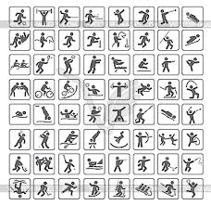](https://www.google.cz/imgres?imgurl=https://images.vector-images.com/clp/183609/clp158600.jpg&imgrefurl=https://vector-images.com/clipart/clp158600/?lang%3Drus&docid=t2gpvAN1rJIwMM&tbnid=LSq2_ZQK6j3k4M:&vet=12ahUKEwig9LTT3rnZAhWHWCwKHYUpDfU4yAEQMyg2MDZ6BAgAEDc..i&w=300&h=291&bih=933&biw=1920&q=%D0%B2%D0%B8%D0%B4%D1%8B%20%D1%81%D0%BF%D0%BE%D1%80%D1%82%D0%B0%20%D0%BA%D0%B0%D1%80%D1%82%D0%B8%D0%BD%D0%BA%D0%B8&ved=2ahUKEwig9LTT3rnZAhWHWCwKHYUpDfU4yAEQMyg2MDZ6BAgAEDc&iact=mrc&uact=8)[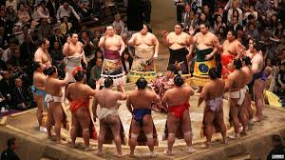](https://www.google.cz/imgres?imgurl=http://miuki.info/wp-content/gallery/people-in-kimono/9fe76bd1-222d-496b-8d99-ca45ed2df0bc.jpg&imgrefurl=http://miuki.info/2013/07/tradicionnye-i-sovremennye-vidy-sporta-v-yaponii/&docid=rpGzYezxKzrbOM&tbnid=gYIU4i8DK6SQxM:&vet=12ahUKEwjjwPrq3rnZAhXMhKYKHbOPDNQ4rAIQMygIMAh6BAgAEAk..i&w=1200&h=675&bih=933&biw=1920&q=%D0%B2%D0%B8%D0%B4%D1%8B%20%D1%81%D0%BF%D0%BE%D1%80%D1%82%D0%B0%20%D0%BA%D0%B0%D1%80%D1%82%D0%B8%D0%BD%D0%BA%D0%B8&ved=2ahUKEwjjwPrq3rnZAhXMhKYKHbOPDNQ4rAIQMygIMAh6BAgAEAk&iact=mrc&uact=8)[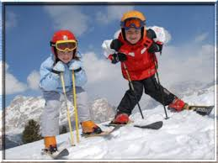](https://www.google.cz/imgres?imgurl=http://mamochki-detishki.ru/wp-content/uploads/2010/03/174.jpg&imgrefurl=http://mamochki-detishki.ru/zimnie-kataniya/&docid=qs-bdU6PEJVuoM&tbnid=I9AtLNsiXA6I0M:&vet=12ahUKEwig9LTT3rnZAhWHWCwKHYUpDfU4yAEQMyghMCF6BAgAECI..i&w=400&h=300&bih=933&biw=1920&q=%D0%B2%D0%B8%D0%B4%D1%8B%20%D1%81%D0%BF%D0%BE%D1%80%D1%82%D0%B0%20%D0%BA%D0%B0%D1%80%D1%82%D0%B8%D0%BD%D0%BA%D0%B8&ved=2ahUKEwig9LTT3rnZAhWHWCwKHYUpDfU4yAEQMyghMCF6BAgAECI&iact=mrc&uact=8)[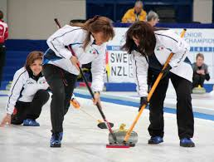](https://www.google.cz/imgres?imgurl=http://cs.mirtoday.com/uploads/sites/2/2015/03/kurling.jpg&imgrefurl=http://mirtoday.com/populyarnye-zimnie-vidy-sporta&docid=nVt16HBf8H1pkM&tbnid=q99s-gUkEYbShM:&vet=10ahUKEwj-7N-23rnZAhUE_iwKHXdgD70QMwiYAShPME8..i&w=2843&h=2146&bih=933&biw=1920&q=%D0%B2%D0%B8%D0%B4%D1%8B%20%D1%81%D0%BF%D0%BE%D1%80%D1%82%D0%B0%20%D0%BA%D0%B0%D1%80%D1%82%D0%B8%D0%BD%D0%BA%D0%B8&ved=0ahUKEwj-7N-23rnZAhUE_iwKHXdgD70QMwiYAShPME8&iact=mrc&uact=8)[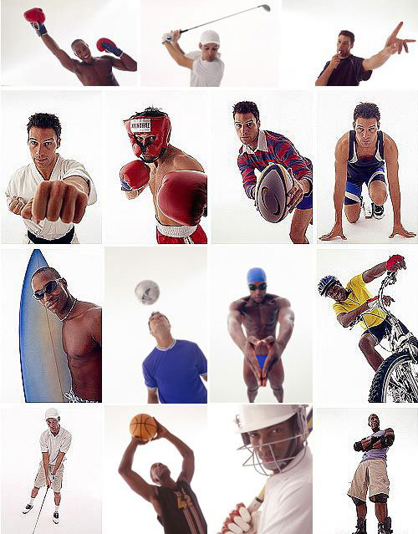](http://www.google.cz/url?sa=i&rct=j&q=&esrc=s&source=images&cd=&cad=rja&uact=8&ved=2ahUKEwiEh6XZ3rnZAhUF36QKHUyzDuQQjRx6BAgAEAY&url=http://hivemind.com.ua/?p%3D5081&psig=AOvVaw1h6L5qgbsuSOwh9mNlP9hd&ust=1519396299455798)[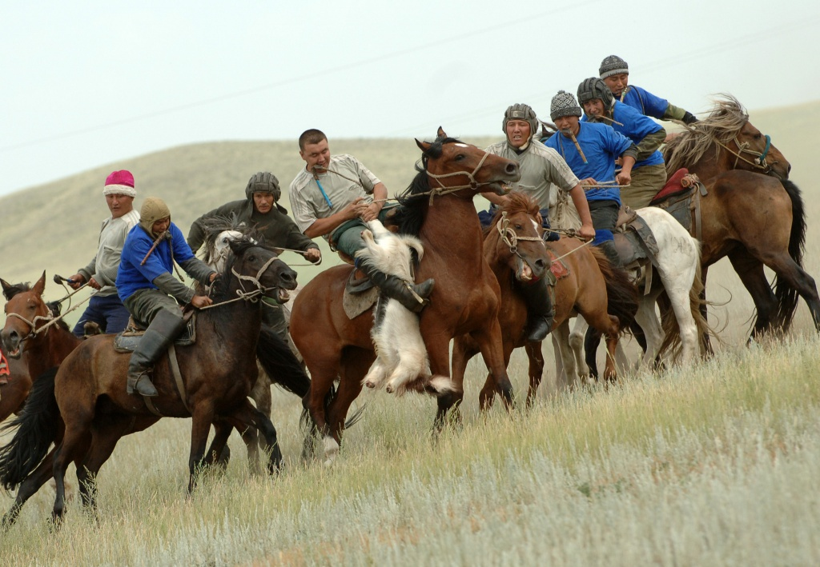](http://www.google.cz/url?sa=i&rct=j&q=&esrc=s&source=images&cd=&cad=rja&uact=8&ved=2ahUKEwjP3OqS37nZAhWFyqQKHcjPDWUQjRx6BAgAEAY&url=http://www.kazakhstanlive.ru/sport/national-kinds-of-sports/&psig=AOvVaw1h6L5qgbsuSOwh9mNlP9hd&ust=1519396299455798)[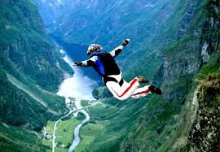](https://www.google.cz/imgres?imgurl=http://1news.az/images/articles/2013/07/09/thumb_20130709114415431.jpg&imgrefurl=http://www.1news.az/news/ekstremal-nye-vidy-sporta-ot-kotoryh-zahvatyvaet-duh---video&docid=wVQVWZ38XNEUIM&tbnid=FG4hU04WVDEuGM:&vet=12ahUKEwiIyuWx37nZAhWrhKYKHcacA2c42AQQMyhLMEt6BAgAEE0..i&w=400&h=277&bih=933&biw=1920&q=%D0%B2%D0%B8%D0%B4%D1%8B%20%D1%81%D0%BF%D0%BE%D1%80%D1%82%D0%B0%20%D0%BA%D0%B0%D1%80%D1%82%D0%B8%D0%BD%D0%BA%D0%B8&ved=2ahUKEwiIyuWx37nZAhWrhKYKHcacA2c42AQQMyhLMEt6BAgAEE0&iact=mrc&uact=8)[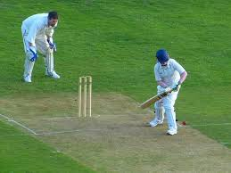](https://www.google.cz/imgres?imgurl=http://www.bugaga.ru/uploads/posts/2018-02/1518520341_sport25.jpg&imgrefurl=http://www.bugaga.ru/interesting/1146764874-top-25-samye-krutye-priznannye-no-ne-odobrennye-olimpiyskie-vidy-sporta.html&docid=4rD2ULzTyYNgsM&tbnid=07ZCj7x2szefeM:&vet=12ahUKEwiIyuWx37nZAhWrhKYKHcacA2c42AQQMyhiMGJ6BAgAEGQ..i&w=610&h=458&bih=933&biw=1920&q=%D0%B2%D0%B8%D0%B4%D1%8B%20%D1%81%D0%BF%D0%BE%D1%80%D1%82%D0%B0%20%D0%BA%D0%B0%D1%80%D1%82%D0%B8%D0%BD%D0%BA%D0%B8&ved=2ahUKEwiIyuWx37nZAhWrhKYKHcacA2c42AQQMyhiMGJ6BAgAEGQ&iact=mrc&uact=8)[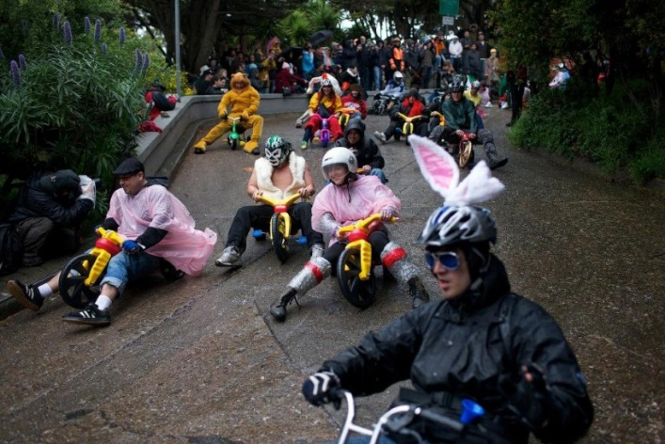](http://www.google.cz/url?sa=i&rct=j&q=&esrc=s&source=images&cd=&cad=rja&uact=8&ved=2ahUKEwi1182q3rnZAhWI-aQKHeq8CLQQjRx6BAgAEAY&url=http://12millionov.com/samye-neobychnye-vidy-sporta.html&psig=AOvVaw2D1KlbAdGBi-p2t3ELhDpu&ust=1519396194641430)[](https://www.google.cz/imgres?imgurl=http://waterwiki.org/wp-content/uploads/2016/06/%D0%91%D0%B0%D1%81%D0%BA%D0%B5%D1%82%D0%B1%D0%BE%D0%BB-%D0%B8-%D0%B5%D0%B3%D0%BE-%D0%B8%D1%81%D1%82%D0%BE%D0%BA%D0%B8.jpg&imgrefurl=http://waterwiki.org/sport-v-amerike-osnovnye-vidy-sporta&docid=R1LuuAzTvNgY4M&tbnid=wV_bZya1dVZI2M:&vet=12ahUKEwj5oIvN37nZAhVCBSwKHdpOC4w4oAYQMygqMCp6BAgAECs..i&w=650&h=428&bih=933&biw=1920&q=%D0%B2%D0%B8%D0%B4%D1%8B%20%D1%81%D0%BF%D0%BE%D1%80%D1%82%D0%B0%20%D0%BA%D0%B0%D1%80%D1%82%D0%B8%D0%BD%D0%BA%D0%B8&ved=2ahUKEwj5oIvN37nZAhVCBSwKHdpOC4w4oAYQMygqMCp6BAgAECs&iact=mrc&uact=8)