**Version I 19.5.2023**

**A: Download the sequence NM_000946.3**

1. What does this sequence encode?

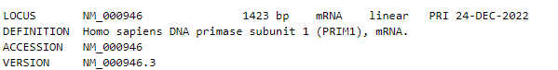

1. How long is the coding sequence and how long will the translated protein be?

CDS: 1263nt

Protein: 420aminoacids

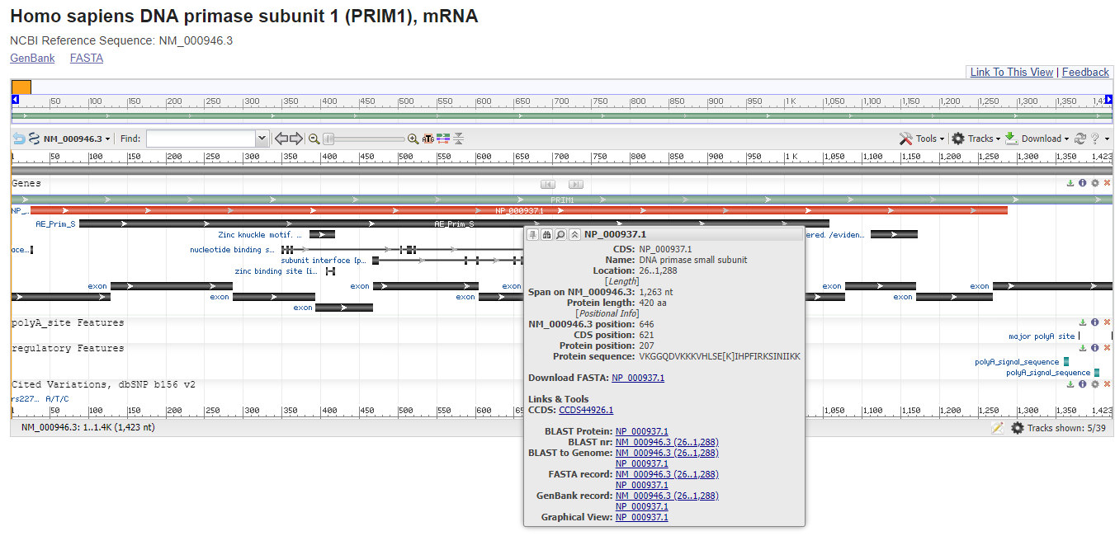

1. Manually design primers for PCR amplification of the CDS.¨

>NM_000946.3:26-1288 Homo sapiens DNA primase subunit 1 (PRIM1), mRNA

ATGGAGACGTTTGACCCCACCGAGCTGCCCGAGCTGCTTAAACTTTATTACCGGAGGCTCTTTCCCTACT

CTCAGTACTATCGCTGGCTCAACTACGGTGGAGTGATAAAGAATTACTTTCAACACCGTGAATTTTCATT

CACATTGAAAGATGATATTTACATTCGCTACCAATCCTTCAACAACCAGAGTGATCTGGAAAAGGAGATG

CAGAAAATGAATCCATACAAGATTGATATAGGCGCAGTATATTCTCACAGACCCAATCAACACAATACAG

TGAAGCTGGGAGCTTTCCAGGCTCAGGAAAAAGAACTGGTATTTGACATTGACATGACAGACTATGACGA

TGTGAGGAGATGTTGTAGTTCTGCAGACATATGTCCTAAGTGCTGGACCCTCATGACAATGGCCATACGC

ATCATTGACAGAGCATTGAAGGAGGACTTTGGATTTAAGCATCGTCTCTGGGTATATTCTGGAAGGAGAG

GTGTTCATTGTTGGGTCTGTGATGAATCAGTTAGAAAACTGTCTTCTGCAGTACGTTCTGGGATAGTTGA

GTATTTGAGCCTTGTAAAGGGTGGTCAAGACGTTAAAAAGAAAGTTCACCTAAGTGAAAAAATTCACCCT

TTTATCAGAAAATCTATAAACATAATAAAAAAATACTTTGAAGAATATGCCTTGGTTAATCAAGATATTC

TCGAAAATAAAGAAAGCTGGGATAAGATTTTAGCCCTTGTTCCTGAAACAATTCATGATGAACTTCAACA

AAGCTTCCAAAAGTCTCACAATTCACTTCAGCGTTGGGAGCACTTGAAGAAAGTAGCCAGCAGATATCAG

AATAACATCAAAAATGACAAATATGGACCCTGGCTGGAGTGGGAGATTATGCTCCAGTACTGTTTTCCAC

GGCTGGATATCAATGTCAGCAAAGGAATCAATCATCTACTGAAGAGCCCTTTTAGTGTTCATCCTAAAAC

AGGTCGCATATCTGTGCCTATTGATTTGCAGAAAGTGGACCAGTTTGATCCATTTACTGTTCCGACCATA

AGCTTCATCTGCCGTGAATTGGATGCCATTTCCACTAATGAAGAGGAAAAAGAGGAGAATGAAGCTGAAT

CTGATGTCAAACATAGAACCAGAGATTATAAGAAGACCAGTCTAGCACCTTATGTGAAAGTTTTTGAACA

TTTTCTTGAAAATCTGGATAAATCCCGAAAAGGAGAACTTCTTAAGAAGAGTGATTTACAAAAAGATTTC

TGA

F: ATG GAG ACG TTT GAC CCC AC

R: TCA GAA ATC TTT TTG TAA ATC ACT CTT

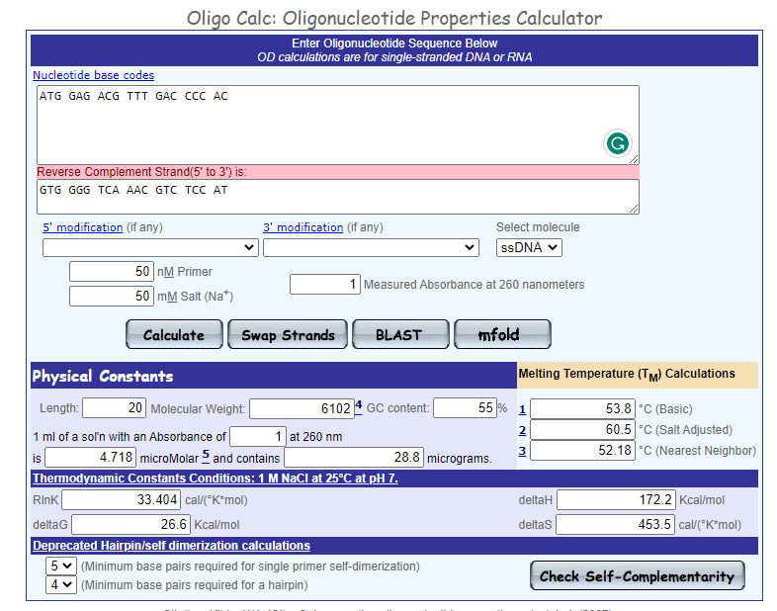

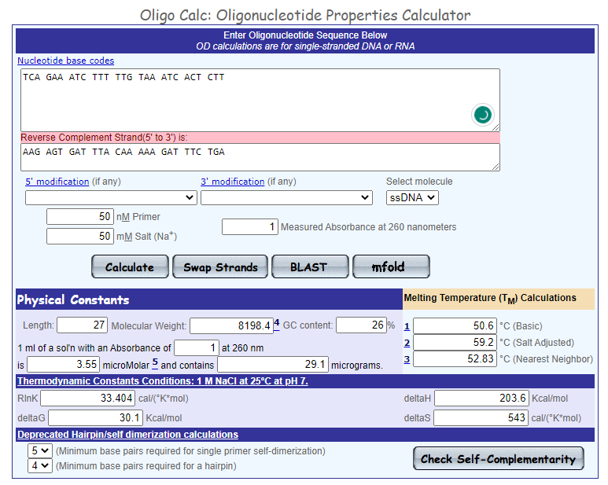

1. Compare the designed primers with the sequence of the mRNA and the CDS.

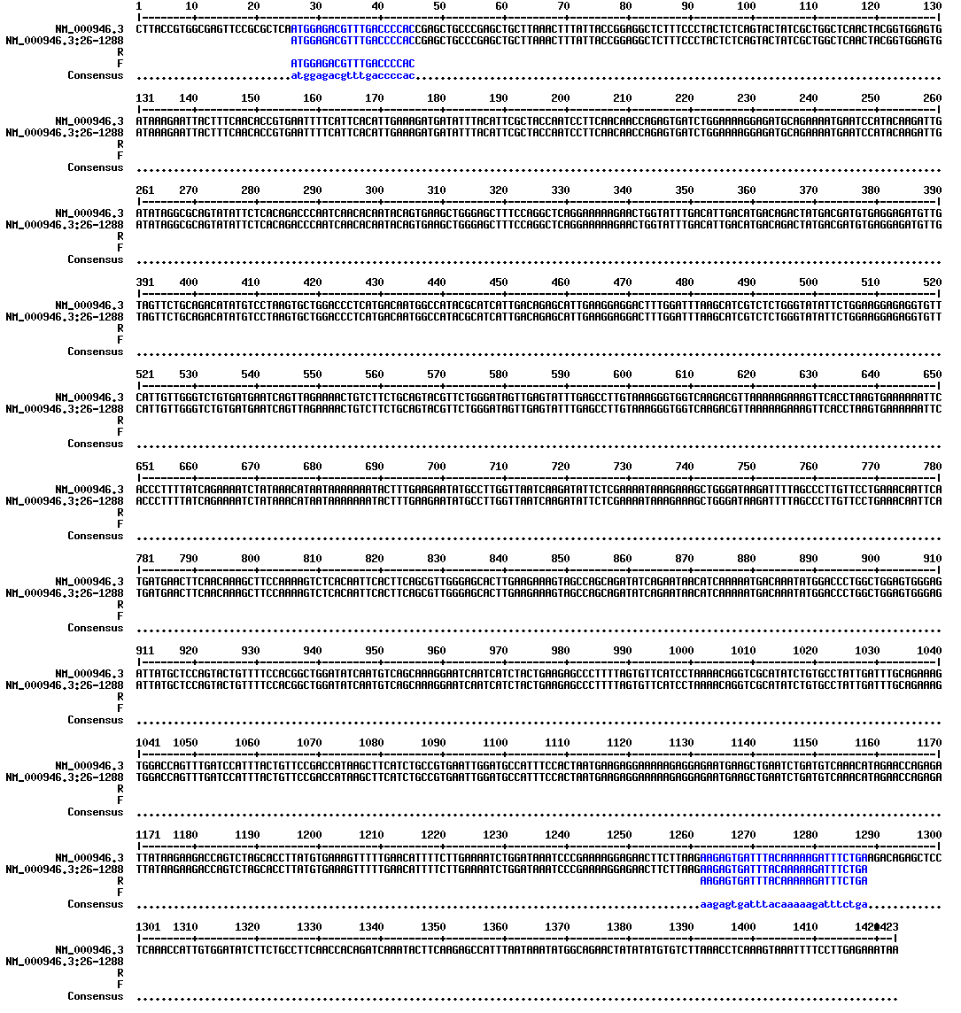

¨

1. Is there a restriction enzyme that would cut the sequence of the third exon exactly once?

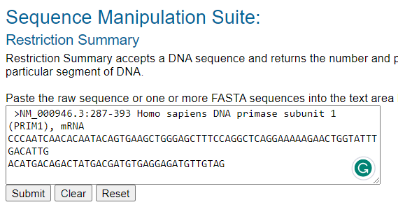



**B: Work with following peptide sequence:**

LALASVFWSISYYSSPFAFFYLYRKGYLSLSKVVPFSHYAGTLLLLLAGVACLRGIGRWT

NPQYRQFITILEATHRNQSSENKRQLANYNFDFRSWPVDFHWEEPSSRKESRGGPSRRGV

ALLRPEPLHRGTADTLLNRVKKLPCQITSYLVAHTLGRRMLYPGSVYLLQKALMPVLLQG

QARLVEECNGRRAKLLACDGNEIDTMFVDRRGTAEPQGQKLVICCEGNAGFYEVGCVSTP

LEACYSVLGWNHPGFAGSTGVPFPQNEANAMDVVVQFAIHRLGFQPQDIIIYAWSIGGFT

1. To which human protein this peptide probably belongs?



1. Does this peptide contain any transmembrane helices?

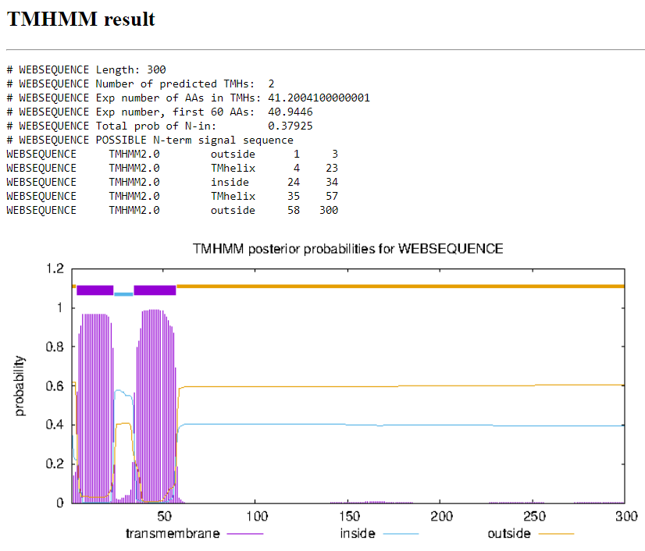

1. What is molecular weigth of this peptide?

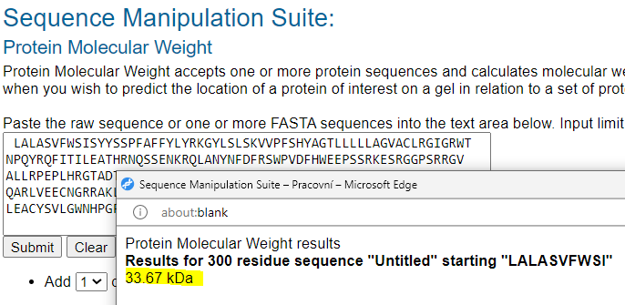

1. How does a given peptide sequence differ from an identified (human) sequence (within the same segment)?

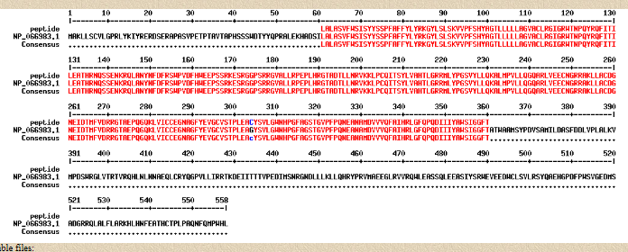

1. Write down the identified mutation.

G304C