**Misery’s the river of the world: Melancholy takes the form of *Acedia***

**I. What is *Acedia*? In the beginning, mostly monks’ problem**

**1.** The demon of acedia –also called 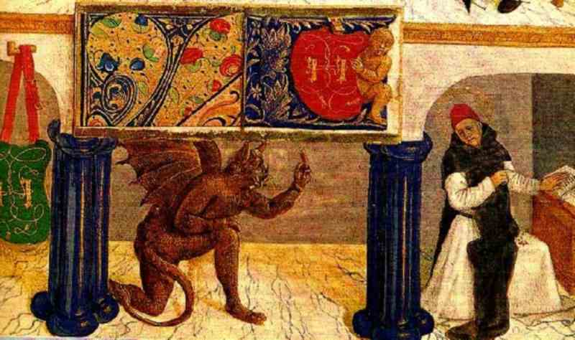the noonday demon [Ps 90:6 LXX] – is one that causes the most serious trouble of all. He presses his attackupon the monk about the fourth hour and besieges the soul until the eight hour. First of all he makes it seem that the sun barely moves, if at all, and that the day is fifty hours long. Then he constrains the monk to look constantly out the windows, to walk outside the cell, to gaze carefully at the sun to determine how far it stands from the ninth hour,to look now this way and now that to see if perhaps [one of the brethren appears from his cell]. Then too he instills in the heart of the monk a hatred for the place, a hatred for his very life itself, a hatred for manual labor. He leads him to reflect that charity has departed from among the brethren, that there is no one to give encouragement. Should there be someone at this period who happens to offend him in some way or other, this too the demon uses to contribute further to his hatred.This demon drives him along to desire other sites where he can more easily procure life’s necessities, more readily find work and make a real success of himself. He goes on to suggest that, after all, it is not the place that is the basis of pleasing the Lord. God is to be adored everywhere. He joins to these reflections the memory of his dear ones and of his former way of life. He depicts life stretching out for a long period of time, and brings before the mind’s eye the toil of the ascetic struggle and, as the saying has it, leaves no leaf unturned to induce the monk to forsake his cell and drop out the fight. No other demon follows close upon the heels of this one (when he is defeated) but only a state of deep peace and inexpressible joy arise out of this struggle. [Evagrius Ponticus, *The Praktikos & Chapters on Prayer*, tr. J. Bamberger, Kalamazoo, 1981, 18-9; 4th century AD]

**2.** Acedia is anxiety or weariness of the heart. [John Cassian, *De institutis coenobiorum*, IX, ed. J-C Guy, Paris, 1965, 5.1, 191; 4th-5th century AD]

**II. Acedia is many things. A (bad) state of mind, a sort of illness, but also a sin**

**1.** Sadness born of confusion of the mind, or weariness and immoderate bitterness of the soul. [Hugh of St. Victor, *Summa de sacramenti fidei.* Patrologia Latina, ed. J-P Migne, 221 vols, Paris 1884-5, 2.13.1; 12th century]

**2.** Vices are corruptions of the soul, from which, unless they are restrained by reason, sins (that is, acts of unrighteousness) arise. When consent is given to the temptation of a vice, an act of unrighteousness occurs, which is called sin. [Hugh of St. Victor, *Summa de sacramentis christianae fidei*, …]

**3.** *Pride* is the love of one’s own excellency, when the mind loves its goodness for its own sake, that is, without Him from Whom it has received the good…after pride, *envy*, and *wrath*, therefore, which despoil man, comes immediately sorrow, which scourges him in his nakedness. Upon it follows *greed*, which throws him out after the scourging; for after losing his inner joy he is compelled to seek comfort outside. Then *gluttony* approaches, which seduces him in his exile; through the natural appetite this vice temps the mind that stands open to external goods and entices [allures] it to engage in excess. Finally, *lust* comes and by violence brings the seduced mind into its slavery. [Hugh of St. Victor, *Summa de sacramentis*, quoted by Wenzel, …]

**4.** The rational soul in its health is a strong and sound vessel without any corruption. When the vices enter into it, they spoil and corrupt it in this way: through pride it becomes blown up, through envy it dries out, through wrath it cracks, through *acedia* it breaks, through greed it is scattered about, through gluttony it is stained, and through lust it is trodden under foot and reduced to clay. [Hugh of St. Victor, *Summa de sacramentis*, quoted by Wenzel, …]

**5.** (Spiritual somnolence is) …when a man is so heavy that he loves nothing but lying down for rest and sleep (…) whereas at other times they are perfectly awake for the works of this world, but are asleep for the works of God. [Friar Laurent of Orléans, *Book of vices and virtues*, ed. W. Nelson Francis, Oxford University Press 1942; 1270-1285]

**III. “The sorrow of the world works unto death”: Aquinas making order**

**1. *Acedia is a passion (a sort of sadness of the soul) that turns to be a sin*.** According to Damascene, acedia is a “sort of heavy sadness” that presses down on a man’s mind in such a way that no activity pleases him, in the same way that what is sour also lacks heat (*sicuti ea quae sunt acidia etiam frigida sunt*). And so acedia involves a sort of weariness with respect to acting (*taedium operandi*), as is clear from this Gloss on Psalm 106:18: (“Their soul hated every sort of food”) “And some say that acedia is a listlessness of mind that neglects to undertake good things”. Now a sadness of this sort is always bad (…) *the sadness is bad in its own right when it is sadness over what appears bad but is genuinely good*, just as, contrariwise, delight is bad when it is delight over what appears good but is genuinely bad. Therefore, since a spiritual good is genuinely good, sadness over a spiritual good is bad in its own right (*secundum se*). (…) Therefore, since acedia, as it is being understood here, names a *sadness over a spiritual good*, it is bad in two ways, both (a) in its own right and (b) in its effect. And so acedia is a sin, since, as is clear from what was said above, something bad in an appetitive movement is what we call a sin. [Thomas Aquinas, ST *IIa IIae* q. 35, reply]

Human soul

Intellective powers (will and intellect)

Sensitive powers (external+internal senses)

Appetitive apprehensive powers

Concupiscible part irascible part

good-bad in general good-bad as difficult

love-hatred, desire, joy anger, *sadness*, fear, hope

**2.** The passions are not sins in their own right; however, insofar as they are applied to something bad, they are blameworthy, just as they are likewise praiseworthy when applied to something good. Hence, sadness does not in itself name anything either praiseworthy or blameworthy. Instead, a moderate sadness over what is bad denominates something praiseworthy, whereas sadness over what is good and, again, immoderate sadness, denominate something blameworthy. And it is in this way that acedia is posited as a sin. [Aquinas, *IIa IIae* q. 35, a. 1, reply to ob. 1]

**3. *Acedia is a mortal sin and concerns everybody, not just monks.*** In *De Institutis coenobiorum* 10 Cassian says that acedia “is known more to those who live solitary lives and is a frequent and vexatious enemy of the hermit”. Therefore, acedia is not a mortal sin. Sed contra. 2 Corinthians 7:10 says, “The sadness of the world works unto death”. But sadness of this sort is acedia, since it is not sadness in accord with God, which is contrasted with the sadness of the world, which works into death. Therefore, acedia is a mortal sin. Reply: (…) a sin is called mortal when it takes away one’s spiritual life, which exists by means of the charity through which God lives within us. Hence, a sin is mortal by its genus when it is contrary to charity in its own right and because of its own proper character.

Now, acedia is a sin of this type. For, as was explained above, rejoicing over God is a proper effect of charity, whereas acedia is sadness over spiritual good insofar as it is the divine good. Hence, by its own genus acedia is a mortal sin. [Aquinas, *IIa IIae* q. 35 a. 3, objection 3, sed contra and reply]

Reading Tips

Wenzel, *The Sin of Sloth: Acedia in Medieval Thought and Literature*, Chapel Hill 1967

R. Kuhn, *The Demon of Noontide: Ennui in Western Literature*, Princeton 1976