Handout 8 – Intellectual property

Vocabulary
- How would you define a patentee? Provide a synonym. Do you know any other words with the -ee suffix?
- What is the difference between work and a work? Which of these words is more frequent in the area of IP?
- What are royalties?
- Which IP rights are covered by industrial property?
- What do people usually get patents for?
- What is meant by design in the area of IP?
- What is the purpose of a trademark?
- There is a car. What can be protected by patent, design and trademark about this car?
- Provide 2 examples of geographical indications.
- Have you ever held copyright to a work?
- When does copyright arise?
- A ________________ is a contract through which the artist or copyright holder grants certain rights to another party.
- What does it mean if you hold an exclusive right to use or authorize others to use a certain work?
- What is meant by fair use?
- Which verb is often used in IP to refer to a breach or violation?
- “A trademark must be distinctive and not descriptive.” Explain and provide an example of a distinctive and non-distinctive trademark.
- Who are counterfeiters? Which form of IP protection is normally associated with counterfeiting?
- Economic Rights vs Moral Rights: What is the difference?
- Which invention is patentable? Can you think of any criteria?
- Which IP right deals primarily with authorship?
- Provide an informal equivalent for copyright infringement.
- John Doe wrote a novel. Provide an example of a derivative work based on that book.
- Explain what passing off is in IP and provide an example. What is the difference between trademark infringement and passing off?
- What is a work for hire?

Identify the relevant IP rights

1 | 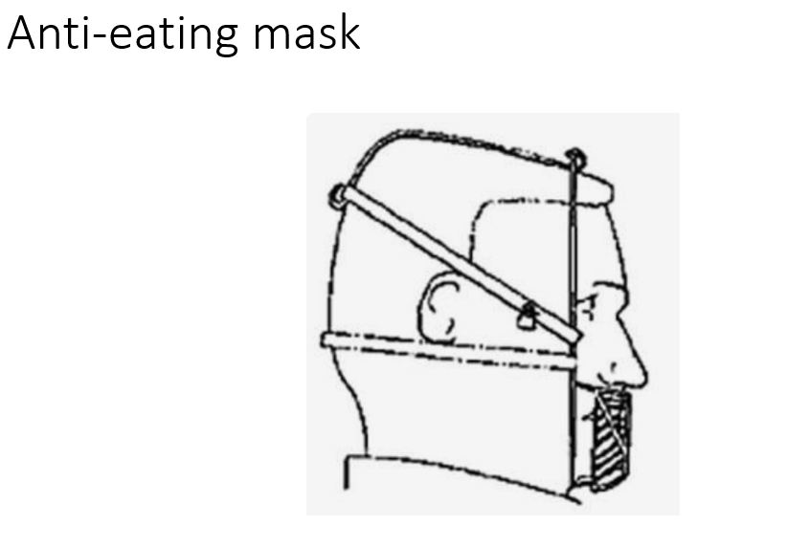
2 | 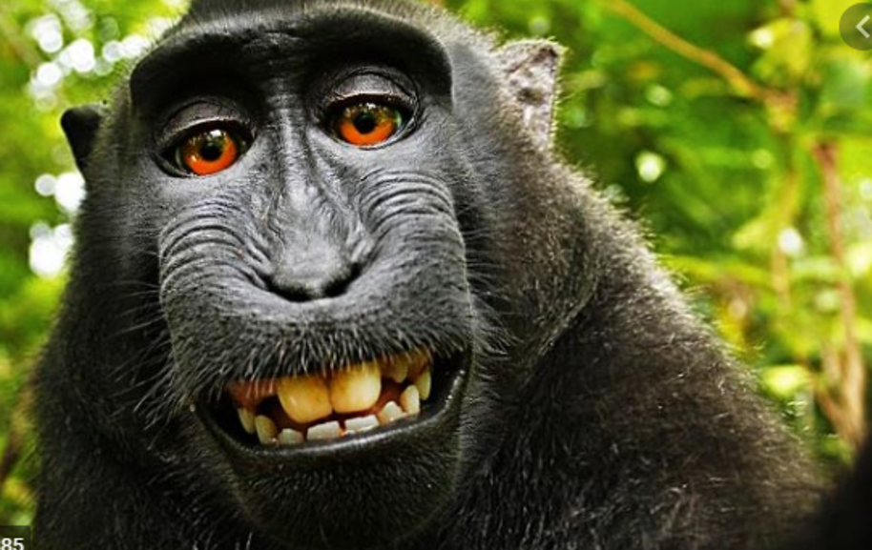
3 | 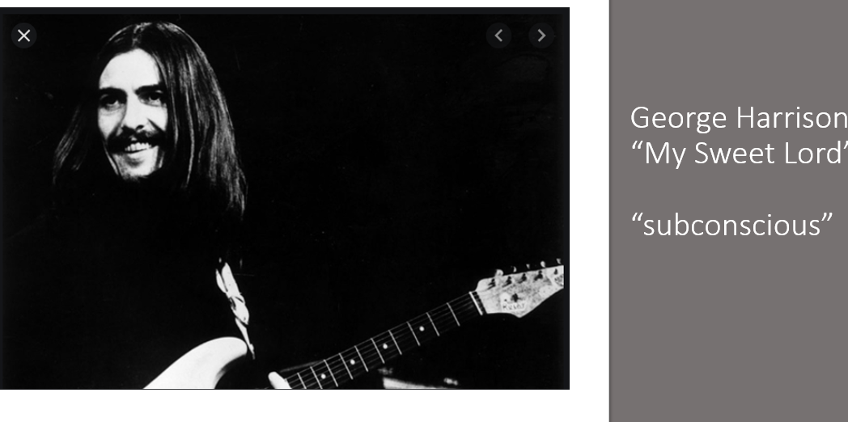
4 | 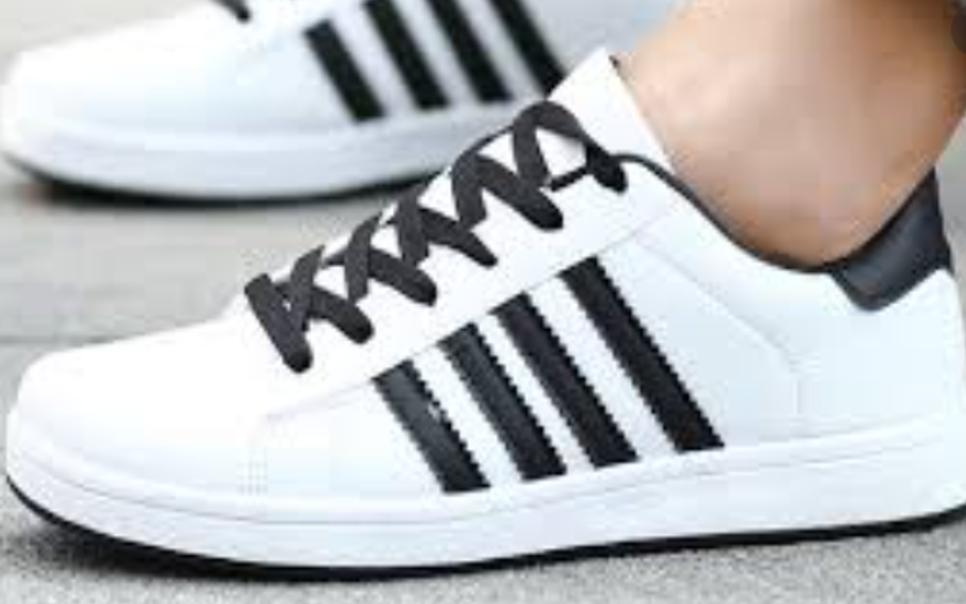
5 | 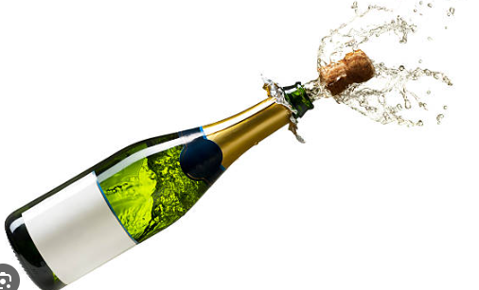
6 | AI
7 | 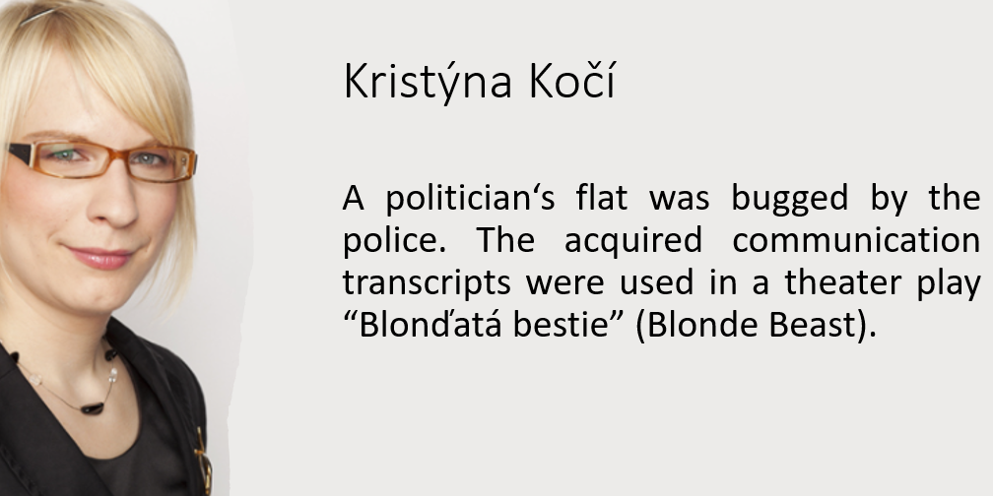
8 | - A Charles University law professor wrote a bestseller legal thriller…  - b. A Charles University law professor wrote a bestseller law textbook…

Legal advice (The Trademark Act)

A client would like to obtain trademark protection for the following designations. Try to explain briefly why some of the designations cannot be registered based on the EU Trademark Regulation (2017/1001).

- A maple tree leaf image for clothes made in China;
- a special smell used in Mango stores;
- Anti-TICK for a new product against ticks (insects);
- FCUK for fashion clothes;
- JESUS for a range of goods;
- Ku-Klux-Klan for a magazine;
- LAWYER for a newly opened law firm;
- ORLWOOLA for clothes made partly from wool;
- Policie privat for a private security agency;
- Scotch Whisky for beverage manufactured by Božkov;
- the shape of scissors facilitating the use by left-handed consumers;

Regulation (EU) 2017/1001 of the European Parliament and of the Council of 14 June 2017 on the European Union trade mark
Article 4 Signs of which an EU trade mark may consist
An EU trade mark may consist of any signs, in particular words, including personal names, or designs, letters, numerals, colours, the shape of goods or of the packaging of goods, or sounds, provided that such signs are capable of:
- distinguishing the goods or services of one undertaking from those of other undertakings; and
- being represented on the Register of European Union trade marks (‘the Register’), in a manner which enables the competent authorities and the public to determine the clear and precise subject matter of the protection afforded to its proprietor.
Article 7 Absolute grounds for refusal
1. The following shall not be registered:
(a) signs which do not conform to the requirements of Article 4;
(b) trade marks which are devoid of any distinctive character;
(c) trade marks which consist exclusively of signs or indications which may serve, in trade, to designate the kind, quality, quantity, intended purpose, value, geographical origin or the time of production of the goods or of rendering of the service, or other characteristics of the goods or service;
(d) trade marks which consist exclusively of signs or indications which have become customary in the current language or in the bona fide and established practices of the trade;
(e) signs which consist exclusively of:
(i) the shape, or another characteristic, which results from the nature of the goods themselves;
(ii) the shape, or another characteristic, of goods which is necessary to obtain a technical result;
(iii) the shape, or another characteristic, which gives substantial value to the goods;
(f) trade marks which are contrary to public policy or to accepted principles of morality;
(g) trade marks which are of such a nature as to deceive the public, for instance as to the nature, quality or geographical origin of the goods or service;
[…]
3. Paragraph 1(b), (c) and (d) shall not apply if the trade mark has become distinctive in relation to the goods or services for which registration is requested as a consequence of the use which has been made of it.

Reading: Alexander, the Ingenious Inventor
In the town of Bellington, there lived a young inventor named Alexander Finch. One day, he developed a device that could harness the power of sunlight to produce clean, renewable energy. Alexander named it the Solar Radiance Converter, and he knew that he had stumbled upon something extraordinary.
Excitedly, Alexander set out to protect his invention. First, he sought a patent. In order for Alexander's invention to be deemed patentable, it had to meet several key requirements stipulated by patent law. Firstly, his invention needed to demonstrate novelty, meaning it must be significantly different from existing technologies or solutions. This required Alexander to conduct thorough research to ensure that no identical or substantially similar inventions had been disclosed prior to his application. Secondly, his invention had to exhibit an inventive step, meaning it must not be obvious to someone skilled in the relevant field. Alexander had to demonstrate that his invention involved a non-trivial advancement or improvement over existing solutions, showcasing his innovative prowess. Lastly, his invention had to be capable of industrial application, meaning it must be useful and applicable in practical contexts.
Alexander drafted his patent application, detailing the features of his invention and its innovative components. He submitted it to the patent office, eagerly awaiting the outcome. Alexander learned that, once granted, a patent provided him with exclusive rights to his invention for a predetermined period, typically ranging from 20 to 25 years, depending on the jurisdiction and type of patent. Additionally, Alexander discovered that maintaining a patent required the payment of periodic maintenance fees, ensuring its validity and enforceability throughout its duration. Moreover, Alexander became acquainted with the concept of filing oppositions—a mechanism enabling third parties to challenge the validity of a patent after its issuance.
Months passed, and finally, Alexander received the news he had been eagerly awaiting—his patent had been granted. No one could replicate, manufacture, or sell his Solar Radiance Converter without his explicit permission.
As Alexander prepared to launch his invention to the world, he encountered another hurdle - trademarks. He knew that to establish a strong brand identity, he needed a distinctive name and logo for his product. After much deliberation, he settled on the name “SolarEco” and designed a sleek, sun-inspired logo to accompany it.
To protect his brand, Alexander registered SolarEco as a trademark. Trademarks protect distinctive signs, including words, names, symbols, or logos, that identify and distinguish goods or services from those of others. This registration ensures that no other company could use the name or logo to market similar products, preventing consumer confusion and safeguarding the reputation Alexander had worked so hard to build. Trademarks must meet criteria such as distinctiveness (being capable of distinguishing the goods or services of one trader from those of another), not being against public policy, and not being deceptive. Additionally, trademarks can last indefinitely as long as they are in use and the required renewal fees are paid.
With his invention patented and his brand trademarked, Alexander's journey was far from over. Alexander created the company's promotional materials. These materials are protected by copyright, granting Alexander exclusive rights as their creator. Copyright law automatically confers protection upon creation. In Alexander's case, the moment he created these promotional materials, they were automatically protected. This protection extends to any original expression of ideas fixed in a tangible medium of expression. Thus, Alexander’s promotional materials are covered by copyright law. Copyright duration varies across jurisdictions and the nature of the work. In many regions, copyright typically lasts for the author's lifetime plus an additional 70 years. As the creator of SolarEco's promotional materials, Alexander stands to enjoy copyright protection for his lifetime and 70 years beyond.
Copyright law often incorporates provisions for fair use, allowing limited use of copyrighted material without the creator's explicit consent. This doctrine permits specific uses such as criticism, comment, news reporting, teaching, scholarship, or research. Leila, a university professor, utilized excerpts from Alexander's copyrighted promotional materials as part of her lecture on renewable energy technologies. Leila carefully selected and incorporated these materials to illustrate real-world examples and demonstrate concepts to her students. Recognizing the educational purpose of Leila's use, Alexander acknowledged that her use fell within the scope of fair use.
Finally, the day arrived for the official launch of SolarEco. With great fanfare and excitement, Alexander unveiled his invention to the world. Thanks to the protection afforded by patents, trademarks, and copyrights, SolarEco quickly became a household name, revolutionizing the renewable energy industry and solidifying Alexander's legacy as a visionary inventor.

Silk 6

Compare and contrast the sentences received in both trials. What was probably the message that the creators of the episode tried to convey?

In some English-speaking countries, there are the following grounds for appeal:
- Legal errors
- Evidentiary issues
- Ineffective assistance of counsel
- Constitutional violations
- Jury misconduct
- Newly discovered evidence

Which ground for appeal was (implicitly) mentioned in the video?

“Appeal as of right” and “appeal with the leave”. Appeal as of right is typical of civil law jurisdictions. Appeal with the leave of the court is quite common in English-speaking countries. What is the difference between these two concepts of appeal?

Which of the following phrases was mentioned in the video?
- Miscarriage of justice
- To pervert the course of justice
- Justice has been served

Has justice been served in these criminal cases?

Revision

Try to provide a definition of one of the words, your neighbours have to guess which word it is.

Fair use
Royalties
Patentee
Industrial design
Trademark
Counterfeiting
Derivative works
Economic rights
Infringement
Distinctiveness
Work for hire

