File 🡪 Builder View, Coder View

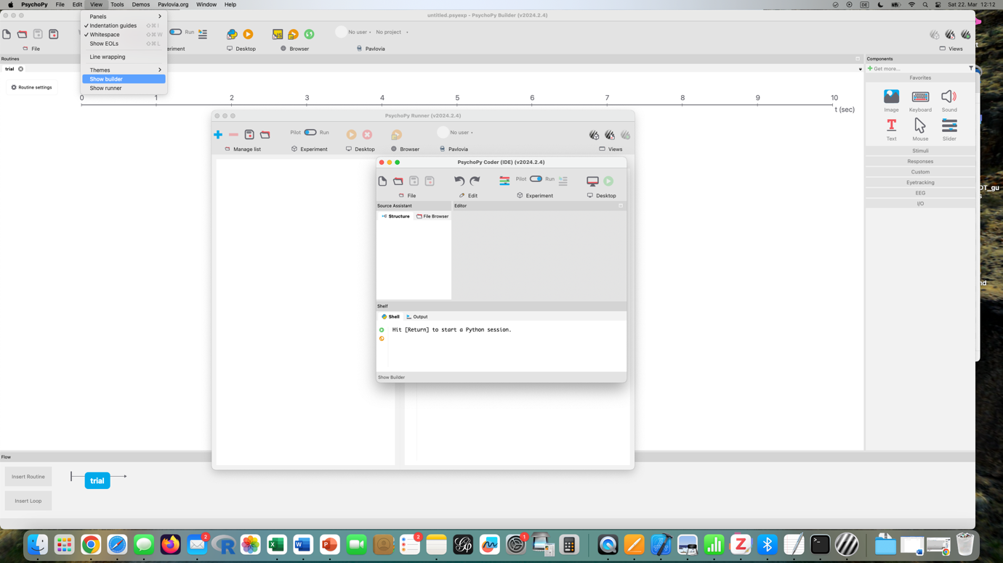

1. VISUAL WORD RECOGNITION (printed word)

Create Folder for all files related to the lexical decision task (no spaces in name, e.g. my example “PsychoPy_Test”)

🡪 save your project in that folder by clicking on disk icon with red dot

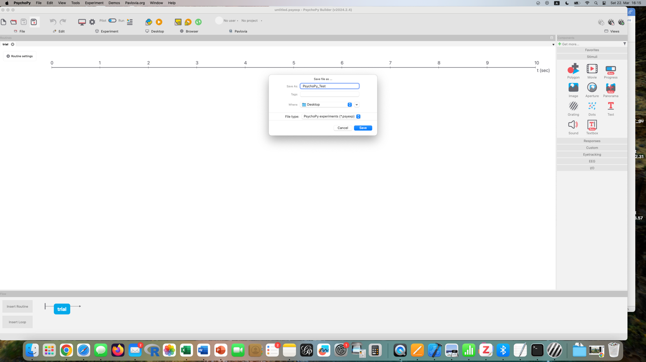

Place your Excel spreadsheet with stimuli in that same folder (in my example “PsychoPy_test_stimuli.xlsx”)

Note the data organization: words to be shown on screen in LDT are in column A (words, non-words)

Make sure there are no spaces between words (e.g., English Neighbors) and no spaces after a header (e.g., word )!

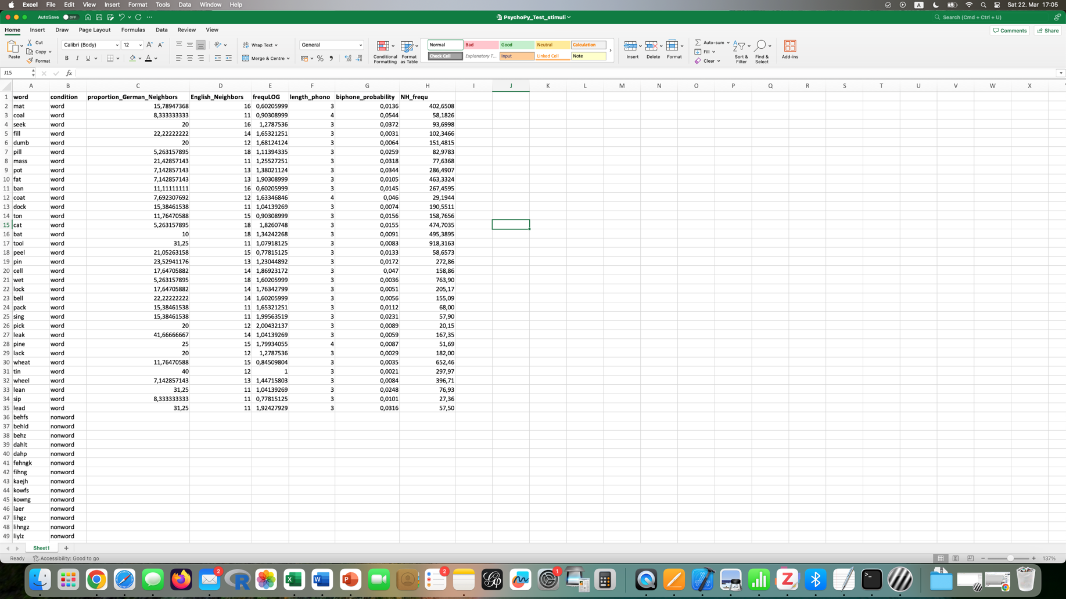

Go to main windown again. On right, select TEXT icon (underlined red T). In that window you can now change and select various options.

*Basic* tab

Name: doesn’t need to be changed (only if you write custom code), leave “text” or change it to whatever you want (e.g., stimulusDisplay)

Time: at what time the stimulus word will appear on the screen. Leave 0.0 if right at the beginning

Duration: how long does stimulus word stay on screen? Delete any number and leave empty if you want to leave stimulus on for as long as participants take to respond (“infinity”)

Text field: where your stimulus words will appear

Selection on right: constant = every trial is the same word (repetition), set every repeat = different word for each trial

In *Text* type: $word

“word” is the header of column A (=my stimulus words)

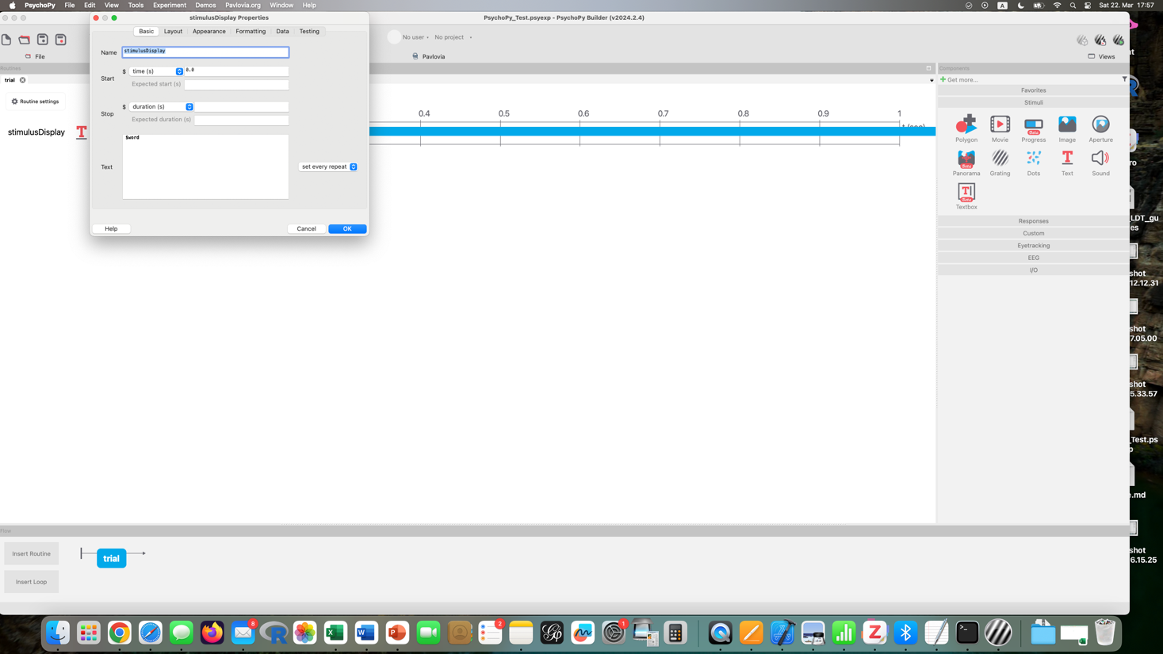

Double click on “stimulusDisplay” on far left to go back to make changes

other tabs in window

*Layout* tab

Position: where on screen? 0, 0 is in middle of screen

*Appearance* tab

Color: set color

*Formatting* tab

Font: choose font

Height: size of text

Add response keys by clicking on “Responses” and “keyboard” in menu on the right.

In window make selection for

Name: e.g. “response”

Start: 0.0 right at beginning of trial

Duration: for how long the keys will be available

Allowed keys: for instance ‘a’, ‘k’ (=only keys that will do something), set to “constant” on right (=these will be the same keys that are available for each trial)

Recommendations: no “y” for “yes” for instance because “y” and “z” keys are switched on some keyboards; “l” may be confused for capital “i”; participants should use right hand for “correct”/ “yes” option

Register keypress on: press, release

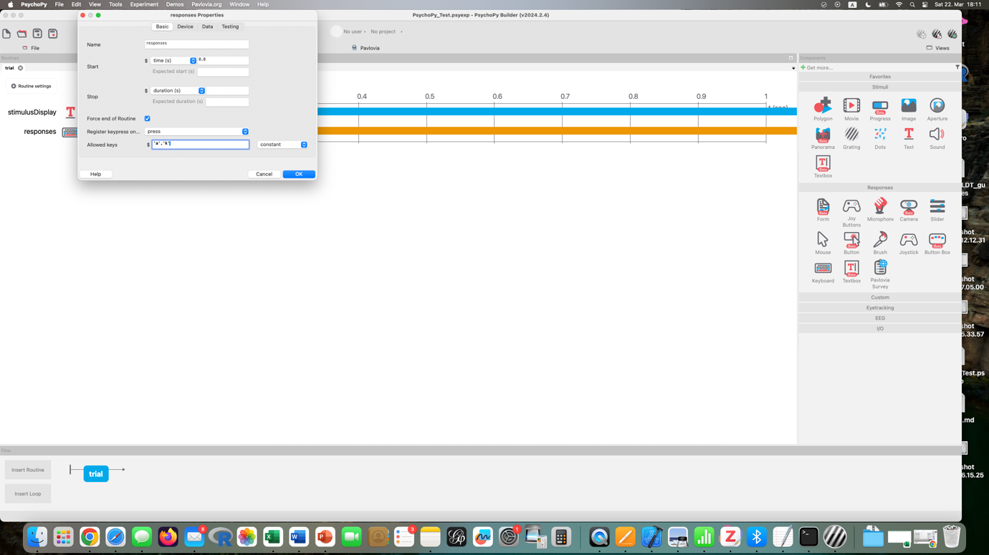

Force end of routine: check (=trial will end when key has been pressed)

*Data* tab

Store: Last key or First key (participants will only be able to make one keypress, so both of these will be the same)

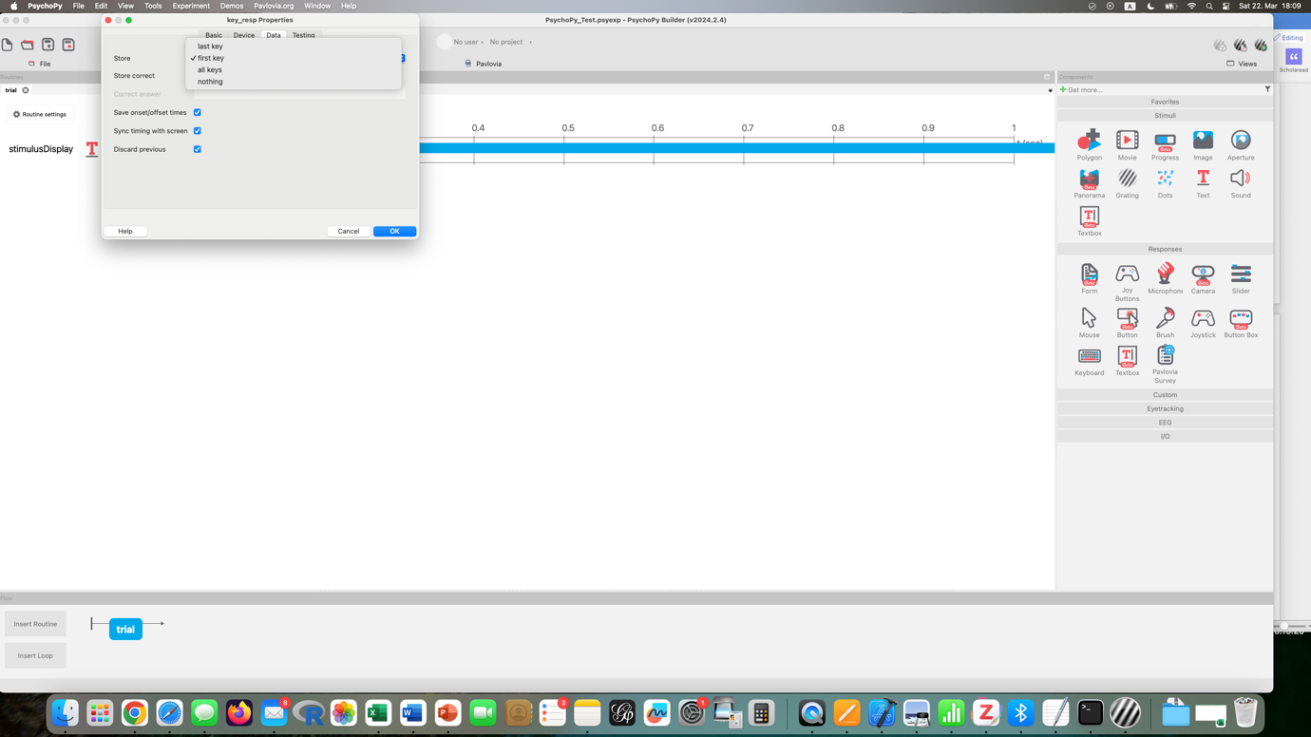

Store correct: only check if you only want correct responses to be saved

Sync RT with screen: check (=synchronizes reaction times with screen)

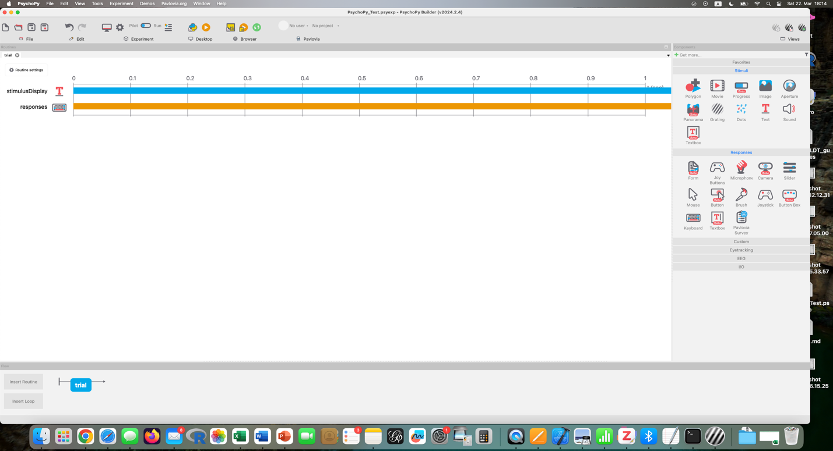

Note: blue and orange lines continue to infinity because response times haven’t been limited

Add routine for fixation point (e.g., +)

Below left: Insert Routine

Suggested name: fixation

Add TEXT stimulus

Name: fixationCross

Start: 0.0

Duration: 1.0 seconds

Text = +, constant (=same across all trials)

Insert Loop, wrap it around fixation & trial (=so that fixation cross and trials – with new word per trial – are repeated)

Click on one of the dots of the loop and give it a name and/ or select order of trial presentation (random, sequential…)

For number of repeats select “1” (you only want each word to be shown once)

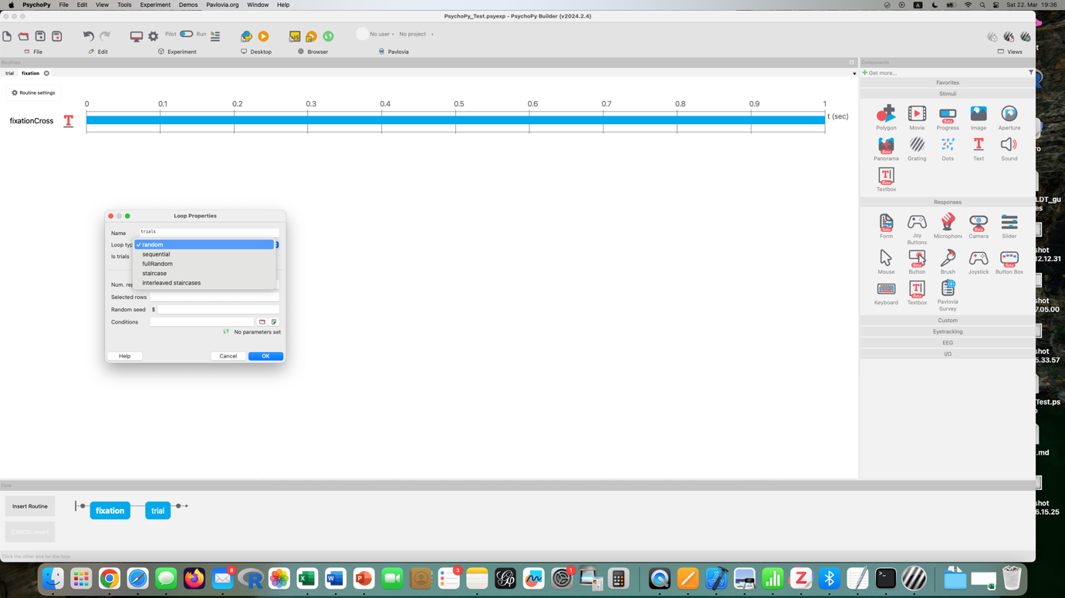

Condition: select file to upload 🡪 the .xlsx file in the PsychoPy folder we created before

Click on RUN to start experiment, in new window PsychoPy Runner, run on desktop. Data folder will be saved in PsychoPy folder (with .csv file of results)

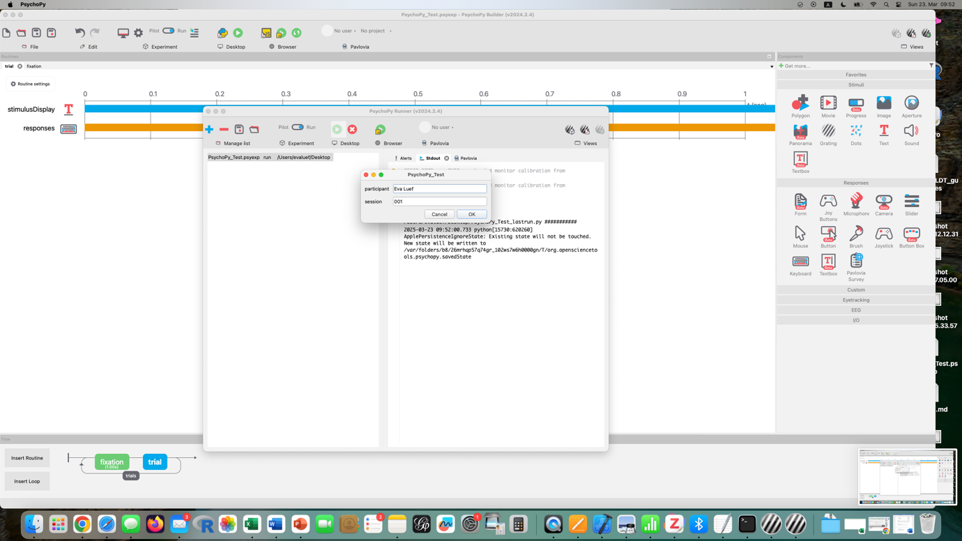

If “run in browser”, data (.csv) will be saved to your computer.

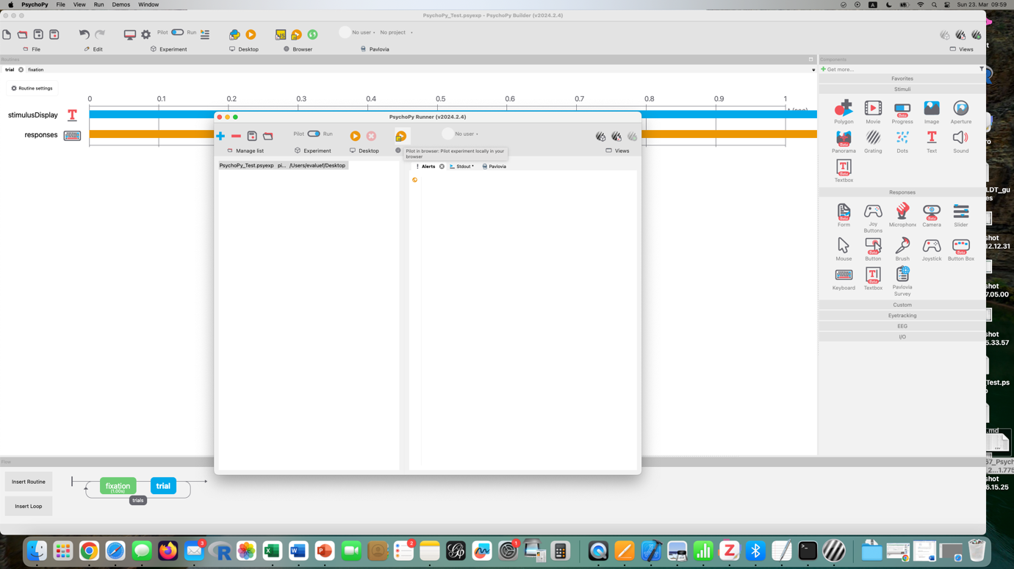

* Response.keys 🡪 what participant pressed
* Response.rt 🡪 reaction time in msec. (observe: dots instead of commas)
* Word
* Condition
* …

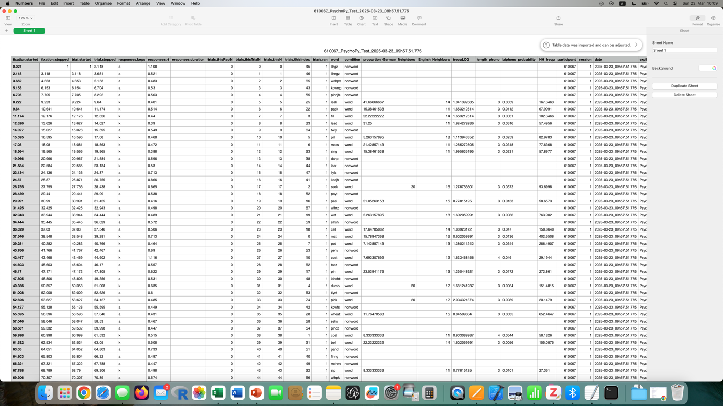

Instructions page: create new routine, name it “instructions” , place it before the loop, add Text stimulus, don’t name it “instructions” (-- no two same names) but something else (“instructionsRoutine”)

Type your instructions in Text field. Suggestion:

In this task you will see letter strings and you need to decide whether or not each letter string is an English word. Each trial starts with a plus sign ‘+' followed by letter string in upper case. If you think the letter string is an English word, you have to press the ‘**k**’ key, and if you think the letter string is not an English word, you have to press the ‘**a**’ key.  
  
As soon as you have responded the plus sign appear again and the next trial starts.  
  
Respond as quickly as possible but also try not to make any errors. The task will take about 5 minutes.

First, you will be given 5 practice trials to get used to the routine. These responses will not be recorded. Press on the space bar to begin the practice trials.

You will be notified before the experiment starts and your responses will be recorded.

Choose how long participants can see the instructions page (recommended “infitity”/ leave space empty = until they press ‘space’ to continue)

Then add keyboard component (named “instructionKey”) and allow only the space bar to be pressed. Duration set to “infinity”, and “force end of routine”, Store: “nothing” (=won’t record anything related to that routine)

Create welcome and goodbye screen

* Create Text elements, write in text box

Customize demographic questions: settings icon, click on plus to add a new line

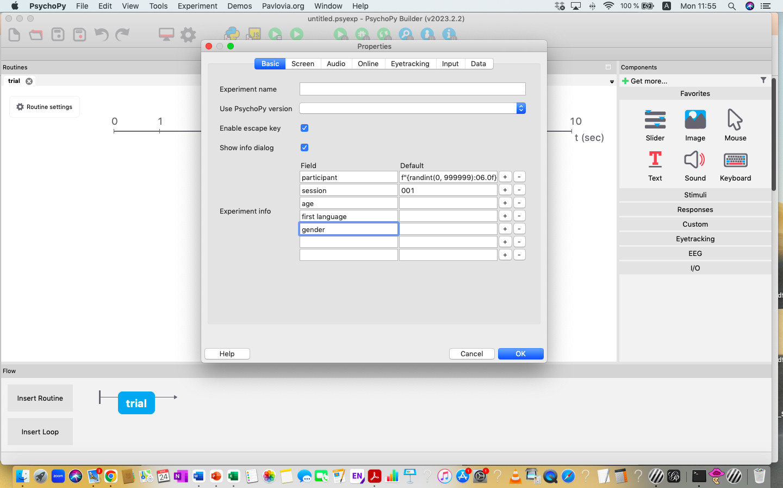

Practice trials:

Add a small number (e.g., 5) practice trials before experiment starts. Otherwise, the first few responses might be unusable (very long reaction times). After welcome and instructions screens, add:

* New routine, trial, with 5 words
* New routine, keystroke, with same instructions (e.g., press “k” for correct and “a” for incorrect)

Then add another text screen telling participants that the experiment will now start and responses will be recorded.

🡪 save experiment (psychopy file)

PRIMING

Priming effect = faster response times to stimuli

*.xlsx data:* “Priming_exp_morphol.csv”

Kahraman, H., & Beyersmann, E. (2024). Sand, Sandpaper, and Sandwiches: Evidence from a Masked Compound Priming Task in L1 and L2 speakers of English. *Journal of Cognition*, 7/1, DOI: 10.5334/joc.350.

Set up Text element for primes: start 1 sec., duration: 25-50 msec is standard (set to 0.05), “set every repeat”

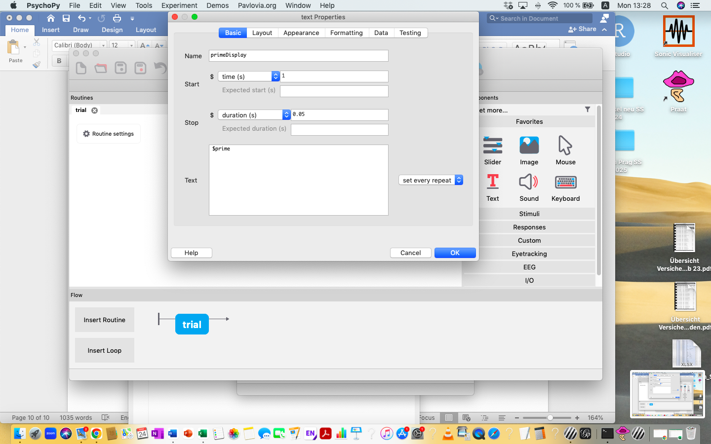

Set up Text element for target words: start: 2 sec., duration: infinity, “set every repeat”

Set up Keyboard response: start at same time as target (2 sec.), allowed keys: “a”, “k”, “constant”

Put loop around trial. nReps = 1 (only one presentation per word), Conditions: import .xlsx file

**Save experiment!**