**Version 07/04/2022**

1. **Work with the following sequence:**

MNWELLLWLLVLCALLLLLVQLLRFLRADGDLTLLWAEWQGRRPEWELTDMVVWVTGASS

GIGEELAYQLSKLGVSLVLSARRVHELERVKRRCLENGNLKEKDILVLPLDLTDTGSHEA

ATKAVLQEFGRIDILVNNGGMSQRSLCMDTSLDVYRKLIELNYLGTVSLTKCVLPHMIER

KQGKIVTVNSILGIISVPLSIGYCASKHALRGFFNGLRTELATYPGIIVSNICPGPVQSN

IVENSLAGEVTKTIGNNGDQSHKMTTSRCVRLMLISMANDLKEVWISEQPFLLVTYLWQY

MPTWAWWITNKMGKKRIENFKSGVDADSSYFKIFKTKHD

* Identify the sequence.

Human DHRS7

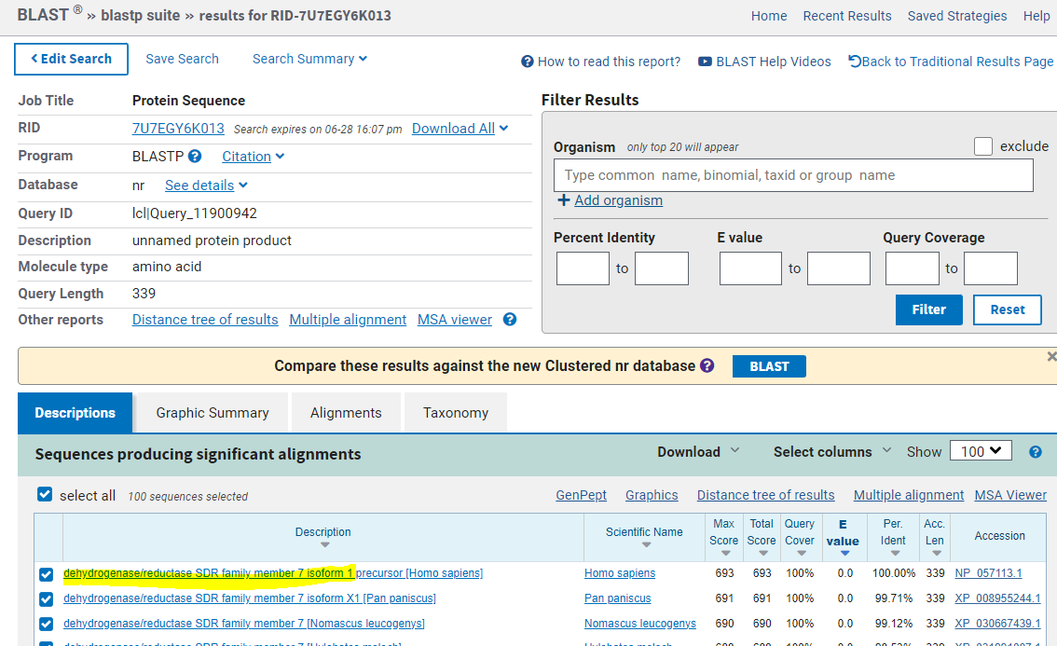

* Does this protein have any transmembrane regions?

Yes, one

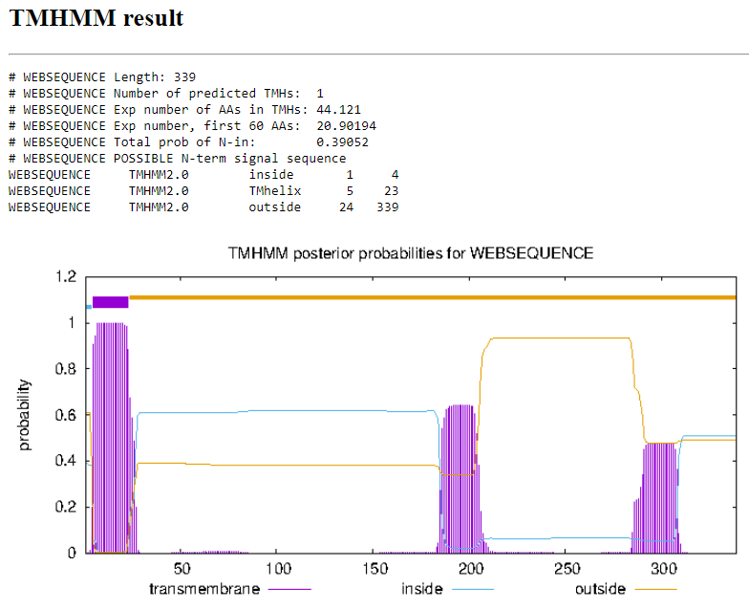

* How many isoforms this protein has? Align them.

In NCBI Four

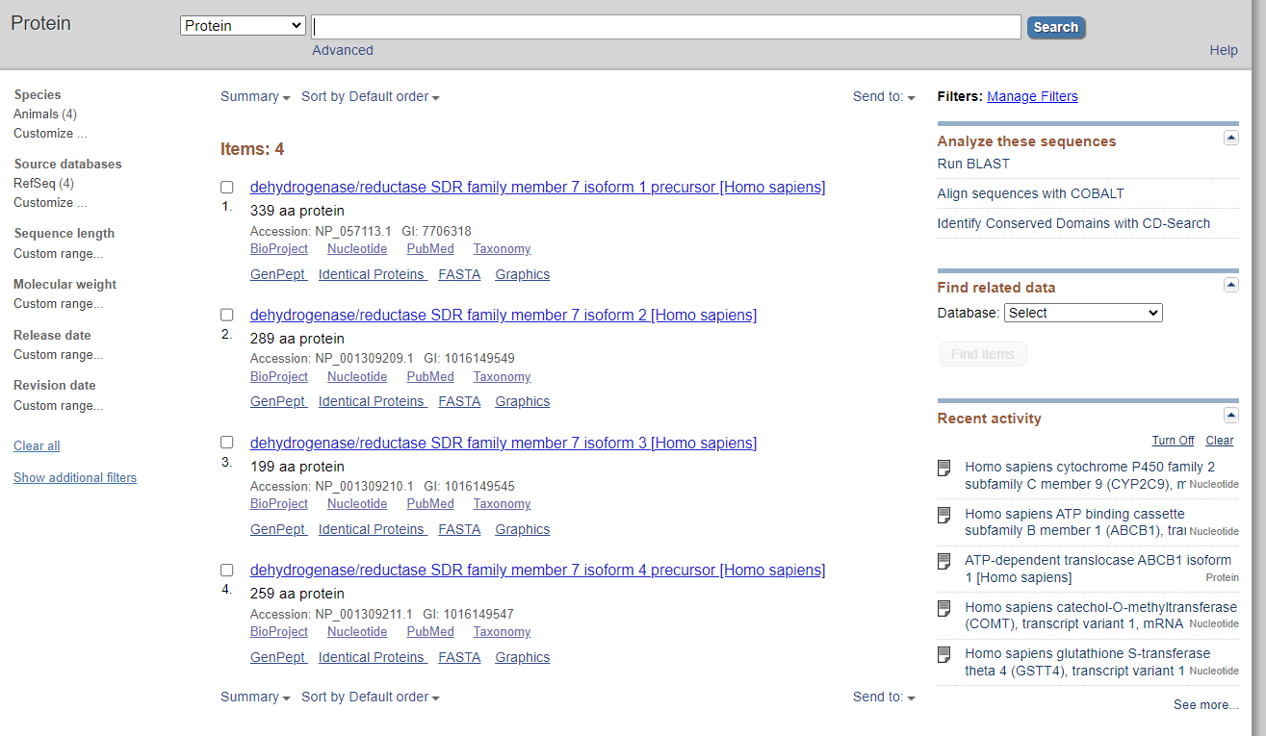

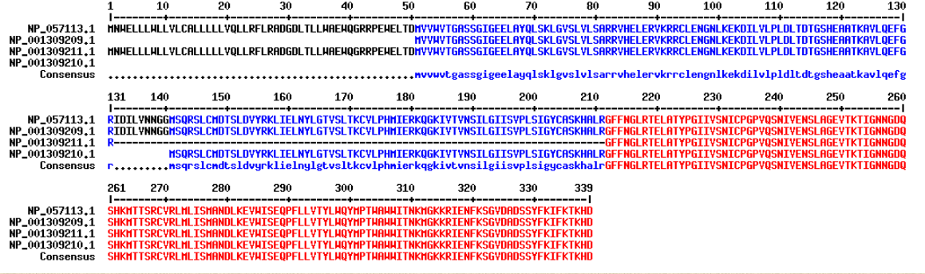

Two in Uniprot

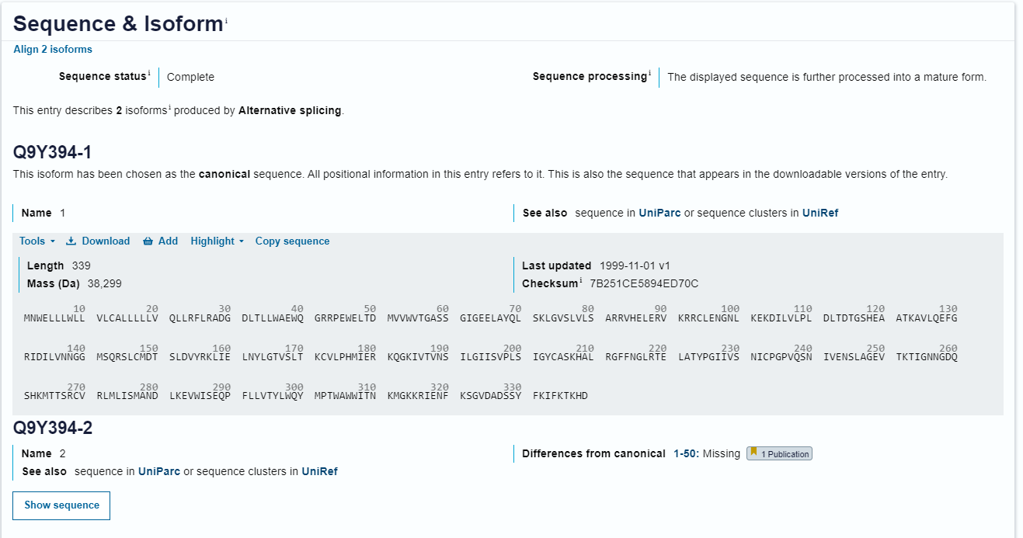

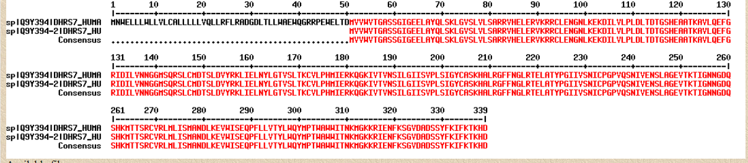

* How many cysteines does the sequence have?

Seven

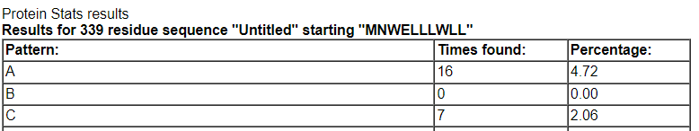

* Design primers to amplify the CDS of the respective gene.

CDS:

>NM_016029.4:90-1109 Homo sapiens dehydrogenase/reductase 7 (DHRS7), transcript variant 1, mRNA

ATGAACTGGGAGCTGCTGCTGTGGCTGCTGGTGCTGTGCGCGCTGCTCCTGCTCTTGGTGCAGCTGCTGC

GCTTCCTGAGGGCTGACGGCGACCTGACGCTACTATGGGCCGAGTGGCAGGGACGACGCCCAGAATGGGA

GCTGACTGATATGGTGGTGTGGGTGACTGGAGCCTCGAGTGGAATTGGTGAGGAGCTGGCTTACCAGTTG

TCTAAACTAGGAGTTTCTCTTGTGCTGTCAGCCAGAAGAGTGCATGAGCTGGAAAGGGTGAAAAGAAGAT

GCCTAGAGAATGGCAATTTAAAAGAAAAAGATATACTTGTTTTGCCCCTTGACCTGACCGACACTGGTTC

CCATGAAGCGGCTACCAAAGCTGTTCTCCAGGAGTTTGGTAGAATCGACATTCTGGTCAACAATGGTGGA

ATGTCCCAGCGTTCTCTGTGCATGGATACCAGCTTGGATGTCTACAGAAAGCTAATAGAGCTTAACTACT

TAGGGACGGTGTCCTTGACAAAATGTGTTCTGCCTCACATGATCGAGAGGAAGCAAGGAAAGATTGTTAC

TGTGAATAGCATCCTGGGTATCATATCTGTACCTCTTTCCATTGGATACTGTGCTAGCAAGCATGCTCTC

CGGGGTTTTTTTAATGGCCTTCGAACAGAACTTGCCACATACCCAGGTATAATAGTTTCTAACATTTGCC

CAGGACCTGTGCAATCAAATATTGTGGAGAATTCCCTAGCTGGAGAAGTCACAAAGACTATAGGCAATAA

TGGAGACCAGTCCCACAAGATGACAACCAGTCGTTGTGTGCGGCTGATGTTAATCAGCATGGCCAATGAT

TTGAAAGAAGTTTGGATCTCAGAACAACCTTTCTTGTTAGTAACATATTTGTGGCAATACATGCCAACCT

GGGCCTGGTGGATAACCAACAAGATGGGGAAGAAAAGGATTGAGAACTTTAAGAGTGGTGTGGATGCAGA

CTCTTCTTATTTTAAAATCTTTAAGACAAAACATGACTGA

F: ATG AAC TGG GAG CTG CTG CT

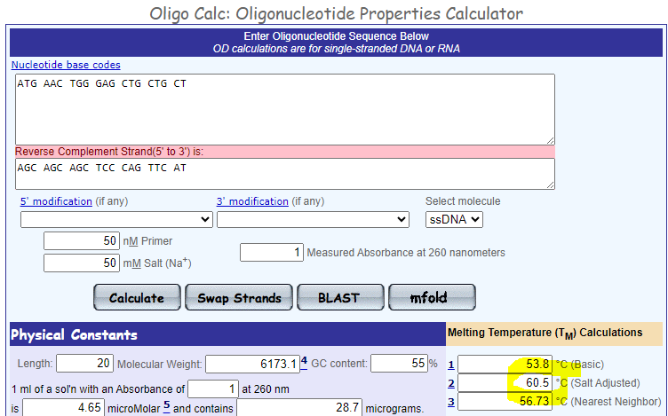

R: TCA GTC ATG TTT TGT CTT AAA GAT TTT A

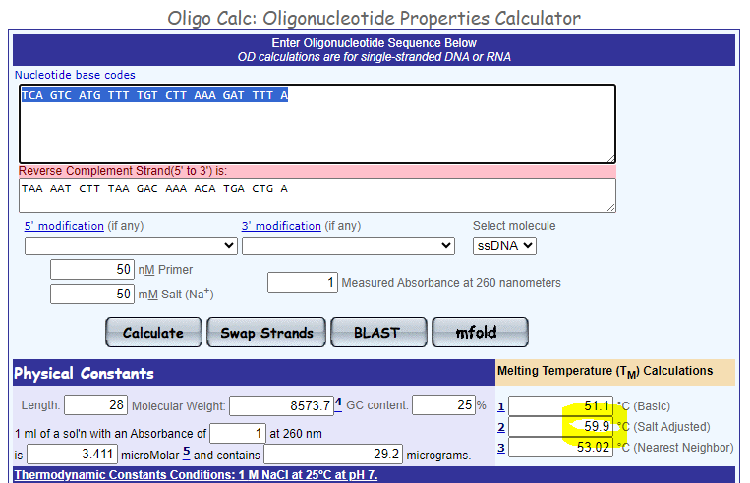

1. **Download from database the sequence NM_001282692.1**

* What does this mRNA encode?

Homo sapiens flavin containing dimethylaniline monoxygenase 1 (FMO1)

* How long is the second exon?

189nt

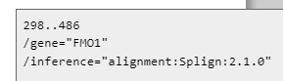

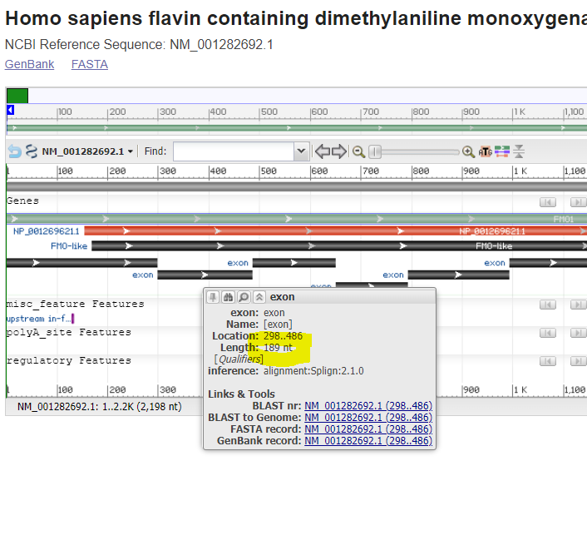

* Will the CDS of this sequence be cleaved by the following enzymes: BamHI, EcoRI or ScaI?

Yes,no,yes





* What fragments are formed after cleavage by all these enzymes at once?

Three fragments: 857+520+234bp

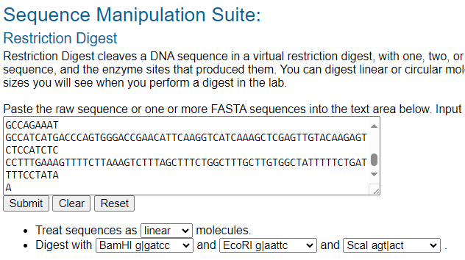

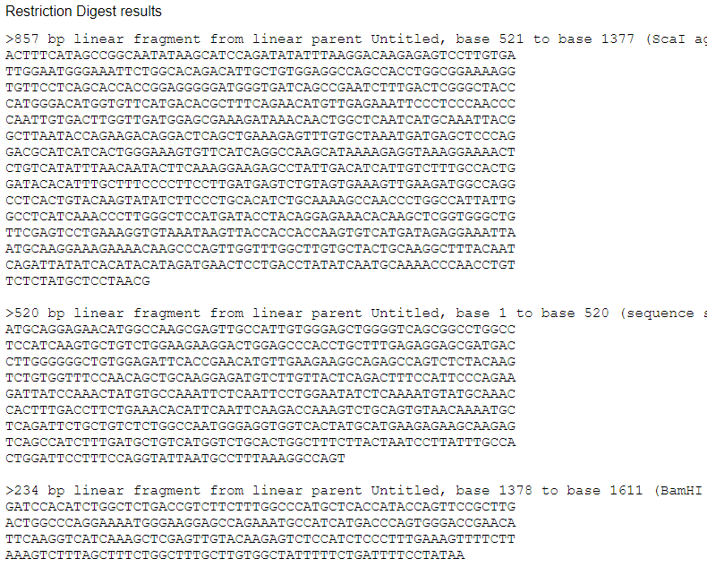

* Compare how similar is the corresponding protein to the respective mouse homologue?

91.2% similarity

