[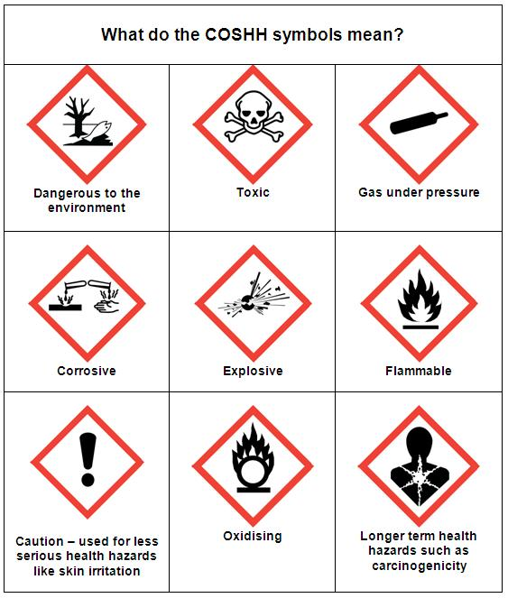](http://www.google.cz/url?sa=i&rct=j&q=&esrc=s&source=images&cd=&cad=rja&uact=8&ved=0ahUKEwjzzeHEmZrMAhXGOxoKHdODDPIQjRwIBw&url=http://rospaworkplacesafety.com/category/coshh/&psig=AFQjCNFC-vJOzOo4FUjBKHwdovKRHq1rPA&ust=1461138048378221)