**Senses**

**Laboratory exercise and seminar in medical physiology**

*Home preparation, study materials and learning objectives*

**Content of the seminar**

In this seminar you will learn some aspects of visual and auditory stimuli perception. You will also realize that under certain conditions your eye movements are controlled involuntarily (reflexively).

**Learning goals of the seminar**

* You will learn how visual stimuli are processed at the level of the retina. You will also realize that what you believe to be reality may not always be reality.
* You will try to perform a basic hearing examination using tuning tests.
* You will find out how physiological nystagmus can be induced and what are its causes.

**Study materials**

* Lectures
* Textbook Guyton and Hall Textbook of Medical Physiology
* Textbook Physiology Linda S. Constanzo

**Home preparation**

1. **Review and draw the individual retinal cell types and their connections.**
2. **Draw visual field deficits for a given damage to the visual pathway.**

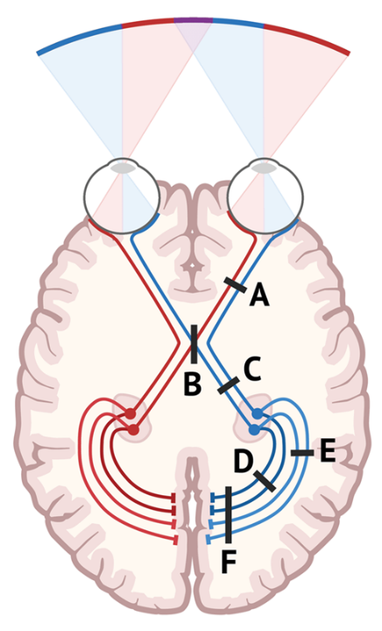 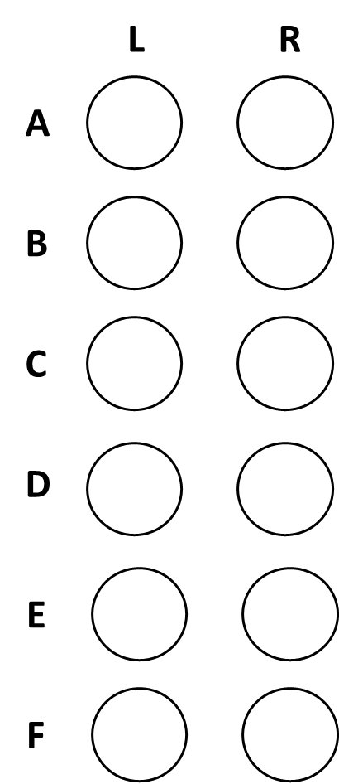

1. **How are the optotypes constructed and why?**
2. **Write into the table concentrations of the ions and potentials.**

