Handout 2 – Basic concepts, division of law

Division of law – questions

- What is the difference between substantive and procedural law? Can you illustrate this by using an example from criminal law?
- Which branches of law fall under public law and which under private law?
- Explain the 2 meanings of civil law.
- Depending on its meaning, civil law can be contrasted with _________________________ or _______________________ .
- A breach of criminal law is known as ______________ . A breach of civil law is a tort.
- The parties to criminal proceedings are called _____________ and ______________ .
- The parties to a civil lawsuit are known as a _____________ and defendant.
- What is the difference between a burden of proof and a standard of proof?
- Beyond any reasonable doubt is the standard of proof in criminal cases. Can you express this in percentage?
- In civil cases, the standard of proof is on the balance of probabilities (UK) or preponderance of the evidence (US). Can you express it in percentage?
- Why is the standard of proof in criminal cases higher?
- What is the difference between a judgment of conviction and a judgment of acquittal?
- Neglect or negligence? Which concept is fundamental in the law of torts?
- Can you explain the difference between damage and damages?
- She was awarded damages. What happened to her? Who awarded the damages to her?
- Who is a natural person?
- What is the opposite of a natural person?

A summary: civil - criminal

 |  | Civil | Criminal
Violation of the law |  | a wrong / a tort | …………………….
Parties |  | …………. x defendant | ………….. x defendant
To start proceedings |  | …………….. | to charge the defendant
Standard of proof |  | ………………… | …………………..
Verdict of the jury |  | liable x not liable | …………. x ………….
Consequences |  | …………………. | ………………………

Synonyms

- The jury rules on the facts.
- According to Article 5.
- We acted unlawfully.
- The defendant failed to deliver the documents in time.
- The company sought compensation.
- The words are not to be construed as if they were provisions in Acts of Parliament.
- The statute was repealed.
- The Civil Code was changed.

Why O.J. Simpson Lost The Civil Trial (video)
Identify 3 reasons

O.J. Simpson: civil or criminal law?

Decide whether the following statements relate to the criminal or the civil trial of O.J. Simpson.
Put the facts in the correct chronological order. No. 1 has been done for you.

Civil or criminal? |  | Chronology
 | The civil trial begins in a wrongful death suit brought against Simpson by the victims' families. The jury is made up of five men and seven women: nine whites, one Hispanic, one African American, and one person of mixed Asian and African descent.
 | Defense lawyer Johnnie Cochran reminds the jury about the glove, "If it doesn't fit; you must acquit."
 | In court, Simpson tries on leather gloves connected to the case, and says they do not fit.
 | Simpson is charged with two counts of murder with special circumstances. He does not surrender and is declared a fugitive. Simpson surrenders to police at his home.
 | Simpson pleads not guilty.
 | Simpson, for the first time, testifies before a jury and denies the murder of his ex-wife and Goldman.
 | Simpson's criminal trial begins.
 | Simpson's ex-wife Nicole Brown Simpson, 35, and Ronald Lyle Goldman, 25, are stabbed to death. | 1.
 | The court orders Simpson to turn over his assets, including a set of golf clubs, his 1968 Heisman Trophy, and a Warhol painting.
 | The jury finds Simpson liable in the civil wrongful death suit brought by the victims' families and awards the plaintiffs $8.5 million in damages.
 | The jury is selected. It consists of four men and eight women: eight black, one Hispanic, one white, two of mixed race.
 | The jury returns a not guilty verdict after less than four hours of deliberations.

OJ Simpson: reconstruction of the case

 |  | - 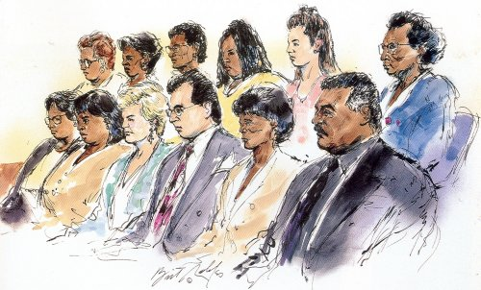
- 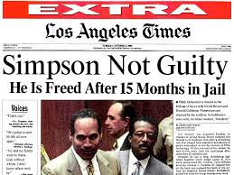 | - 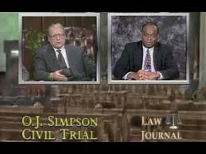 | over $33 million in damages

Precedent

R v R (1991) was a case involving marital rape. Before 1991, a husband could not rape his wife under the English law. The husband was convicted and sentenced to a term of imprisonment.

  - What are the elements of rape?
  - What were the legal arguments of the lawyers who claimed that a husband could never rape his wife?
  - What are the advantages of precedents over statutes, using the example of R v R?
  - The convicted husband brought the case before the ECtHR. On what basis?
  - What are the disadvantages of precedents over statutes, using the example of R v R?

Drafting

 | Provision | Instructions
Task 1 | “Every Bill which shall have passed the House of Representatives and the Senate, shall, before it become a Law, be presented to the President of the United States; If he approve he shall sign it, but if not he shall return it, with his Objections to that House in which it shall have originated, who shall enter the Objections at large on their Journal, and proceed to reconsider it.”  (s. 7, the US Constitution) | Re-write the provision in informal style
Task 2 | “Thou shalt not kill”  (from the Ten Commandments) | Re-write the sentence in very formal, legalistic style (remember the “orange” text)  - make it wordy  - use legalisms and strings of synonyms  - …
Task 3 | “If you were arrested as stated in Article 1, they must take you asap to a judge or another similar guy, and you should have a trial quickly, or they must set you free.”  (adapted from ECHR) | Re-write the provision in formal style
Task 4 | “ARTICLE 72  (1) The Chamber of Deputies may adopt a resolution of no confidence in the government.  (2) The Chamber of Deputies may debate a proposed resolution of no confidence in the government only if it has been submitted in writing by at least fifty Deputies. To adopt the resolution, an absolute majority of all Deputies must give their consent.”  (Czech Constitution) | Re-draft the provision so that your 10-year old brother can understand it.

