Follow up: Descartes’ short scholastic treatise on sensations
(Principles of Philosophy, IV, §188-199)

I should also like it to be noted than in attempting to explain
The general nature of material things I have not employed any principle
which was not accepted by Aristotle and all other philosophers of every age.
So, this philosophy is not new, but the oldest and most common of every age. [Descartes, PP IV, §200]

§188: to complete the Principles, a further part, in which the “qualities” of the bodies known by the senses, such as “colours, smells, sounds and such-like”, are considered.

§189: the human soul is located in the brain. It is said by Descartes “to inform the human body”, but the way it knows all that happens to the body depends on this specific localization, that is the brain. How is the soul affected? Via the nerves that are located throughout the whole body, “stretching like threads from the brain to the limbs”. Also, the “soul or mind” is said to be “closely joined to the brain”: that is how “various different states of mind, or thoughts, … or sensations” are produced.

§190: division brain/heart: location of thoughts and sensations/ location of “disturbances or passions and emotions of the mind, such as joy, sorrow, love, hate and on so on”. Responsible for the latter are the nerves distributed around the heart. Division between intellectual passions/physical passions (e.g. intellectual and physical joy, as double events). Definition of the passions of the soul, as
Emotions or passions….as confused thoughts, which the mind does not derive from itself alone but experiences as a result of something happening to the body with which it is closely conjoined. These emotions are quite different in kind from the distinct thoughts which we have concerning what is to be embraced or desired or shunned.

§191-195: the five external senses/ or how bodies stimulate the nerves located in certain parts of our body. New reminder about the “qualities” (hardness, heat, etc): the nerves of touch have everything to perceive such properties of the body and receive a consequent stimulation. Origin of pleasure and pain: again, the nerves. Pleasure/pain are “perceived” in the soul.

§196: only “from the brain”, from this special place, the soul is aware of what happens to the body. Example of the blindfolded girl and her amputated hand: pain is present in the soul

§197: there is no similarity between external movements and the kind of affections they cause: example of the emotions that can arise from writing, etc. Again, on pain, and important conclusion:
The nature of our mind is such that it can be subject to all the other sensations merely as a result of other local motions
§198: bodies know bodies: senses know nothing, but the properties of the body (but through the nerves, they “inform” the brain and consequently, the soul of what happens to the body)
“Concordance du toucher et de la vue” (illustrations of the Treatise on Man, published in 1666)
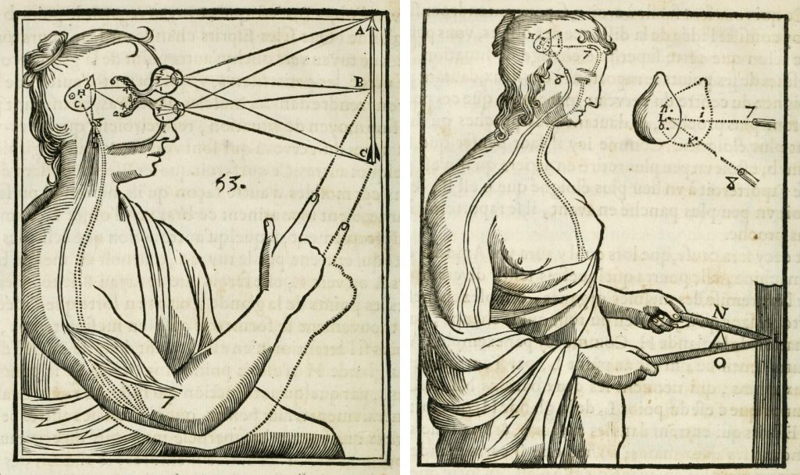

II. What does “the soul inform the body” means? Is Descartes truly in agreement with “old philosophy”?

Descartes’ position in philosophy of mind = Thomas Aquinas’ position in philosophy of mind?

- Aquinas’ position in philosophy of mind: Christian hylomorphism

Aquinas takes on Aristotle’s position in psychology.
• His main task is to integrate Aristotelian hylomorphism within the framework of Christian theology.
• This is a challenging task, since the Christian framework requires a personal immortality of the human being and is from its very beginning tuned on a dualistic conception of the human soul.

Ø Quick reminder: what is Aristotelian hylomorphism in psychology? [source: On the Soul!]

According to Aristotle,
• the soul is the form (principle of organization) of the living body;
• the soul is the capacity (“first actuality”) of a living body to perform
vital activities, i.e. vegetative, cognitive and motoric activities;
• the soul is a unity that encompasses a plurality of parts;
• the parts of the soul are powers to perform specific vital activities;
• the powers of the soul are localized in organs of the living body;
• the soul is not separable from the body;
• the intellect (rational power) is incorporeal and therefore separable

Aquinas’ own hylomorphism: Summa theologiae, Ia, q. 75-76

Please mind the short hint by Aquinas in his intro to q. 75:

Now that we have considered the spiritual creature and the corporeal creature, we must consider man, who is composed of a spiritual and a corporeal substance (ex spirituali et corporali substantia componitur). We will consider first the nature of man (questions 75-89) and then the production of man (questions 90-102). Now the theologian’s role is to consider man’s nature with respect to the soul and not the body, except insofar as the body is related to the soul. And so the first part of our consideration will have to do with the soul. [tr. by A. J. Freddoso]

1. The soul is not (a part of) the body

STh I, q. 75, art. 1:

1. […] one must take for granted that what is called a ‘soul’ is a first principle of life [= something that is essentially a principle of life] in those things around us that are alive; for we say that living things are ‘ensouled’ and that things which lack life are ‘not ensouled’. There are two operations by which life is especially made manifest, i.e. cognition and movement.

2. The ancient philosophers, unable to transcend the imagination, posited bodies as the principle of these operations, and they claimed that bodies alone are entities […] Accordingly, they claimed that a soul is a certain sort of body.

3. […] even though a body can in some sense be a principle of life, in the way that the heart is a principle of life in an animal, nonetheless, a body cannot be the first principle of life. For it is clear that being a principle of life, or being alive, cannot belong to a body by reason of its being a body; otherwise, each body would be alive or would be a principle of life.

4. Therefore, the fact that a body is alive […] belongs to it by virtue of the fact that it is a body of a given sort. But the fact that a body is actually of a given sort is due to a principle that is called its [first] act [= specific capacity = form]. Therefore, a soul, i.e., a first principle of life, is the act of a body and not itself a body—just as heat, i.e., a principle of heating, is a certain act of a body and not
itself a body.

What does it mean?

As the first act [= form] of the body, the soul is not (a part of) the body, but is inseparable from the body

This is unconditionally true of the soul of animals (STh I, q. 75, art. 3):

[…] sensing and the resulting operations of the sentient soul clearly occur with bodily changes; e.g., in the act of seeing the pupil is changed by the species of color […] And so it is clear that the sentient soul does not have any proper operation of its own; instead, every operation of the sentient soul belongs to the conjoined entity. From this it follows that since the souls of brute animals do not operate in their own right (per se), they are not subsistent; for each thing has its being in the same way that it has its operation.

Aquinas’ last argument in focus:
• The soul of animals is the “sentient soul”, i.e. a form (= principle of organization) which grounds vegetative and sensitive functions.
• All the sensitive functions require the body, i.e. they can only be performed if bodily changes take place in bodily organs (e.g. sight).
• This fact shows that the sensitive soul (= soul of animals) is not independent from the body = does not subsist without the body.

→ Criterion for the ontological independence of the soul: in order for the soul to be considered ontologically independent from the body, there must be at least one function of the ensouled being which is performed independently from the body (→ by the soul alone).

2. …but a part of it, the most noble, is in its own right independent (subsistent)

STh I, q. 75, art. 2:

1. [The human soul is the rational soul (= intellect), i.e. the form in virtue of which human beings are able to perform all their vital functions (= vegetative, sensitive and rational activities).]

2. […] by means of his intellect a man is able to have cognition of the natures of all bodies. But that which is able to have cognition of given things must be such that it has nothing of those things in its own nature, since what exists in it naturally would in that case impede the cognition of those other things. E.g., we see that a sick tongue infected with bilious and bitter humors is unable to perceive anything sweet; instead, everything seems bitter to it.

3. Therefore, if an intellectual principle had within itself the nature of any sort of body, it would be unable to have cognition of all bodies […] Similarly, it is impossible that it should have intellective
understanding through a bodily organ, since the determinate nature of that bodily organ would likewise prevent its having cognition of all bodies — in the same way that if some determinate color exists not only in the pupil but also in the glass vase, then a liquid poured into that vase seems to be of that same color.

4. Therefore, the intellectual principle itself, which is called the mind or the intellect, has an operation in its own right (per se) that the body does not share in […] It follows, then, that the human soul is something incorporeal and subsistent.

Ø Questions:

Is Aquinas moving in a dualistic direction?
Does he share (a) Aristotle’s view with regard to the soul of animals and
(b) Plato’s and Augustine’s views with regard to the human soul (the rational/intellectual soul)?

Does Aquinas think that, in the special case of human beings (and only in this case) the soul is not linked to the body as its form, but rather as a different substance, e.g. as a captain to the ship?

At first glance it could seem so, but this is not his view. He clearly rejects dualism in psychology, namely both the soul/body dualism (as in Plato or Augustine) and the intellect/soul dualism (as in Avicenna or Averroes).

3. Aquinas against soul/body dualism: the human soul is not a whole human being, but only part of a human being:

STh I, q. 75, art. 4:
[…] the claim that the soul is the man is understood to mean that this soul is this man. This claim could be sustained if one asserted that the sentient soul’s operations are its own without the body, since in that case all the operations attributed to the man would belong to the soul alone. But it is the entity that performs the entity’s operations. Hence, it is the man that performs the man’s operations. But it has been shown that an act of sensing is not an operation belonging only to the soul. Therefore […] it is clear that a man is something composed of a soul and a body and is not the soul alone.

The same point is made with special regard to the intellect in STh I, q. 76, art. 1:

[…] either (a) one must claim that Socrates has intellective understanding by himself as a whole, as Plato posited when he claimed that a man is an intellective soul, or (b) one must claim that the intellect is a part of Socrates. However, as was shown above (q. 75, a. 4), the first answer (= a) cannot hold up. For it is the very same man who perceives that he both understands and senses, and yet sensation does not exist without the body. Hence, the body must be a part of the man. Therefore, it follows that the intellect by which Socrates has intellective understanding is a part of Socrates in such a way that the intellect is somehow united to Socrates’ body.

Ø Fair enough, but why does the intellect need to be linked to the body exactly as its form (and not as an autonomous substance)?

Aquinas provides several arguments against an intellect/soul dualism (like in Avicenna). For instance:

STh I, q. 76, art. 1:

If an intellect were not his [= Socrates’] form, it would follow that it [= the intellect] lies outside his [= Socrates’] essence, and in that case an intellect would be related to the whole Socrates as a mover is related to the thing moved. But intellective understanding is an action that comes to rest within the agent and that, unlike the action of heating, does not pass into another. Therefore, it cannot be the case that understanding is attributed to Socrates by virtue of his being moved by an intellect.

