Athletes should begin practicing after demonstrating and explaining the skill.
But, this brings you to a critical decision. Will the athletes practice the skill as a whole or break it into parts?
The decision of what method for learning a new skill to choose depends on many things:

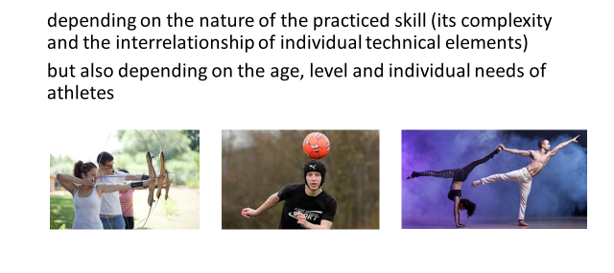
We have three options (methods):
- Comprehensively (whole) - The whole methods of practice is obvious. The whole skill is practiced intact.
- Analytical-synthetic (part-part-whole)
- Synthetic-analytical (whole-part-whole) - You teach the whole method as just outlined, practice it in parts and the recombine the parts back into the whole through practice.
What´s the best method to use?
The whole method (comprehensively)
- when practicing simple movement skills, often of a natural nature
- in relation to age, this procedure is essential for the youngest children, as they perceive it as a whole
When possible, it is the best to practice the whole skill to avoid spending time to combine the parts back into the whole.
However, if the skill is so complex that athletes cannot develop a good mental plan (the first stage of learning), then it is better to break the skill into parts.
How do you know where to make the breaks in the sequence of movements?
In the general, the more interdependent the movement, the more the more it should be left intact. You need to evaluate how interdependent or independent the parts of the task (skill) are. That is, how closely is one part of the skill related to the next?
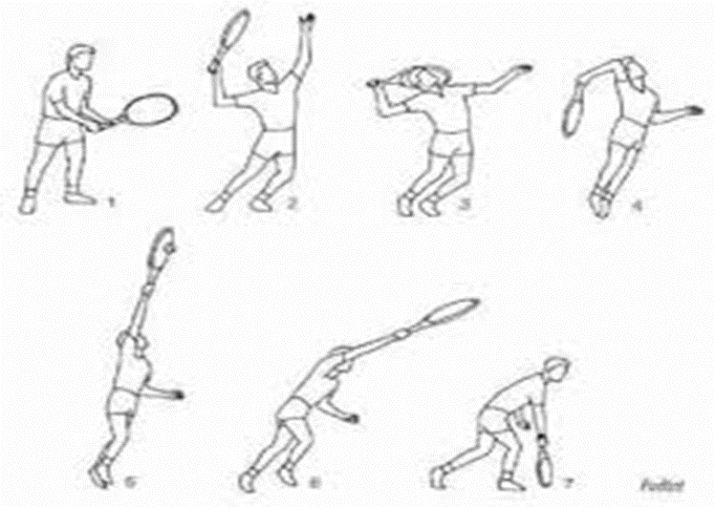
For example, in the tennis serve, you can fairly easily separate the ball toss from the swing of the racquet.
But it's quite difficult to separate the racquet swing and contact with the ball from the follow-through.

In the analytical-synthetic way (method)
If the technique is too difficult and complicated, it is necessary to divide it into several parts so that the athlete can get an idea of movement.
In terms of age, it is used in more advanced children who are able to take the analytical form.
We have two possibilities:
- Classical - we divide the skill into individual elements (parts), practice them separately and then combine them into a whole (synthesis).
- Progressive - we practice the first part of the movement, once it is mastered, you add another part, then another, until the athlete is able to demonstrate the whole skill in its entirety. (Progress through each part of the skill until the athlete is finally practicing the entire skill.)
In the synthetic-analytical (method)
It is based on the equivalence of the two previous didactic methods. Most skills can be practiced using a combination of both methods.
We have two possibilities also:
- Classic - you start comprehensively (as a whole) and if you see problems in one of the key points, you can, practice this part separately and then re-integrate it into the whole
- By focusing attention - you practice the whole technique, but you focus attention on only one aspect of it: This approach again involves practicing the entire skill, but athletes are instructed to concentrate only on one aspect of the skill.
You might discus throwers, for example, to practice the entire throw, but to focus only on keeping the discus as far as possible from the body as they put.
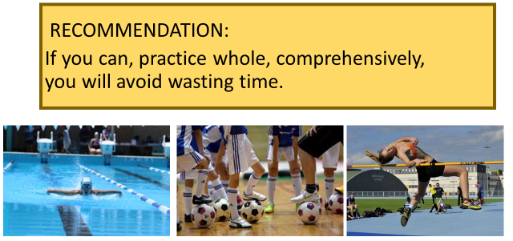
It´s worth mentioning that this method tends to work best with more skilled athletes. Athletes who are still trying to learn fundamentals of skill may have difficulty focusing only on one aspect.

