CLASS 1 ORIGINS AND UNIQUE NATURE OF HUMAN LANGUAGE
What enables TALKING?
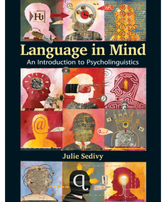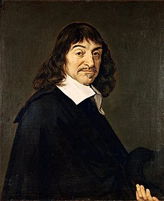
Descartes’ (1596-1650) Meditations ar. 1637, on the on the significance of language, and homo sapiens vs. the beasts: For it is a very remarkable thing that there are no men, not even the insane, so dull and stupid that they cannot put words together in a manner to convey their thoughts. On the contrary, there is no other animal however perfect and fortunately situated it may be, that can do the same. And this is not because they lack the organs, for we see that magpies and parrots can pronounce words as well as we can, and nevertheless cannot speak as we do, that is, in showing that they think what they are saying. On the other hand, even those men born deaf and dumb, lacking the organs which others make use of in speaking, and at least as badly off as the animals in this respect, usually invent for themselves some signs by which they make themselves understood. And this proves not merely animals have less reason than men but that they have none at all, for we see that very little is needed to talk (Descartes, 1637/1960, p. 42).

LANGUAGE ADVANCEMENT/ becoming advanced due to human language
- What’s implied by the humanizing nature of language?
- Is human language different down to its core or just a sophisticated modification of a system that predated it? What might it have been like?
- What’s implied by human language being conventional?
- Is language a genetic blueprint or learned on the basis of general cognitive skills?
- How did language start and get invented (cf. Dan Everett’s bows and arrows analogy)?
- If there is no stone-age language, is language an outcome of evolution?
- What is communication in relation to language?
- In what ways is LANGUAGE ORIGIN related to the origin of human brain?
- Is ART evidence of thinking and speaking?
- How did language humanize us in anatomy, genes, brain and cognition?
- When did human ancestors start behaving modern/using modern l.?
- WHY does LANGUAGE exist in so many languages and, from the perspective of our brain, is language diversity a blessing?
- In what ways does language distinguish human cognition from animal cognition?
- What are the basic goals of animal communication systems?
- What makes the phenomenon of language possible? Aside from brain, genes and anatomy, it is commitment to arbitrary l. and grammar (J. Searle)
- Do we use the same sort of thinking and language to do math or listen to music?
Your questions:
Some answers:
Human language endowment: That it is unique and universal implies that…
Language is used independently of what‘s experienced;
is displaced from the moment of experience;
is used to make thoughts revealed and shared;
their structuring is recursive;
thoughts are in abstract concepts that carved through words;
is arbitrary and symbolic;
is based on the principle of compositionality and discreteness;
interchangeability of messages used and received;
is constrained by grammar, learned gradually in its complex rules;
is creative/productive;
is dynamic and changing naturally;
acquired instinctively, universally and predictably;
multifunctional: enables learning, communicating, recording, etc.
orchestrates thinking – sharing information, remembering, deciding, imagining, planning, constructing history.
is learned while learning about the world.
There is no "stone-age" language.
Humans are speakers. Language made us human.
Language was not intended for survival (its functions surpass biological needs) but for a new sort of living based in socializing and transferring information.
We became a different sort of animals with an enhanced brain. Language is written into our anatomy, brain and genes that interact for language and were refashioned to handle language.
Language is not a matter of our mouths and hands but comes from the brain.
Language is lodged in brain cells, neural pathways and neural intersections where cognition resides, i.e., our thoughts, memories, feelings, etc.
Linguistic intelligence is interconnected with and dependent on non-linguistic senses.
BRAIN = a biological structure designed to handle language and other cognition;
by observing BRAIN through functional magnetic resonance/ neuroimaging MRI we can trace its cognitive activity
by observing injured brain we detect language functions that got impaired
LANGUAGE = the engine of our brain and the cognition of linguistic intelligence

