In order to remove plaque effectively, choose either dental floss or an interdental brush according to the size of the gaps between your teeth.
- When using dental floss or an interdental brush, check the locations of gaps between the teeth using a mirror, and pay attention so as not to damage your gums
- Ask your dentist or a dental hygienist for instructions if you cannot use dental floss or an interdental brush thoroughly.

Points for Using Dental Floss
When cleaning between teeth, where plaque easily accumulates and causes caries or periodontal disease, you can effectively remove plaque by using dental floss in combination with a toothbrush.

How to Use Dental Floss
 | Break off approximately 40 cm of dental floss. | 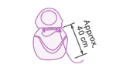
 | Wrap the floss around your middle fingers until the length remaining between the fingers is 1 to 2 cm. | 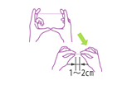
 | Slowly slide the floss between two teeth at an angle along the tooth surface. | 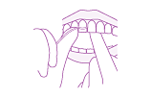
 | Move the floss up and down against the surface of the side of the tooth (both the right and left sides) 2 to 3 times, as if wrapping the floss around the tooth.
 | When moving to the next gap, move the used portion of floss aside and repeat the above process using a clean portion of floss.
 | After you finish flossing, rinse your mouth with water.

How to Use Floss in a Holder
How to Use Floss in a Holder
Slide the floss between the teeth while moving it back and forth in small motions, and slowly move the floss up and down into your gums along the surface of the side of the tooth 2 to 3 times to remove plaque.

Reminders for Using Dental Floss
- When using dental floss or an interdental brush, check the locations of gaps between the teeth using a mirror and pay attention so as not to damage your gums. After you are done cleaning, rinse your mouth.
- If the floss gets caught or frays, there may be caries or tartar between the teeth.
- Consult with a dental clinic.
- Dental floss is necessary for preventing caries in children's teeth.
- Floss your child’s teeth if they cannot floss their teeth themselves.
- If you don’t know how to use dental floss, ask your dentist or dental hygienist for instructions.

Points for Using an Interdental Brush
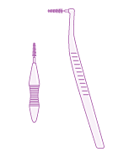What is an Interdental Brush?
When the gaps between teeth are wide, an interdental brush is effective for removing plaque. It is effective to use an interdental brush to clean areas where caries have been treated, behind the rearmost molars, under dental bridges or in spaces left open after teeth have been extracted. In addition, an L-shaped interdental brush is suitable for cleaning between molars. Use it from both the outer and inner sides of the teeth.

How to Use an Interdental Brush
 | Use an interdental brush while looking into a mirror. Holding the brush like a pencil will make it easy to use. | 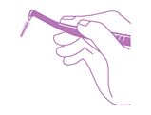
 | Slowly slide the brush between two teeth, so as not to damage the gums. | 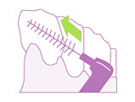
While holding the brush horizontally, move it back and forth along the tooth surface 2 to 3 times.
*When cleaning between molars, it is effective to brush from both the inner and outer sides.
 | 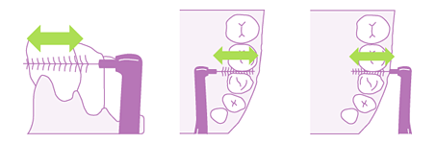
 | Lightly place the brush along the adjacent anterior and posterior teeth and brush.
 | Wash the brush with running cold water and store it in a well-ventilated place after use.

Reminders for Using an Interdental Brush
- It is important to select an appropriate size when choosing an interdental brush.
- Select a size that suits the condition of your gums and the locations for use.
- Choose an interdental brush of a size that you can insert smoothly between your teeth, without it feeling tight.
- Use the interdental brush while checking the insertion direction of the brush in a mirror.
- When you use an interdental brush for the first time, start with the smallest size.
- If you cannot insert an interdental brush of the smallest size, it is recommended that you use dental floss instead.
- If you do not know how to use an interdental brush, ask your dentist or dental hygienist for instructions.

