Skin diseases

Seborrheic dermatitis

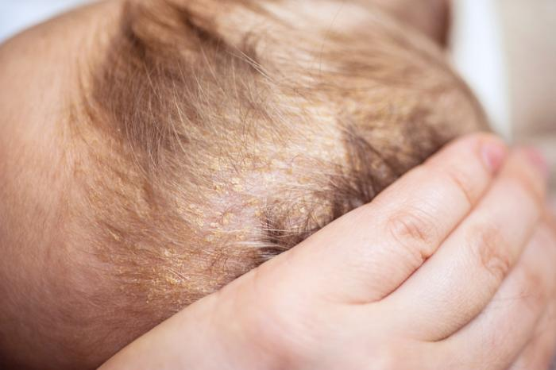
In babies, this is commonly known as cradle cap. Greasy and scaly patches of skin form on the baby's skin, most commonly on the scalp. The patches can become thick and crusty, but cradle cap is harmless. Cradle cap is hermless and usually goes away on its own within a few months.
In adults, it may appear anywhere, and is prone to flare up and disappear for the rest of a person's life. The affected skin may be reddish, swollen, and appear greasy. A white-to-yellow crust may appear on the surface of the skin as well.

Moles

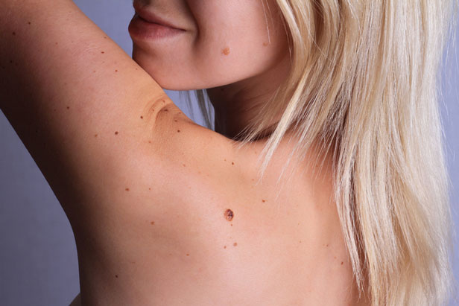
Common growths on the skin that appear when the skin cells bunch up with tissue surrounding them.
Most people have them and may develop new ones from time to time.
They have no symptoms, but should be regularly checked if they grow larger, appear abnormal, or change in color.

Melanoma

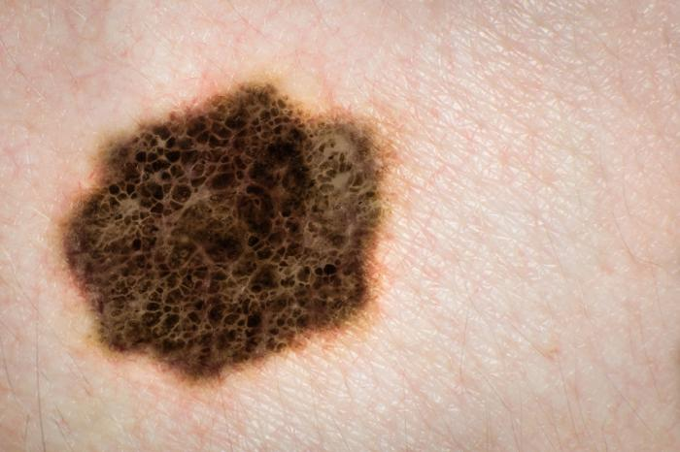
Abnormal moles may lead to this serious and life-threatening type of cancer.
If moles have asymmetrical shapes, ragged edges, uneven colors, or change in size, they should be checked.
Patients with this type of cancer may have surgery, or undergo chemotherapy or radiation treatments.

https://www.medicalnewstoday.com/articles/316622.php

Psoriasis

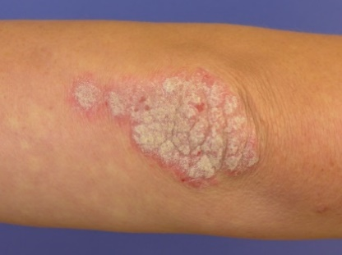
An autoimmune disorder. Symptoms typically include patches of abnormal skin. The affected skin is typically red, scaly, and very itchy. The affected areas vary in size and severity. There are five main types of this disease: plaque, pustular, erythodermic, inverse and guttate.
- Plaque psoriasis causes thick red patches of skin.
- Pustular psoriasis causes pustules surrounded by red skin.
- Erythodermic psoriasis causes patches of skin that look like severe burns covering large portions of the body.
- Inverse psoriasis causes a shiny red rash in the folds of the skin.
- Guttate psoriasis causes small red spots on the scalp, face, torso, and limbs.

Eczema

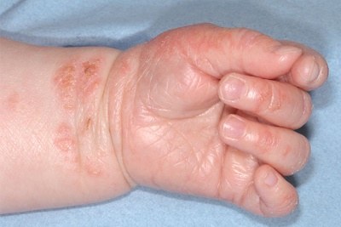
The condition is commonly found in infants and young children, though it continues into adulthood as well. Symptoms include rashes on the face, scalp, behind the elbows, or on the neck, wrists, ankles, or legs.
The rashes are very itchy and may become bumpy, change color, or thicken. In adults, the rashes may cover more of the body, causing very dry skin that is permanently itchy.
There are a few different types of eczema, each causing their own symptoms. There is no known cure for eczema. It either clears up on its own or the symptoms are treated with medications and creams.

Vitiligo

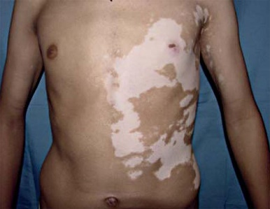
The loss of pigmentation in the skin. White patches of skin are the main symptom, and more commonly appear in areas where the skin is exposed to sunlight. People with this condition often lose their hair color early as well.
For some people, the symptoms are in one area, while others find that it spreads slowly over many years. There is no known cure for vitiligo. There are some medical and surgical treatment options, though they are not right for everyone.

Acne

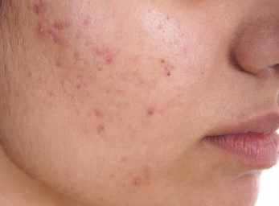
One of the most widespread skin conditions A long-term skin disease that occurs when hair follicles are clogged with dead skin cells and oil from the skin.^{[10]} It is characterized by blackheads or whiteheads, pimples, oily skin, and possible scarring.^{[1]}, it comes in many forms.
- Pustules are the common red pimples that have pus at their tips.
- Papules are the raised red bumps caused by infected hair follicles.
- Nodules are the painful lumps that lie underneath the surface of the skin.
- Cysts are the typically larger painful, pus-filled infections that lie beneath the skin.
All types are commonly treated with creams, and sometimes medication is necessary.
^{[2][11]} It including the face, upper part of the chest, and back.^{[12]} Many treatment options for acne are available, including lifestyle changes, medications, and medical procedures.

Warts

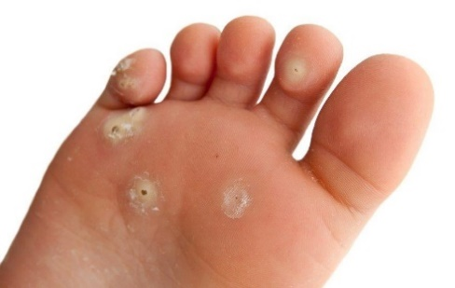
These common raised bumps on the skin are actually caused by the human papillomavirus (HPV). They are unsightly and contagious, and can appear on any part of the body, most typically on the hands, feet, and joints. They often go away on their own, or can be treated with liquid nitrogen or medicated creams.

Cold sore
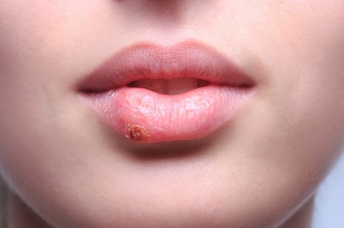
This is a red, fluid-filled blister usually found near the mouth. It is painful or delicate. Other symptoms include itching or burning sensations on the site before the problem is visible.
It is mainly caused by the herpes simplex virus, and there is no known cure for the virus. The problems may return and last for up to 2 weeks. Medical treatment includes creams and medications.

Age spots

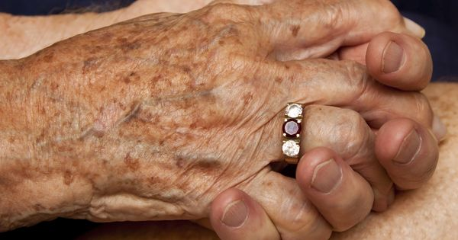
Also called liver spots, they are flat patches on the skin with more pigment than the surrounding area. This may be caused by prolonged exposure to the sun over the years.
They cause no symptoms themselves, but most patients do not like their appearance. They can be treated in a variety of ways, but medical treatment is not necessary.

Impetigo

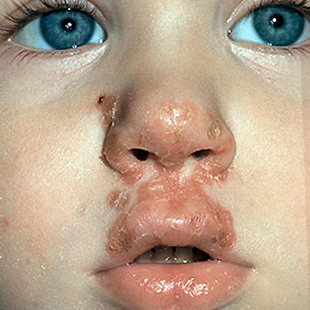
A bacterial skin infection more common in children 2-5-year –olds) than in adults. It is contagious and is caused by strains of both staph and strep bacteria. The symptoms and signs include a rash characterized by either small blisters, or dark or honey-colored crust that forms after the pustules burst. Impetigo is most commonly spread by close contact (such as between family members).It is not serious and is easy to treat with either prescription topical or oral antibiotics. Scarring is very rare.

Dandruff

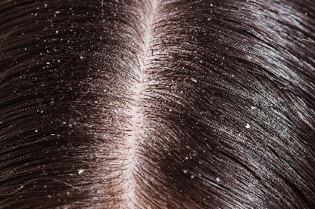
A common chronic scalp condition marked by flaking of the skin on your scalp. For most teens and adults, the symptoms are easy to spot: white, oily-looking flakes of dead skin that dot your hair and shoulders, and a possibly itchy, scaly scalp. Sometimes the scalp can be itchy. It isn't contagious or serious. But it can be embarrassing and sometimes difficult to treat.
Mild cases may need nothing more than daily shampooing with a gentle cleanser. More-stubborn cases often respond to medicated shampoos.

