IRREGULAR PLURALS OF LATIN/GREEK ORIGIN – 2 EXCERCISES WITH KEY

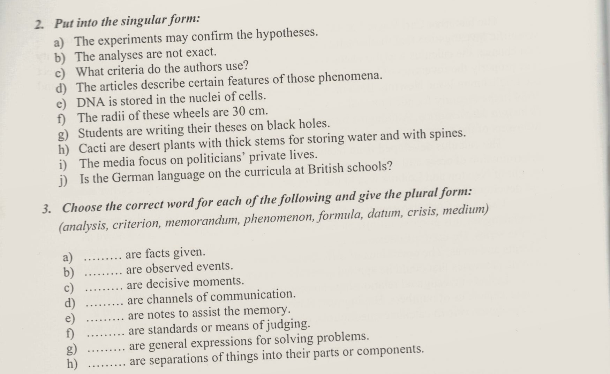

KEY
