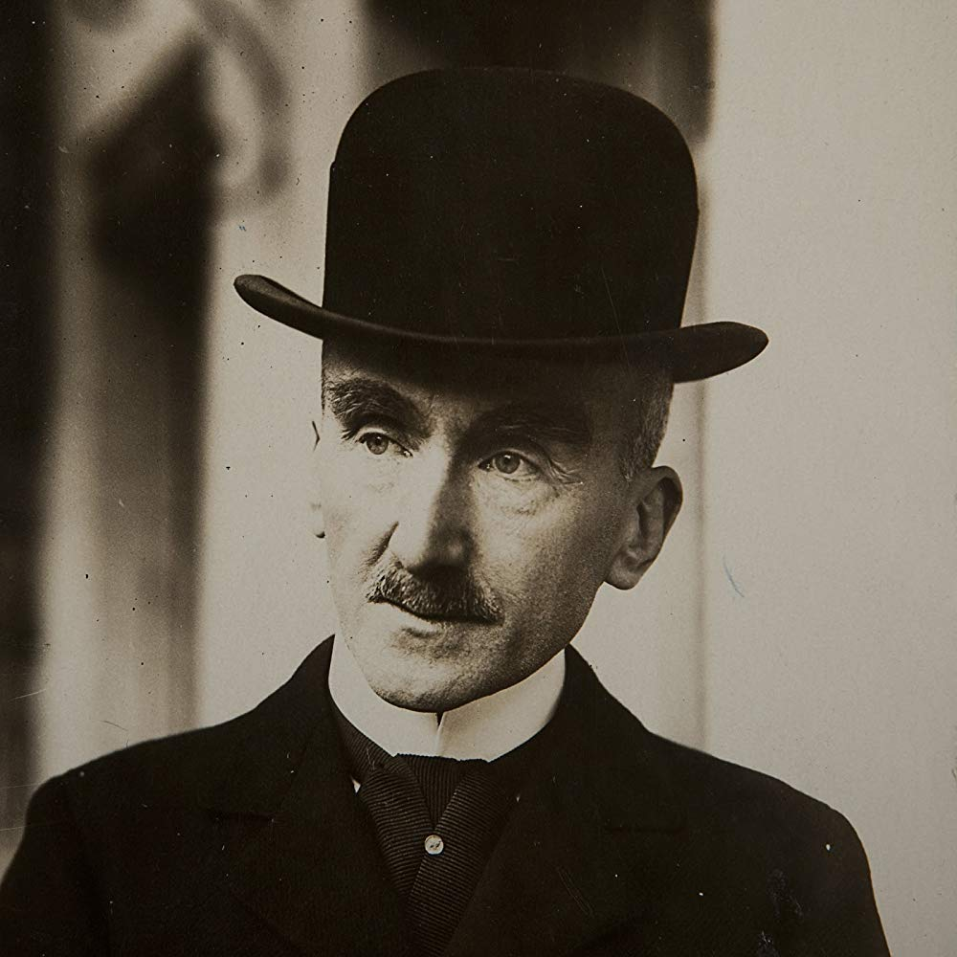
SUMMER 2019
Charles University
Department of Philosophy and Religious Studies
(BA Module + Erasmus students)

Daniele De Santis, Ph. D.

H. Bergson, Matière et mémoire. Essai sur la relation du corps à l’esprit
(Matter and Memory. An Essay on the Relation Between Body and Mind) (1896)

• New Account of “Perception”

“(…) if this be so, is not the growing richness of this perception likely to symbolize the wider range of indetermination left to the choice of the living being in its conduct with regard to things? Let us start, then, from this indetermination as from the true principle, and try whether we cannot deduce from it the possibility, and even the necessity, of conscious perception. In other words, let us posit that system of closely-linked images which we call the material world, and imagine here and there, within the system, centers of real action, represented by living matter: what we mean to prove is that there must be, ranged round each one of these centers, images that are subordinated to its position and variable with it; that conscious perception is bound to occur, and that, moreover, it is possible to understand how it arises” (31)

Real Action ≠ Action (and Re-Action)

As an image among images (i.e., as part of the material world), the body acts and re-acts
As a body (i.e., as living matter), it really acts

“the more immediate the reaction is compelled to be, the more must perception resemble a mere contact; and the complete process of perception and of reaction can then hardly be distinguished from a mechanical impulsion followed by a necessary movement. But in the measure that the reaction becomes more uncertain, and allows more room for suspense, does the distance increase at which the animal is sensible of the action of that which interests it. By sight, by hearing, it enters into relation with an ever greater number of things, and is subject to more and more distant influences; and, whether these objects promise an advantage or threaten a danger, both promises and threats defer the date of their fulfillment” (32)

“we can affirm that its amplitude [i.e., of perception] gives the exact measure of the indetermination of the act which is to follow” (32)

Perception is master of space in the exact measure…
In which action is master of time

“la perception dispose de l’espace dans l’exacte proportion où l’action dispose du temps”

