Special neurophysiology

Laboratory exercise and seminar in medical physiology
Home preparation, study materials and learning objectives

Content of the seminar
In this seminar, we will discuss several topics regarding the higher functions of the brain – control of the movements, generation and saving memory engrams, control of sleep and wakefulness, and generation of speech. You will learn about functional areas of the brain cortex.

Learning objectives of the seminar
- You will learn about the role of the specific neurotransmitter systems in the control of sleep and wakefulness
- You will be able to describe basic anatomical and functional areas of the brain lobes
- You will understand the contribution of the brain cortex, cerebellum, and basal ganglia to the control of movements
- You will be able to describe the mechanisms of formation of memory traces on cellular and molecular level
- You will learn about the cortical structures involved in speech understanding and production and how to distinguish specific speech dysfunctions based on damage to these brain structures

Learning materials
- Lectures from general physiology
- Textbook Guyton and Hall Textbook of Medical Physiology
  - Chapters 56-59
- Textbook Physiology Linsa S. Constanzo
  - Pages 103-116

Home Preparation

Ascending reticular activation system (ARAS) and control of sleep and wakefulness

In the diagrams of the brain, draw the neuromediators below and the structures where they are synthesized together with areas of their projections. Match the individual terms (neuromediators and structures) and explain their basic functions in the regulation of sleep and wakefulness. In the next picture, draw which mediators predominate during sleep and which during wakefulness. Damage of which structure leads to narcolepsy and which condition leads to insomnia?

norepinephrine hypothalamus
serotonine VLPO
histamine locus coeruleus
GABA thalamus
orexine (hypocretine) pontine tegmental ncll., basal forebrain
acetylcholine tuberomammillary ncl.
glutamate ventral tegmental area
dopamine raphe nuclei

norepinephrine
serotonine

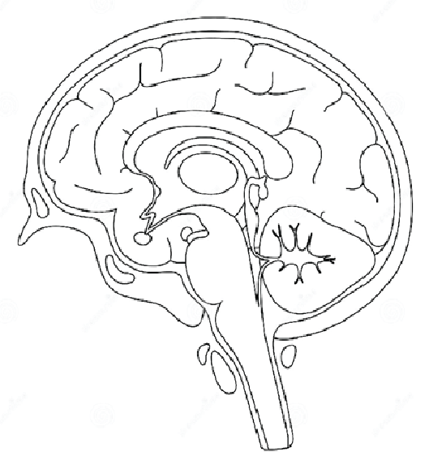

acetylcholine
histamine

