Week 1 Introduction

Legal English: difficulties

- Have you ever heard of arraignment in the context of criminal procedure?
- What kind of murder is a first degree murder?
- Who is a plaintiff, claimant, petitioner, and applicant?
- Joint tenancy and joint ownership. Are these expressions synonymous?
- Definition of burglary (m-w.com): the act of breaking and entering a dwelling at night to commit a felony (such as theft). Is there a crime of burglary in your own country?
- The trial court found for the plaintiff.
- Do you know what consideration means in contract law?
- The law came into force. The law came into effect. Is there any difference, or are these expressions synonymous?
- Have you ever been Mirandized?
- The Czech Parliament consists of two chambers. What are they called?
- In Scots law, the word heritage refers to inheritance.
- If you practise law, it means that …….
- The barrister drafted an advice. Is the sentence grammatically correct?
- What does the word regulation mean?
- The word justice can have several meanings. Explain 2 meanings.
- He was a party _______ that contract. (fill in the missing preposition)
- What is the doctrine of stare decisis?
- How do you pronounce jus cogens?
- The jury was hung. Did anybody die?
- In the Czech criminal procedure, which bodies are included under investigative, prosecuting, and adjudicating bodies?
- Which legal profession could be translated into English as private enforcement agent?
- In the UK, courts and tribunals are not the same. Explain the difference.

Features of Legal English

“Know all persons by these presents that I hereby give, grant, release, convey, transfer and quitclaim all my right, title, interest, benefit and use whatsoever in, or and concerning this chattel, otherwise known as an orange, or citrus aurantium, together with all the appurtenances thereto of skin, pulp, pip, rind, seeds and juice to have and to hold the said orange, for his own use and behoof, to himself and his heirs, in fee simple forever, free from all liens, encumbrances, easements, limitations, restraints or conditions whatsoever, any and all prior deeds, transfer, or other documents whatsoever, now or anywhere made to the contrary notwithstanding, with full power to bite, cut, suck or otherwise eat the said orange or to give away the same, with or without its skin, pulp, pip, rind, seeds or juice.”

Features of legal English | Examples from the text

Legal English: reading (The Cambridge Encyclopedia of the English Language)

Text 1: Plain English
- What argument is sometimes raised to defend legalistic writing in official documents?

- What plain English efforts were undertaken in the U.S.?

- What argument is used to support plain English?

- What arguments are raised by the critics of plain English? Are they valid?

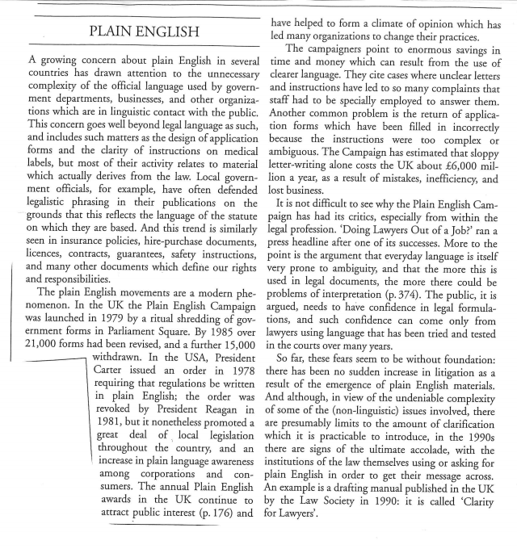

Legal English: reading (The Cambridge Encyclopedia of the English Language)

Text 2: Precision and Tradition

- Explain the relationship between precision and bad faith.

- Is legal language precise?

- Apart from the need for precision, which other factors have shaped legal language?

- Explain what is meant by “a suspicion of change” in the article.

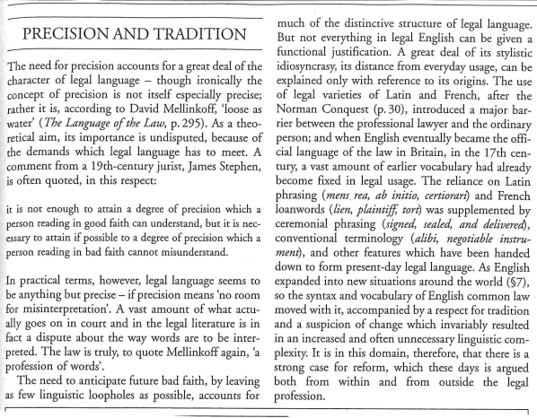

Genres

Text 1

THE MASTER OF THE ROLLS: In summertime village cricket is the delight of everyone. Nearly every village has its own cricket field where the young men play and the old men watch. In the village of Lintz in County Durham they have their own ground, where they have played these last seventy years. They tend it well. The wicket area is well rolled and mown. The outfield is kept short. It has a good club-house for the players and seats for the onlookers. The village team play there on Saturdays and Sundays. They belong to a league, competing with the neighbouring villages. On other evenings after work they practice while the light lasts. Yet now after these 70 years a Judge of the High Court has ordered that they must not play there anymore, lie has issued an injunction to stop them. He has done it at the instance of a newcomer who is no lover of cricket. This newcomer has built, or has had built for him, a house on the edge of the cricket ground which four years ago was a field where cattle grazed. The animals did not mind the cricket. But now this adjoining field has been turned into a housing estate. The newcomer bought one of the houses on the edge of the cricket ground. No doubt the open space was a selling point. Now he complains that, when a batsman hits a six, the ball has been known to land in his garden or on or near his house. His wife has got so upset about it that they always go out at weekends. They do not go into the garden when cricket is being played. They say that this is intolerable. So they asked the Judge to stop the cricket being played. And the Judge, I am sorry to say, feels that the cricket must be stopped: with the consequences, I suppose, that the Lintz cricket-club will disappear. The cricket ground will be turned to some other use. I expect for more houses or a factory. The young men will turn to other things instead of cricket. The whole village will be much the poorer. And all this because of a newcomer who has just bought a house there next to the cricket ground. […]

Text 2

I, ______________________________, resident in the City of ____________________, County of ____________________, State of ____________________, being of sound mind and disposing memory and not acting under duress or undue influence, and fully understanding the nature and extent of all my property and of this disposition thereof, do hereby make, publish, and declare this document to be my Last Will and Testament, and do hereby revoke any and all other wills and codicils heretofore made by me.
FIRST:
- I direct that all my debts, and expenses of my last illness, funeral, and burial, be paid as soon after my death as may be reasonably convenient, and I hereby authorize my Personal Representative (or Executor), hereinafter appointed, to settle and discharge, in his or her absolute discretion, any claims made against my estate.
- I further direct that my Personal Representative (or Executor) shall pay out of my estate any and all estate and inheritance taxes payable by reason of my death in respect of all items included in the computation of such taxes, whether passing under this Will or otherwise. Said taxes shall be paid by my Personal Representative (or Executor) or Trustee as if such taxes were my debts without recovery of any part of such tax payments from anyone who receives any item included in such computation. (…)

Text 3
THE EUROPEAN SMALL CLAIMS PROCEDURE
Article 4
Commencement of the Procedure
1. The claimant shall commence the European Small Claims Procedure by filling in standard claim Form A, as set out in Annex I, and lodging it with the court or tribunal with jurisdiction directly, by post or by any other means of communication, such as fax or e-mail, acceptable to the Member State in which the procedure is commenced. The claim form shall include a description of evidence supporting the claim and be accompanied, where appropriate, by any relevant supporting documents.
2. Member States shall inform the Commission which means of communication are acceptable to them. The Commission shall make such information publicly available.
3. Where a claim is outside the scope of this Regulation, the court or tribunal shall inform the claimant to that effect. Unless the claimant withdraws the claim, the court or tribunal shall proceed with it in accordance with the relevant procedural law applicable in the Member State in which the procedure is conducted.
4. Where the court or tribunal considers the information provided by the claimant to be inadequate or insufficiently clear or if the claim form is not filled in properly, it shall, unless the claim appears to be clearly unfounded or the application inadmissible, give the claimant the opportunity to complete or rectify the claim form or to supply supplementary information or documents or to withdraw the claim, within such period as it specifies. The court or tribunal shall use standard Form B, as set out in Annex II, for this purpose.

Text 4
…
WHEREAS, Seller owns certain Goods, as defined below, and Seller desires to sell such Goods under the terms and conditions set forth in this Agreement; and
WHEREAS, Buyer desires to purchase the Goods offered for sale by Seller under the terms and conditions set forth in this Agreement.
NOW THEREFORE, in consideration of the mutual promises and for other good and valuable consideration exchanged by the Parties as set forth in this Agreement, the Parties, intending to be legally bound, hereby mutually agrees as follows:
1. Sale of Goods. Seller agrees to sell, transport and deliver to Buyer, and Buyer agrees to purchase the following items in the following quantities and at the prices (the “Goods”): (…)
2. Purchase Price. Buyer will pay to Seller for the Goods and for all obligations specified in this Agreement, if any, as the full and complete purchase price, the sum of $______.
Unless otherwise stated, Seller shall be responsible for all taxes in connection with the purchase of Goods in this Agreement.
3. Payment.
Seller shall invoice Buyer upon the shipment of the Goods. Unless otherwise stated, payment for the Goods is due within ____ days of the date of Seller’s invoice, which date will not be before the date of Seller’s delivery of the Goods. (…)

Legal professions

- drafting, authenticating, and registering certain types of transactional or legal instruments,  - conveyancing,  - contract drafting,  - company formation,  - successions and estate planning,  - powers of attorney. | - representing the government in the case brought against the accused person,  - initiating and directing further criminal investigations,  - guiding and recommending the sentencing of offenders
- handling the legal aspects of the day-to-day operations of the company,  - familiar with corporate law and labor law,  - providing opinions on legal and compliance matters,  - anticipating and guarding against legal risks and liabilities that the company may face. | - presiding over court proceedings,  - ruling on questions of law,  - acting as a referee between the litigating parties,  - rendering decisions in legal disputes.

Difference between barristers and solicitors

Student A

- How do lawyers operate in the US and in the UK?
- What does it mean to “be instructed”?
- What do barristers do?
- Can solicitors do the same work as barristers?

Student B

- Do solicitors and barristers receive any on-the-job training?
- Where do solicitors and barristers work?
- Do barristers have an employment contract?
- How are barristers and solicitors generally paid?

STUDENT A
Lawyer is a generic term; solicitors and barristers are both lawyers. However, there are some very important differences between solicitors and barristers regarding their training, the work they do, how they work and how they are regulated.
In England and Wales we have a split system with a division of labour between barristers and solicitors. In other countries such as the USA there is a fused system where all lawyers can potentially, do all things.
It can be helpful to think of barristers as the “front of house” of the legal system (the Courts) and solicitors as making up the “back office”. However, there is no pecking order as such when it comes to solicitors and barristers, one is not better, more senior or more important than the other!
Role and purpose
Barristers are engaged by solicitors to work on their client’s case (referred to as “being instructed”). Solicitors will usually have a good knowledge of the different barristers chambers and the specialisms of the barristers working within them. This means they are in an ideal position to match up clients with the most appropriate barrister for their case.
Barristers are essentially advocates whose role is to explain an individual’s case in court and argue their position. They are less likely to be involved with a case until it is apparent that it will end up in a court hearing – many cases settle before this stage and so there is never any need to get a barrister involved.
Barristers can also advise clients on the strength of their case, assist with drafting documentation prior to any court hearing and help with negotiations but, generally this is something which will be handled by primarily a solicitor. Solicitors will often attend court with their barrister but, only to take notes and help with the documentation.
The caveats to all that…
For many years barristers were the only people authorised to present cases in the “higher courts” for example, the Court of Appeal and Supreme Court. However, some solicitors do now have rights of audience in the higher courts although this is still very much the exception.
We wouldn’t want anyone to get the impression that solicitors are always stuck behind a desk and never get on their feet to argue on behalf of their clients! In the lower courts such as the employment tribunal you are just as likely to see a solicitor as a barrister standing up to address the tribunal. However, when it comes to full hearings and complex cases, it is often more cost effective to hand the advocacy work over to a barrister.
Finally, in recent years it has become possible for members of the public to instruct barristers directly without first going through a solicitor. However, the ability to do this is still quite limited to certain types of cases and requires the individual to effectively act as their own solicitor.
https://www.springhouselaw.com/knowledge-hub/legal-costs/whats-the-difference-between-a-solicitor-a-barrister-and-a-lawyer/

STUDENT B
Training
Solicitors will go to law school prior to joining a law firm as a trainee. During their training contract they will learn on the job for two years, rotating through various departments before deciding which specific area of they wish to qualify into. This used to be referred to as “articles” and trainees were known as “articled clerks”.
Once they have reached the required standards, qualified solicitors’ names are placed on the roll of solicitors and in England and Wales are regulated by the Solicitors Regulation Authority, which issues practising certificates (renewable every year) to those wish to practise law. The Law Society is the professional body for solicitors.
It should be noted that there are some alternative routes to becoming a solicitor and, these are likely to increase in the future.
Barristers will attend bar school prior to obtaining a pupillage at a barristers’ chambers where they will work under the supervision of a qualified barrister, generally for 12 months (sometimes longer). Qualified barristers are “called to the Bar” and regulated by the Bar Standards Board Council which maintains the Barristers’ Register showing all those who are authorised to practise in England and Wales and who hold a current practising certificate.
Law firms v chambers
Solicitors are either employed by their law firm or, are a partner in their law firm or, work in-house as employed solicitors at a company or public sector organisation.
Barristers are self-employed individuals who are not allowed to form partnerships and tend to congregate together in offices known as chambers. Each individual barrister in chambers is independent – they group together simply to enable joint administration, marketing etc.. Consequently, two barristers who work out of the same set of chambers may be on opposing sides in a case. However, two solicitors working for the same firm would be prevented from working for clients who were on opposing sides in a case as this would be a conflict of interest and contrary to solicitors’ professional rules.
Payment and continuity
Solicitors still generally bill by the hour however, barristers are more likely to be paid by the piece of work, i.e. £x to attend for this hearing and £y to draft this document.
A solicitor will remain responsible for a client and their case all the way through from start to finish. This is because they are retained by a client to deal with matters as and when they arise. However, a barrister may not always be available for a client to attend a particular hearing because these dates are not previously known.
Barristers must honor any booking to appear for another client. This is called the ‘cab rank rule’ and helps keep barristers independent by preventing them from picking and choosing the cases they want to do. This means that a different barrister may have to be found for certain hearings.
https://www.springhouselaw.com/knowledge-hub/legal-costs/whats-the-difference-between-a-solicitor-a-barrister-and-a-lawyer/

Video: TED talk Alan Siegel: Let’s simplify legal jargon

- Why did Alan Siegel mention “empathy” and “humanity”?
- In what ways was he professionally involved in plain English?
- In the IRS letters, what did the red colour indicate?

