Name………………………………………………………………….

GIT II - Digestion
Students‘ protocol
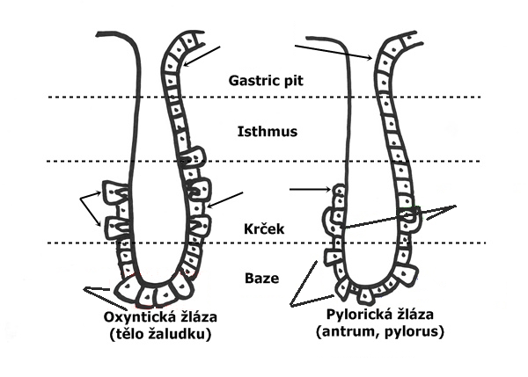
Neck
Base
Stomach body

Antrum, pylorus

Which cells are responsible for secretion
- hydrochloric acid
- pepsinogen
- gastric lipases
- internal factor
- mucus
- bicarbonate

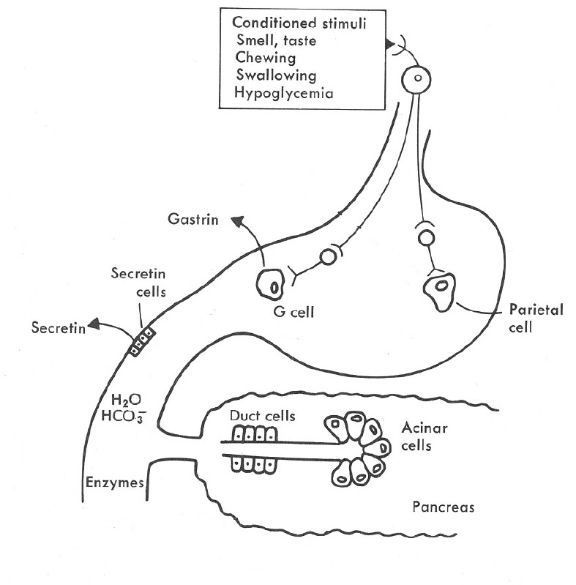
Draw how and where it works
- gastrin
- secretin

Where are they secreted from?

- H⁺
- H₂O + HCO₃ ⁻

Glycolytic enzymes

Lipolytic enzymes

Proteolytic enzymes

Complete the table
 | change in blood level | bone | kidneys | intestine
Parathormon PTH | Ca²⁺ P
Calcitonin | Ca²⁺ P
Calcitriol D₃ | Ca²⁺ P

