Version 07/04/2022
- Work with the following sequence obtained after sequencing (also in Moodle):
TACTGTTTTCGTACAGTTTTGTAATAAAAAAACCTATAAATATTCCGGATTATTCATACCGTCCCACCAT
CGGGCGCGGATCTTTTTATCTAGCATAGCCAAAAAGAAAGAGCTTGCACATATGGAGAGATCAAACAGCA
CAGCTTCTATGGCCGTGCAAGAACTTCACCATGGAGCTATGGAGATTATGATAATTGCCAACAGGATCAT
GATTATCTTCTAGGGTTTTCATGGCCACCAAGATCCTACACTTGCAGCTTCTGCAAAAGGGAATTCAGAT
CGGCTCAAGCACTTGGTGGCCACATGAATGTTCACAGAAGAGACAGAGCAAGACTCAGATTACAACAGTC
TCCATCATCATCTTCAACACCTTCTCCTCCTTACCCTAACCCTAATTACTCTTACTCAACCATGGCAAAC
TCTCCTCCTCCTCATCATTCTCCTCTAACCCTATTTCCAACCCTTTCTCCTCCATCCTCACCAAGATATA
GGGCAGGTTTGATCCGTTCCTTGAGCCCCAAGTCAAAACATACACCAGAAAACGCTTGTAAGACTAAGAA
ATCATCTCTTTTAGTGGAGGCTGGAGAGGCTACAAGGTTCACCAGTAAAGATGCTTGCAAGATCCTGAGG
AATGATGAAATCATCAGCTTGGAGCTTGAGATTGGTTTGATTAACGAATCAGAGCAAGATCTGGATCTAG
AACTCCGTTTGGGTTTC
- Determine if this sequence is contaminated with vector, rewrite the purified sequence in FASTA format. 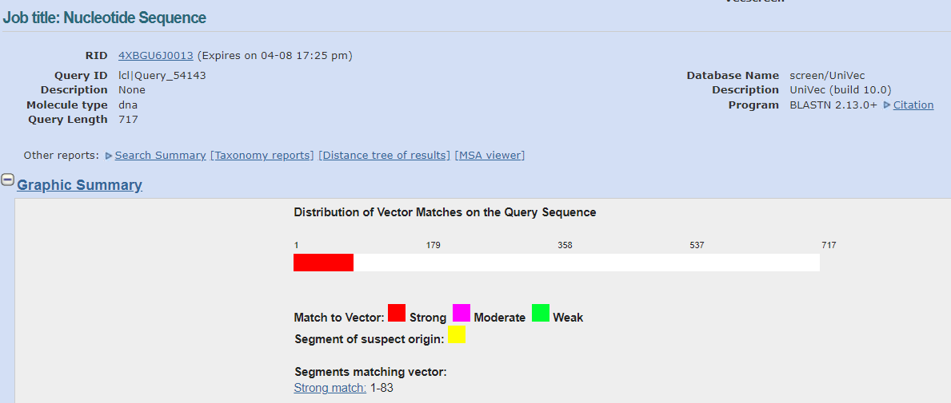
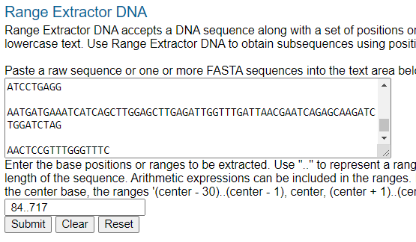
>purified sequence
TTTTATCTAGCATAGCCAAAAAGAAAGAGCTTGCACATATGGAGAGATCAAACAGCACAG
CTTCTATGGCCGTGCAAGAACTTCACCATGGAGCTATGGAGATTATGATAATTGCCAACA
GGATCATGATTATCTTCTAGGGTTTTCATGGCCACCAAGATCCTACACTTGCAGCTTCTG
CAAAAGGGAATTCAGATCGGCTCAAGCACTTGGTGGCCACATGAATGTTCACAGAAGAGA
CAGAGCAAGACTCAGATTACAACAGTCTCCATCATCATCTTCAACACCTTCTCCTCCTTA
CCCTAACCCTAATTACTCTTACTCAACCATGGCAAACTCTCCTCCTCCTCATCATTCTCC
TCTAACCCTATTTCCAACCCTTTCTCCTCCATCCTCACCAAGATATAGGGCAGGTTTGAT
CCGTTCCTTGAGCCCCAAGTCAAAACATACACCAGAAAACGCTTGTAAGACTAAGAAATC
ATCTCTTTTAGTGGAGGCTGGAGAGGCTACAAGGTTCACCAGTAAAGATGCTTGCAAGAT
CCTGAGGAATGATGAAATCATCAGCTTGGAGCTTGAGATTGGTTTGATTAACGAATCAGA
GCAAGATCTGGATCTAGAACTCCGTTTGGGTTTC
• Does the purified sequence encode a protein? How long is the longest open reading frame (ORF)? the longest ORF: 414nt=137aa
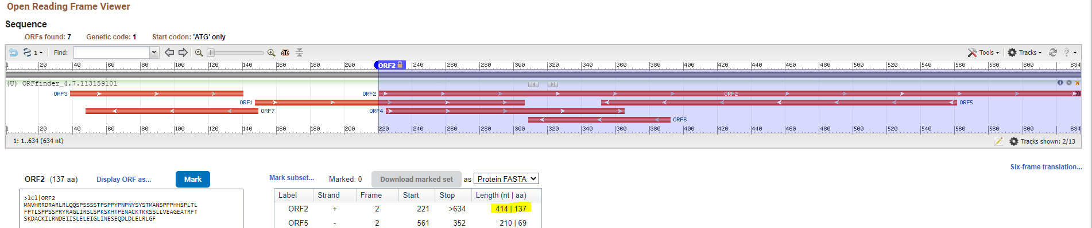
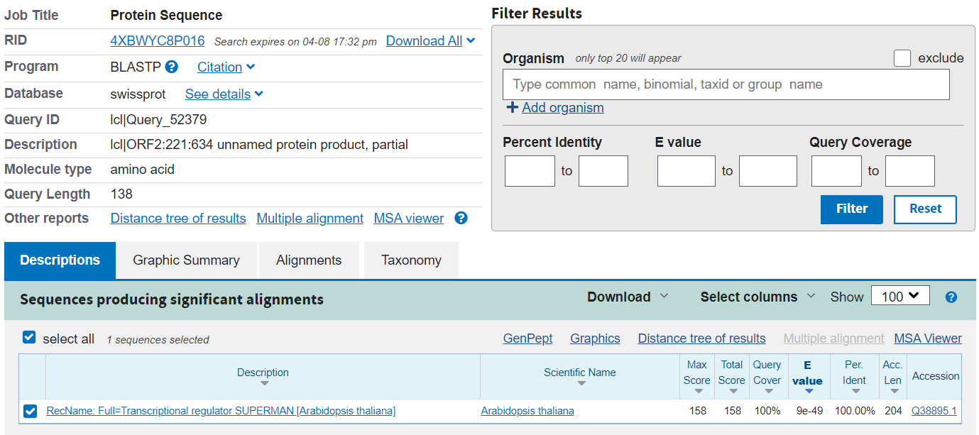

• What organism does this sequence likely come from? A. thaliana
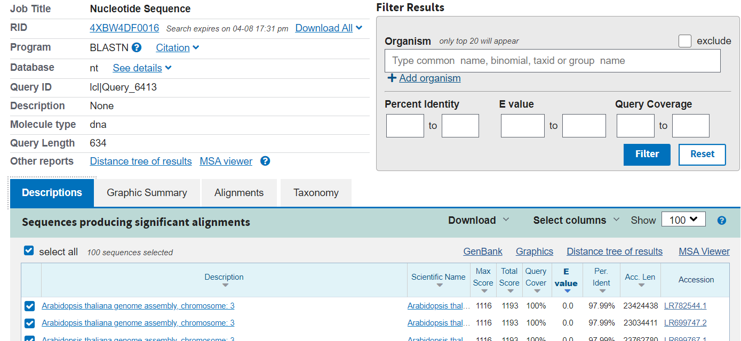
• Will the purified sequence be cleaved by the following enzymes: EcoRI, KpnI or MseI?
EcoRI 1x
KpnI 0x
MseI 1x
• What fragments are formed after cleavage by all these enzymes at once?
Three fragments: 400bp,188bp,46bp
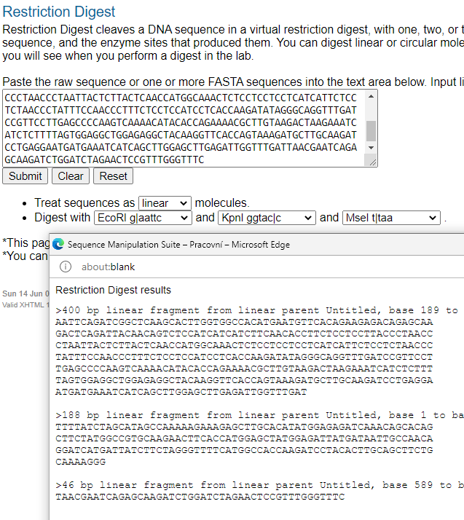

- Find a human protein sequence called FOX1
- What is the accession number and function of this protein?
Q9NWB1 / NP_665898
RNA-binding protein that regulates alternative splicing events by binding to 5'-UGCAUGU-3' elements. Regulates alternative splicing of tissue-specific exons and of differentially spliced exons during erythropoiesis.
• Does this protein have any transmembrane regions? None
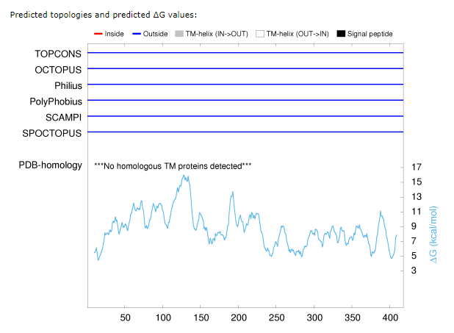
- How many cysteines does the sequence have? 1 cysteine
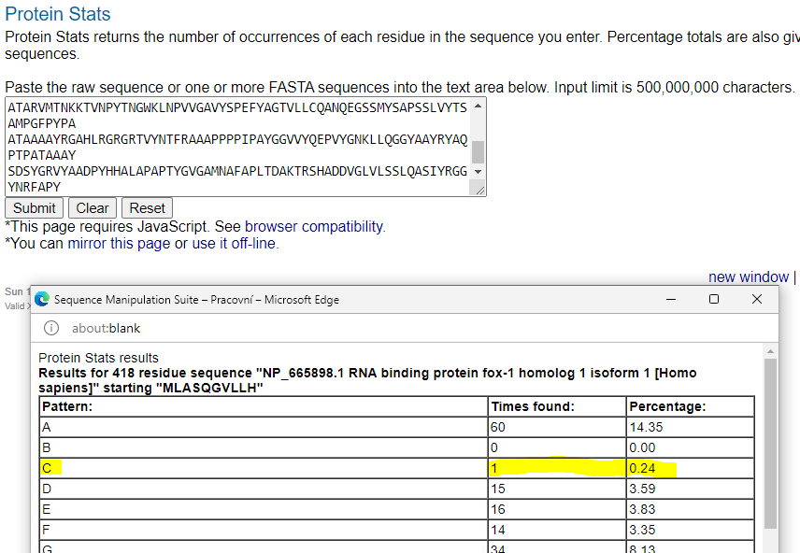
• Compare how similar the protein is to the respective mouse homologue?
Laling: 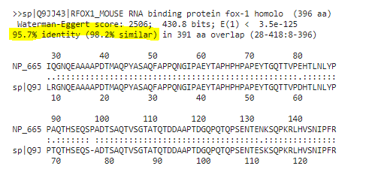
Needle
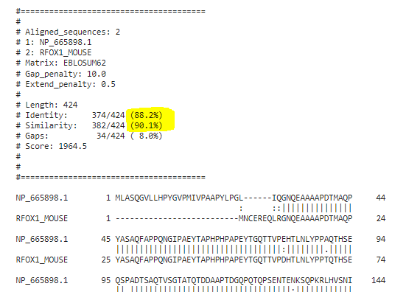
- Design primers to amplify the CDS of respective gene.
>NM_145891.3:158-1414 Homo sapiens RNA binding fox-1 homolog 1 (RBFOX1), transcript variant 1, mRNA
ATGCTGGCGTCTCAAGGAGTTCTCCTGCATCCTTATGGCGTGCCTATGATTGTACCGGCAGCTCCTTACC
TTCCTGGACTGATTCAGGGTAATCAGGAAGCAGCCGCTGCCCCTGACACAATGGCTCAGCCTTACGCTTC
GGCCCAGTTTGCTCCCCCGCAGAACGGTATCCCCGCGGAATACACGGCCCCTCATCCCCACCCCGCGCCA
GAGTACACAGGCCAGACCACGGTTCCCGAGCACACATTAAACCTGTACCCTCCCGCCCAGACGCACTCCG
AGCAGAGCCCGGCGGACACGAGCGCTCAGACCGTCTCTGGCACCGCCACACAGACAGATGACGCAGCACC
GACGGATGGCCAGCCCCAGACACAACCTTCTGAAAACACGGAAAACAAGTCTCAGCCCAAGCGGCTGCAT
GTCTCCAATATCCCCTTCAGGTTCCGGGATCCGGACCTCAGACAAATGTTTGGTCAATTTGGTAAAATCT
TAGATGTTGAAATTATTTTTAATGAGCGAGGCTCAAAGGGATTTGGTTTCGTAACTTTCGAAAATAGTGC
CGATGCGGACAGGGCGAGGGAGAAATTACACGGCACCGTGGTAGAGGGCCGTAAAATCGAGGTAAATAAT
GCCACAGCACGTGTAATGACAAATAAAAAGACCGTCAACCCTTATACAAATGGCTGGAAATTGAATCCAG
TTGTGGGTGCAGTCTACAGTCCCGAATTCTATGCAGGCACGGTCCTGTTGTGCCAGGCCAACCAGGAGGG
ATCTTCCATGTACAGTGCCCCCAGTTCACTTGTATATACTTCTGCAATGCCAGGCTTCCCGTATCCAGCA
GCCACCGCCGCGGCCGCCTACCGAGGGGCGCACCTGCGAGGCCGCGGTCGCACCGTGTACAACACCTTCA
GGGCCGCGGCGCCCCCGCCCCCGATCCCGGCCTACGGCGGAGTAGTGTATCAAGAGCCTGTGTATGGCAA
TAAATTGCTGCAGGGTGGTTATGCTGCATACCGCTACGCCCAGCCTACCCCTGCCACTGCCGCTGCCTAC
AGTGACAGTTACGGACGAGTTTATGCTGCCGACCCCTACCACCACGCACTTGCTCCAGCCCCCACCTACG
GCGTTGGTGCCATGAATGCTTTTGCACCTTTGACTGATGCCAAGACTAGGAGCCATGCTGATGATGTGGG
TCTCGTTCTTTCTTCATTGCAGGCTAGTATATACCGAGGGGGATACAACCGTTTTGCTCCATACTAA

F: ATGCTGGCGTCTCAAGGAG
R: TTAGTATGGAGCAAAACGGTTG
F:
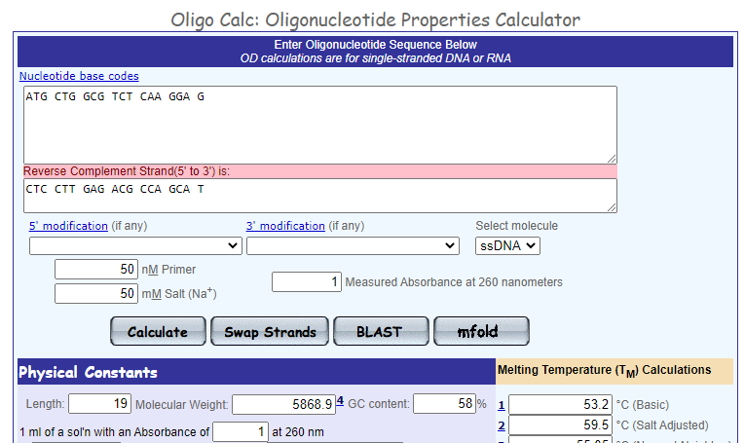

R:
